IQRA NATIONAL UNIVERSITY
Phase-1 Phase 2 Hayatabad, Peshawar, Khyber PakhtunKhwa
PAPER | FINAL TERM
COURSE TITLE | WATER DEMAND SUPPLY & DISTRIBUTION
SUBMITTED TO | SIR ENGR.NADEEM ULLAH
SUBMITTED BY | MEHRAN ALI SHAH
REGISTRATION NO | 14347
DEPARTMENT | CIVIL ENGINEERING
MODULE | MS(CEM)
DATE | 25-06-2020
CANDIDATE SIGNATURE

QUESTION_2

- Methods of Setting Water Distribution System Layouts
Different methods of laying out distribution system are as follows:
- Dead end system
- Grid iron system
- Ring system
- Radial system
- Dead End Water Distribution System

- Advantages of Dead End System
- Pipes in this network can be laid easily.
- The pressure and discharge in each pipe can be determined very easily and accurately which makes design calculations very simple.
- The diameters of pipes of main, sub mains and branches can be designed based on the required demand of population. So, cost of the project can be reduced.
- Dead end system requires less number of cutoff valves.
- Disadvantages
- The pressure is not constant and is very less at remote parts.
- Because of dead ends water stagnation takes place which results in deposition of sediment. To remove this sediments, more number of scour valves are to be provided at the dead ends which increase economy.
- If there is any damage occurs in the branch line, the whole portion should be stopped to repair that which creates discomfort to the other users in that sub main line.
- In this system, Limited discharge is available for firefighting.

- Grid Iron Water Distribution System

- Advantages of Grid Iron System
- Water will flow continuously without any dead ends or sediment deposits.
- Head loss is minimum in this case because of interconnection of pipes.
- The discharge will meet the required discharge for firefighting.
- Repair works can be easily done just by closing cutoff valve in that line which do not affect the other users.
- In case of breakdown in some section, water is available from some other direction.
- Disadvantages
- Because of circulating flow from all directions, the pipes used in this system should be of large diameters and longer lengths.
- We cannot determine the accurate discharge, velocity or pressure in a particular pipe. So, design is difficult.
- Laying of pipes will be done by skilled workers which consume more cost.
- Cutoff valves required should be more in this system.

- Ring Water Distribution System

- Advantages of Ring System

- Advantage:
✔ Water can be supplied to any point from at least two directions.

- No stagnation of water
- Repair works can be done without affecting larger network.
- Large quantity of water is available for firefighting.
- Disadvantages
- Longer length and large diameter pipes are required.
- More number of cutoff valves are necessary.
- Skilled workers are necessary while laying pipes.
- Radial Water Distribution System

- Advantages of Radial System
Advantages:
✔It gives quick service.
✔Stagnation does not occur.

- The water distributed with high velocity and high pressure.
- Head loss is very small because of quick discharge.
- Disadvantages
Cost of the project is more because of number of individual distribution reservoirs.

- Hilly Areas Construction Layout: - In the hilly areas, houses with sloping roofs are preferred so that snow and water may slip down. Besides, stones are easily available there than sand. Hence stones are mostly used to build houses in these areas. Even the roofs are made up of slate stone.

QUESTION_1

- DESALINATION: - Desalination is a process that takes away mineral components from saline water. Due to its energy consumption, desalinating sea water is generally more costly than fresh water from rivers or groundwater, water recycling and water conservation.

- METHODS:-
- Solar distillation
Solar distillation mimics the natural water cycle, in which the sun heats the sea water enough for evaporation to occur. After evaporation, the water vapor is condensed onto a cool surface. There are two types of solar desalination. The former one is using photovoltaic cells which converts solar energy to electrical energy to power the desalination process. The latter one utilizes the solar energy in the heat form itself and is known as solar thermal powered desalination.

- Vacuum distillation
In vacuum distillation atmospheric pressure is reduced, thus lowering the temperature required to evaporate the water. Liquids boil when the vapor pressure equals the ambient pressure and vapor pressure increases with temperature. Effectively, liquids boil at a lower temperature, when the ambient atmospheric pressure is less than usual atmospheric pressure. Thus, because of the reduced pressure, low-temperature "waste" heat from electrical power generation or industrial processes can be employed.
- Multi-stage flash distillation
Water is evaporated and separated from sea water through multi-stage flash distillation, which is a series of flash evaporations. Each subsequent flash process utilizes energy released from the condensation of the water vapor from the previous step.
- Multiple-effect distillation
Multiple-effect distillation (MED) works through a series of steps called effects. Incoming water is sprayed onto pipes which are then heated to generate steam. The steam is then used to heat the next batch of incoming sea water. To increase efficiency, the steam used to heat the sea water can be taken from nearby power plants. Although this method is the most thermodynamically efficient among methods powered by heat, a few limitations exist such as a max temperature and max number of effects.

- Vapor-compression distillation
Vapor-compression evaporation involves using either a mechanical compressor or a jet stream to compress the vapor present above the liquid. The compressed vapor is then used to provide the heat needed for the evaporation of the rest of the sea water. Since this system only requires power, it is more cost effective if kept at a small scale.

REVERSE OSMOSIS METHOD IS MORE EFFECTIVE
- Reverse Oosmosis
Reverse osmosis is an effective means to desalinate saline water, but it is more expensive than other methods. As prices come down in the future the use of reverse osmosis plants to desalinate large amounts of saline water should become more common.

The leading process for desalination in terms of installed capacity and yearly growth is reverse osmosis (RO). The RO membrane processes use semipermeable membranes and applied pressure (on the membrane feed side) to preferentially induce water permeation through the membrane while rejecting salts. Reverse osmosis plant membrane systems typically use less energy than thermal desalination processes. Energy cost in desalination processes varies considerably depending on water salinity, plant size and process type. At present the cost of seawater desalination, for example, is higher than traditional water sources, but it is expected that costs will continue to decrease with technology improvements that include, but are not limited to, improved efficiency, reduction in plants footprint, improvements to plant operation and optimization, more effective feed pretreatment, and lower cost energy sources.
Reverse osmosis uses a thin-film composite membrane, which comprises an ultra-thin, aromatic polyamide thin-film. This polyamide film gives the membrane its transport properties, whereas the remainder of the thin-film composite membrane provides mechanical support. The polyamide film is a dense, void-free polymer with a high surface area, allowing for its high water permeability.
The reverse osmosis process is not maintenance free. Various factors interfere with efficiency: ionic contamination (calcium, magnesium etc.); DOC; bacteria; viruses; colloids and insoluble particulates; bio fouling and scaling. In extreme cases, the RO membranes are destroyed. To mitigate damage, various pretreatment stages are introduced. Anti-scaling inhibitors include acids and other agents such as the organic polymers polyacrylamide and polymeric acid, phosphates and polyphosphates. Inhibitors for fouling are biocides (as oxidants against bacteria and viruses), such as chlorine, ozone, sodium or calcium hypochlorite. At regular intervals, depending on the membrane contamination; fluctuating seawater conditions; or when prompted by monitoring processes, the membranes need to be cleaned, known as emergency or shock-flushing. Flushing is done with inhibitors in a fresh water solution and the system must go offline. This procedure is environmentally risky, since contaminated water is diverted into the ocean without treatment. Sensitive habitats can be irreversibly damaged.
Off-grid solar-powered desalination units use solar energy to fill a buffer tank on a hill with seawater. The reverse osmosis process receives its pressurized seawater feed in non-sunlight hours by gravity, resulting in sustainable drinking water production without the need for fossil fuels, an electricity grid or batteries. Nano-tubes are also used for the same function (i.e., Reverse Osmosis).

QUESTION_3

- Reservoir: - A reservoir is, most commonly, an enlarged natural or artificial lake, pond or impoundment created using a dam or lock to store water.
Reservoirs can be created in a number of ways, including controlling a watercourse that drains an existing body of water, interrupting a watercourse to form an embayment within it, through excavation, or building any number of retaining walls or levees.

- Types:-
- Dammed valleys
A dam constructed in a valley relies on the natural topography to provide most of the basin of the reservoir. Dams are typically located at a narrow part of a valley downstream of a natural basin. The valley sides act as natural walls, with the dam located at the narrowest practical point to provide strength and the lowest cost of construction. In many reservoir construction projects, people have to be moved and re-housed, historical artifacts moved or rare environments relocated. Examples include the temples of Abu Simbel (which were moved before the construction of the Aswan Dam to create Lake Nasser from the Nile in Egypt), the relocation of the village of Capel during the construction of Celyn, and the relocation of Borgo San Pietro of Petrella Salto during the construction of Lake Salto.
Construction of a reservoir in a valley will usually need the river to be diverted during part of the build, often through a temporary tunnel or by-pass channel.
In hilly regions, reservoirs are often constructed by enlarging existing lakes. Sometimes in such reservoirs, the new top water level exceeds the watershed height on one or more of the feeder streams such as at Llyn Clywedog in Mid Wales In such cases additional side dams are required to contain the reservoir.
Where the topography is poorly suited to a single large reservoir, a number of smaller reservoirs may be constructed in a chain, as in the River Tiff valley where the Llwyn-on, Cantref and Beacons Reservoirs form a chain up the valley.
- Coastal
Coastal reservoirs are fresh water storage reservoirs located on the sea coast near the river mouth to store the flood water of a river. As the land based reservoir construction is fraught with substantial land submergence, coastal reservoir is preferred economically and technically since it does not use scarce land area many coastal reservoirs were constructed in Asia and Europe. Saemanguem in South Korea, Marina Barrage in Singapore, Qingcaosha in China, and Plover Cove in Hong Kong, etc. are few existing coastal reservoirs.

- Bank-side
Where water is pumped or siphoned from a river of variable quality or size, bank-side reservoirs may be built to store the water. Such reservoirs are usually formed partly by excavation and partly by building a complete encircling bund or embankment, which may exceed 6 km (4 miles) in circumference. Both the floor of the reservoir and the bund must have an impermeable lining or core: initially these were often made of puddled clay, but this has generally been superseded by the modern use of rolled clay. The water stored in such reservoirs may stay there for several months, during which time normal biological processes may substantially reduce many contaminants and almost eliminate any turbidity. The use of bank-side reservoirs also allows water abstraction to be stopped for some time, when the river is unacceptably polluted or when flow conditions are very low due to drought. The London water supply system is one example of the use of bank-side storage: the water is taken from the River Thames and River Lee; several large Thames-side reservoirs such as Queen Mary Reservoir can be seen along the approach to London Heathrow Airport.
- IMPORTANCE OF RESERVOIR:-
A reservoir is an artificial lake where water is stored. Most reservoirs are formed by constructing dams across rivers. A reservoir can also be formed from a natural lake whose outlet has been dammed to control the water level. The dam controls the amount of water that flows out of the reservoir.
Service reservoirs are entirely manmade and do not rely on damming a river or lake. These reservoirs, sometimes called cisterns, hold clean water. Cisterns can be dug in underground caverns or elevated high above ground in a water tower.
People have been creating reservoirs for thousands of years. The oldest known dam in the world is the Jawa Dam in what is now Jordan. It was built in about 3000 BCE to store water to use for irrigation, or watering crops.
People build reservoirs because the amount of water in a river varies over time. During very rainy times or when mountain snow is melting, the water in a river rises and sometimes overflows its banks. By limiting the amount of water allowed to continue downriver, reservoirs help control flooding.
During droughts, or extended dry periods, the water level in a river may be very low. Under these conditions, more water is released from the reservoir so farmers can water their crops and homes and businesses can function normally.
Reservoirs serve other purposes. They are used for boating, fishing, and other forms of recreation. Some of the dams that create reservoirs are used to generate electricity.
The largest reservoir in the world by surface area is Lake Volta, which was created by damming the Volta River in the African nation of Ghana. Lake Volta covers about 8,500 square kilometers (3,280 square miles), an area larger than the U.S. state of Delaware. Lake Volta ranks fourth in the world in terms of volume, the total amount of water in the lake. The world's biggest reservoir by volume is also in Africa. Lake Kariba lies on the border between Zambia and Zimbabwe.
This lake, which was formed by damming the Zambezi River, stores 185 cubic kilometers (44 cubic miles) of water.
The water in reservoirs is very still. Because of this, bits of sand, rock, dirt, and other material, called sediment, sink to the bottom, leaving the water quite clear. But over time, this sediment builds up, greatly reducing the total amount of water in the reservoir

- CAPACITY OF RESERVOIR CAN BE CALCULATED AS:-
Analytical method• Capacity of the reservoir is determined from the net inflow and demand. Storage is required when the demand exceeds the net inflow. The total storage required is equal to the sum of the storage required during the various periods.

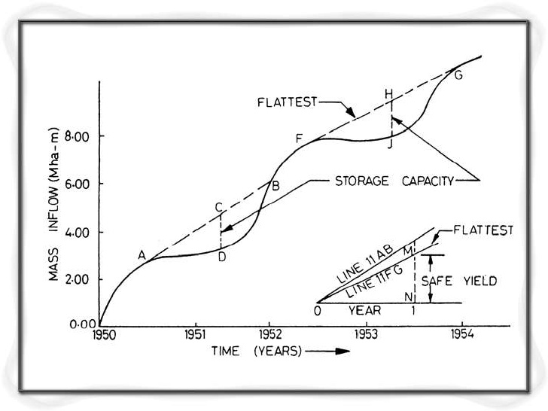

QUESTION_4

Because it delivers a constant flow of water at a constant pressure for any given set of conditions, the centrifugal pump is ideal for delivering water to customers. Most well pumps are centrifugal pumps. They are ideal for use in the distribution system since they do not produce pulsating surges of flow and pressure.
PUMP CURVE:- Curves typically include performance metrics based on pressure, flow, horsepower, impeller trim, and Net Positive Suction Head Required (NPSHr).Pump curves are useful because they show pump performance metrics based on head (pressure) produced by the pump and water-flow through the pump. Flow rates depend on pump speed, impeller diameter, and head.

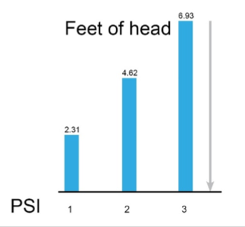

THE FORMULA FOR PSI:

FEET OF HEAD/2.31 = PSI
Flow is the volume of water a pump can move at a given pressure. Flow is indicated on the horizontal axis in units like gallons per minute, or gallons per hour, as shown in Figure.2

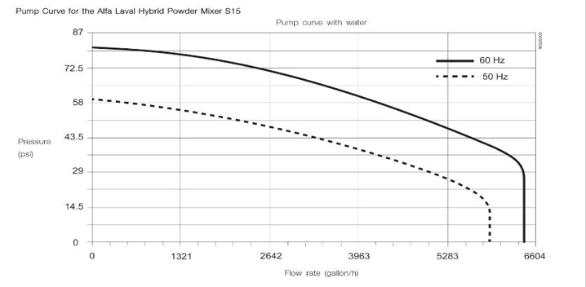

THE END

