Name: Ayesha Salman
Id: 16635
Sub: Anatomy
Instructor: Dr. Arooba
Department BS Radiology 2nd Semester
Section B
Date: 22 June
Q1: what are the major features of intracranial fossae of the skull?
Ans:
MAJOR FEATURES OF INTRACRANIAL FOSSAE OF THE SKULL:
The floor of the cranial cavity is divided into three distinct depressions. They are known as the anterior cranial fossa, middle cranial fossa and posterior cranial fossa. Each fossa accommodates a different part of the brain. The anterior cranial fossa is the most shallow and superior of the three cranial fossae.
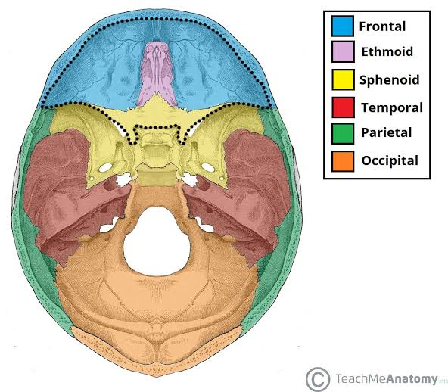
• Anterior cranial fossa
• Middle cranial fossa
• Posterior cranial fossa
Anterior cranial fossa:
The frontal bone turns sharply back to form a large part of the roof of the orbit. This part of the bone is therefore called orbital plate of the frontal bone which is the largest contributor to the anterior fossa.
It is convex and ridged in roughly H-Shape in the conformity with the orbital surface of the frontal lobe of the cerebral hemisphere.
The frontal lobe of the brain occupies the anterior cranial fossa.
Anteriorly the groove for the superior sagittal sinus is traceable down as a crest for the falx cerebri and behind the lower end of the crest is the foramen cecum which is plugged by the fibrous tissue of the falx.
The posterior boundary of the anterior cranial fossa is made by the lesser wing of the sphenoid.
Laterally the lesser wing meets the grrater wing and the frontal bone at the pterion. Here the bone is commonly tunneled by the anterior branch of the middle meningeal artery.
Medially lesser wing of the sphenoid is projected back as the anterior clinoid process.
In front of the anterior clinoid process, the base of the lesser wing is perforated by the optic canal which transmits the optic nerve and ophthalmic artery to the orbits. The two optic foramina are joined by the optic groove.
Inserted into a gap between the anterior pat of the orbital plates is the cribriform plates( L; cribrum =sieve) of the ethmoid with its crista galli ( cock's comb; L, crista= crest , galli= cock) projecting upwards in the midline.
Anterior cranial fossa boundaries
Anterolaterally
Frontal sinus
Posteriorly
Lesser wing and body of sphenoid
Medially
Cribriform plate ( Horizontal and vertical part), crista galli.
Floor
Frontal bone ( orbital plates) Ethmoid
Lesser wing and body of sphenoid
Relations
Nasal cavity , orbital cavity
Contents
Frontal lobes of cerebral hemisphere
Landmarks
Frontal crest = falx cerebri
Ethmoid = crista galli
Sphenoid = lesser wings , anterior clinoid
Process = tentorium cerebelli.

Q2. Write a note on cranial nerves?
CRANIAL NERVES
Cranial nerves are the nerves that emerge directly from the brain (including the brainstem). In contrast, spinal nerves emerge from segments of the spinal cord. Cranial nerves relay information between the brain and parts of the body, primarily to and from regions of the head and neck.

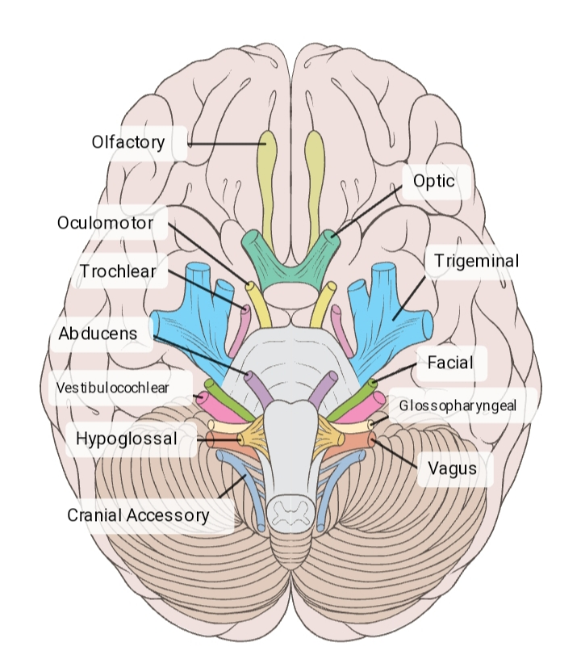
There are 12 cranial nerves
- Olfactory
- Optic
- Oculomotor
- Trochlear
- Trigeminal
- Abducens
- Facial
- Vestibulocochlear
- Glossopharyngeal
- Hypoglossal
- Vagus
- Cranial accessory

Olfactory nerve
The olfactory nerve transmits information to the brain regarding a person’s sense of smell.
Specialized olfactory neurons and nerve fibers meet with other nerves, which pass into the olfactory tract.
The olfactory tract then travels to the frontal lobe and other areas of the brain that are involved with memory and notation of different smells.
Optic nerve
The optic nerve transmits information to the brain regarding a person’s vision.
When light enters the eye, it hits the retina, which contains rods and cones. These are photoreceptors that translate gnals from light into visual information for the brain.
Cones are located in the central retina and are involved with color vision. Rods are located in the peripheral retina and are involved with non-color vision.
These photoreceptors carry signal impulses along nerve cells to form the optic nerve. Most of the fibers of the optic nerve cross into a structure called the optic chiasm. Then, the optic tract projects to the primary visual cortex in the occipital lobe at the back of the brain. The occipital lobe is where the brain handles visual information.
Oculomotor nerves
The oculomotor nerve helps control muscle movements of the eyes.
The oculomotor nerve provides movement to most of the muscles that move the eyeball and upper eyelid, known as extraocular muscles.
Trochlear nerves
The trochlear nerve is also involved in eye movement.
The trochlear nerve, like the oculomotor nerve, originates in the midbrain. It powers the contralateral superior oblique muscle that allows the eye to point downward and inward.
Trigeminal nerve
The trigeminal nerve is the largest cranial nerve and has both motor and sensory functions.
Its motor functions help a person to chew and clench the teeth and gives sensation to muscles in the tympanic membrane of the ear.
Abducen Nerve
The abducens nerve also helps control eye movements.
It helps the lateral rectus muscle, which is one of the extraocular muscles, to turn the gaze outward.
The abducens nerve starts in the pons of the brainstem, enters an area called Dorello’s canal, travels through the cavernous sinus, and ends at the lateral rectus muscle within the bony orbit.

Facial nerve
The facial nerve also has both motor and sensory functions.
The facial nerve is made up of four nuclei that serve different functions:
movement of muscles that produce facial expression
movement of the lacrimal, submaxillary, and submandibular glands
the sensation of the external ear
the sensation of taste
The four nuclei originate in the pons and medulla and join together to travel to the geniculate ganglion.

Vestibulocochlear nerve
The vestibulocochlear nerve is involved with a person’s hearing and balance.
The vestibulocochlear nerve contains two components:
The vestibular nerve helps the body sense changes in the position of the head with regard to gravity. The body uses this information to maintain balance.
The cochlear nerve helps with hearing. Specialized inner hair cells and the basilar membrane vibrate in response to sounds and determine the frequency and magnitude of the sound.
These fibers combine in the pons and exit the skull via the internal acoustic meatus in the temporal bone.

Glossopharyngeal nerve
The glossopharyngeal nerve possesses both motor and sensory functions.
The sensory function receives information from the throat, tonsils, middle ear, and back of the tongue. It is also involved with the sensation of taste for the back of the tongue.
The motor division provides movement to the stylopharyngeus, which is a muscle that allows the throat to shorten and widen.
The glossopharyngeal nerve starts in the medulla oblongata in the brain and leaves the skull through the jugular foramen, which leads to the tympanic nerve.

Vagus nerve
The vagus nerve is the longest cranial nerve as it starts in the medulla and extends to the abdomen.
The vagus nerve has a range of functions, providing motor, sensory, and parasympathetic functions.

Asseccory nerve
The accessory nerve provides motor function to some muscles in the neck:
It controls the sternocleidomastoid and trapezius muscles that allow a person to rotate, extend, and flex the neck and shoulders.
The accessory nerve separates into spinal and cranial parts.
The spinal component starts in the spinal cord and travels into the skull through the foramen magnum. From there, it meets the cranial component of the accessory nerve and exits the skull along the internal carotid artery.
The cranial part of the accessory nerve combines with the vagus nerve.

Hypoglossal nerve
The hypoglossal nerve is a motor nerve that supplies the tongue muscles.
The hypoglossal nerve originates in the medulla.
Disorders of the hypoglossal nerve can cause paralysis of the tongue, most often occurring on one side.
Q3: write note on the salient features of Norma funtalis and norma occipitalis of skull.
NORMA OCCIPITALIS:
Most of the occipital bone can be seen
The lambda is where the lambdoid and sagittal sutures intersect .
The posterior pole of the skull which is the part that will hit the ground first when falling backwards is located below the lambda.
Posterior fontanelle
In the newborn skull , sagittal and lambdoid sutur donot quite meet and there is a triangular posterior fontanelle .
This is much smaller than the anterior fontanelle.
External occipital protuberance
A projection located below the lambda
It can be felt by running a finger upto the midline groove at the back of the neck
Nuchal lines
Stretching laterally from the external occipital protuberance are the superior nuchal lines and below them the inferior nuchal lines.
Inferior nuchal lines
The surface landmark for the attachment of the tentorium cerebelli which straddles the transverse venous sinus.
Superior nuchal lines
The superior nuchal lines is the superior limit of the neck
It provides attachment for the sternocleidomastoid and trapezius muscles. Above the superior nuchal line is the highest nuchal line which gives origin to occipitofrontalis muscle.
The inion
Is the summit of the externa occipital protuberance.
The inion lies opposite the interval between the occipital poles of the cerebrum.
Mastoid emissary foramen
The mastoid foramen is near or in the occipitomastoid suture.
The mastoid foramen transmits an emissary vein from the sigmoid sinus.

NORMA FRONTALIS

When viewed from the front the skull exhibits a somewhat oval outline, limited above by the frontal bone, below by the body of the mandible, and laterally by the zygomatic bones and the mandibular rami. The upper part, formed by the frontal squama, is smooth and convex.

The frontal bone forms the forehead. Its upper part is smooth and convex, but the lower part is irregular and is interrupted by the orbits and by the anterior bony aperture of the nose.

The right and left maxillae form the upper jaw.

The right and left nasal bones form the bridge of the nose.

The zygomatic bones form the bony prominence of the superolateral part of the cheeks.4. The zygomatic bones form the bony prominence of the superolateral part of the cheeks.

The mandible forms the lower jaw.

The Norma Frontalis will be studied under the following heads:
(a) Fronted region.
(b) orbital opening.
(c) anterior piriform-shaped bony aperture of the nose.
(d) lower part of the face.
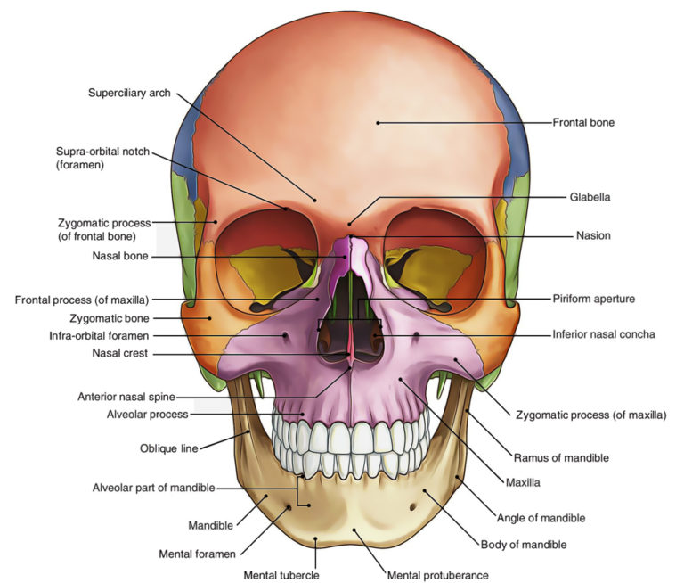

Q4: what do you know about the muscles of hip and knee?
Ans: MUSCLES OF HIP
The movements that can be carried out at the hip joint are listed below, along with the principle muscles responsible for each action: Flexion – iliopsoas, rectus femoris, sartorius, pectineus. Extension – gluteus maximus; semimembranosus, semitendinosus and biceps femoris (the hamstrings)
Type of joint
• Synovial, ball-and-socket joint Capsule:
• Encloses the joint •
Attached to acetabular labrum medially
• Laterally attached to intertrochanteric line of femur in front
• Half way along the posterior aspect of neck of the bone behind.
Ligaments of Hip joint
• Iliofemoral ligament • Pubofemoral ligament • Ischiofemoral ligamenth
• Transverse acetabular ligament • Ligament of the head of the femur
Iliofemoral ligament
• Strong, inverted Y shaped ligament • Base is attached to the anterior inferior iliac spine above • Below the 2 limbs of Y are attached to
upper and lower parts of intertrochanteric line of the femur
• Prevents over extension during standing
Pubofemoral ligament
• Triangular shaped ligament • Apex attached to lower part of intertrochanteric line
• Base is attached to superior ramus of pubis • Limits extension and abduction
Spiral shaped ligament Ischiofemoral ligament
• Attached to body of ischium near acetabular margin
• Fibers pass upward and laterally and are attached to the greater trochanter
• Function: limits extension Transverse acetabular ligament
• Formed by acetebular labrum • It bridges acetabular notch • Converts the notch into a tunnel through which blood vessels and nerves enter the joint.
Flat and triangular in shape Ligament of the Head of the femur
• Apex is attached to the pit on the head of the femur (fovea capitis)
• Base is attached to the transverse ligament and the margins of the acetabular notch
• Lies within the joint • covered by synovial membrane.
Synovial membrane of the hip joint
• Lines the capsule • Attached to the margins of the articular surfaces • Covers the portion of the neck of the femur that lies within the joint capsule
• Ensheathes ligament of the head of the femur • Covers the pad of fat contained in the acetabular fossa
• Pouch of the membrane that protudes through a gap in the anterior wall of the capsule between pubofemoral and iliofemoral ligaments forms psoas bursa beneath psoas tendon.
MOVEMENTS OF HIP JOINT
The movements that can be carried out at the hip joint are listed below, along with the principle muscles responsible for each action:
Flexion – iliopsoas, rectus femoris, sartorius, pectineus
Extension – gluteus maximus; semimembranosus, semitendinosus and biceps femoris (the hamstrings)
Abduction – gluteus medius, gluteus minimus, piriformis and tensor fascia latae
Adduction – adductors longus, brevis and magnus, pectineus and gracilis
Lateral rotation – biceps femoris, gluteus maximus, piriformis, assisted by the obturators, gemilli and quadratus femoris.
Medial rotation – anterior fibres of gluteus medius and minimus, tensor fascia latae
The degree to which flexion at the hip can occur depends on whether the knee is flexed – this relaxes the hamstring muscles, and increases the range of flexion.
Extension at the hip joint is limited by the joint capsule and the iliofemoral ligament. These structures become taut during extension to limit further movement.
MUSCLES OF KNEE
The quadriceps muscles and hamstring muscles provide most of the power and control for the knee joint. The quariceps muscles. This is a group of four muscles: (vastus lateralis, vastus intermedius, vastus medialis, and rectus femoris) located on the front of the thigh.
nded condyles of the femur
• Below are the condyles of the tibia and their cartilaginous menisci
• In front is the articulation between the lower end of the femur and the patella
• The articular surfaces of the femur, tibia and patella are covered with hyaline cartilage
Type
• The joint between the femur and tibia is a synovial joint of the hinge variety.
Some degree of rotatory movement is also possible • Joint between patella and femur is a synovial joint of the plane gliding variety
Capsule:
• Capsule is attached to the margins of the articular surfaces
• Surrounds the sides and the posterior aspect of the joint
• Capsule is absent on the front of the joint, permitting the synovial membrane to pouch upward beneath the quadricepts tenson to form suprapatellar bursa.
Ligaments
• Divided into those that lie outside the capsule and those that lie within the capsule
Extracapsular:
• Ligamentum patellae • Lateral collateral ligament • Medial collateral ligament • Oblique popliteal ligament
Intracapsular:
• Cruciate ligaments – Anterior cruciate ligament – Posterior cruciate ligament
• Menisci.
Extracapsular ligaments
Ligamentum patellae: • Attached above to the lower border of the patella
• Below to the tuberosity of the tibia
• It is the continuation of the central portion of the common tendon of quadriceps femoris muscle
Lateral collateral ligament: • Cord like
• Attached above to the lateral condyle of the femur
• Attached below to the head of fibula.
Medial collateral ligament
• Flat band • Attached below to the medial condyle of the femur
• And below to the medial surface of the shaft of tibia
• Firmly attached to the edge of the medial meniscus
Oblique popliteal ligament
• Tendinous expansion derived from the semimembranosus muscle
• Strengthens the posterior aspect of the capsule.
Intracapsular ligaments Cruciate ligaments:
• 2 strong intracapsular ligaments that cross each other within the joint cavity
• Named anterior and posterior according to their tibial attachments • These ligaments are the main bond between femur and tibia throughout the joint’s range of movement
Anterior Cruciate ligaments:
• Attached to the anterior intercondylar area of the tibia
• Passes upwards, backwards and laterally to be attached to the posterior part of the medial surface of the lateral femoral condyle.
There are four main movements that the knee joint permits:
Extension: Produced by the quadriceps femoris, which inserts into the tibial tuberosity.
Flexion: Produced by the hamstrings, gracilis, sartorius and popliteus.
Lateral rotation: Produced by the biceps femoris.
Medial rotation: Produced by five muscles; semimembranosus, semitendinosus, gracilis, sartorius and popliteus.

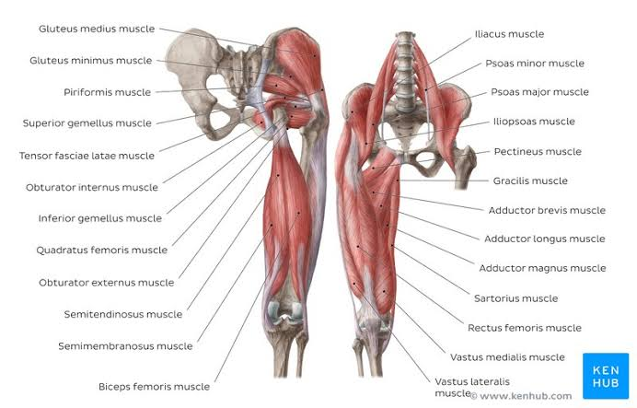

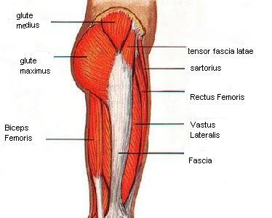

Q5: write a comprehensive note on femoral triangle.
FEMORAL TRIANGLE
The femoral triangle is a wedge-shaped area formed by a depression between the muscles of the thigh. It is located on the medial aspect of the proximal thigh. It is the region of the passage of the main blood vessels between the pelvis and the lower limb, as well as a large nerve supplying the thigh.
Borders
As this area is a triangle, it has three borders:
Superior border – Formed by the inguinal ligament, a ligament that runs from the anterior superior iliac spine to the pubic tubercle.
Lateral border – Formed by the medial border of the sartorius muscle.
Medial border – Formed by the medial border of the adductor longus muscle. The rest of this muscle forms part of the floor of the triangle.
Contents
The femoral triangle contains some of the major neurovascular structures of the lower limb. Its contents (lateral to medial) are:
Femoral nerve – Innervates the anterior compartment of the thigh, and provides sensory branches for the leg and foot.
Femoral artery – Responsible for the majority of the arterial supply to the lower limb.
Femoral vein – The great saphenous vein drains into the femoral vein within the triangle.
Femoral canal – A structure which contains deep lymph nodes and vessels.
The femoral artery, vein and canal are contained within a fascial compartment – known as the femoral sheath.

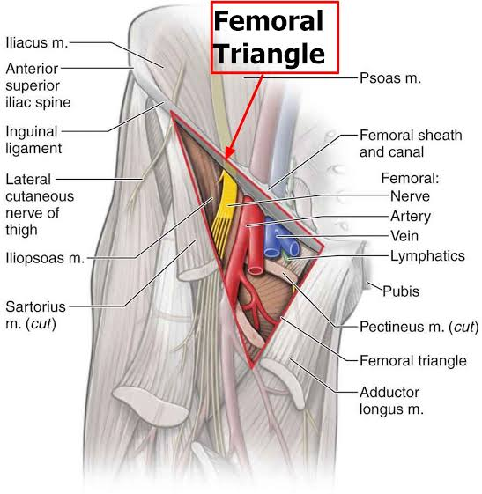

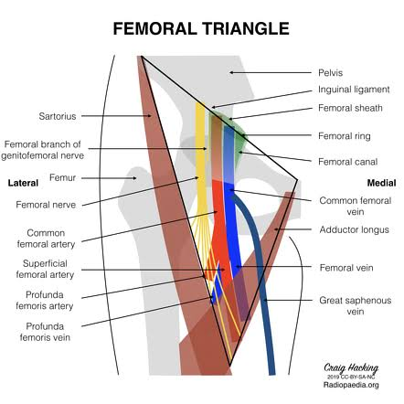
The borders of the femoral triangle are composed of the inguinal ligament superiorly, the adductor longus muscle medially, and the sartorius muscle laterally.

THE END

