NAME ABDULLAH JAN
ID 16105
SECTION A
QUESTION NO 1: Point out slums in Peshawar. What steps would you recommend to improve the livelihood of people living in these slums? While suggesting slum improvements keep the current economic and political situation of the government in mind as well as pay careful attention to the context.
Slum in Peshawar:
So as to improve everyday environments in ghettos of Peshawar, the UN-Living space in a joint effort with the Urban Strategy Unit of the Legislature of Khyber Pakhtunkhwa appointed an examination to break down of the current states of the ghettos.
This section presents the main findings of the “Slum study in Peshawar KP” in a summary form. Subsequent sections present detailed analysis of the living and socio-economic conditions of the four slums surveyed1.
Based on the desk review, discussions with key stakeholders2, and site visits, 18 slums were identified in Urban Peshawar.
four slums namely:
1: Shaheedabad
2: Tajabad
3: Changarabad
4: Gujjar
Only one slum is define
Gujjar camp:
Gujjar camp is situated at 71.4715°E, 34.0093°N close to Peshawar College. In West it is limited by the Kabul stream tributary. The ghetto isn't legitimately open through a street. The closest vehicle terminal is accessible a good way off of 1.5 kilometers on Palosi street in the East through the College of Peshawar grounds, and another entrance is arranged 1 kilometer away towards the South on Trench Street and is open through clogged avenues. The close by ghetto of Gujjar Camp is Tajabad. It would be ideal if you allude to outline "Land Use Guide of Gujjar Camp. Gujjar camp is an aimless settlement of mud houses worked over the ghetto with no appropriate arranged avenues or mohallas. All the occupants are Afghan displaced people who settled around there in 1980s' subsequent to escaping the Soviet War in Afghanistan. Right now, there are around 400 to 500 houses in the ghetto, with a normal family unit size of 11 individuals. The place where there is Gujjar Camp has a place with the Arbab family who keep up full responsibility for land right up 'til today, while allowing the outcasts to assemble their residences and live on a leaseterm premise. Plot sizes shift from 3 marlas or more, and normal month to month lease in the ghetto is Rs. 2,180, with a chance of yearly agreement reestablishment. The transcendent vocation wellsprings of the ghetto incorporate every day wage work and independent work through distributing or shop keeping in Board Bazar, Gujjar Camp, Hayatabad, Karkhano Market, Peshawar City, and so forth. Normal month to month family unit low salary. Practically all the houses in the ghetto are made of mud and dirt. The lanes are limited and unpaved and the sewer water moves through open channels in the avenues and released in the Kabul waterway tributary in the West. There is no formal instructive or wellbeing office in the region. Be that as it may, there are barely any specialists center in close by private settlements for example the Dhobi Ghat zone. It would be ideal if you allude to delineate "Guide of Administrations in Gujjar Camp".
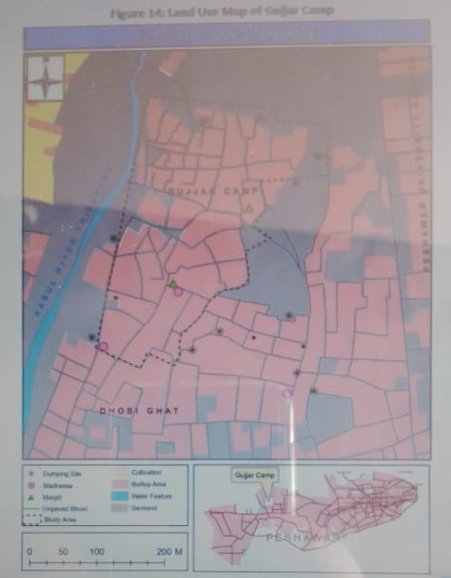

Conclusion:
The urban foundation of Peshawar region has been essentially influenced because of spontaneous development and improvement. In the course of recent decades, the region's characteristic populace development, and deluge of Afghan evacuees followed by ongoing settlement of IDPs from FATA district has brought about creation and extension of regions that are presently delegated ghettos by both worldwide and neighborhood measures. Thusly, ideas of town arranging have progressively gotten unessential, while government offered types of assistance, for example, training, wellbeing, and sanitation can no longer adapt to the necessities of the consistently extending urban ghetto populace. Besides, the financial status of these occupants has likewise been seriously sabotaged. Low proficiency rates and aptitude levels bring about low earnings and absence of access to stable work openings.
Question no 2: Explain the structure and pattern of Islamabad Master Plan. Also mention what could have been done during the planning stage to make this master plan better or mention what was done wrong while planning Islamabad by criticizing it?
Answer: Islamabad Master plan:
The city's master-plan, designed by Greek architect Constantinos Apostolou Doxiadis, divides the city into eight zones, including administrative, diplomatic enclave, residential areas, educational sectors, industrial sectors, commercial areas, and rural and green areas. The city is known for the presence of several parks and forests, including the Margalla Hills National Park and Shakarparian Park. The city is home to several landmarks, including the Faisal Mosque, the largest mosque in South Asia and the fourth largest in the world. Other landmarks include the Pakistan's National Monument and Democracy Square.
Islamabad is a gamma-global city it is categorised as Medium on the Human Development Index, with an HDI of 0.678, the highest in the country. Its life expectancy at 70.77 years, as of 2018, is also higher than the Pakistan average of 67.11. Furthermore, it also has the highest per capita income in the country at GNI Per capita US$8,527 as of 2018 (in constant 2011 international. The city has the highest cost of living in Pakistan, and its population is dominated by middle and upper middle class citizens. Being an expensive city, the prices of most of fruits, vegetable and poultry items increased in Islamabad during the year.
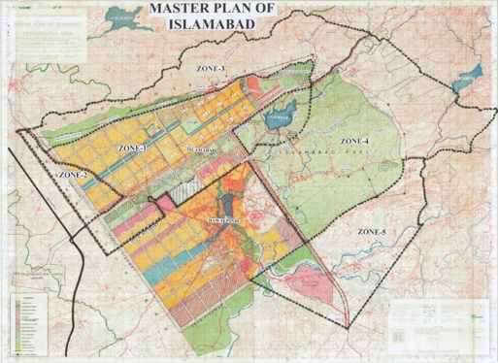

CRITICIZING OF ISLAMABAD:
In 1986 and 2005 CDA made two comprehensive reviews of the Master Plan of Islamabad but both reviews could not obtain approval of the Federal Cabinet.

In compliance of the Supreme Court Order in SMC 10 of 2007, CDA amended the ICT Zoning Regulations 1992 in 2010 in which the Zone-4 of Islamabad was further subdivided into 4 Zones.

In 2015, government promulgated the Islamabad Local Government Act 2015 and Metropolitan Corporation Islamabad was established to perform the municipal functions in Islamabad. The whole city was divided into 50 Union Councils including the sectoral area.
CDA Board in its meeting held on 17-01-2018 decided to hire the services of consultants for review of the Master Plan but the work could not be started due to the forthcoming election and change of the government.
QUESTION ON 3: Which Land use model best represents Peshawar (i.e. Concentric Zone Model, Sector Model or Multiple Nuclei Model). After identifying Model Type, mark (sketch) all the zones (i.e. CBD, Residential, Industrial etc.) on the map as discussed in the model. Additionally, explain the form of Peshawar city.
ANSWER: The part of Peshawar city does not show a sector or concentric patterns. It is more a multiple nuclei city due to many historical, physical and social factors. In term of historical evolution, the city evolved from a number of nuclei such as walled city, cantonment, university town, hayatabad town etc.
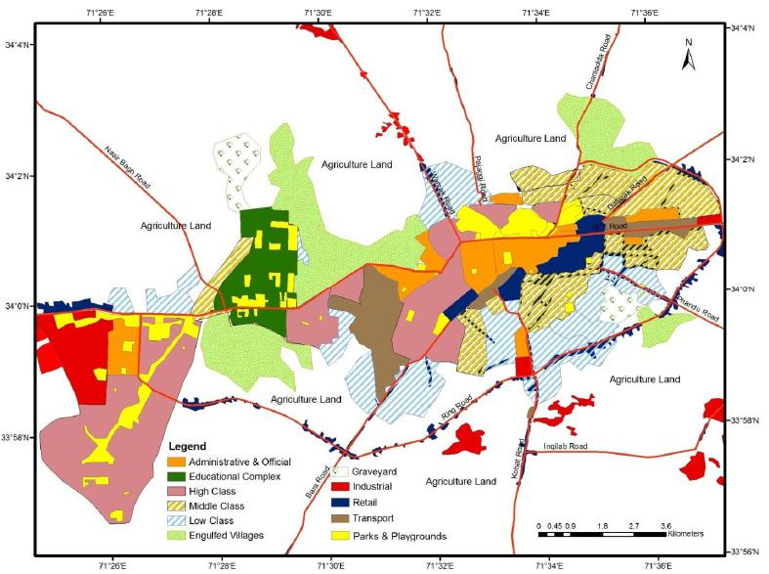
multiple nuclei model:
: The multiple nuclei model is an economical model created by Harris and Edward Ullman in 1945.
: This model describes the layout of a city it is based off of Chicago.
: It notes that while a city may have started with a central business district, similar industries with common land-use and financial requirements are established near each other. These groupings influence their immediate neighborhood.
: Each nucleus acts as a growth point
: Growth occurs outwards from each nucleus, until they all merge into one large urban area
: It says even though a city may have begun with a CBD, it will have other smaller CBDs develop on the outskirts of the city
: If other CBDs develop on the outskirts of a city they would be around valuable housing areas to allow shorter commutes to the outskirts of the city.

