Name: Junaid Awan
ID: 13761
Department: BBA
Semester: 6TH
Assignment: BUSINESS AND LABOR LAW
(Major Assignment)
Submitted to: MAAM BEENISH SHUJA
Q1: Negotiable instruments:
It is only a document that has highlights of monetary worth and transferability. Despite the fact that the Negotiable Instrument Act doesn't contain a definition.
Section 13(1) says NIs incorporate promissory notes, bills of trade or cheques payable either to arrange or to carrier.
We have following Negotiable instruments:
- Cheque
- Promissory note
- Bill of exchange
Cheque:
According Section 6 of the Negotiable Instruments Act characterizes what a ‘cheque’ signifies. As indicated by this provision, a check is essentially a bill of trade drawn on a particular banker.
An electronic cheque is a cheque which exists in digital format. A PC asset produces such cheques using digital signatures (either with or without biometrics).
A portion of the significant details which should be available in a check are as per the following:
- A cheque ought to be dated.
- A cheque should make reference to the measure of cash in figures and words.
- A cheque must be signed by the individual (Drawer) giving the cheque
- A cheque must be drawn upon a specified bank (Drawee).
- A cheque must have the name of the beneficiary (Payee) of the cheque

Different types of cheques
There are following types of checques. Some are discuss in detail:
- Bearer cheques.
- uncrossed cheque
- Self-Cheques
- Account Payee Cheques
- Postdated cheque
- Banker's cheque.
- Traveler’s cheque.
- Crossed cheque.

- Bearer Cheque:
Bearer Cheque are the Cheque which withdrawn to the cheque's owner. These kinds of checks ordinarily utilized for a money exchange.
- Account Payee Cheques:
A bearer cheque turns into an Account Payee Cheques by stating “Account Payee” or intersection it twice with two equal lines on the left-hand side top corner. Amount in cheque is only transferred to the bank account of the payee whose name is mentioned on the cheque.
- Crossed Cheque:
On the Crossed Cheque, two lines are made on the upper right of the check. Sum referenced on the cheque is just moved to the financial balance of the payee. No money payment is made.
- Uncrossed or open cheque:
A check is called uncrossed cheque when the cheque isn't crossed by drawing two equal lines on it. Money can be acquired on the bank's counter by utilizing this kind of cheque. This kind of check can be order or bearer cheque.

- Post – dated cheque (PDC):
A cheque is called post-dated cheque when the date referenced on the cheque is yet to come. These kinds of cheque are given on common understanding of payer and payee. In any case, these sorts of cheque can't be paid before the date composed on the cheque.
Drawing of cheque:
HBL HBL BANK LIMITED CHEQUE NO.  GULBAHAR NO 1 PESHAWAR ACCOUNT NO. | 31556632516  001148979258566669
Pay against this cheque: JUNAID AWAN | DATE: 20-09-2020
RUPEES: FIVE THOUSAND ONLY | RS. 5000/-
 | Signature...
‘’0049726w9262fsdf:6600*10068566”

Promissory Note:
A promissory note alludes to a financial instrument that incorporates a composed guarantee from the issuer to pay a second party – the payee – a particular total of cash, either on a particular future date or at whatever point the payee requests payment (depending on the terms of the note). The promissory note ought to incorporate all terms that identify with the obligation, including when and where the note was issued, the amount the issuer owes, what the loan fee on the note is, and when the note arrives at maturity (becomes due).
Promissory notes are obligation instruments. They can be given by monetary establishments. However, they can likewise be given by little organizations or people. They empower an individual or a business to acquire financing without experiencing a bank. The issuer of the note essentially willing to carry it until maturity and be willing and ready to give the funds determined in the settled upon terms spread out in the note.

Kinds of Promissory Notes:
Depending on the sort of promissory credit, notes are of various kinds. Few are referenced underneath.
- Personal Promissory Notes:
This is a specific credit taken from family or fellows. In spite of the fact that individuals maintain a strategic distance from legitimate works when looking for a credit from close contact, the promissory note shows conviction and trust in light of a legitimate concern for the borrower.
- Commercial:
Here, the note is made when managing business loan specialists, for example, banks. The greater part of the business promissory understanding is like individual notes.
- Real Estate:
This is like business notes as far as delinquency results. In the event that the borrower turns into a defaulter, at that point the gathering has the privilege to keep the property until the obligation is cleared. It is a little dangerous as all the fundamental subtleties become open, which can obstruct the borrower's record as a consumer later on.
- Investments:
The promissory note is at times used to raise assets for the business. It is utilized as a security reason and oversaw by protections laws. It incorporates terms and conditions identified with returns of investment.

Parties of Promissory Note:
Every single promissory note establish three essential gatherings. These incorporate the drawee, drawer and payee.
- Drawer:
A Drawer: is a borrower or indebted person who vows to pay the obligation to the moneylender.
- Drawee:
She/he is a person, in whose favor the note is readied. She/he is the creditor and gives products or services using a loan or loans capital.
- Payee:
A payee is somebody to whom the payment is made.

Drawing of Promissory Note:

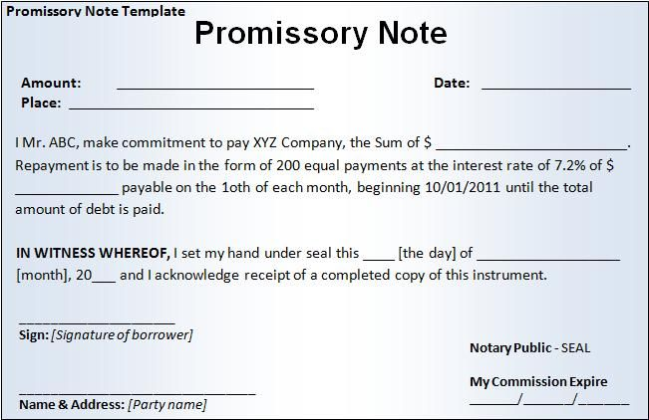

Bills of exchange:
A bill of exchange is a composed order once used primarily in international trade that ties one party to pay a fixed total of cash to another gathering on request or at a foreordained date.
OR
A composed, unequivocal request by one party (the drawer) to another (the drawee) to pay a specific total, either quickly (a sight bill) or on a fixed date (a term bill), for payment of goods and/or services got. The drawee acknowledges the bill by signing it, hence changing over it into a post-dated check and a coupling contract.
Bill of exchange Types:
- If a bill of exchange of trade is given by a bank, it tends to be referred to as a bank draft.
- If they are given by people, they can be alluded to as trade drafts.
- If the funds are to be paid promptly or on-request, the bill of Exchange is known as a sight bill, and
- If they are to be paid at a set date later on, it is known as a term bill.

A bill of exchange normally have the following information:
- Title: "bill of exchange"
- Amount.
- As of. The date on which the amount is to be paid.
- Payee. The name of the party to be paid.
- Identification number.
- Signature. The bill is signed by a person authorized
Parties of Bills of exchange:
- Drawer:
A Drawer is a borrower or indebted person who vows to pay the obligation to the moneylender.
- Drawee:
She/he is a person, in whose favor the note is readied. She/he is the creditor and gives products or services using a loan or loans capital.
- Payee:
A payee is somebody to whom the payment is made.

Drawing of bill of exchange:

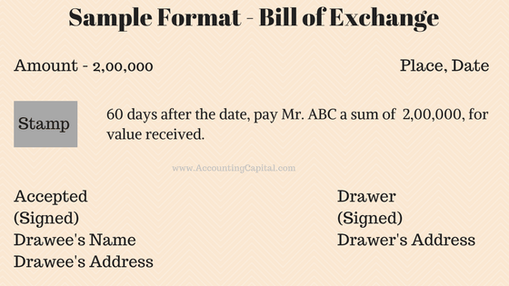

-----------------------------------------------------------------------------------------------------------------

Q2: Functions of labor court?
Ans: A labor court (or labour court or industrial tribunal) is a governmental legal executive body which manages on labor or employment related issues and questions. In various nations, labor cases are regularly taken to isolate national work high courts.
- According to Section 7 of the Industrial Dispute Act, 1947 the suitable Government has been enabled to comprise Labor Court. The fitting government, by warning, in the official paper, may comprise at least one work Courts for mediation of mechanical question determined in the second schedule. It comprised of one individual, delegated by the legislature. He is known as the presiding officer.

There are number of Articles in the Constitution pertaining to Labour in Pakistan:
  - Article 11 of the Constitution prohibits all forms of slavery, forced labour and child labour;
  - Article 17 provides for a fundamental right to exercise the freedom of association and the right to form unions;
  - Article 18 proscribes the right of its citizens to enter upon any lawful profession or occupation and to conduct any lawful trade or business.
  - Article 25 lays down the right to equality before the law and prohibition of discrimination on the grounds of sex alone.
The functions elements of the Court are the accompanying:
(a) To investigate trade disputes and make suggestions for their settlement;
(b) To make conclusions on claims from Equality Officers in segregation cases (or to hear cases legitimately where the complainant is testing an excusal);
(c) To choose advances against proposals of Rights Commissioners;
(d) To build up Joint Labor Committees and make work guideline arranges as put together by such bodies; and
(e) To enroll and change certain employment agreements.
There are five stages to cases before the Labour Court:
- Referral of dispute/appeal.
- Arrangement for a Labour Court hearing
- Parties lodge written submissions
- Hearing before the Court
- Court issues its Recommendation/ Determination/Decision.

==========================END============================

