SUBJECT
BUSINESS AND LABOR LAW

Submitted to
Ms.Bneeshi Shuja

Submitted by
Farhad Khan
I’d # 13673
Program
BBA
Semester
6th

IQRA NATIONAL UNIVERSITY PESHAWAR

Answer no 1

A negotiable instrument is a document guaranteeing the payment of a specific amount of money, either
on demand, or at a set time, with the payer named on the document. Or it is a written document
transfer by delivery.
Ex. promissory notes, bills of exchange, banknotes, demand draft and cheque.
Negotiable instrument is like a contract. It is a document with set of rules which guarantees the payment
of a certain amount of money at a set of time. In this document the payer’s name is mentioned. The time
with in which the money is to be paid is decided by the payer (the person who is paying) and the payee
(the person who is receiving the money from the payer).
The expression "Negotiable Instrument" means a piece of paper in writing entitling a right to the holder, a
certain sum of money. It is a piece of paper which contains some value and is transferable by simple
delivery or sometimes by endorsement and delivery.

Bill of exchange
A bill of exchange is an instrument that contains a promise to pay some amount of money to a certain person after a certain period of time. It is generally drawn by the creditor(maker or drawer) on his debtor(acceptor or drawee) and debtor gives the acceptance to that he will pay the money to the maker(drawer) after some certain period or a specific date. It should be accepted by the person to whom it is created or by another person on his/her behalf. Without acceptance, this document doesn’t have any value.
Definition: –
“A bill of exchange is an instrument in writing containing an unconditional order, signed by the maker, directing a certain person to pay a certain sum of money only to, or to the order of, a certain person, or to the bearer of the instrument.”

The feature of the Bill of Exchange: –
- It should be in writing.
- In order to make a payment on the specific date or after a certain period.
- An unconditional order of payment, it does not contain any condition of payment.
- A certain amount should be described in it.
- It must be signed by both parties Drawer (maker) and Drawee.
- The amount must be payable to either a certain person or on his/her behalf.
- It should be paid on the date of maturity or on-demand or on mutual understanding.
The Parties Involved in the Bill of exchange:-
There are three parties are involved, shown as follows:-
- Drawer
- Drawee
- Payee
1. Drawer: –
The drawer is the person who makes the bill of exchange on his/her debtor and he will also a receiver of the money mention in it. The seller of goods and services is known as a drawer (expect some cases will explain further).
2. Drawee: –
The drawee is the person to whom the bill of exchange created and he will pay the amount mention in it at the time of maturity of a bill. The purchase of goods and services is known as a drawee (expect some cases will explain further). The Drawee is also known as acceptor because he gives the acceptance to pay the mentioned amount on the mentioned date or after a specific period.
3. Payee: –
The person to whom the payment is made is known as the payee. basically, the drawer of the bill is known as payee but in some cases in which the bill in not retain by the drawer himself then the payee will be the person who has a bill. In the following cases the drawer will not be treated as payee: –
- When the bill is discounted by the drawer from the bank then the bank will be treated as the payee.
- When the drawer endorsed the bill to his/her creditor then the receiver of that bill will be treated as the payee.
Contents of Bills of Exchange: –
Bills of Exchange include the following contents: –
1. Title of Bill: –
The title “Bill of Exchange” will be mention on the face of the document.
2. Date of drawn: –
The date of drawn a bill should be written on it.
3. Amount to be paid: –
The certain amount payable will be described on it in the figures and also in words.

4. Date of Maturity or Term: –
The specific date or the term of the bill will be mention on it. The term means for 2 months or 3 months etc. The term is the tenure of the bill and runs from the date of the bill. There will be a grace period of 3 days in addition to the total term of the bill.
5. Unique Identification Number: –
Every bill has a unique identification number. it will be mention on it.
6. Name of both Parties: –
The name of both parties will be mention on the bill.
7. Signature of both parties: –
The bill is also signed by both parties.
The format of Bills of Exchange: –
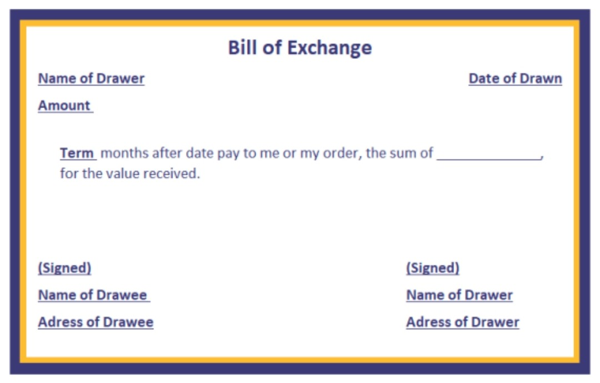
The following image shows the specimen of the BOE.

Answer no 2
Unpaid Seller
Ø The seller of goods is deemed to be an “unpaid seller” within the meaning of this Act.
Ø at the point when the entire of the cost has not been paid or tendered;
Ø at the point when a bill of trade or other debatable instrument has been received as conditional payment, and the condition on which it was received has not been fulfilled by reason of the dishonor of the instrument or otherwise.

An unpaid seller is a seller who has not received the hole price, or to whom the whole price has not been tendered, or to whom a bill of trade or other debatable instrument, such as a cheque has been given as conditional payment and the condition on which it was given has not been fulfilled either on account of the instrument having been dishonored, or otherwise. If the bill of exchange or other instrument is given as absolute payment the seller will not be an unpaid seller.
The seller is unpaid not only when the price has not in any way been paid or tendered in full, but also if the has taken bills of exchange or other negotiable instruments as conditional payment and the buyer has failed to meet them at has expired without the price having been paid or tendered; and the third is, where the buyer becomes insolvent before the price is paid or tendered. In this third case, the seller is entitled to retain possession even if the goods are sold on credit and the term of the credit has not expired.

Subject to the provisions of this Act and of any law for the time being in force, not withstanding that the property in the goods may have passed to the buyer, the unpaid seller of goods as such, has by implication of law--
(a) A lien on the goods for the price while he is in possession of the;
(b) In case of the insolvency of the buyer a right of stopping the goods in transit after he has parted with the possession of them;
(c) A right of re-sale as limited by this Act
Ø Where the property in goods has not passed to the buyer, the unpaid seller has, in addition to his other remedies, a right of withholding delivery similar to and coextensive with his rights of lien and stoppage in transit where the property has passed to the buyer. Section 46
Seller’s lien
Subject to provisions of this act the unpaid seller of goods who is in possession of them is entitled to retain possession of them until payment or tender of the price in these conditions

- Where the goods have been sold without any stipulation as to credit;
- Where the goods have been sold in credit but the term of credit has expired;
- Where the buyer becomes insolvent
Case in which a lien arises
This section declares that there are three cases in which an unpaid seller is qualified for a lien. The main is, the place good are sold using a consideration but neither the time of payment nor the time of delivery is fixed; the second is where the goods are sold on credit but the period of credit, the seller waives his lien during the currency of the credit, or where the seller accepts a bill of exchange for the price payable at a future day, he waives his lien during the money of the bill. In the last two cases the lien restores when the period of credit expires or when the bill is dishonored.
In possession of
The lien of an unpaid seller depends upon the actual possession of the goods and upon a mere title thereto So long as the actual possession of the goods is with the seller, the right of lien can be exercised.
Termination of lien
The unpaid seller of goods loses his lien thereon
- When he delivers the goods to a carrier or other bailee for the purpose of transmission to the buyer without reserving the right of disposal of the goods;
- When the buyer or agent lawfully obtains possession of the goods;
- By waiver thereof

Delivery to carrier or other bailee
The general rule is that when goods are delivered to a carrier or other baliee for the purpose of transmission to the buyer the property in the goods is completely transferred to the buyer and the seller has, in that case, no connection with the goods. But an exception has been recognized by law to this general rule. It is that the property in the goods does not pass to the buyer in the above circumstances if the seller reserves the right of disposal of the goods.

Answer no 3
The law of contract act

1. INTRODUCTION
The rules relating to trusts are contained in the Trusts Act 1882. It came into force on 1st day of March 1882 and extends to the whole of Pakistan. The Trusts Act 1882 deals with private trusts. It does not discuss the rules of Islamic Law relating to waqaf. A trust is purely equitable obligation and is enforceable only in a court in which equity is administered. The most distinctive feature of a trust is that it is not issuing out of the land but as thing collateral to it. It is not a Jus in for it is not a legal property.

2. RELEVANT PROVISIONS
Sec. 3, 4, 5 6. 7 of Trusts Act

3. DEFINITIONS
I. BLACK LAW DICTIONARY
Trust is a right of proper, real or personal, held by one party for the benefit of other. It is a confidence reposed in one person, who is termed trustee, for benefit of another, who is called cestui que trust.

II. DR. UNDERHILL
A trust is an equitable obligation, either expressly undertaken or constructively imposed by the court, where by the obligator is bound to deal with property over which he has control for the benefits of persons of which he may or may not himself he one and anyone of whom may enforce the obligation.

III. DR. MATT LAND
A trust enforced when a person has rights which he is bound to exercise:

i. On behalf of another, or
ii. For accomplishment of some particular purpose
He is said to have those rights in trust or for that "purpose" and he is called a trustee.

IV. TRUST ACT 1882
According to Sec. 3 a trust is an obligation annexed to the ownership of the property and arising out of a confidence reposed in and accepted by the owner and declare and accepted by him, for the benefit of another and the owner.

4. KINDS OF TRUST
Kinds of trust are as under
i. Constructive Trust
ii. Executed Trust
(iii) Private Trust
(iv) Public Trust or Charitable
(v) Expressed Trust
(vi) Secret Trust
(vii) Executory Trust
(viii) Implied Trust

5. PARTIES OF TRUST
i. Trustee
The person who accepts the confidence is called a trustee.

(ii) Author
The person who reposes or declares confidence is called author of the trust.

(iii) Beneficiary
The person for whose benefit the confidence is accepted is called the beneficiary.

6. TRUST PROPERTY
The subject matter of the trust is called trust property.
7. INSTRUMENT OF TRUST
The instrument by which the trust is declared is called the instrument of trust.

8. WHO MAY CREATE A TRUST
(i) By every person competent to contract.

(ii) With, the permission of a principal civil court or original jurisdiction, by or on behalf of a minor.

9. DECLARATION OF A TRUST
A trust regarding immoveable property is not valid unless it is declared by a non-testamentary instrument in writing signed by the author of the trust, or the trustee and, registered or by the will of the author or of the trustee. Similarly a trust regarding moveable property is not valid unless it is declared as aforesaid or unless the ownership of property is transferred to the trustee.

10. CREATION OF TRUST
According to Sec. 6 a trust is created when the author of the trust indicates with reasonable certainty by words or acts.

(i) An intention on his part he creates it.
(ii) The purpose of a trust.
(iii) The beneficiary.
(iv) The trust property

11. REQUISITES OF A VALID TRUST
Requisites of a valid trust are as under:
(i) The intention of the author of the trust.
(ii) The beneficiaries.
(iii) Lawful purpose of the trust.
(iv) Subject matter.
(v) Transfer of possession of trust property.
12. PURPOSE OF TRUST
According to Sec 4, a trust may be mated for lawful purpose. If the purpose is unlawful, it is void.
13. RULE OF CERTAINTY
Following are rule of certainty:
(i) Certainty of words.
(ii) Certainty of subject matter.
(iii) Certainty of object.
14. UNLAWFUL PURPOSES OF TRUST
Following purposes of a trust are unlawful. Forbidden by Law
I. If it is forbidden by law, the purpose will be unlawful.
II. Fraudulent
If it is fraudulent.
III. Against Provision of any Law
It would defeat the provisions of any law.
IV. Involves any Injury
If it involves or implies any injury to the person or property of author.
V. Immoral
If it is regarded by the court as immoral.
VI. Against Public Policy
If it is regarded by the court as opposed to public policy.
15. EFFECT OF UNLAWFUL PURPOSE 0R OBJECT
If purpose of trust is not lawful. It is absolute void.
I. In case of two Purposes
Where two purposes are so interconnected that they cannot be separated, the whole trust shall become void.
16. CONCLUSION
To conclude I can say that the trust is defined as that relation between two persons by virtue of which one of them holds property for benefit of the other, or as an equitable right, title or interest in property, real or personal, distinct from the legal ownership thereof. A trust can only be created for a lawful purpose. If purpose of trust is unlawful, it is void.

Answer no 4
Freedom of association:

Under Article 3 of the IRO 2002, workers as well as employers in any establishment or industry have the right to establish and to join associations of their own choosing.
Registration of trade unions

Registration of a trade union is to be made under the Industrial Relations Ordinance. Workers’ trade unions are registered with the Registrar Trade Unions in the Province, and if the industry or establishment is nationwide with the National Industrial Relations Commission, after fulfilling a number of requirements, listed in Article 6 of the IRO 2002.

Commencement of a dispute

Under the IRO 2002, if an employer or a Collective Bargaining Agent finds that an industrial dispute has arisen or is likely to arise, they may communicate their views in writing to the other party. Upon receipt of the communication, the other party has fifteen days (or more if agreed) to try and settle the dispute by bilateral negotiations.
Proceedings of strikes and lock-outs

If dispute settlement proceedings before the Conciliator fail and no settlement is reached, and if the parties have not agreed to refer their dispute to an arbitrator, the workers retain the right under section 31 of the Industrial Relations Ordinance 2002, to go on strike providing due notice to their employer within seven days.
Labour Courts

Section 33 of the Industrial Relations Ordinance, 2002 permits any CBA or any employer to apply to the Labour Court for the enforcement of any right guaranteed or secured by law or any award or settlement.
Pay Issues

Payment of Wages Act, 1936 stipulates that wages to workers employed in factories and on railways are to be paid within seven days of completion of the wages period, if the number of workers employed therein is less than 1,000. In other cases, the time limit for payment of wages to the workers is 10 days.
The Factories Act, 1934 allows for the employment of children between the ages of 14 and 18 years provided that each adolescent obtains a certificate of fitness from a certifying surgeon
Other Leave Entitlements

In addition to the 14 days of annual leave with pay, the Factories Act, 1934 provides that every worker is entitled to 10 days casual leave with full pay and further 16 days sick or medical leave on half pay.
Working hours

Under the Factories Act, 1934 no adult employee, defined as a worker who has completed his or her 18th year of age, can be required or permitted to work in any establishment in excess of nine hours a day and 48 hours a week.
Every employer in an industrial or commercial establishment is required to issue a formal appointment letter at the time of employment of each worker.

Answer no 5
Free Consent;
Free Consent means an act of assenting to an offer. According to section 13, "Tow or more persons are said to consent when they agree upon the same thing in the same thing in same sense." Thus, consent involves identity of minds in respect of the subject matter of the contract. In English Law, this is called 'consensus-ad-idem'.
Effect of Absence of consent:
When there is no consent at all, the agreement is void ab-initio, i.e. it is not enforceable at the option of either party. Example: X has one Maruti car and one fiat car. He wants to sell fiat car. Y does not know that X has two cars. Y offers to buy X's Maruti car Rs 50,000. X accepts the offer thinking it to be an offer for his Fiat car. Here, there is no identity of mind in respect of the subject of the subject matter. Hence there is no consent at all and the agreement is void ab-initio.
Meaning of Free consent: It is one of the essential elements of a valid contract as it is evidenced by section 10 which provides that all agreements are contracts if they are made by the free consent of the parties... according to section 14, consent is said to be free when it is not caused by (a) Coercion, or (b)Undue influence, or (c) Fraud, or (d) Misrepresentation, or (e) Mistake.
Effect of Absence of free consent:
When there is consent but it is not free (i.e. when it is caused by coercion or undue influence or fraud or misrepresentation), the contract is usually voidable at the option of the party whose consent was so caused.

Offer;
When one person signifies to another his willingness to do or to abstain from doing anything, with a view to obtaining the assent of that other to such act or abstinence, he is said to make a proposal. – Section 2(a) Contract Act

Essentials of Valid Offer
- It may be express or implied
- It must create legal relations
- It must be definite and clear
- It is different from invitation to offer
- It may be specific or general
- It must be communicate to offeree
- It should not contain negative condition
- It may be subject to any terms and conditions
- It must not contain cross offers

