Submitted to: Miss Shoala Rasheed Khan Submitted by: Sayed Agha Student ID: 16961 Program / Semester: BBA, First (1st)
Final Assignment
Principle of Management

AZ
Ahmadzai
Imports/Exports
Introduction:
It is the mission of my Imports to provide complete import/export brokerage services including purchase contracts, shipping, warehousing, and delivery scheduling. The company will concentrate on special and cultural imports from our country to the unique of town of our country, and i also plans to provide trade consultation services to newly started farms created under the Co Consumers Farmland Fund initiative.
The Company.
AZ Company Imports will be a limited liability partnership registered in the state of Delaware for tax purposes. Its founder is Mr. Sayed Khan, a former master distributor with Fisher-Mills. Mr. Hashmat Ullah has brought together a highly respected group of individuals who are well versed in foreign trade processes.
The company has a limited number of private investors and does not plan to go public. The company has its main offices in Wenatchee, Washington. The facilities include conference rooms and office spaces. The company expects to begin offering its services in future.
The Services:
AZ Company offers complete import/export brokerage services plus inventory consulting services. As mentioned previously, this includes the following:
Supplier/buyer identification
Purchasing, contracting and consulting
Shipping
Warehousing
Delivery
It must be noted that Sayed Khan does not possess any warehousing facilities and intends to outsource this particular service. We expect to earn revenues by charging a commission based on the value of goods moved per order.
The Market:
AZ Company will be concentrating on servicing just two types of clients, the gift shops of our town, in our country, and the farmers of our country Consumers Co-op. For both market segments, we have secured exclusive contracts or endorsements putting us in a unique position to service these niche firms and their needs.
Profitability in these two markets is expected to be excellent, especially in the import section as gift shops draws in over a million tourists each year. We expect profitability in the co-op end to be much slower in the first five years of operation, but it too will increase steadily.
Financial Considerations:
Start-up assets required include expenses and cash needed to support operations until revenues reach an acceptable level. Most of the company's liabilities will come from outside private investors and management investment, however, we have obtained current borrowing from Bank of America Commercial Investments, the principal to be paid off in two years. A long-term loan through Charter Bank of our state will be paid off in ten years.
The company expects to reach profitability in year 2 and does not anticipate any serious cash flow problems. We expect that about 3,500 units per month will guarantee a break-even point.
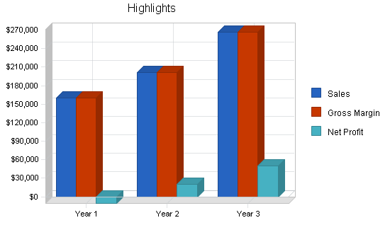
1.1 Mission:
It is the mission of AZ Company Imports to provide complete import/export consultation and brokerage services including purchase contracts, shipping, warehousing, and delivery. The company will concentrate on special and cultural imports to our all country to the unique our town of our country, AZ Company also plans to export apples and other produce by newly started farms created under the Consumers Co-op's Farmland Fund initiative.
It is our long-term goal to become the preferred import company for the unique tourist town of our country. AZ Company understands that the import shops and restaurants in our country have special needs of most unique gifts for the million tourists that visit the town annually. AZ Company Imports also understands that the newly launched farms of the PCC farmland fund initiative also have higher costs than most competitors and will need to export their produce at a cost that provides sufficient profit. Az Company Imports has a combined expertise of experience working in the import/export business. Our philosophy is in creating a long-term relationship with clients so that the delivery of their products becomes a seamless experience that promotes loyalty.
1.2 Keys to Success:
AZ Company Imports' keys to long-term and profitability are as follows:
Differentiate our services to our niche clients so that they realize that we are better able to serve their needs than a more generic competitor.
Keeping close contact with clients and establishing a well functioning long-term relationship with them to generate repeat business and create a top notch reputation.
Establish a comprehensive service experience for our clients that includes consultation, product/client search, purchasing contracts, warehousing, shipping, delivery, and follow up service analysis.
1.3 Objectives:
The three year goals for AZ Company Imports are the following:
Achieve break-even by year 2.
Retain our long-term contracts with local import shops in our country through excellent customer service.
Become the premier importer of our country specialty products in our towns and become the prime exporter of apples and other produce for the farmers of the co consumer Farmland Fund initiative.

