Course Title: Medical Biochemistry II
DT 2nd, Sec A
Student Name: Majid iqbal
Student ID: 15946
Max Marks: 50

Note: There are FIVE questions, each carry 10 marks with grand total of 50 marks
ATTEMPT all questions
Avoid copy paste material, as it may deduct your marks

Q1. Explain the process of “ATP synthesis coupled with electron flow”.
Ans: “ATP SYNTHESIS COUPLED WITH ELECTRON FLOW”:
Electron transfer through the respiratory chain releases more than enough free energy to form ATP. Mitochondrial oxidative phosphorylation therefore poses no thermodynamic problem. However, one cannot deduce from thermodynamic considerations the chemical mechanism by which energy released in one exergonic reaction (the oxidation of NADH by O₂) is channeled into a second, endergonic, reaction (the condensation of ADP and Pi). To describe the process of oxidative phosphorylation completely, we need to identify the physical and chemical changes that result from electron flow and cause ADP phosphorylation - the mechanism that couples oxidation with phosphorylation.
- Phosphorylation of ADP Is Coupled to Electron Transfer:
When isolated mitochondria are suspended in a buffer containing ADP, Pi, and an oxidizable substrate such as succinate, three easily measured processes occur:
- The substrate is oxidized (succinate yields fumarate).
- O₂ is consumed (respiration occurs).
- ATP is synthesized. Careful experimental measurements of the stoichiometry of electron transfer to O₂ and the associated synthesis of ATP show that with NADH as electron donor, mitochondria synthesize nearly 3.0 ATP per pair of electrons passed to O₂, and with succinate nearly 2.0 ATP per electron pair.
- Oxygen consumption and ATP synthesis are dependent upon substrate oxidation.
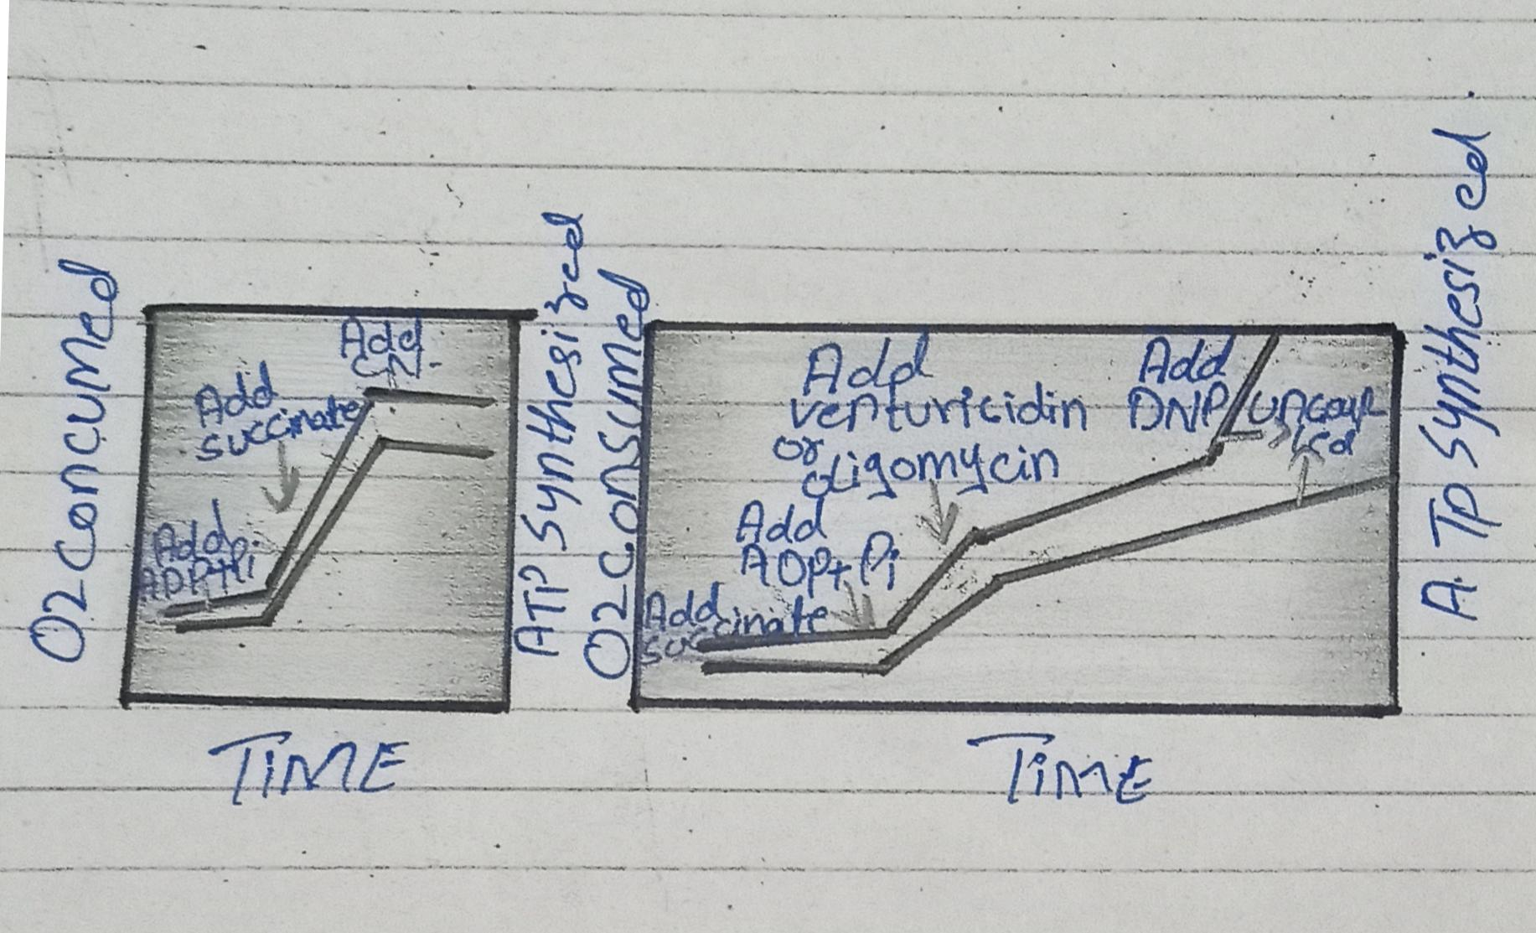

………………………………………………………………………………………………………
Q2. Write the reactions that are catalyzed by the following enzymes.
    - Acyl CoA dehydrogenase
    - Adenosine deaminase
    - Nucleotidase
    - Gluconolactonase
    - Enoyl-CoA hydratase
ANS : “CATALYZED REACTION”:
- DEFINITION:
Catalysis is the process of increasing the rate of a chemical reaction by adding a substance known as a catalyst, which is not consumed in the catalyzed reaction and can continue to act repeatedly.
- Acyl CoA dehydrogenase: Fatty acid synthesis starts with the carboxylation of acetyl CoA to malonyl CoA .This irreversible reaction is the committed step in fatty acid synthesis. The synthesis of Malonyl CoA is catalyzed by acetyl CoA carboxylase, which contains a biotin prosthetic group.

- Adenosine deaminase: Adenosine deaminase is an enzyme involved in purine metabolism. It is needed for the breakdown of adenosine from food and for the turnover of nucleic acids in tissues. Its primary function in humans is the development and maintenance of the immune system.
- Enoyl-CoA hydratase: Ech catylzes the second stepin the physiologically important beta oxidation pathway of fatty acid metabolism. This enzyme facilitates the synaddition of a water molecule across the double of a trans 2 enoyl CoA thioester,resulting in the formation of a beta-hydroxyacyl - CoA thioester.
- Nucleotidase: A nucleotidase is a hydrolytic enzyme that catalyzes the hydrolysis of a nucleotide into a nucleoside and a phosphate. A nucleotide + H₂O = a nucleoside + phosphate. For example, it converts adenosine monophosphate to adenosine, and guanosine monophosphate to guanosine.
- Gluconolactonase: In enzymology, a gluconolactonase is an enzyme that catalyzes the chemical reaction D-glucono-1,5-lactone + H₂O D-gluconate Thus, the two substrates of this enzyme are D-glucono-1,5-lactone and H₂O, whereas its product is D-gluconate.
………………………………………………………………………………..
Q3. Define nucleotide, nucleoside and differentiate between DNA and RNA?
Ans: NUCLEOTIDE:
- Definition:
A compound consisting of a nucleoside linked to a phosphate group. Nucleotides form the basic structural unit of nucleic acids such as DNA.
NUCLEOSIDE:
- Definition:
A compound (e.g. adenosine or cytidine) consisting of a purine or pyrimidine base linked to a sugar.
- DIFFERENTIATE BETWEEN DNA AND RNA :
- DNA :
- Definition:
It is a long polymer. It has a deoxyribose and phosphate backbone having four distinct bases: thymine, adenine, cytosine, and guanine.
- Location:
It is located in the nucleus of a cell and in the
mitochondria.
- Sugar portion:
It has 2-deoxyribose.
- Function:
DNA is functional is the transmission of genetic information. It forms as a media for long-term storage.
- Predominant Structure:
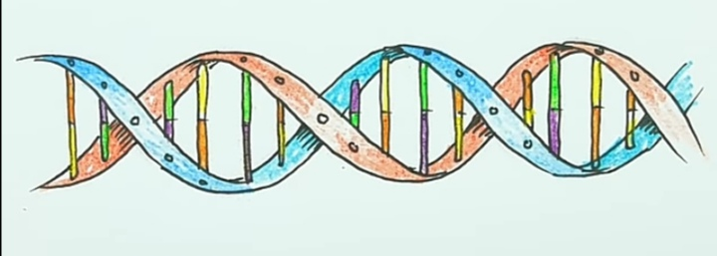
The DNA is a double-stranded molecule that has a long chain of nucleotides.
- Propagation:
DNA replicates on its own, it is self-replicating.

- RNA:
- Definition:
Is a polymer with a ribose and phosphate backbone with four varying bases: uracil, cytosine, adenine, and guanine.

- Location:
It is found in the cytoplasm, nucleus, and in the ribosome.
- Sugar portion:
It has Ribose.
- Function:
RNA is functional is the transmission of the genetic code that is necessary for the protein creation from the nucleus to the ribosome.
- Predominant Structure:
The RNA is a single-stranded molecule which has a shorter chain of nucleotides.
- Propagation:
RNA does not replicate on its own. It is synthesized from DNA when required.
……………………………………………………………..
Q4. Why Dickens and Horecker’s Pathway is called HMP pathway. Enlist the enzymes used in PPP Pathway.?
Ans: DEFINITION:
1)The pentose phosphate pathway (also called the hexose monophosphate pathway) is a metabolic pathway parallel to glycolysis.
2)This pathway is also called Dickens and Horecker’s pathway.
3)It generates NADPH and pentose (5 carbon sugar), a precursor for the synthesis of nucleotides.
- ENZYMES:
- Glucose -6- phosphate dehydrogenase is the rate-controlling enzyme of this pathway .It is allosterically stimulated by NADP+ and strongly inhibited by NADPH….An NADPH- utilizing pathway forms NADP+, which stimulates Glucose-6-phosphate dehydrogenase to produce more NADPH. This step is also inhibited by acetyl CoA.
....................................................................................
Q5. What is the function of carnitine shuttle system? Write down the stages and steps involved in Beta oxidation of Lipids.
Ans: CARNITINE SHUTTLE SYSTEM : Mitochondrial oxidation of long-chain fatty acids provides an important source of energy for the heart as well as for skeletal muscle during prolonged aerobic work and for hepatic ketogenesis during long-term fasting.The carnitine shuttle is responsible for transferring long-chain fatty acids across the barrier of the inner mitochondrial membrane to gain access to the enzymes of beta-oxidation.
- STAGES:
- TRANSPORTATION OF FATTY ACYL-CoA FROM CYTOPLASM TO MITOCHONDRIA:
- Fatty acyl-CoA from the cytosol reacts with carnitine in the outer mitochondrial membrane, forming fatty acyl carnitine.The enzyme used is carnitine acyl transferase I (CAT I).
- Fatty acyl carnitine easily passes from the inner membrane to mitochondrial matrix, where it re-forms to fatty acyl-CoA.The enzyme used is carnitine acyl transferase II.
- Inside the mitochondria, the fatty acyl-CoA undergoes beta-oxidation.
- BETA-OXIDATION OF ACTIVATED FATTY ACIDS:
- Beta-oxidation (in which all reactions involve the beta-carbon of a fatty acyl-CoA ) will occur in 4 steps. These steps are repeated until all the carbons of fatty acyl-CoA are converted to acyl-CoA.
- STEPS:
The 4 steps are:
- Dehydrogenation.
- Hydration.
- Dehydrogenation.
- Cleavage.
- DEHYDROGENATION:
FAD + accept hydrogens from a fatty acyl-CoA in the first step.A double bond is producted between the Alpha and Beta-carbons, and an Enoyl-CoA is formed in the presence of Acyl CoA dehydrogenase.The FADH2 that is produced interacts with the electron transport chain,generating ATP.
- HYDRATION:
H2O will adds across the double bond, and a beta-hydroxyl acyl-CoA is formed in the presence of Enoyl-CoA hydratase.
- Dehydrogenation:
Beta-hydroxyl acyl-CoA is oxidized by NAD + to a beta-keto acyl-CoA in the presence of beta-hydroxyl acyl-CoA dehydrogenase. The NADH that is produced intracts with the electron transport chain, generating ATP.
- CLEAVAGE:
The bond between the alpha and beta carbons of the Beta-keto acyl-CoA is cleavage by aThiolase enzyme that requires coenzyme that requires coenzyme A . Acetyl-CoA is produced from the two carbons at the carboxyl end of the original fatty acyl-CoA, and the remaining carbons form a fatty acyl-CoA that is two carbons shorter than the original.
- The shortened fatty acyl-CoA repeats these four steps repetitions continue untill all the carbons of the original fatty acyl-CoA are converted to acetyl CoA .
…………………………………………………………

