Name: BILAL AHMAD
ID: 14654
Subject: Computer Application to Business
Semester: 4th
Submitted to: Sir Zakir Rahim
Assignment: 1st Word Exercise

1. Insert a multilevel list.

Computer

Software

System Software

Window

XP window

Linux window

Application Software

MS office

MS Photoshop

CorelDraw

Hardware

Hard disk

Ram
2. Insert a heading and draw an outside border around that heading.
Word Exercise

3. Insert a heading, apply a heading style from home ribbon and customize that heading style. Insert a screen shot of customizing heading style.
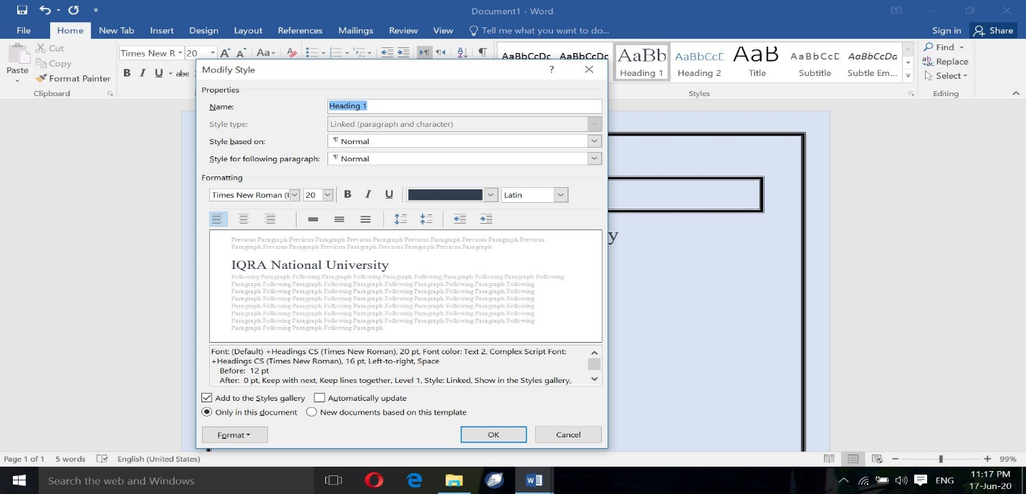
4. Insert a hyperlink in the same document.
    - Heading
    - Screenshot
    - Table
5. Insert a table of 3 columns (heading are Roll Number, Name, and Address) and 20 rows. Set table property to repeat header rows.
Roll No | Names | Address

7. Draw the following hierarchy chart using shapes in Insert Ribbon.
Managing Directing

Marketing Directing

Finance Directing

Operation Directing

HRM Directing

Marketing Managers

Finance Supervisors

Production Team Leader

Personnel Manager

Sales Team

Accounts Assistants

Production Team Members

8. Insert a bookmark (insert a random paragraph and use bookmark):
LIKE,
- JOB INTERVIEW
Video provides a powerful way to help you prove your point. When you click Online Video, you can paste in the embed code for the video you want to add. You can also type a keyword to search online for the video that best fits your document.
- PROPESHANEL PRESENTATION:
To make your document look professionally produced, Word provides header, footer, cover page, and text box designs that complement each other. For example, you can add a matching cover page, header, and sidebar. Click Insert and then choose the elements you want from the different galleries.
- EYE CATECHING
Themes and styles also help keep your document coordinated. When you click Design and choose a new Theme, the pictures, charts, and SmartArt graphics change to match your new theme. When you apply styles, your headings change to match the new theme.
- TIME SAVING:
Save time in Word with new buttons that show up where you need them. To change the way a picture fits in your document, click it and a button for layout options appears next to it. When you work on a table, click where you want to add a row or a column, and then click the plus sign.

9. Change the page color of your exercise file and insert page border.

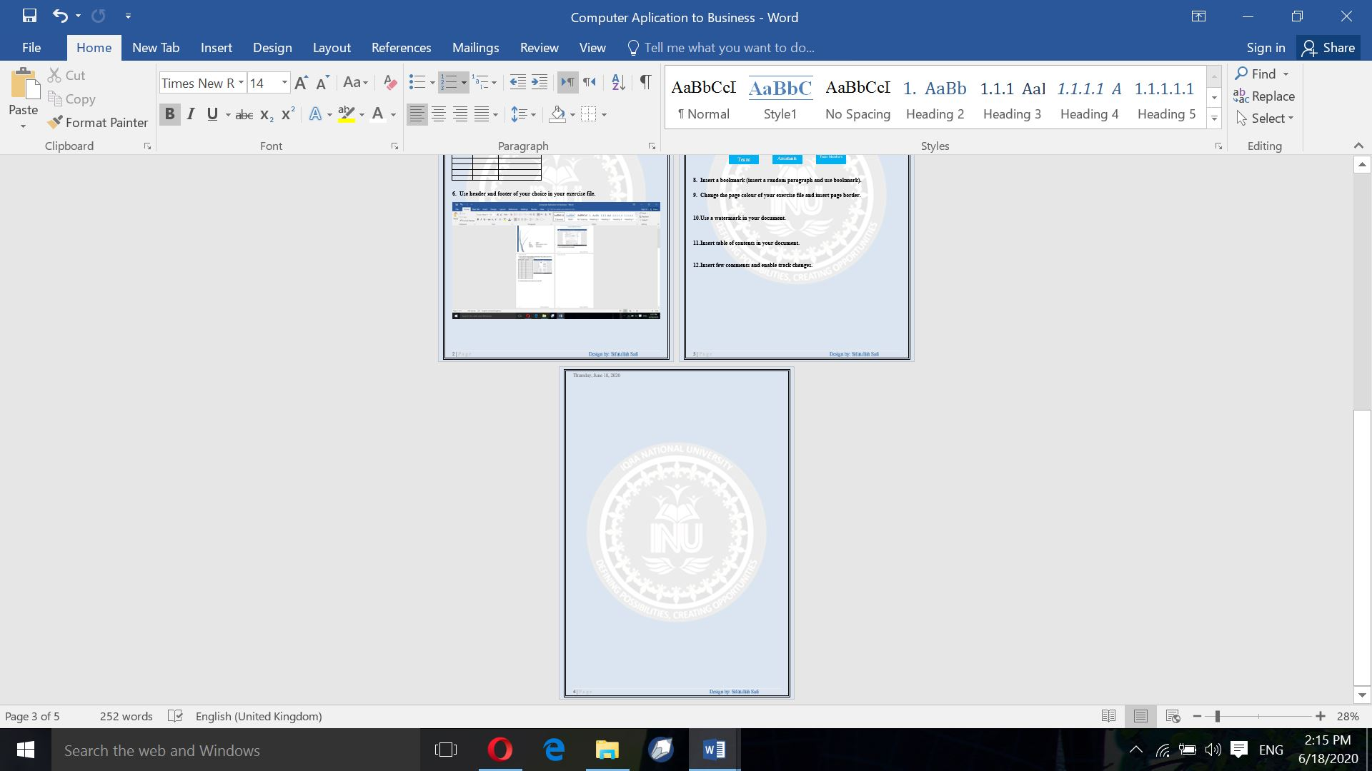

10. Use a watermark in your document.

11. Insert table of contents in your document.
Table of Contents
1. Computer 1
1.1. Software 1
1.1.1. System Software 1
1.1.1.1. Window 1
1.1.1.2. xp window 1
1.1.1.3. Linux window 1
1.1.2. Application Software 1
1.1.2.1. Ms office 1
1.1.2.2. Ms Photoshop 1
1.1.2.3. CorelDraw 1
2. Hardware 1
2.1. Hard disk 1
2.2. Ram 1

