PAPER: Architecture and Town Planing
Name: Muhammad jalal khan
Semester: 2nd
Section: A
ID: 16089
Dept: Civil Engineering
Assignment: 2
DATE: 14 June 2020

Islamic Architecture Indonesian
Architecture of Indonesia :
The Architecture of Indonesia reflects the diversity of cultural, historical and geographic influences that have shaped Indonesia as a whole. Invaders, colonizers, missionaries, merchants and traders brought cultural changes that had a profound effect on building styles and techniques. Traditionally, the most significant foreign influence has been Indian. However, Chinese, Arab—and since the 18th and 19th centuries—European influences have played significant roles too in shaping Indonesian architecture.
Materials:
Brick Timber
Hard Wood/ Worok Wood
Bamboo
Coconut Trunk
Sugar Palm Leaves
Alang-alang Grass
Rice Straw
Coconut Fiber
Climate:
The climate of Indonesia is almost entirely tropical. Temperature varies little from season to season, and Indonesia experiences relatively little change in the length of daylight hours from one season to the next; the difference between the longest day and the shortest day of the year is only forty-eight minutes. This allows crops to be grown all year round.

Climate Influence to Architecture:
Row houses, canals and enclosed solid walls - first thought as protection against tropical diseases coming from tropical air, years later the Dutch learnt to adapt their architectural style with local building features (long eaves, Verandahs, porticos, large windows and ventilation openings)
The sharply inclined roof allows the heavy tropical rain to quickly sheet off, and large overhanging eaves keep water out of the house and provide shade in the heat. In hot and humid-low lying coastal regions, homes can have many windows providing good cross-ventilation, whereas in cooler mountainous interior areas, homes often have a vast roof and few windows.
Climate Influence to Architecture
The Indo-European hybrid villa of the 19th century was among the first colonial buildings to incorporate Indonesian architectural elements and attempt adapting to the climate. The basic form, such as the longitudinal organizations of spaces and use of joglo and limasan roof structures, was Javanese, but incorporated European decorative elements such as neo-classical columns around deep verandahs.
Climate design of the Malay house
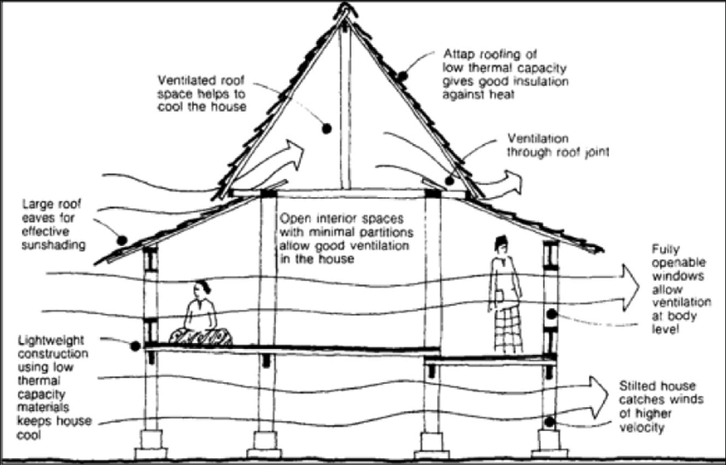

Geography
Indonesia is an archipelagic island country in Southeast Asia, lying between the Indian Ocean and the Pacific Ocean. It is in a strategic location astride or along major sea lanes from Indian Ocean to Pacific Ocean. The country's variations in culture have been shaped—although not specifically determined—by centuries of complex interactions with the physical environment. Although Indonesians are now less vulnerable to the effects of nature as a result of improved technology and social programs, to some extent their social diversity has emerged from traditionally different patterns of adjustment to their physical circumstances.
Influence to Architecture:
Building houses off the ground allows breezes to moderate the hot tropical temperatures, It elevates the dwelling above storm water runoff and mud; it allows houses to be built on rivers and wetland margins it keeps people, goods and food from dampness and moistur, lifts living quarters above malaria-carrying mosquitos and reduces the risk of dry rot and termites.
The sharply inclined roof allows the heavy tropical rain to quickly sheet off, and large overhanging eaves keep water out of the house and provide shade in the heat.
In hot and humid low-lying coastal regions, homes can have many windows providing good cross-ventilation, whereas in cooler mountainous interior areas, homes often have a vast roof and few windows. Traditional buildings in Indonesia are built on stilts with oversized saddle roofs which have been the home of the Batak and the Toraja.
Religion:
The first principle of Indonesia's philosophical foundation, Pancasila, is "belief in the one and only God".
A number of different religions are practiced in the country, and their collective influence on the country's political, economic and cultural life is significant.
The Indonesian Constitution guarantees freedom of religion.
The government only recognizes six official religions (Islam, Protestantism, Catholicism, Hinduism, Buddhism and Confucianism).
Indonesian law requires that every Indonesian citizen hold an identity card that identifies that person with one of these six religions, although citizens may be able to leave that section blank.
Religion Influence to Architecture:
Architecture in Indonesia focuses on defining terms that relate to their religions such as; Islam, Buddhist, early Indonesia Hindu, and Balinese Hindu.
Architectural heritage influences by religious are commonly found in Java.

TYPES OF ARCHITECTURE:
Religious architecture:
Although religious architecture has been widespread in Indonesia, the most significant was developed in Java. The island's long tradition of religious syncretism extended to architecture, which fostered uniquely Javanese styles of Hindu, Buddhist, Islamic, and to a lesser extent, Christian architecture.
Candi = Religious structures:
large and sophisticated, tower-like structures - built in Java during the peak of Indonesia’s Great Hindu-Buddhist Kingdoms (18th-14th Century)
The earliest surviving Hindu temples in Java are at the Dieng Plateau, thought to have originally numbered as many as 400, only 8 remain today.
Design Structures:
Small and relatively plain But architecture developed substantially and just 100 years later the second Kingdom of Mataram built the Prambanan complex near Yogyakarta; considered largest and finest example of Hindu architecture in Java.
Complex Candi Arjuna:

Candi Prambanan, Yogyakarta, Indonesia:
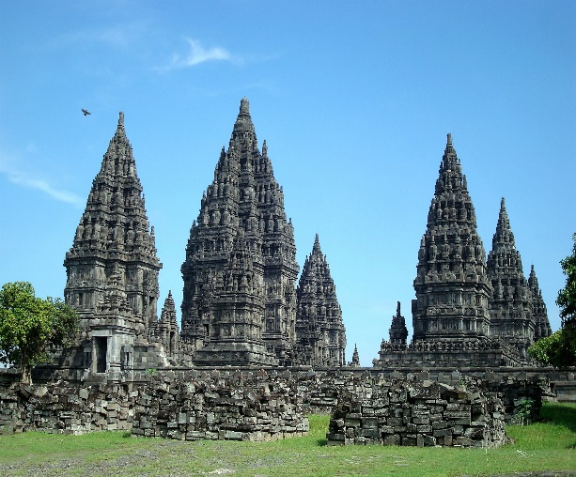
The origin of Buddhist and Hindu temple are built of stone, which is raised on a basement and surmounted by a stepped pyramidal roof, ornamented with relics. In symbolic terms, the building is as a representation of the legendary Mount Meru, which in Hindu- Buddhist mythology is identified as the residence of the gods.
Majapahit Hindu Temple:
The use of bricks in Indonesia’s Classical Era – mastered by the Majapahit builders, using a mortar of vine sap and palm sugar. Temples of Majapahit - have a strong geometrical quality with a sense of verticality achieved through the use of numerous horizontal lines often with an almost art-deco sense of streamlining and proportion. Majapahit influences can be seen today in the enormous number of Hindu temples of varying sizes spread throughout Bali. Although they have elements in common with global Hindu styles, they are of a style largely unique to Bali and owe much to the Majapahit era.
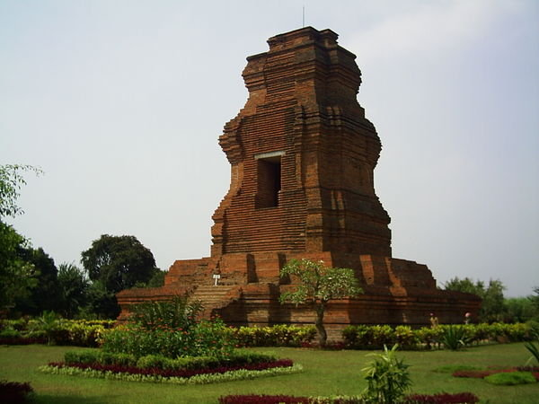
Mosques (15th Century):
Islam had become the dominant religion in Java and Sumatra, Indonesia's two most populous islands; absorbed and reinterpreted, with mosques given a unique Indonesian/Javanese interpretation. Javanese Mosques - took many design cues from Hindu, Buddhist, and even Chinese architectural influences - lacked, for example, the ubiquitous Islamic dome which did not appear in Indonesia until the 19th century, - had tall timber, multi-level roofs similar to the pagodas of Balinese Hindu temples still common today Menara Kudus Mosque in Kudus Sultan Suriansyah Mosque in Banjarmasin
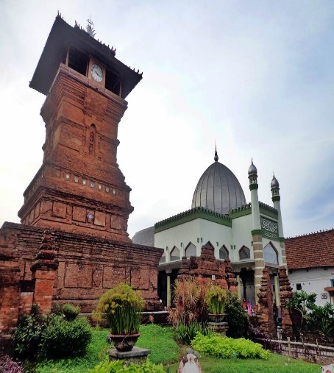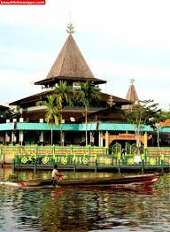
Menara kudus mosque. Sultan Suriansyah mosque

Mosques (19th Century):
Sultanates of Indonesian archipelago began to adopt and absorb foreign influences of Islamic architecture - The Indo-Islamic and Moorish style are particularly favoured as displayed in Banda Aceh Baiturrahman Grand Mosque built in 1881, and Medan Grand Mosque built in 1906 - mosques have tended to be built in styles more consistent with global Islamic styles, which mirror the trend in Indonesia towards more orthodox practice of Islam Baiturrahman Grand Mosque, Medan Grand Mosque.
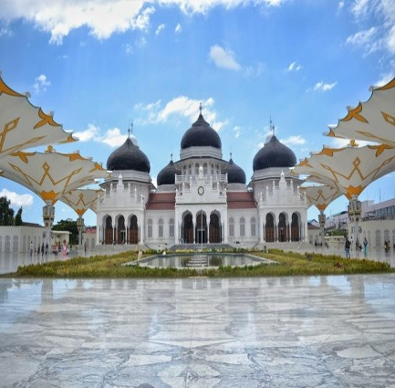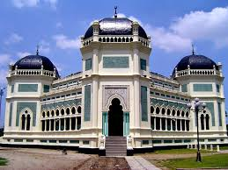
Baiturrahman Grand Mosque Medan Grand Mosque.

Traditional and vernacular architecture:
Traditional and vernacular architecture in Indonesia originates from two sources. One is the great Hindu tradition brought to Indonesia from India via Java. The second is an indigenous architecture pre-dating the Hindu epic.
It has its own unique form because Indonesia has 33 provinces; each of Indonesia’s ethnic groups has its own distinctive form of the traditional vernacular architecture, known as Rumah adat.
Traditional Indonesian homes are not architect designed, rather villagers build their own homes, or community will their resources for a structure built under the direction of a master builder and/or a carpenter.
Rumah Adat:
Rumah adat or Custom House is at the center of a web of customs, social relations, traditional taboos, myths, and religions that villagers together. - The house provides the focus for the family and its and is the point of departure for activities of its residents.
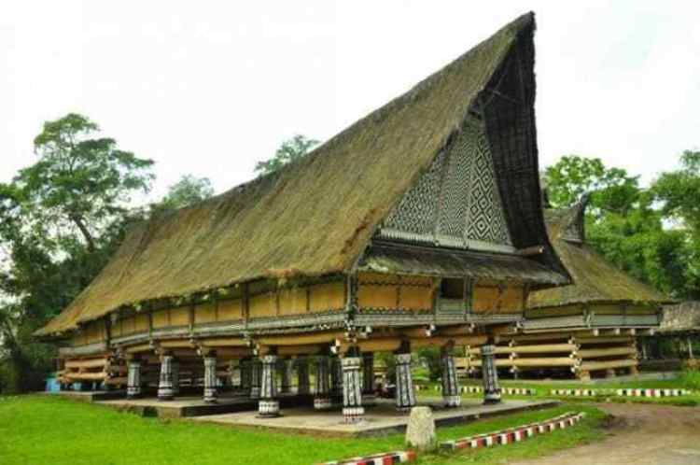
Characteristics :
• timber construction,
• varied and elaborate roof
• longhouses on stilts
• steep sloping roofs and heavy
• Built on stilts except for Java and Rumah Adat Batak
Construction System:
• post, beam and lintel structural system with either wooden or bamboo walls that are non-load bearing
• rather than nails, mortis and tenon joints and wooden pegs are used
Palace architecture:
• Istana (or "palace") architecture of the various kingdoms and realms of Indonesia is more often than not based on the vernacular and domestic styles of the area. Royal courts, however, were able to develop much grander and elaborate versions of this traditional architecture.
Rumah Gadang:
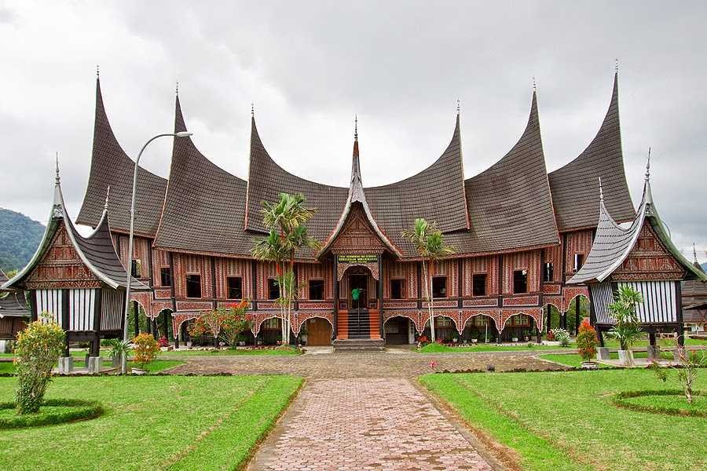
The palaces of the Balinese such as the Puri Agung in Gianyar use the traditional bale form, and the Pagaruyung Palace is a three-storey version of the Minangkabau Rumah Gadang.
A rumah gadang serves as a residence, a hall for family meetings, and for ceremonial activities. In the matrilineal Minangkabau society, the rumah gadang is owned by the women of the family who live there; ownership is passed from mother to daughter.
The bodi caniago design reflects a democratic social structure, with the floors being flat and on one level.
Architectural Elements of Rumah Gadang:
Each element of a rumah gadang has its own symbolic meaning, which is referred to in adapt speech and aphorisms.
The elements of a rumah gadang include:
• Gonjong hornlike roof structure
• Singkok triangular wall under the ends of gonjong
• Pereng shelf under the singkok
• Pnjuang raised floor at the end of one style of rumah gadang
• Dindiang ari the walls on the side elevations
• Dindiang tapi the walls on the front and back elevations
• Papan banyak front façade
• Papan sakapiang a shelf or middle band on the periphery of the house.
• Salangko, wall enclosing space under a house that has been built on stilt.
Colonial architecture:
• 16th and 17th centuries - arrival of European powers in Indonesia who used masonry for much of their construction. - One of the first major Dutch settlements was Batavia (later named Jakarta) which in the 17th and 18th centuries was a fortified brick and masonry city. - the Dutch learnt to adapt their architectural style with local building features (long eaves, verandahs, porticos, large windows and ventilation openings)
• The Indo-European hybrid villa of the 19th century was among the first colonial buildings to incorporate Indonesian architectural elements and attempt adapting to the climate. The basic form, such as the longitudinal organization of spaces and use of joglo and limasan roof structures, was Javanese, but it incorporated European decorative elements such as neo-classical columns around deep verandahs,
Post Independence architecture:
• Early twentieth century modernisms are still very evident across much of Indonesia, again mostly in Java
• 1930s world depression was devastating to Java, and was followed by another decade of war, revolution and struggle, which restricted the development of the built environment
• The Javanese art-deco style from the 1920s became the root for the first Indonesian national style in the 1950s
• The politically turbulent 1950s meant that the new but bruised Indonesia was neither able to afford or focused to follow the new international movements such as modernist brutalism.
Projects:
Projects approved by Sukarno, himself a civil engineer who had acted as an architect, include:
• A clover-leaf highway.
• A broad by-pass in Jakarta (Jalan Sudirman).
• Four high-rise hotels including the famous Hotel Indonesia.
• A new parliament building.
• The 127 000-seat Bung Karno Stadium.
• Numerous monuments including The National Monument.
• Istiqlal Mosque, Jakarta the largest mosque in Southeast Asia.
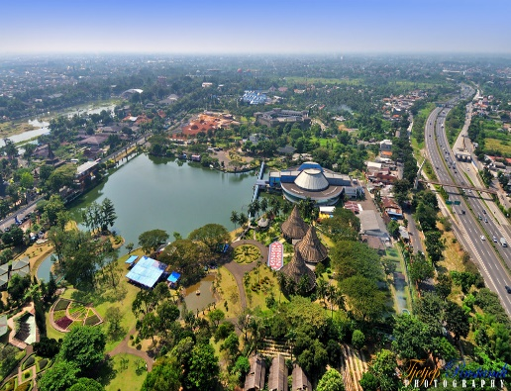
Tama Mini Indonesia Indah Theme Park
Contemporary architecture
• The 1970s, 1980s and 1990s saw foreign investment and economic growth; large construction booms brought major changes to Indonesian cities, including the replacement of the early twentieth styles with late modern and postmodern styles. Many new building s are clad with shiny glass surfaces to reflect the tropical sun. Architectural styles are influenced by developments in architecture internationally, including the introduction of deconstructivism architecture.
• Following the pattern of colonial architecture in Malaysia and Singapore, architects in the former Dutch East Indies relieved heavily on imported European models for their public buildings, clubs and churches
• Institute of Technology, Bandung, Jakarta (1920) by Henri MacLaine Pont.
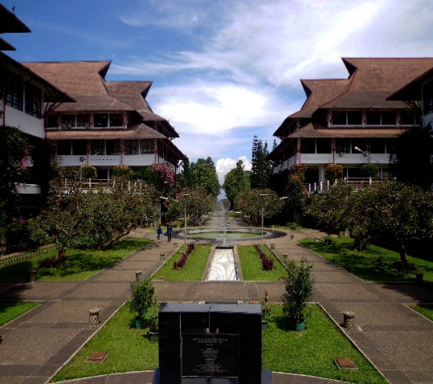
First on a series of remarkable buildings, based on meticulous study of regional traditions Incorporated indigenous features:
• Timber houses-on-stilts of the Minangkabau region in Sumatra, with their distinctive peaked
• suspended roofs
• The multi-layered roofing provides ventilation in the gaps between thelayers, as well as their high peaks, while the open structure at ground level provides further movement of air.

AULA – Main hall
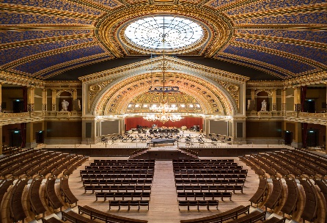
An impressive and an imposed structure of giant parabolic beams of laminated wood bound with iron clamps.

Difference of Western and Indonesian architecture:
The difference of Western and Indonesian architecture according to Dutch architect is correlation between building and people. Western architecture (occidental) is a totality construction, while Indonesian’s have been developed as subjective matter, elementary, with preferring outside appearance especially front façade. The natural condition between the sub-tropical Netherlands and wet-tropical Indonesia is also the main consideration of Dutch buildings in Indonesia.

Islamic Architecture (Malaysia)
Geographical:
Malaysia is located on the Sunda shelf and is tectonically inactive. The oldest rocks in the country date from 540 million years ago and are mostly sedimentary. The most common form of rock is limestone, formed during the Paleozoic Era. Limestone laid down in East Malaysia during the Tertiary period has since eroded, and such erosion forms basins of sedimentary rocks rich in oil and natural gas. The mountain ranges in Malaysia were formed through orogenesis beginning in the Mesozoic era
The total land area of Malaysia is 329,847 square kilometres (127,350 sq mil), the 66th largest country in the world in terms of area.
Peninsular Malaysia makes up 132,090 square kilometres (51,000 sq mil) or almost 40% of the country's land area, while East Malaysia covers 198,847 square kilometres (76,780 sq mi), or 60%. From the total land area, 1,200 square kilometres (460 sq mi) or 0.37% is made up of water such as lakes, rivers, or other internal waters.

An Influence Of Colonial Architecture To Building Styles And Motifs In Colonial Cities In Malaysia:
The colonists had adopted their architectural styles in building modified to the climate context (warm and humid climate). These colonial buildings in Malaysia also have combinations of the styles from other cultures such as Indian and Chinese due to migrations and from the local Malay traditions. This paper will discuss about the development of architectural styles that have been experienced in Malaysia since the colonial era. These unique architectural styles and motifs have heritage values, many of which are being conserved until today. Apart from that, we will also look into their influences in a smaller scale as well as in a larger scale as this has formed an identity for Malaysia’s architecture. We have been arguing for some time about the true identity that represents Malaysia’s architecture, and this matter has recently become a main factor to consider when deciding the style of architectural decorations to be integrated into building design. On the contrary there is also an urgent need to develop new appropriate design linked with the past and present. A synchronized awareness by both the architects and the planners of the historical and cultural perspective of a place and its architectural precedence provides a firmer basis in the pursuit to relate new designs with the local technology and sosio-economic development.
Colonial Period
Due to the constraint of fire, flood, filthy condition and overcrowding in Malay Peninsular during 1881-1882, the government decided to rebuild the colonial town. Consequently in 1884, Frank Swettenhem, the British resident of Selangor, had introduced Building Regulations and town planning methods was imposed in all the building constructions. In 19th century, the British had adopted architecture style, originated from the British building style, a mixture of the British and Moghul Architectural style (Indian Muslim) in India. This architectural style is commonly used in administrative buildings. According to Gullick (2000), before the Second World War, the British had started to make its impact in Malaya’s architecture. In most British colonial countries, the Public Works Department (PWD) was entrusted to design and construct the public sector buildings such as government offices, court buildings, schools, station buildings, quarters or human resources and plantations
Post-Colonial Period:
After the Second World War, this is the time in which the new nation took control of its own reign. Yeang (1987) stated that the Malaysian architects, who received their architectural education overseas especially in UK and in Australia were given full responsibilities for the major building projects in the country. However, most of the main architectural firms were still controlled by foreigners and eventually they obtained commissions from the British Trading Houses. The local architects are still mostly influenced by the existing British architecture
Identifications of Architectural Style
According to Heritage of Malaysia Trust (1990), the architectural style of Malaysia has been classified according to the building styles. It consists of influences by the European, Chinese, Malay and Indian sources that were a mixture of various styles modified to the Malaysian environment. These included:
Indian Kingdoms (7th – 14th Centuries)
Malay Vernacular (pre-15th Century to present)
Straits Eclectic (15th Century to mid-20th Century)
Chinese Baroque (19th Century to early 20th Century)
Chitya Indian Vernacular (15th Century to Mid 20thCentury)
Colonial (17th Century to mid-20th Century)
Modern (1950s – 1980s)
Architectural Styles in Malaysia:
Mughal
Buildings with Mughal architecture began popping up at the trun of the 20th century in Kualal Lampur. Majorite of the buildings in this style of architecture can be found near Merdeka square and Chinatown.
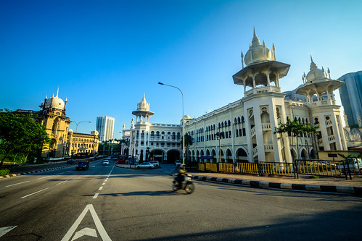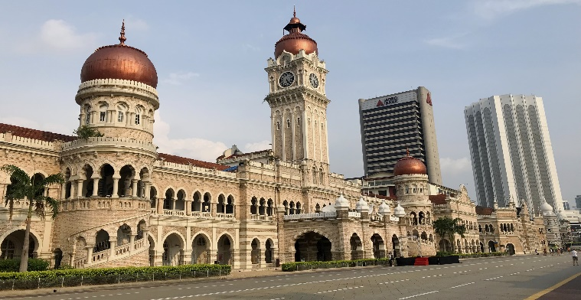
Sultan Abdul Samad Building, Kuala Lumpur
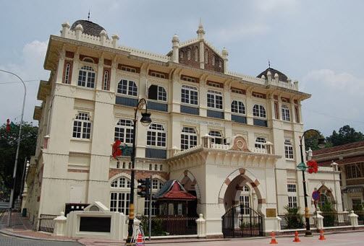
National history museum
Grecian-Spanish:
Many buildings in Kuala Lumpur, especially in the old centre draw inspiration from Straits Eclectic and European architecture. Many of them even employ white and red brick patterns with an emphasis on old architecture-Spanish architecture.
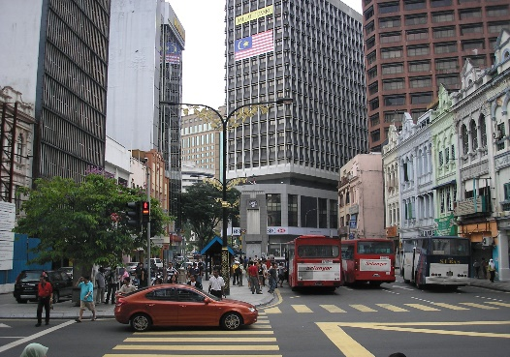
Old market square
The most significant influence introduced by the Chinese traders was their art and architecture. The architectural influences of the Chinese architectural led to a style called Straits Eclectic that instigated from the 15th century to mid-20th century. The impact was mostly in urban areas in a form of shop houses and terrace houses. The architecture adapted to the tropical climate has combination influence of Malay and European architecture.
Famous Structures in Malaysia:
Guan Di Temple, Chinatown Kuala Lumpur
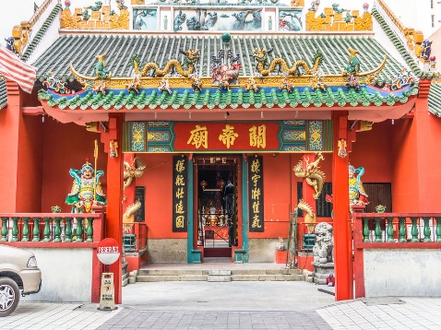
Founded in 1886, this atmospheric temple is dedicated to Guan di, a historical Chinese general known as the Taoist god of war, but more commonly worshipped as the patron of righteous brotherhoods: he is in fact patron of both police forces and triad gangs. The temple's high ceilings, red walls, tiled eaves and pointy gable ends give it a distinctive look that's great for photos.
Thean Hou Temple:
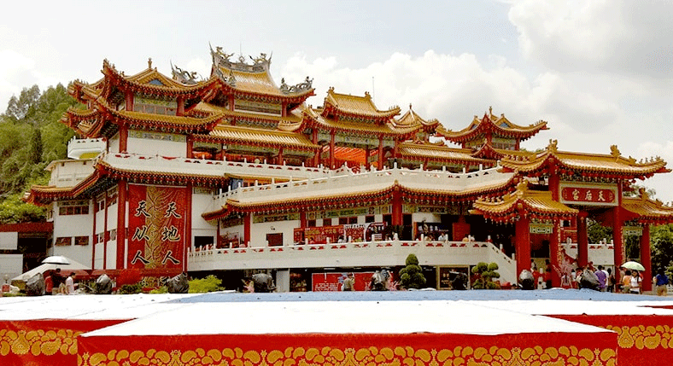
The temple is built on a 1.67-acre piece of land. The original temple was initially at Jalan Sultan but was relocated at the present location in 1987. The temple has four levels. The top level is the main temple hall where all the cultural and religious activities are held regularly. At level one is the souvenir shops and the food court while the 2nd level is the banquet hall where most Chinese wedding dinners are held. And at the 3rd level is the marriage registration and administrative offices.
Temple of Supreme Bliss
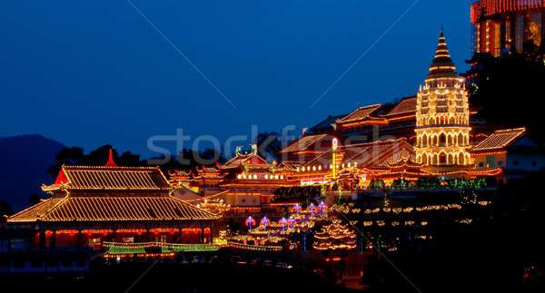
The ‘Temple of Supreme Bliss’ is also the largest Buddhist temple in Malaysia and one of the most recognisable buildings in the country. Built by an immigrant Chinese Buddhist in 1890, Kek Lok Si is a cornerstone of the Malay-Chinese community, who provided the funding for its two-decade-long building (and ongoing additions). It was inspired by Beow Lean, the chief monk of the Goddess of Mercy Temple.
Kapitan Keling Mosque,
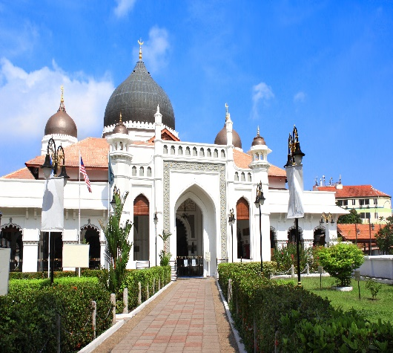
The largest mosque in the city, the Kapitan Keling Mosque started as single-story brick building in 1801, built primarily for the Indian Muslim community. It has grown to encompass 8 acres and is used by all Muslims on the island. You are free to wander the grounds and gaze up at the Mughal-style domes, whitewashed walls and the Moorish decorations of crescents and stars. You might even try for a picture of the towering minaret, sans the intrusive high-tech speakers, if you aim your camera just right. Remember that this is still a house of worship used five times daily. Cover up bare legs and shoulders, and if you enter the main hall, take off your shoes.
Kuala Lumpur Tower Architect :Kumpulan Senireka Sdn Bhd.
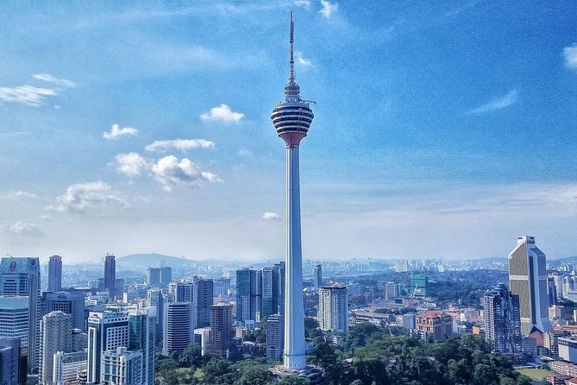
The Kuala Lumpur Tower is a tall tower located in Kuala Lumpur, Malaysia. Its construction was completed on 1 March 1995. It is used for communication purposes and features an antenna that reaches 421 metres (1,381 feet) and is the 7th tallest freestanding tower in the world. The roof of the pod is at 335 metres (1,099 feet). The rest of the tower below has a stairwell and an elevator to reach the upper area, which also contains a revolving restaurant, providing diners with a panoramic view of the city. Races are held annually, where participants race up the stairs to the top. The tower also acts as the Islamic flak observatory to observe the crescent moon which marks the beginning of Muslim month of Ramadan, Saywal, and Zulhijjah, to celebrate fasting month of Ramadan, Hari Ray Aidilfitri and Aidiladha. The tower is the highest viewpoint in Kuala Lumpur that is open to the public.

Petronas Twin Towers (Architect César Pelli)
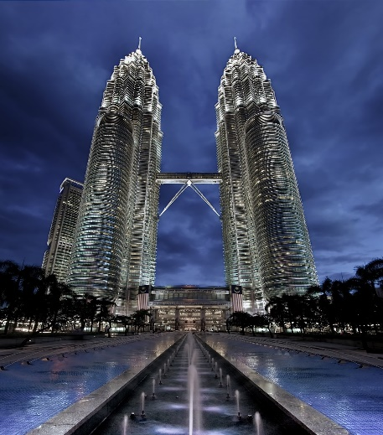
Petronas Twin Towers were once the tallest buildings in the world. Now the world’s tallest twin structures, the 88-storey buildings were designed by Cesar Pelli & Associates with both towers joined at the 41st and 42nd floors (175m above street level) by a 58 metre-long, double-decker Sky Bridge.
Standing 452 metres tall, the Petronas Twin Towers retained its world-title claim to fame until 2004 when Taipei's 101 was built, measuring 508 metres tall. Today, the Burj Khalifa in Dubai (opened in 2010) retains the spot as the world’s tallest building. Located in the KL city centre, the Petronas Twin Towers’ architecture is Islamic- inspired and the buildings primarily house the corporate headquarters of the Petronas

