Iqra National University
Name: Madeeha Maqood Hussain
Id: 14213
Subject: Pakistan-Studies
Assignment: Final Assignment
Teacher name: Ma’am Beenish
Submitted to: Ma’am Beenish
Submitted by: Madeeha Maqsood Hussain
Date: 14-09-2020

Q1. Period of any dictator in Pakistan
ZIA UL HAQ
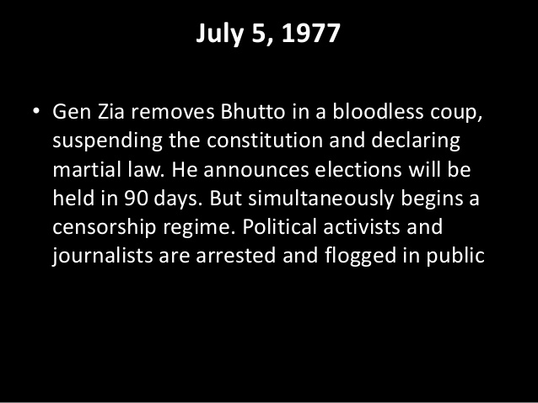
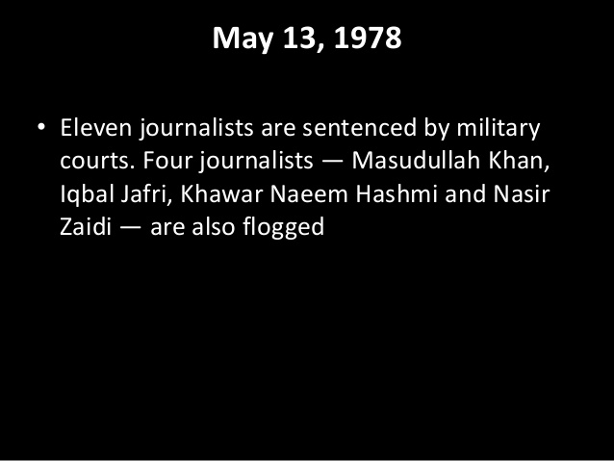
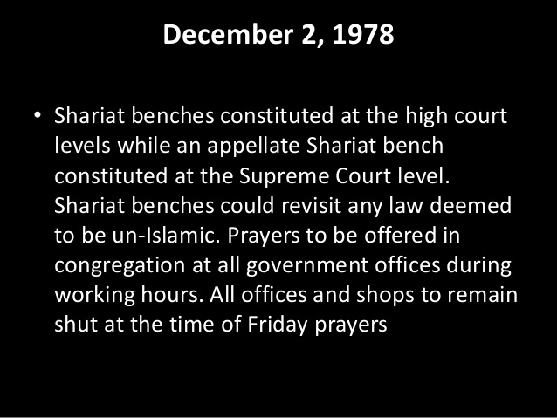
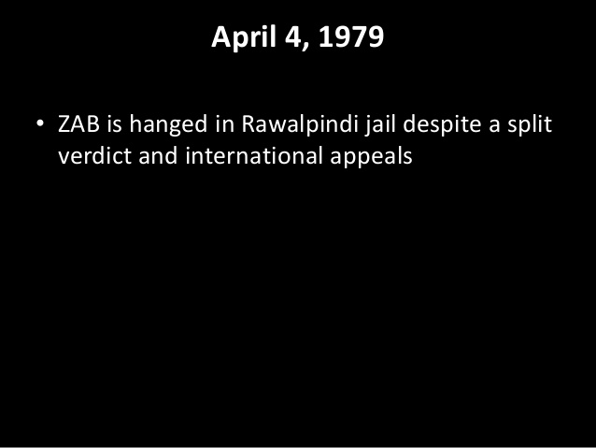
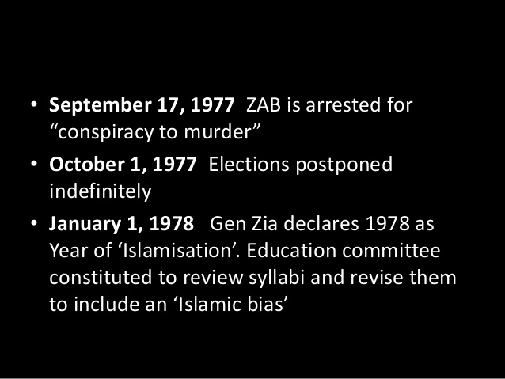
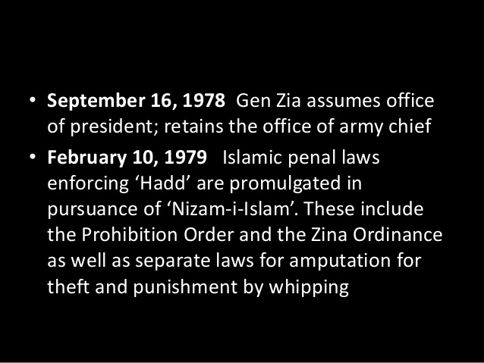
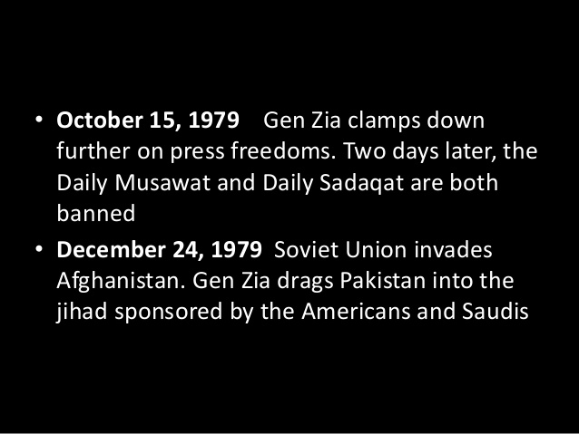

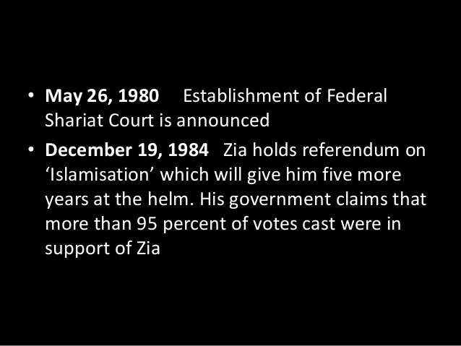
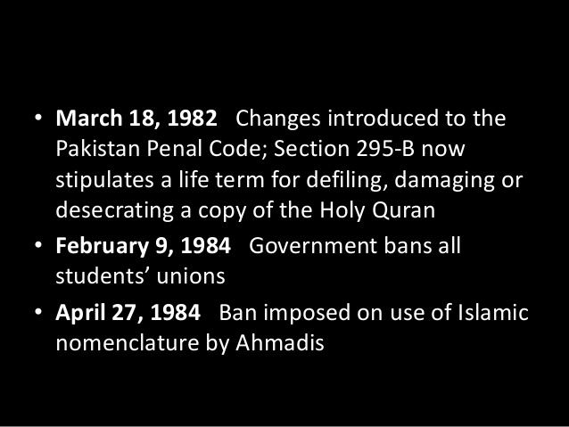

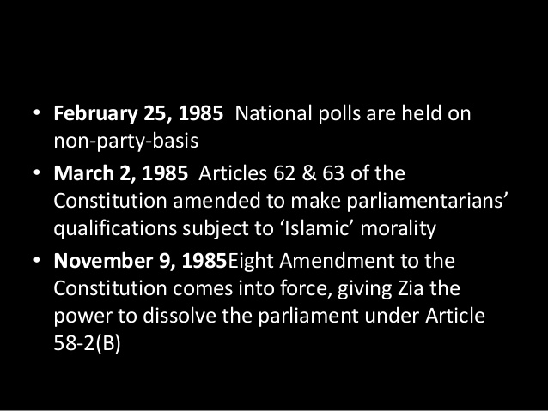
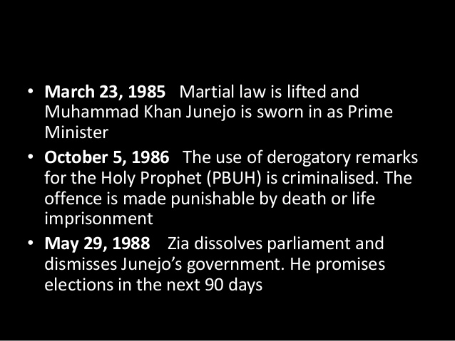

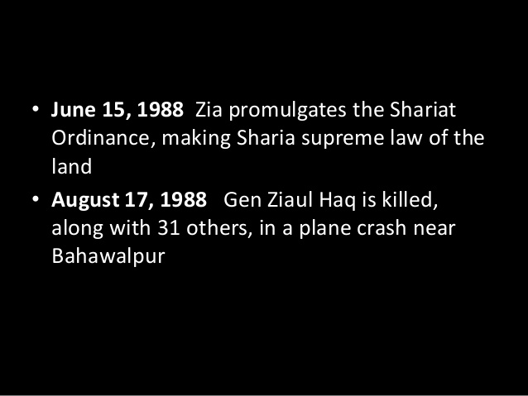

.
Q2. Kashmir issue and your views
The conflict between India and Pakistan over Kashmir started in 1947 after the British government decided to withdraw from the region. Britain wanted to conduct a referendum to let the people decide Kashmir's status during its pullback. Although 90% of the Kashmir population was Muslim, Kashmiri Prince Maharaja Hari Singh decided Kashmir would become a part of India. Since that day, there have been different levels of conflict between parties. It has caused the deaths of 95,000 people and hundreds of thousands injuries. Although the Kashmir region officially became part of India with the prince's decision, it was given a special status under Article 370 within the Indian constitution by the government.
According to this article, the Kashmir region is independent in domestic affairs but dependent on the foreign level. Despite the special status of Kashmir, there have been different forms of tension between the Indian and Pakistani governments, and the Kashmiri people who reflect on the relationship between both sides. Pakistan and Indian officials blame each other of provoking the circumstances in Kashmir from time to time. While discussions keep going, the special status of Kashmir was recently changed on Aug. 5 by the Indian governing party, Bharatiya Janata Party (BJP), which is the Hindu nationalist party.The BJP has long opposed Article 370 and promised to abolish the rule during its election campaign in 2019. After the declaration of the abolition of the special status in Kashmir, the region was blockaded by Indian forces, telephone and internet wires were cut off, leading politicians were placed under arrest and public gatherings were banned.
This attempt by India re-escalated the conflict between India and Pakistan and led to increasing tension at the local, regional and international levels. Although the international community, particularly the U.N., NATO, SAARC and the U.S., has been involved in the issue, there has been no concrete resolution.
Meanwhile, Kashmir is located in the middle of three nuclear powers; India controls 45% of the land, Pakistan is 35%, and China is 20%. That's why the conflict has not only regional dimensions but it is also one of the leading issues remaining on the international agenda.
The U.N. and NATO position:
The United Nations' position in the Kashmir conflict is considered a failure by several international actors and people living in the region. The U.N. is yet to play its full role in the issue and apparently, its non-implementation policy has not been enough to find a common ground between parties. On the other hand, NATO occasionally releases a statement on the current issues including Kashmir between Pakistan and India but hasn’t proposed any substantial roadmap as far as resolving the issues is concerned. At stage, the international community's position and attitude are very crucial to get a peaceful resolution.

Role of SAARC on disputes between Pakistan and India:
SAARC (South Asian Association for Regional Cooperation) was established in December, 1985 at Dhaka with the objective of promoting regional cooperation, trade, and economic ties amongst the states of South Asia. The SAARC has been functioning since 1985 but it could not become an active organization and the dream of greater cooperation could not materialise fully. The bilateral problems of the states of the region have been the major obstacle to cooperation. In addition to this, The SAARC charter included two provisions to separate it from the bilateral problems. First, the charter provided that bilateral issues could not be raised in SAARC meetings. Second, all discussions would be taken with the consent of all members. The principle of unanimity for decision making has made the SAARC forum actually ineffectual and dormant.
Conclusion:
Being the two major states of South Asia, India and Pakistan need to provide lead to cooperation for the stability of the South Asia region and both countries should discuss and resolve the Kashmir issue. More importantly, the governments of both countries must not reduce the Kashmir situation to a Pakistan-India one. U.N had called for plebiscite in its resolution to allow Kashmir’s to decide their own future. The issue should not be made into a dispute that alienates the people of Kashmir. Leave it to the Kashmiri people to decide what they want.
Q3. Women empowerment and Islam and also write down a note on any Pakistani female life history and her struggle?
Women empowerment and Islam:
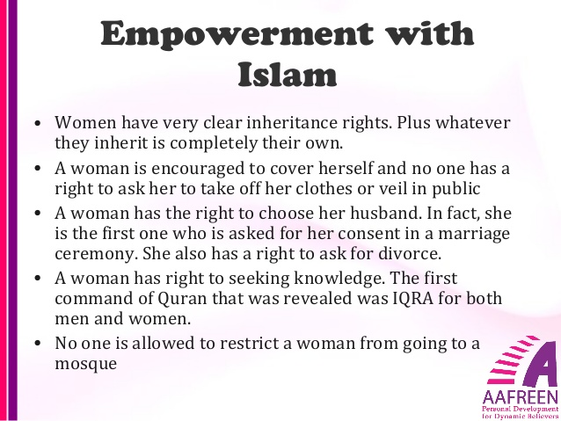
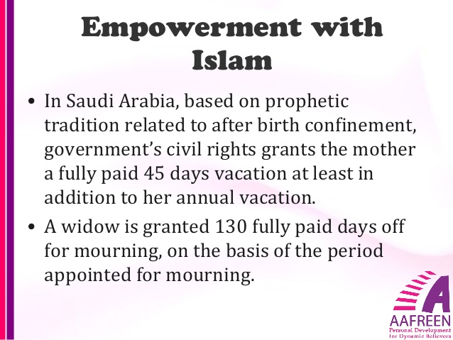

Pakistani female life history and her struggle
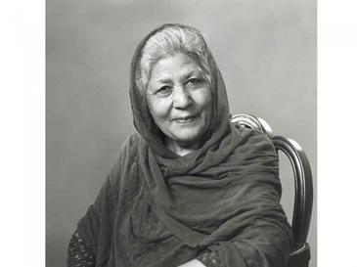

Bano Qudsia (Urdu: بانو قدسیہ‎‎; 28 November 1928 – 4 February 2017), also known as Bano Aapa, was a Pakistani novelist, playwright and spiritualist. She wrote literature in Urdu, producing novels, dramas and short stories. Qudsia is best known for her novel Raja Gidh. Qudsia also wrote for television and stage in both Urdu and Punjabi languages. Her play Aadhi Baat has been called "a classic". Bano Qudsia died in Lahore on 4 February 2017.

PERSONAL LIFE
Bano Qudsia was born on 28 November 1928 in Firozpur, British India, as Qudsia Chattha. Her father was a Bachelor of Agriculture and her brother Pervaiz Chattah was a painter. She migrated to Lahore with her family after the partition of India and had begun writing short stories while studying in class 5. She graduated from the Kinnaird College in Lahore and then joined the Government College University (Lahore) (GCU) to do her masters in Urdu literature which she completed in 1951.
Qudsia married writer Ashfaq Ahmed whom she had met at the Government College University (Lahore). They had three sons Aneeque, Anees and Aseer. The couple had been considered inseparable in their social lives.

LITERARY WORK
Qudsia's novel Raja Gidh (The King Vulture) is considered a modern Urdu classic. Among her more prominent writings are Aatish-i-zer-i-paa, Aik Din, Asay Pasay, Chahar Chaman, Chhotaa Sheher Baray Log, Footpath ki Ghaas, Haasil Ghaat and Hawa Kay Naam. The most well known plays she wrote include Tamasil, Hawa ke Naam, Seharay and Khaleej.
Her critically acclaimed play Aadhi Baat was about a retired headmaster. The play examined the headmaster's day-to-day life problems and had Qavi Khan acting as the lead character. The play's director was Agha Nasir and it was produced by Tauqeer Nasir. Aadhi Baat was performed in May 2010 in Islamabad at a three-day event which was organized by the Pakistan National Council of the Arts. Ashfaq Ahmed's autobiography Baba Saheba was incomplete at the time of his death in September 2004. Qudsia completed the biography and the second part of it was published as Rah-i-Rawaan. The contrast in the narrative styles of the couple is evident in these two books; while the first half is considered "provoking, lucid and utterly spellbinding" by critics, the second half takes the feeling of sorrow. Qudsia credits Ahmed for transforming her after their marriage and eventually allowing her to devote to her writing. Qudsia's novel Raah-e-Rawaan was published in 2011. It is an analytical look at Ashfaq Ahmed's philosophical thinking and how it may relate to certain aspects of life itself. Qudsia had the highest regards for her husband and she has placed Ashfaq Ahmed on a very high pedestal. However she does not even claim to understand the man she lived with for more than five decades. So, an attempt at writing the biography of Ashfaq Ahmed took her beyond that ‘one person’— and she started to write about his ancestry, the family including his grandfather, father, uncles, brothers, sisters and their children so as to fully understand the enigma that was Ashfaq Ahmed.
Qudsia’s novel [Haasil Ghaat] was published in 2005 and was noted for its diction but also criticized then for usages of English slangs than her usual traditional Urdu narrative. The language however became popular amongst other writers in future.
Bano Qudsia also wrote a book about Qudrat Ullah Shahab titled "Mard-e-Abresham" "مردِابریشم". The book mainly portrays Shahab's life and how it was connected with Ashfaq Ahmed and his family both on social and spiritual level.

DEATH
Bano Qudsia died on 4 February 2017 at the Ittefaq Hospital in Lahore at the age of 88. Her son Aseer Ahmed informed that she died around the time for Maghrib prayers (after sunset). She was buried at Lahore on 5 February and prayer services were held at Model Town, Lahore.

AWARDS AND RECOGNITION
In 1983, Qudsia was awarded the Sitara-i-Imtiaz (Star of Excellence) by the Government of Pakistan. In 2010, the Pakistani government awarded her the Hilal-i-Imtiaz (Crescent of Excellence) for her services in literature. In 2012, the Pakistan Academy of Letters (PAL) awarded Qudsia the Kamal-e-Fun Award, which is a lifetime achievement award. In 2016, the GCU’s Old Ravians Union (GCU-ORU) at its annual reunion conferred on her a lifetime achievement award. The same year, the Pakistan Life Care Foundation (PLCF) also awarded the lifetime achievement award to Qudsia.

Q4. Experience of democracy in Pakistan.
