ASSIGNMENT FOR VIVA
WARDAH NAVEED
ID 13637
BS DT 6
Para functional habit:
A parafunctional habit, like grinding, thumb sucking, or tongue thrusting, is basically the repeated use of the oral structures for things other than eating, swallowing, speaking or breathing. When something goes wrong in the mouth, though, it causes a chain reaction of failures. Parafunctional habits are like the monkey wrench in the machine.
Let’s explore a few of the most common parafunctional habits and how they affect the mouth:
BRUXISM:
- Bruxism, or grinding is the monkey wrench of all monkey wrenches.
- It happens during sleep and comes in episodes where the jaws exert large amounts of force and grind against each other.
- Over time, bruxism leads to a breakdown of the teeth and can cause damage to the temporomandibular joint (TMJ).
- There are likely different causes of bruxism.
- Bruxism can be caused by things like a bad bite, obstructive sleep apnea, or possibly stress.
- Many people are unaware that they grind until they are told either by their dentist, who can see signs of bruxism in the mouth or by a spouse or roommate who can see or hear the grinding.
What are symptoms of bruxism:
- Sore or stiff jaw muscles
- Headaches especially upon waking
- Sore back or neck
- Sensitive teeth
- Painful Salivation when first eating
- Jaw pain
- Snoring – grinding can be caused by Obstructive Sleep Apnea
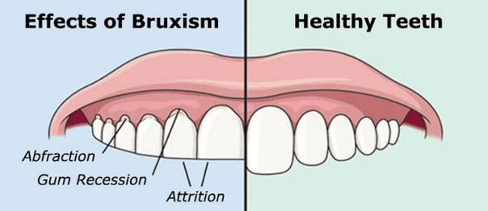
When your dentist examines your teeth, they will look for signs of bruxism like:
- Scalloped tongue
- Ridges along the inside of the cheek
- Worn teeth
- Notching at the gum line of teeth
- Broken and chipped teeth
- Worn or broken fillings
- Narrow airway
- Large tonsils
- Small chin
- Large tongue
How Do I Treat Bruxism:
Finding the cause of your grinding is the first step to choosing a treatment.
Your dentist will evaluate your teeth and oral structures and look at your medical history. They will ask you questions about your sleep and snoring and examine your bite for discrepancies that may contribute to your grinding. Depending on what they find, they will make a treatment recommendation.
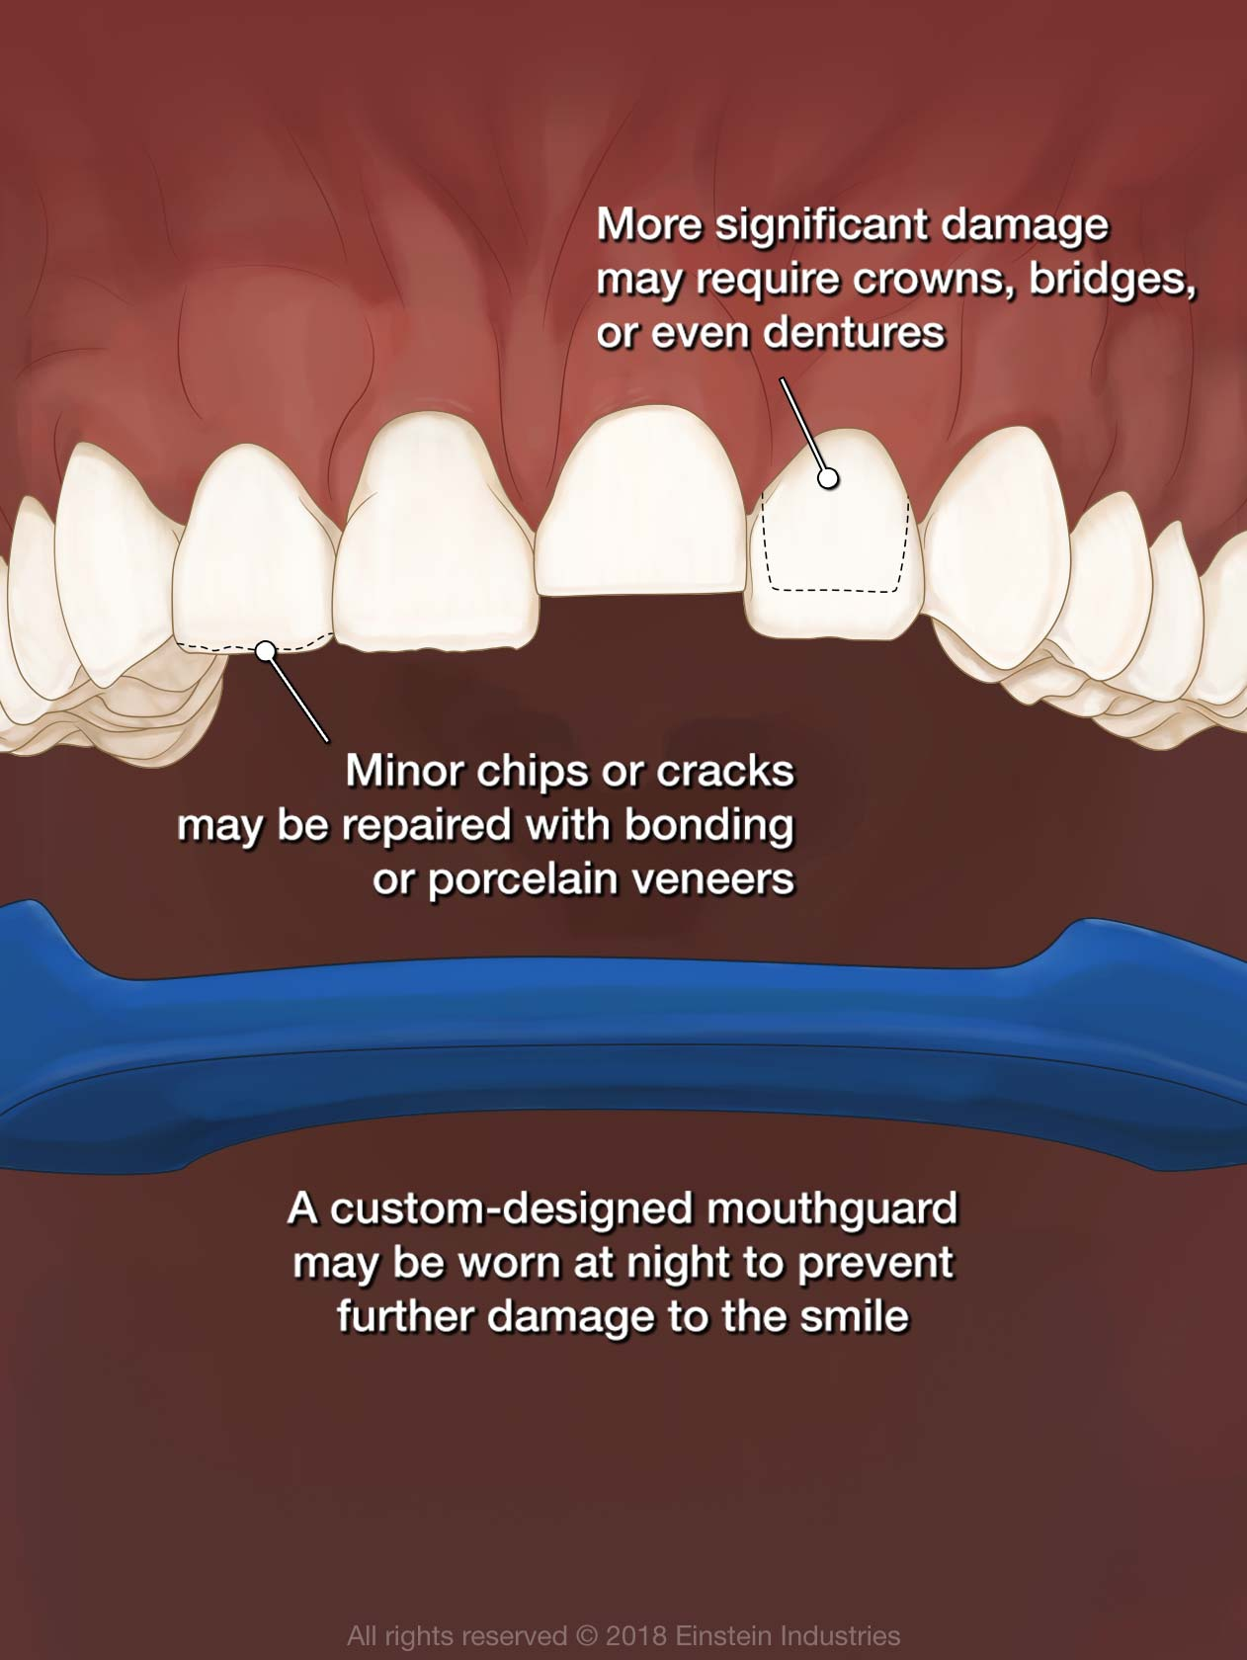
Treatment for Obstructive Sleep Apnea:
If your dentist suspects you have Obstructive Sleep Apnea that is causing your grinding, they will refer you to a sleep specialist for a sleep study. Treatments for sleep apnea usually resolve grinding.
- CPAP
- Oral appliance
Occlusal Guard
Occlusal guards are usually made of a hard acrylic which is custom-made for your teeth and are calibrated for your bite. They are worn at night and protect the teeth and provide relief for the jaw joint and its muscles. They are not a good option for people who suffer from OSA.\
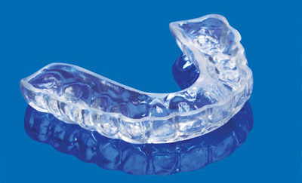
Bite Correction
If your dentist finds that you have a problem with how your teeth meet, you may be given options to correct your bite. Studies have shown a reduction of grinding with a corrected bite. There are different ways of correction. Talk to your dentist about the best choice for you!
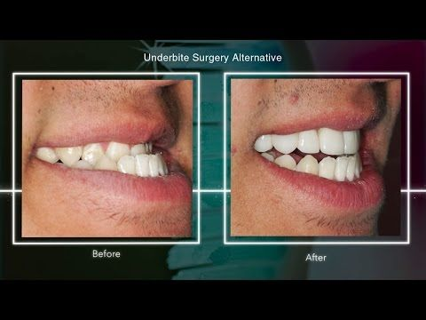
- Orthodontics
Braces can move the teeth into a better position
- Equilibration
Small adjustments made to the teeth using a dental hand piece to help the teeth meet in the proper position with no interferences
- Restoring the bite with crowns
This is done when the teeth are very worn or as an alternative to orthodontics
THUMB SUCKING
Oh yes. Thumb, finger, or pacifier sucking, also called non-nutritive sucking, is a parafunctional habit. Sucking is a reflex and is important for self-soothing in infancy. Infants suck their fingers or thumbs after feeding for comfort, and for some, it becomes a habit. Most children outgrow it in early toddlerhood, but those who don’t are faced with a parafunctional habit that is both difficult to manage and destructive.
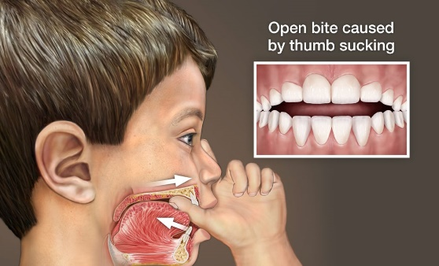
What Does Thumb Sucking Do:
Because the thumb exerts a pressure against the roof of the mouth and front teeth, thumb sucking actually reshapes the bones of the upper jaw. The result is front teeth that protrude, a high narrow palate and a “reverse smile line” where the upper teeth form a rainbow shape, in what is known as an Anterior Open Bite. The narrow palate and open bite from thumb sucking can contribute to another parafunctional habit called Tongue Thrust. Speech can also be affected. S and Z sounds can become difficult and orthodontics may be needed.
Finger sucking can cause an open bite on just one side of the mouth, depending on where the finger or fingers are placed. It can also cause an Anterior Open Bite.

How Do You Treat Thumb Sucking?
Thumb sucking can be a very difficult habit to break. Prevention is the key here. The sucking reflex starts to diminish around 3 to 4 months of age. If babies are given a pacifier to suck rather than their thumbs in infancy, it can be pulled between 4 and 6 months fairly easily with just a few difficult bedtimes. If it’s too late, and the thumb sucking habit is already established, there are methods to try, but unfortunately, there is no silver bullet approach to sucking a thumb.
- THUMBUDDY is a character that is like a thumb puppet. It has been helpful for some people,
- Limiting time to thumb suck in the house or at bedtime
- Talking to your child about quitting
- parafunctional habits thumb sucking oral hygiene
TONGUE THRUST
All babies are born with tongue thrust. It is how the infant eats. As you grow, the pattern of swallowing changes and tongue thrust should disappear. If it lingers after about the age of four, it is considered to be a parafunctional habit. So what is it, exactly? When you swallow, your tongue should be positioned on the hard palate behind the upper front teeth.
In people with tongue thrust, the tongue is positioned on the backs of the front teeth and the result is that the tongue protrudes through them. Keep in mind that the average person swallows between 1200 and 2400 times a day and each time you swallow, you exert 4 pounds of pressure with your tongue. Move the tongue from the palate to the teeth and you can see how a tongue thrust can quickly change things!

In thumb sucking, we talked about how the pressure from the thumb caused the palate to become high and narrow. Well, think about that precision machine, again. The palate is U-shaped for a reason–it accommodates the tongue. If the palate becomes narrow and high, the tongue has nowhere to sit and the jaw drops open and now the tongue isn’t able to exert its force to properly shape the palate, so even in speech and at rest, the tongue is exerting pressures where it shouldn’t be.
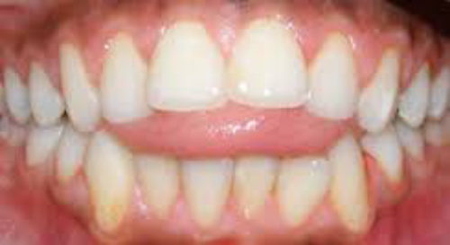
What Causes Tongue Thrust
There are many possible causes. We know that anything that prevents nose breathing can contribute to tongue thrust. It makes sense. If you can’t breathe through your nose, you open your mouth. Your tongue comes out of your palate space and anatomy shifts. Face elongates, palate narrows and gets deeper, teeth protrude. Other possible causes include:
- Thumb sucking
- Difficulty swallowing
- Large tongue
- Angle of jaw line
- Genetics
- Muscular, neurological, or other abnormalities
- Short tongue or being tongue-tied.
How Do you Know if Your Child Has a Tongue Thrust?
Many times tongue thrust is found by your dentist, pediatrician, or orthodontist. Your dentist can see changes in the teeth and the palate during the exam. They may hold the lower lip and ask your child to swallow to observe whether tongue thrust is present. Other things to look for include:
- Mouth breathing
- Puckered lips when swallowing
- Open bite
- Gum problems – often seen with mouth breathing
- Drooling
Types of Tongue Thrust
Yep. A tongue can thrust in more than one direction. Depending on where the pressure is exerted, different malformations of the teeth occur. Your dentist or orthodontist is able to look at the pattern of the teeth to determine which type of thrust is present. Cool, huh!
- Anterior Open Bite
Most common type of thrust. Lips close improperly, tongue protrudes through lips. This type of thrust is often seen with a large tongue.
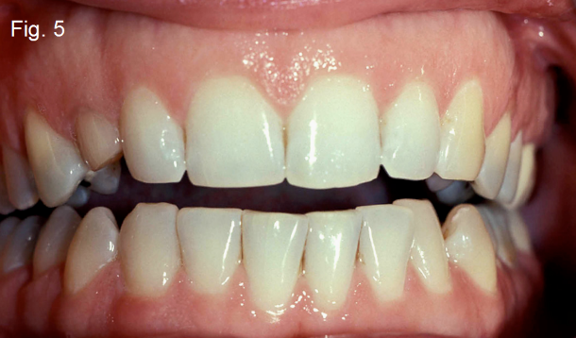
- Anterior Thrust
This happens when the lower lip pulls on the lower teeth and the tongue is thrusting against the upper front teeth. The upper teeth become very protruded.
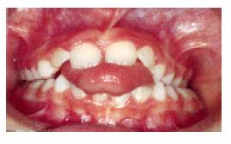
- Unilateral Thrust
This happens when the tongue postures to one side. The result is an open bite on one side of the mouth.
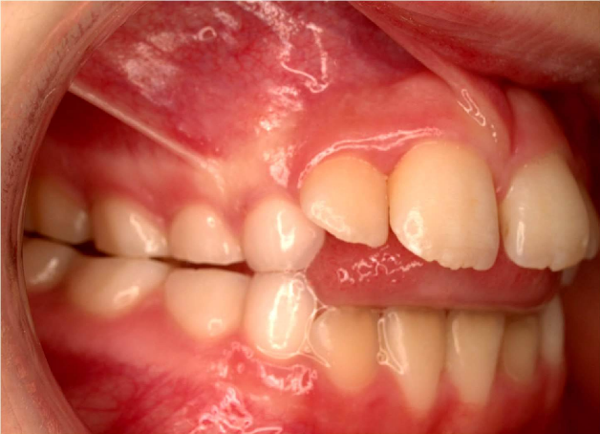
- Bilateral Thrust
In bilateral thrust, the tongue thrusts to the sides of the mouth. This causes the teeth on the sides and back of the mouth to open. This is a very hard situation to correct.
- Bilateral Anterior Open Bite
The tongue is usually large in this instance. The only teeth that touch are the molars and everything else is open.
- Closed Bite Thrust
In this type of thrust, the teeth meet, so they are closed, not open. But, both the top and bottom teeth are flared out
- Mandibular Thrust
This type of thrust is seen in people with an inherited pattern of growth. The tongue is held low and forward causing a protrusion of the lower jaw.
How Do You Treat Tongue Thrust?
Treating a tongue thrust can be difficult, but it is successful about 75% of the time. Even if you correct the alignment of the teeth with orthodontics, unless your treat the tongue thrust, the orthodontics will fail. As long as there is a thrust, the teeth will move. There are two basic types of treatments.
- Myofunctional or Tongue Therapy
Therapy helps to retrain the tongue by doing exercises.
- Appliance Therapy
A crib type of appliance is worn to keep the tongue from the backs of the front teeth.
Your dental exams aren’t just for finding cavities! Your dentist can see early signs of parafunction long before it becomes an insurmountable problem!

