ID. Name Mansoor Khan
NO 15866
Radiology 2nd Semester Section “A”
Instructor Name Dr. M .Shahzeb Khan (PT)
-----------------------------------------------------------------------------------------------------------------------------------------
Q1: (A) How stimulate of smell moves from nostril to brain? Make a diagram as well.
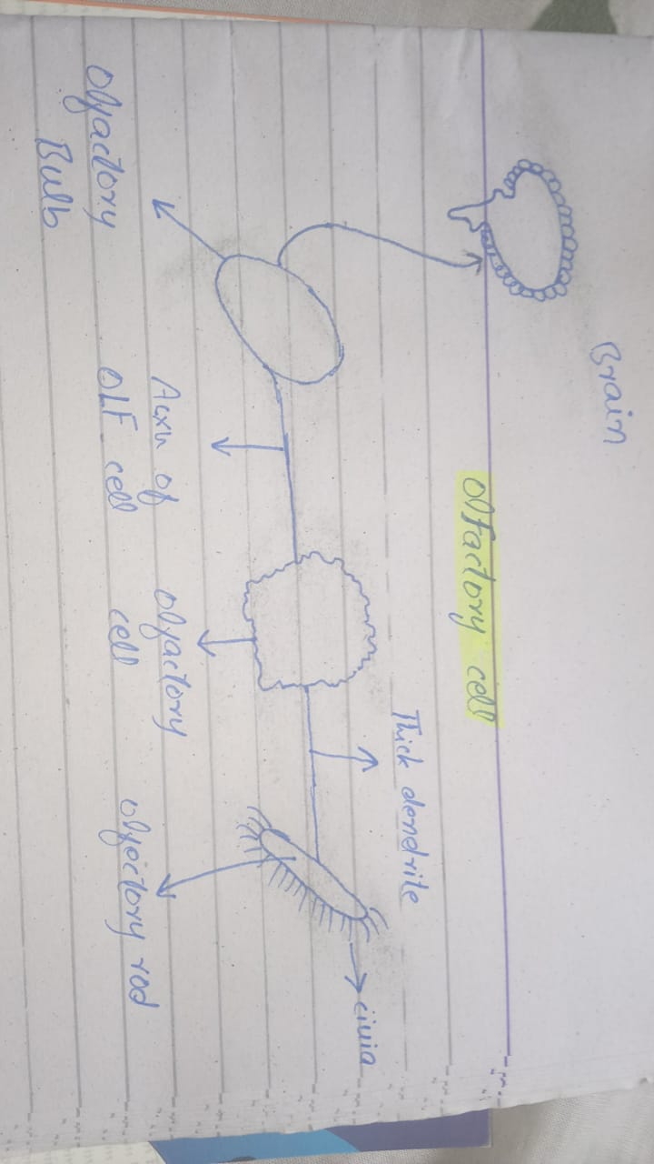
Ans: The human sense of smell is less acute than in other animals many animals secret odours pheromones. Which an important part in chemical communication. All odours material give all volatile molecules which are carried by or into the nose with inhaled air and never low concentration when dissolved in mucus. Stimulate the olfactory chemorecepters. The air entering the nose is washed and conviction current carry eddies of inspired air to the roof of the nasal cavity, sniffing concentrates. Volatile molecules in the roof of the nose. This increase the number of olfactory receptors stimulate and thus peroception of smell. The smell advert olfactory receptor in the nasal cavity, the glomeruli receive this signal and transmit this in to the olfactory bulb. Where the sensory input will start to interact with part of the brain is responsible for brain. Thus the sensation of smell occurs.
Diagram

Q2: (A) What is different between haemostasis, Haematopoiesis and homeostasis?
Ans: Haemostasis: is the stopping of blood flow from the circulatory of an animals this include humans, haemostasis help the circulatory system to perfus the right organs prevent blood toss from circulation when vessels is ruptured wound healin and blood cloting during haemostasis the blood flow is slow down and clot is formed to prevent the loss of blood.
Haematopiesis: Is the formation and development of the neco blood cells. All new blood cell originate from the stem cell called haemostasis. If become a red cell of blood.
Hemocyto blast ------ Erythroid stem cell ------ RBC. If become a lymphocyte
Hemocyto blast ------ lymphoid stem cell ------ lymphocyte. If become a non lymphocyte with blood cell.
Homeostasis: The composition of internal environment is tightly controlled and fairly constant state called homeostasis. It is a dynamic ever changing situation where a multitude of physiological mechanism and measurement are kept within narrow limits when this balance is threadent or lost. There is a serious risks to the well beino of body. Example : Regulation of the body temperature acidity. allcalinity occurs in homostasis.
(B) What is erythroblastosis fetalis?
Ans: Erythroblastosis fetalis: this is called hemolytic disease of the new born. This a type of anemia in which the red blood cells of the fetus are destroyed in material immune reaction resulting from a blood group incompatibility between the mother and fetus this is due to when the fetus inhevits a contain blood factors from father that one absent in the mother of the new born. This a type of anemia in which the reed blood cells of the fetus or destroyed in material reaction resulting from a blood group incompatibility between the mother and fetus. This is due to when the fetus inhevits a contain blood factor from father that one absent in the mother.
Q3: What is immunity? Explain different type of immunity.
Ans: Immunity: the body first line of defance its collection of non specific defences. Immunity is the obility of an organism to rests harmful micro organism from entering the blood cells.
Different Type of immunity:
- Active naturally acasuired immunity: this immunity is produce when the body is stimulated by its own antibodies by having the disease during the illness, B cells develop into plasma cells that produce antibodies in sufficient amount to overcome the infetim. After the recovery the b cell which is called memory b cell, produce confer immunity to future infection by some antigen.
- Active artificially acasuired immunity: this type of immunity develop in response to the introduction of deed or live artificially welted pathooen or de activated toxin. The vaccine and toxids retain the antigen and stimulate the development of immunity they can not cause the disease. Example. Cholera vaccine etc
- Passive naturally acasuired immunity: this type of immunity is acasuired by the fetus before birth. The antibodies of mother cross the plaante and enter to the fetus and after the birth the breast feeding is another source of entering mother antibody to in infant.
- Passive artificially acasuired immunity: in this type of immunity a really mad antibodies is administered into the body. This anti body are obtain from human and animal serum.

(B) What is different between antigen and antibody?
Ans: Antigen: antigen is any substances that triggers immune response in the body.
2. Also called immunozens.
3. Can be either protein, carbohydrate, lipids or nucleic acid.
4. intereeting domain with the antibody is called eptope.
5. cause disease of allergic reaction.

Antibody: 1. Antibody is a blood protein that is produce against specific antigen.
2. also called immunoglobulin.
3. Glycoproteins.
4. variable sid can bind to epitope.
5. protect body from antigen.

Q4. (A) Write down different function of antibody.
Ans: Function of antibody:
- Neutralization of infectivity.
- Phagocytosis.
- Antibody dependent cellular cytotoxicity.
- Complement mediated lysis of pathogen antibody activate the complement system to destroy bacteria cell by lysis.
- Transcytosis mucosal immunity of bacterial immunity.

(B) Write difference between primary and secondry response to an antigen.
Ans: Primary response: Exposure of immune system to an antigen for the final time lead to a slow and delayed rise of antibody level. This delayed response reflectet time resuised time resuised to activate the T-Cell system. Which then stimulate cell B-cell division antibody level start to fall once the infection is cleared but the immune system response and make antibodies for future infection.
Secondry response: on subseasment exposure to the same antigen the immune response is much faster and 10-15 times more powerful because the memory B-Cell generated after the first infection rapidly divide the antibody production suddenly.

Q5. Write different between cell mediated and antibody mediate immunity.
Ans: cell mediated immunity :
- The t-cell are main cell that are involved in cell mediated immunity.
- Component of cell mediate immunity is helps is T –cell .
- This type of immunity protects again in intracellular pathogens.
- For the detection of antigen they use MHC molecules.
- T- Cell receptor on cell bind to T- Cell which in turn bind to antigen.
- This involved T-Cell co-receptor which is called (TCRs).

Antibody mediate immunity:
1.B-Cell are the main cell that involved in this immunity.
2. B-Cell, T-Cell and and macrophages are component.
3. This immunity protect against P-extra cellular pathogens and toxins.
4. This process not require antigen processing.
5. This involved B-Cell receptor.
---------------------------------------------------------------------------------------------------------------------

THE END

