Name:Faridullah
Reg no:16748
Dept:BBA
Sec:A
Sub:Principle of Marketing
Submitted to:Sir Shahzaib Anwar

Qno.1 What is SWOT Analysis? Why companies use it? Develop SWOT Analysis for IQRA National University.
Ans: SWOT ANALYSIS is a strategic planning, technique used to help a person or organization identify
the strengths, weaknesses, opportunities and threats related to business competition.
▪ Internal( attributes of the organization)
Strengths, Weaknesses
▪ External ( attributes of the Environment)
Opportunities, Threats
Strengths:
Internal capabilities that may help a company reach its objectives.
Weakness:
Internal limitations that may interfere with a company reach its objectives.
Opportunities:
External factors that the company may be able to exploit to its advantage.
Threats:
Current and emerging external factors that may challenge the company's performance.
Why companies use SWOT analysis?
It is a simple and useful technique for analyzing our organization’s strengths, weaknesses, opportunities
and threats. It helps us to build on what we do well, to address what we are lacking, to minimize risks,
and to take the greatest possible advantage of chances for success. It helps to determine not only the
capabilities but also all the available advantages over competitors. deeper analysis of various factors of influence. SWOT analysis helps to develop an understanding of the circumstances.

SWOT analysis for IQRA university:
STRENGTH:
▪ Provide quality education at affordable price.
▪ Dedicated and expert faculty and support staff.
▪ Have many departments unique including fashion designing.
Safety measures.
▪ All programs under one roof.
▪Transportation.
▪Discipline
▪Foreign affiliations
WEAKNESSES:
▪ Resistance to change
▪Leading competitors
Location
• OPPERTUNITIES:
▪ Strong collaboration with local companies.
▪ Growth potential
▪ New constructions
▪ Internal scholarship
▪ Introduction of new specialization to attract wider customer segment
Threats :·
• Political and socio economical conditions.
• Emergence of new business schools and universities.
• Negative public perception.
• Development of another university in the area.

Qno.4 Write briefly about Branding along with examples?
Ans: Branding is a process which involves creating a specific name, logo, and an image of a particular product, service or company. This is done to attract customers. It is usually done through advertising with a consistent theme.
Branding aims to establish a significant and differentiated presence in the market that attracts and retains loyal customers. A brand is a name, term, symbol, or other feature that distinguishes an organization or product from its rivals in the eyes of the customer. Brands are used in business, marketing, and advertising.
Examples of Branding
Branding often takes the form of a recognizable symbol to which consumers easily identify, such as a logo.
Some common examples of brands are Nike “swoosh”, the golden arches of McDonald’s, the Apple used by apple computers, Coca-Cola, Ferrari,etc.

Qno3. Write briefly about Product Life Cycle and draw its model?
Ans:Product life cycle :·

As organizations introduce new products to consumers, demand for the product increases, peaks, and declines. Each product passes through a series of stages from product introduction to product decline. The series of stages is known as product life cycle. Most products have a short life span and organization must be aware which product life cycle stage the is in at a particular point in time. There are four stages in the product life cycle.
1. The introduction stage
2. The growth stage
3. The maturity stage
4. The decline stage

Model :·
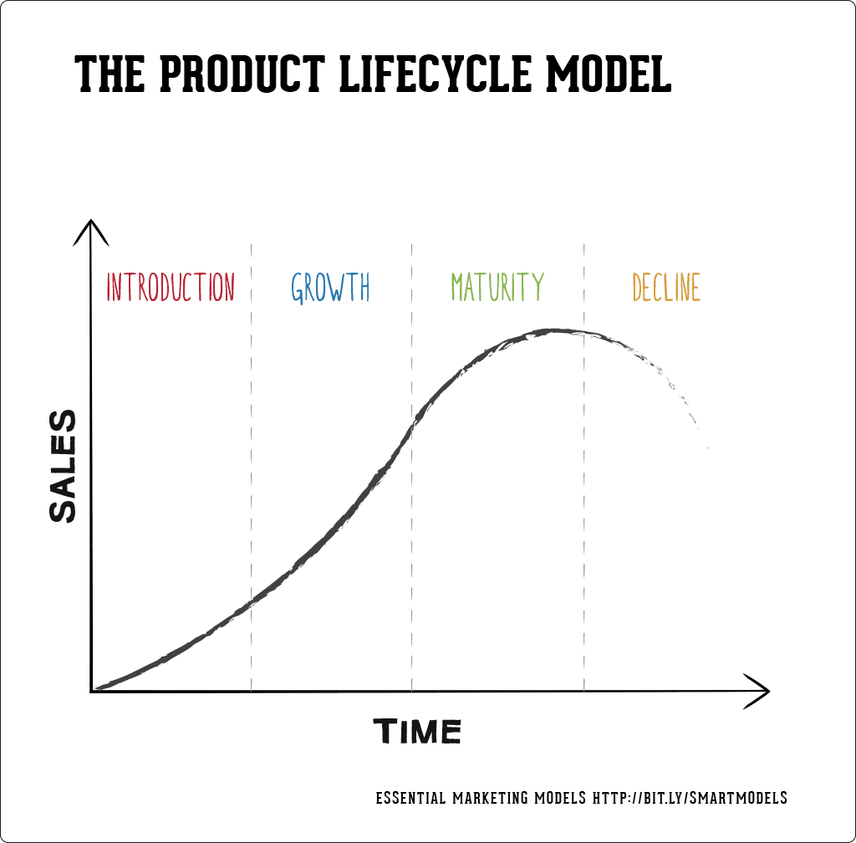

Qno2. Discuss New Product Development Process and draw its model?

Ans: 1 ) Idea generation:
• New product development start with idea generation- the systematic search for new product.
• Using internal sources, the company can find the new ideas through formal R&D.
• Company can also obtain good new product ideas from any of a number of external sources.

2 ) Idea screening
• The first reducing stage is idea screening, which helps spot good ideas and drop poor ones as soon as possible.
• Product development costs rise greatly in later stages, so the company wants to go ahead only with those product ideas that will turn into profitable products.
3 ) Concept development and testing
• Product concept
A detailed version of the new product idea stated in meaningful consumer terms.
• Concept testing
Testing new product concept with a group target consumers to find out if the concept have strong consumer appeal.

4 ) Marketing Strategy Development
• The marketing strategy statement consist of three parts.
a) The first part describe the target market; the planed value position; and the sales, market share, and profit goals the first few years.
b) The second part of market strategy statement outlines the product panned price, distribution, and marketing budget for the first year.
c) The third part of the marketing strategy statement describes the planned long run sales, profit goals, and marketing mix strategy.

5 ) Business analysis
• Business analysis involve a review of the sales, costs, and profit projection for the new product to find out whether they satisfy the company’s objectives.
• If they do, the product can move the product development stage.

6 ) Product development
• If the concept passes the business test, it moves into product development.
• Here R&D or engineering develops the product concept into a physical product.
7 ) Test marketing
• If the product passes both concept test and product test, the next step is test marketing, the stage in which the product and it’s proposed marketing program are into realistic marketing settings.

8 ) Commercialization
• Test marketing gives management the information needed to make a final decision whether to launch the new product.
• If a company goes ahead with commercialization, introducing the new product into the market, it will face high costs.
Modle:
Concept development and
testing
Idea
generation
Idea screening

Product development
Marketing
Strategy development

business analysis

commercialization
Test marketing

