IQRA NATIONAL UNIVERSITY
DEPARTMENT OF ALLIED HEALTH SCIENCES
Final-Term Examination 2020

Course Title: microbiology and pathology DPT 4th Instructor: Dr. Imran khan
Time: 6 hours Total Marks: 50

Name: Faiqa Hassan ID: 15137

Q1. What do you know about healing and repair? Explain (15)
ANSWER: Healing/Repair
Definition:
Healing: The body’s attempt after injury, at restoring normal structure and function.
Repair: it consists of a combination of regeneration and scar formation by the decomposition of collagen
It usually consists of two processes
- Tissue regeneration.
- fibrous organization (Fibrosis, also known as fibrotic scarring, is a pathological wound healing in which connective tissue replaces normal parenchymal tissue to the extent that it goes unchecked, leading to considerable tissue remodeling and the formation of permanent scar tissue)
- Regeneration: The Growth of cells and tissues to replace lost structures with restoration of normal architecture of cells.
- Organization/Fibrous repair: It is the Conversion of an inflammatory exudate into a fibrous scar. Also called healing by fibrous repair by haemostasis, inflammation, granulation tissue, etc.
Resolution: Complete disappearance of an inflammatory exudate.
Granulation tissue: Newly formed small blood vessels and fibroblasts, occurring in the early phase of repair (24-72h). There is often accompanying oedema.
Gross appearance: pink, soft, granular on the wound surface.

KEY Players:
- Cells, Macrophages, lymphocytes, platelets, endothelial cells, fibroblasts etc.
- Cytokines, growth factors, enzymes
- Extracellular matrix
EVENTS:
Scar Formation
• If there is substantial damage with loss of
the basement membrane or connective
tissue framework then:
• Fibrosis or a scar results
Repair by Fibrosis
• Angiogenesis
• Migration and proliferation of fibroblasts
• Deposition of extracellular matrix
• Organization of collagen “remodeling”
• Fibrosis – scar formation
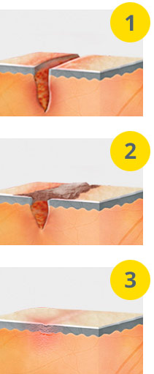
Phases of the Wound Healing Process
The wound healing process can be characterized by four overlapping phases:
- An initial response to maintain homoeostasis.
- An inflammatory response to prevent infection.
- A proliferative phase to reconstitute the wound site.
- A remodeling phase where tissue strength and function are restored.

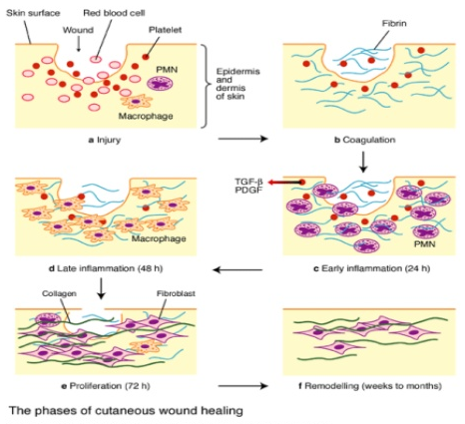

Q2. What are hemodynamic disorders? Explain any 3 (10)
ANSWER: Hemodynamic:
Definition: hemodynamics deals with flow and distribution of blood and fluids within the body.
Hemodynamic disorders:
- Hyperemia • Hyperemia is an increased volume of blood in a tissue
Types of hyperemia:
- Active hyperemia occurs due to dilation of arterioles & capillaries • exercise, inflammation, heat, digestion, menopause and due to release of a blockage.
- Passive hyperemia (congestion) occurs due to increased venous pressure that occurs with impaired outflow of blood from the area which is caused from heart failure, Deep vein thrombosis (DVT) and Hepatic vein thrombosis (HVT), also called Budd-Chiari syndrome
- Cyanosis is a bluish discoloration of the lips and skin indicating a lack of oxygen
SYMPTOMS: The main symptoms of hyperemia are:
Redness
Warmth

- Hemorrhage: Hemorrhage is the loss of blood
• In external hemorrhage blood exits the body
• In internal hemorrhage blood remains in the body
Blood may enter a body cavity
• Hemothorax is blood in thoracic cavity
• Hemoperitoneum is blood in peritoneal cavity
• Hemopericardium is blood in pericardial cavity
• Hematoma is coagulated blood in tissue (bruise)
• Petechiae is a pinpoint hemorrhage due to rupture of a capillary
• Purpura is a bruise >3mm in size
• Echymoses are larger hemorrhagic spots on skin and mucosa
• Terminology
– Hemoptysis refers to coughing up blood from lungs
– Hematemesis refers to vomiting blood from upper GI tract
– Hematochezia refers to passing bright red blood per rectum
– Melena refers to passage of dark (black) stools (UGI bleed)
– Hematuria refers to passage of blood in urine
– Metrorrhagia refers to excessive menses
• Symptoms depend on amount, site, and duration of blood loss
– Rapid loss of less than 20 % of blood volume is compensable
– Massive loss (>1500 ml) results in hypovolemia and shock
– Chronic loss results in anemia
– hemorrrhage into brain may result in herniation of the brain
- Thrombosis (clot formation)
• Blood clots in order to prevent loss of blood
– If endothelium is damaged then a “plug” is made to fill hole
• Vessel constriction, platelet plug, reinforced by fibrin
• Clotting requires platelets, endothelium, and plasma proteins
– Normally there is a balance of clot formation and clot lysis
• Thrombus is formation of clot within vessel during life
– Formation of a thrombus may cause complications
– Certain factors predispose to thrombus formation (Virchow’s triad)
• Stasis of blood (CHF, dehydration)
• Hypercoaguable states (inherited, malignancy)
• Endothelial injury (thrombogenic surface revealed)
• A thrombus has 4 major fates
– Lysis of the thrombus removal of thrombus by fibrinolysis
– Organization and recanalization replacement of the thrombus by granulation tissue and creation of new
Channels through thrombus
– Propagation is complete occlusion of a vessel with extension of the thrombus proximal in vein
– Embolus formation is detachment of a thrombus and impaction lodge distally
• Types of thrombus
– Venous
• Deep vein thrombosis
– Arterial
Q3. What is renewal and regeneration? (10)
ANSWER:
Regeneration is the proliferation of cells and tissues to replace lost tissues.
Occurs only in regenerative organs having regenerative activity.
There are some human organs and tissues that regenerate rather than simply scar, as a result of injury. These include the liver, fingertips, and endometrium. Passive replacement of tissues in the human body and stem cell are also used. 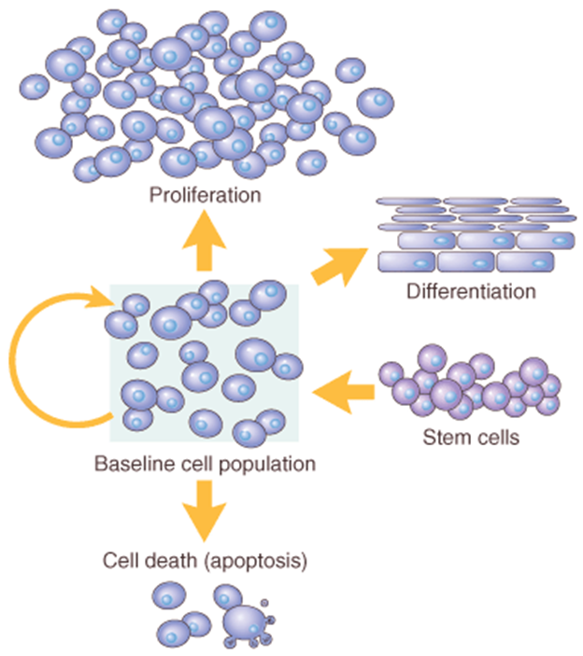
The proliferative phase can itself be divided into four phases
• Re-vascularisation: New blood vessels are formed around the wound site in order to supply the cells and nutrients required to remodel the wound.
• Granulation: Fibroblasts attracted to the wound site quickly lay down a temporary extra cellular matrix, comprised of collagen and fibronectin, upon which the epidermis can be reconstituted.
• Re-epithelialization: The exact mechanism of re-epithelialization is poorly understood. It is thought that surviving epithelial cells around the wound edge become more motile and stretch to cover the wound site. Once a continuous epidermis is formed they lose this motility and begin to divide.
• Contraction: Re-epithelization is thought to occur simultaneously with contraction, where myo-fibroblasts recruited around the wound site pull against each other to contract the size of the wound.
- Remodeling
The epidermis proliferates and returns to its normal character; fibroblasts and immune cells which were recruited to the site are degraded; and the temporary extra cellular matrix that was laid down is remodeled into a stronger, more permanent structure
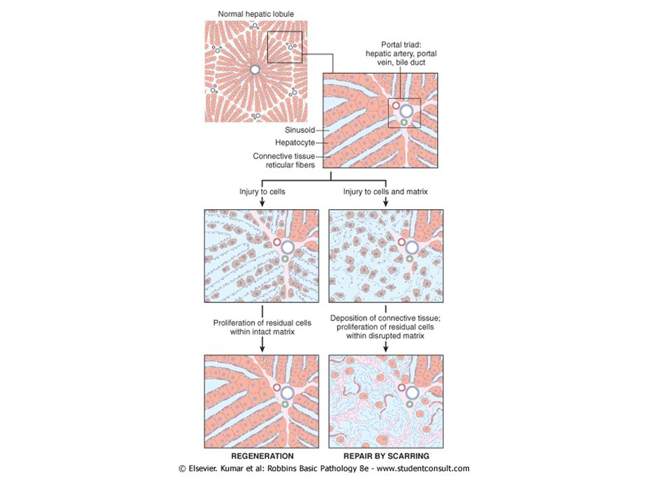

Q4. Write a detailed note on staphylococcus and streptococcus (15)
ANSWER:
- Staphylococcus is a genus of Gram-positive bacteria in the family Staphylococcaceae from the order Bacillales. Under the microscope, they appear spherical (cocci), and form in grape-like clusters. Staphylococcus species are facultative anaerobic organisms (capable of growth both aerobically and anaerobically).
Domain: Bacteria
Phylum: Firmicutes
Class: Bacilli
Order: Bacillales
Family: Staphylococcaceae
Genus: Staphylococcus
Structure: Staphylococci are Gram-positive cocci 1μm in diameter. They form clumps.
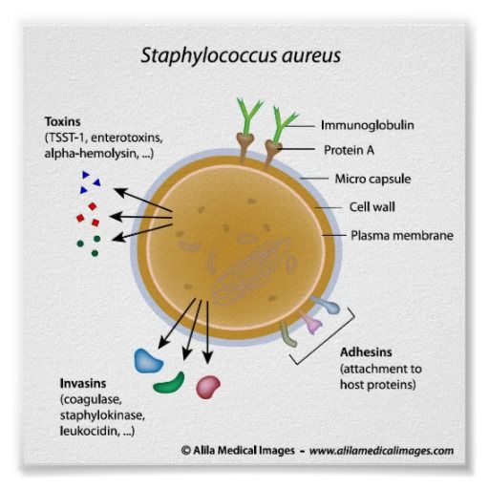
Classification: S aureus and S intermedius are coagulase positive. All other staphylococci are coagulase negative. They are salt tolerant and often hemolytic. Identification requires biotype analysis.
Natural Habitat: S aureus colonizes the nasal passage and axillae. S epidermidis is a common human skin commensal. Other species of staphylococci are infrequent human commensals. Some are commensals of other animals.
Pathogenesis: S aureus expresses many potential virulence factors.
(1) Surface proteins that promote colonization of host tissues.
(2) Factors that probably inhibit phagocytosis (capsule, immunoglobulin binding protein A).
(3) Toxins that damage host tissues and cause disease symptoms. Coagulase-negative staphylococci are normally less virulent and express fewer virulence factors. S epidermidis readily colonizes implanted devices.
Host Defenses: Phagocytosis is the major mechanism for combatting staphylococcal infection. Antibodies are produced which neutralize toxins and promote opsonization. The capsule and protein A may interfere with phagocytosis. Biofilm growth on implants is impervious to phagocytosis.
Treatment: Infections acquired outside hospitals can usually be treated with penicillinase-resistant β-lactams. Hospital acquired infection is often caused by antibiotic resistant strains and can only be treated with vancomycin.
Antibiotic Resistance: Multiple antibiotic resistance is increasingly common in S aureus and S epidermidis. Methicillin resistance is indicative of multiple resistance. Methicillin-resistant S aureus (MRSA) causes outbreaks in hospitals and can be epidemic.
Epidemiology: Epidemiological tracing of S aureus is traditionally performed by phage typing, but has limitations. Molecular typing methods are being tested experimentally.
Diagnosis: Diagnosis is based on performing tests with colonies. Tests for clumping factor, coagulase, hemolysins and thermostable deoxyribonuclease are routinely used to identify S aureus. Commercial latex agglutination tests are available. Identification of S epidermidis is confirmed by commercial biotyping kits.
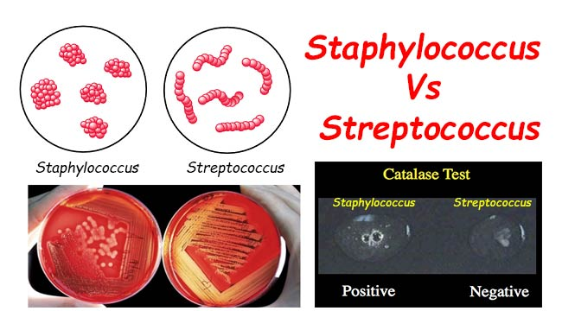
- Streptococcus is a genus of gram-positive coccus (plural cocci) or spherical bacteria that belongs to the family Streptococcaceae, within the order Lactobacillales (lactic acid bacteria), in the phylum Firmicutes. Cell division in streptococci occurs along a single axis, so as they grow, they tend to form pairs or chains that may appear bent or twisted. (Contrast with that of staphylococci, which divide along multiple axes, thereby generating irregular, grape-like clusters of cells.) Domain: Bacteria
Phylum: Firmicutes
Class: Bacilli
Order: Lactobacillales
Family: Streptococcaceae
Genus: Streptococcus
Structure: Staphylococci are Gram-positive cocci 1μm in diameter. They form clumps.
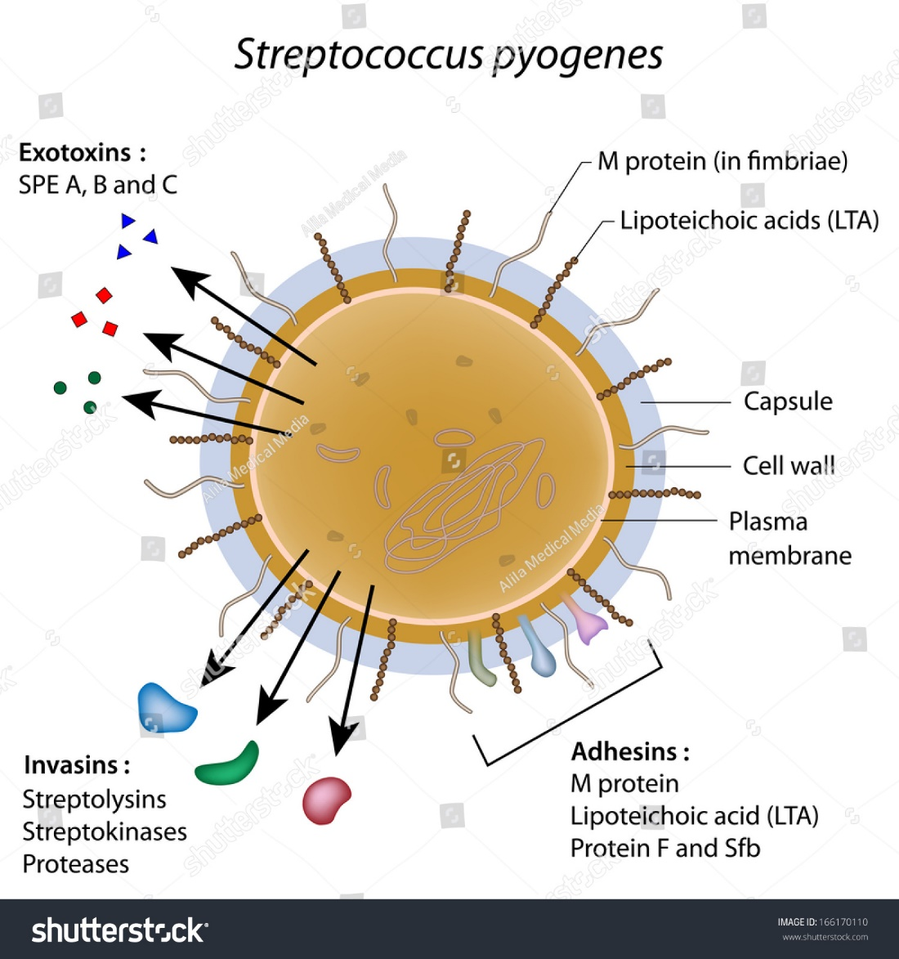
Classification: S aureus and S intermedius are coagulase positive. All other staphylococci are coagulase negative. They are salt tolerant and often hemolytic. Identification requires biotype analysis.
Natural Habitat: S aureus colonizes the nasal passage and axillae. S epidermidis is a common human skin commensal. Other species of staphylococci are infrequent human commensals. Some are commensals of other animals.
Pathogenesis: S aureus expresses many potential virulence factors.
(1) Surface proteins that promote colonization of host tissues.
(2) Factors that probably inhibit phagocytosis (capsule, immunoglobulin binding protein A).
(3) Toxins that damage host tissues and cause disease symptoms. Coagulase-negative staphylococci are normally less virulent and express fewer virulence factors. S epidermidis readily colonizes implanted devices.
Host Defenses: Phagocytosis is the major mechanism for combatting staphylococcal infection. Antibodies are produced which neutralize toxins and promote opsonization. The capsule and protein A may interfere with phagocytosis. Biofilm growth on implants is impervious to phagocytosis.
Treatment: Infections acquired outside hospitals can usually be treated with penicillinase-resistant β-lactams. Hospital acquired infection is often caused by antibiotic resistant strains and can only be treated with vancomycin.
Antibiotic Resistance: Multiple antibiotic resistance is increasingly common in S aureus and S epidermidis. Methicillin resistance is indicative of multiple resistance. Methicillin-resistant S aureus (MRSA) causes outbreaks in hospitals and can be epidemic.
Epidemiology: Epidemiological tracing of S aureus is traditionally performed by phage typing, but has limitations. Molecular typing methods are being tested experimentally.
Diagnosis: Diagnosis is based on performing tests with colonies. Tests for clumping factor, coagulase, hemolysins and thermostable deoxyribonuclease are routinely used to identify S aureus. Commercial latex agglutination tests are available. Identification of S epidermidis is confirmed by commercial biotyping kits

