Name Noman
Deportment Be civil engineering
Section. A
Roll. Number 16116
Assignment No. 1

Iranian architecture or Persian architecture (Persian: معمارى ایرانی, Memāri e Irāni) is the architecture of Iran and parts of the rest of West Asia, the Caucasus and Central Asia. Its history dates back to at least 5,000 BC with characteristic examples distributed over a vast area from Turkey and Iraq to Uzbekistan and Tajikistan, and from the Caucasus to Zanzibar. Persian buildings vary from peasant huts to tea houses, and garden pavilions to "some of the most majestic structures the world has ever seen".[2] In addition to historic gates, palaces, and mosques, the rapid growth of cities such as the capital Tehran has brought about a wave of demolition and new construction.
Iranian architecture displays great variety, both structural and aesthetic, from a variety of traditions and experience. Without sudden innovations, and despite the repeated trauma of invasions and cultural shocks, it has achieved "an individuality distinct from that of other Muslim countries".[3] Its paramount virtues are: "a marked feeling for form and scale; structural inventiveness, especially in vault and dome construction; a genius for decoration with a freedom and success not rivaled in any other architecture".[4]
Traditionally, the guiding formative motif of Iranian architecture has been its cosmic symbolism "by which man is brought into communication and participation with the powers of heaven".[5] This theme has not only given unity and continuity to the architecture of Persia, but has been a primary source of its emotional character as well.
According to American historian and archaeologist Arthur Pope, the supreme Iranian art, in the proper meaning of the word, has always been its architecture. The supremacy of architecture applies to both pre- and post-Islamic periods.[6]
Fundamental principles

Si-o-se Pol, one of the bridges of Isfahan.
Traditional Persian architecture has maintained a continuity that, although temporarily distracted by internal political conflicts or foreign invasion, nonetheless has achieved an unmistakable style.

In this architecture, "there are no trivial buildings; even garden pavilions have nobility and dignity, and the humblest caravanserais generally have charm. In expressiveness and communicativity, most Persian buildings are lucid, even eloquent. The combination of intensity and simplicity of form provides immediacy, while ornament and, often, subtle proportions reward sustained observation."[7
Zoroastrian:
The Parsian style (up until the third century BCE) including:
Pre-Parsian style (up until the eighth century BCE) e.g. Chogha Zanbil,
Median style (from the eighth to the sixth century BCE),
Achaemenid style (from the sixth to the fourth century BCE) manifesting in construction of spectacular cities used for governance and inhabitation (such as Persepolis, Susa, Ecbatana), temples made for worship and social gatherings (such as Zoroastrian temples), and mausoleums erected in honor of fallen kings (such as the Tomb of Cyrus the Great),
The Parthian style includes designs from the following eras:
Seleucid era e.g. Anahita Temple, Khorheh,
Parthian era e.g. Hatra, the royal compounds at Nysa,
Sassanid era e.g. Ghal'eh Dokhtar, the Taq-i Kisra, Bishapur, Darband (Derbent).
Islamic:
The Khorasani style (from the late 7th until the end of the 10th century CE), e.g. Jameh Mosque of Nain and Jameh Mosque of Isfahan,
The Razi style (from the 11th century to the Mongol invasion period) which includes the methods and devices of the following periods:
Samanid period, e.g. Samanid Mausoleum,
Ziyarid period, e.g. Gonbad-e Qabus,
Seljukid period, e.g. Kharraqan towers,
The Azari style (from the late 13th century to the appearance of the Safavid Dynasty in the 16th century), e.g. Soltaniyeh, Arg-i Alishah, Jameh Mosque of Varamin, Goharshad Mosque, Bibi Khanum mosque in Samarqand, tomb of Abdas-Samad, Gur-e Amir, Jameh mosque of Yazd
The Isfahani style spanning through the Safavid, Afsharid, Zand, and Qajarid dynasties starting from the 16th century onward, e.g. Chehelsotoon, Ali Qapu, Agha Bozorg Mosque, Kashan, Shah Mosque, Sheikh Lotf Allah Mosque in Naqsh-i Jahan Square.

Materials
Available building materials dictate major forms in traditional Iranian architecture. Heavy clays, readily available at various places throughout the plateau, have encouraged the development of the most primitive of all building techniques, molded mud, compressed as solidly as possible, and allowed to dry. This technique, used in Iran from ancient times, has never been completely abandoned. The abundance of heavy plastic earth, in conjunction with a tenacious lime mortar, also facilitated the development and use of brick.[9]
Geometry
Iranian architecture makes use of abundant symbolic geometry, using pure forms such as circles and squares, and plans are based on often symmetrical layouts featuring rectangular courtyards and halls.

Pre-Islamic architecture of Persia
Main articles: Achaemenid architecture and Sasanian architecture
- 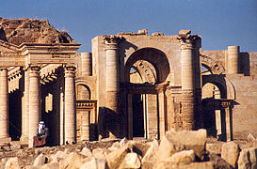
Hatra in Iraq. In the 3rd to 1st century BCE, during the Parthian Empire, Hatra was a religious and trading center. Today it is a World heritage site, protected by UNESCO.

- 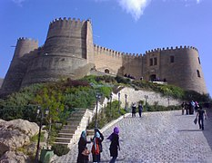
Dej-e Shapour-Khast

- 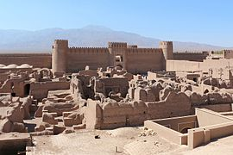
Sassanid Rayen Castle

- 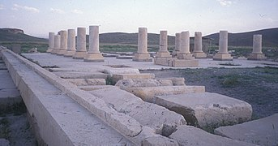
Pasargad

- 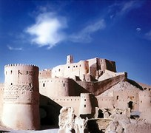
Arg-e Bam
The pre-Islamic styles draw on 3000 to 4000 years of architectural development from various civilizations of the Iranian plateau. The post-Islamic architecture of Iran in turn, draws ideas from its pre-Islamic predecessor, and has geometrical and repetitive forms, as well as surfaces that are richly decorated with glazed tiles, carved stucco, patterned brickwork, floral motifs, and calligraphy.
Iran is recognized by UNESCO as being one of the cradles of civilization.[11]
Each of the periods of Elamites, Achaemenids, Parthians and Sassanids were creators of great architecture that, over the ages, spread far and wide far to other cultures. Although Iran has suffered its share of destruction, including Alexander The Great's decision to burn Persepolis, there are sufficient remains to form a picture of its classical architecture.
The Achaemenids built on a grand scale. The artists and materials they used were brought in from practically all territories of what was then the largest state in the world. Pasargadae set the standard: its city was laid out in an extensive park with bridges, gardens, colonnaded palaces and open column pavilions. Pasargadae along with Susa and Persepolis expressed the authority of 'The King of Kings', the staircases of the latter recording in relief sculpture the vast extent of the imperial frontier.
With the emergence of the Parthians and Sassanids new forms appeared. Parthian innovations fully flowered during the Sassanid period with massive barrel-vaulted chambers, solid masonry domes and tall columns. This influence was to remain for years to come.
For example, the roundness of the city of Baghdad in the Abbasid era, points to its Persian precedents, such as Firouzabad in Fars.[12] Al-Mansur hired two designers to plan the city's design: Naubakht, a former Persian Zoroastrian who also determined that the date of the foundation of the city should be astrologically significant, and Mashallah ibn Athari, a former Jew from Khorasan.[13]
The ruins of Persepolis, Ctesiphon, Sialk, Pasargadae, Firouzabad, and Arg-é Bam give us a distant glimpse of what contributions Persians made to the art of building. The imposing Sassanid castle built at Derbent, Dagestan (now a part of Russia) is one of the most extant and living examples of splendid Sassanid Iranian architecture. Since 2003, the Sassanid castle has been listed on Russia's UNESCO World Heritage list.

