Nam.... Robeena.
iD ....16404.
Department...BS(MLT).
Paper ....Biochemistry .
Date..26/9/2020.
"""""""""""''''"""""""""""'"'''''"""""""""""""""""""""""""""""""
Question Number 2..
Answer.Glycolysis...Glycolysis comes from a merger of two Greek words.
. Glyky." Sweet
. Lysis" breakdown / splitting.
. It's is also known as Embaden- Meyerhof- of parnas - pathway or EMP pathway.
Two Phase of Glycolysis..
. Glycolysis leads to breakdown of 6-c glucose into two molecules of 3-c pyruvate with the enzyme catalyzed reaction beings bifurcated or categorised into 2 Phase.
1) phase 1- preparatory phase.
2) phase 2- payoff phase.
Preparatory Phase..
. It's consist of the 1st 5 steps of glycolysis in which the glucose is enzymeatically phosphorylated by ATP to yield Fructose- 1,6 biphosate.
. This fructure- 1,6 biphosate is then split in half to yield 2 molecule of 3- carbon containing.
.Glyceraldehyde - 3 phosphate/ dihyrixyactone phosphate .
.Thus the first phase result in cleavge of the hexose chain.
.This clevagevrequires an investment of ATP molecules to activate the glucose mole and prepare it is for its cleavge into 3-carbon compound.
PAYOFF PHASE.....
.....* This phase constitute the last 5 reaction of glycolysis .
* This phase mark the release of ATP molecules during conversion of glycolysis aldehyde 3_phosphte to 2 molecules of pyruvate.
* Hera 4 molecules of ADP are phosphate to ATP .
Step(1)... phosphate..
*Glucose is phosphate by ATP to from sugar phosphate..
* This is an irreversible reaction and is catalyzed by hexokinase .
* Thus the reaction can be rep as follows .
Step(2) isomerisation...
* It is a reversible rearrangment of chemical structure of carbonyl oxygen from c1_c2 forming a ketose from the aldose.
* Thus isomerisation of the aldose glucose 6phosphhate give the ketose Fructose 6phosphate.
Step(3) phophorylation.
* Hera the Fructose 6phyosphte is phosphorylated by ATP to Fructose - 1,6 bisohosphate.
* This as in irreversible reaction and is Catalyzed by phosphofructokinase enzymes.
Step(4) Breakdown.
* This six carbon sugar is clever to produce two 3- C molecule.Glyceradehyde- 3 phosphate ( GAP) and duhydrixyacetilone phosphate (DHAP).
* This reaction is catalyzed by aldolase.
Step (5) .Isomerisation.
* Dihydroxyactone phosphate is oxidizes to form Glyceraldehyde-3- phosphate.
* This reaction is catalyzed by triode phosphate isomerase enzymes.
Step(6).
* 2 molecule of Glyceraldehyde-3- phosphate are oxidizes.
* Glyceraldehyde-3- phospate dehydrogenase catalyzed the conversion of Glyceraldehyde3- phosphate into 1, 3 bisophosglycerate.
*""""*******""""""""*******""""""****"""""*****
Question number 3...
Answer..Digestion of Carbohydrates..
* The major source of Carbohydrates is found in plants.
* Dietary carbohydrate principally of .
* Polysaccharide..Starch ,glycogen and cellulose.
* Disaccharides.Sucrose and Maltose.
* Monosaccharides..
Glucose and fructose.
* Monosaccharides dose not neend digestion.
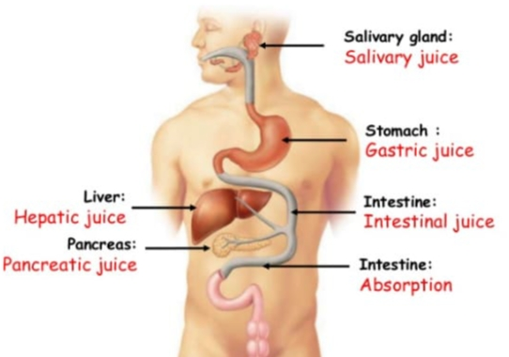

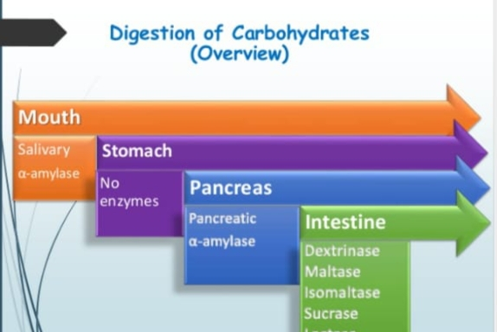

Digestion in Mouth...
* Digestion of Carbohydrates start's at the mouth.
* Mouth, food undergoes mastication.
* During mastication ,food comes in contact with saliva( secerated by salivary gland).
* Saliva contain salivary amylase( ptyalin).
Action of silivary amylase..
. It requires cl,in activation and PH 6.7.
. The enzyme hydrolyze a ( 1,4) glucoside bonds at random deep inside polysaccharides ( starch, glycogen ). Producting restrains , Maltose ,maltotriose ,glycogen.
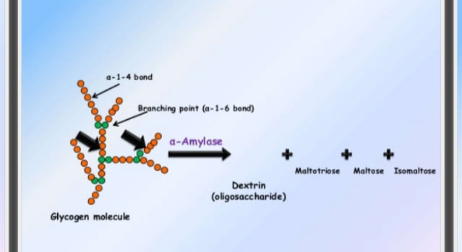
Digestion in stomach..
. Digestion of carbohydrat temporarily stopes in the stomach.
.The action of salivary amylase stops in stomach because of high acidity of stomach.
. No carbohydrate splitting enzymes available in gastric juice.
Digestion in intestine..
. Further digestion of carbohydrat occur in small intestine by pancreatic enzymes.
.Food bolus reach the small intestine form stomach where it meets the pancreatic form juice.
. Pancreatic juice contain enzyme called pancreatic amlyase similar to S, amylase.
.There are two phase of intestinal digestion.
* Digestion due to pancreatic amylase.
* Digestion due to intestinal brush border enzyme.
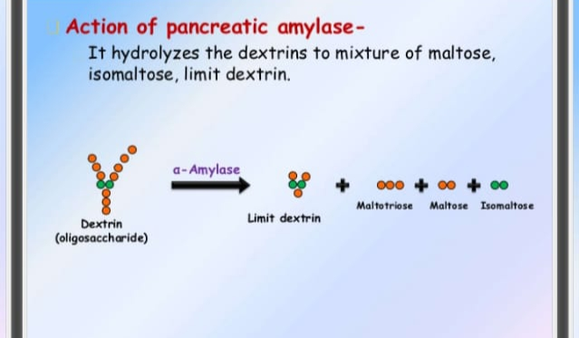
***********************************************
Question number 4...
Answer...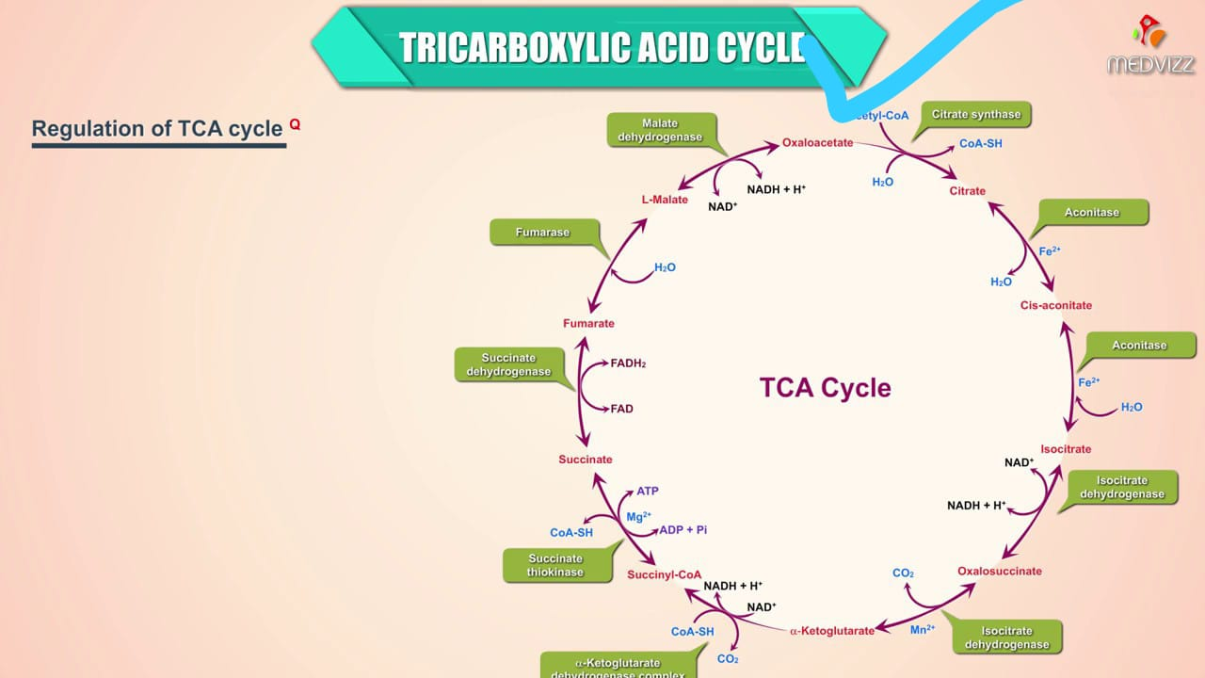
Question number 5..
Answer...Fat and Oil..
.Oils and fats belonged to a group of organic compound known as lipides.
. Oils and fats are natural occuring esters.
. Fats are found in animals.
. Oils are found in about animals and plants.
.Fats and oils are esters ( fatty acids+ glycerol).
. Fatty acids containing 12- 18 Carobn atoms per molecule.
Differents between oils and Fats...
. Fats are solids at room temperature whil oils are liquids at room temperature.
.The melting point of fats are high than the melting points of oils .
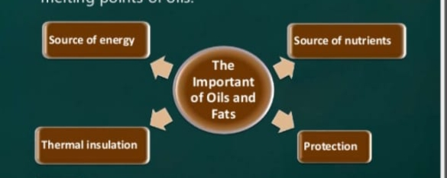
Question number 6..
Answer...Macromolecules..
The term macromolecule coined by Nobal laureate Hermine Staudinger in the 1920, although his first relevent publication on this field only mentioned high molecular compound in excess of 1000 atoms ) .At that time the phrase polymer as introduced by Berzelius in 1833 had a different meaning from that of today.
(A) Carbohydrate..
. A carbohydrate is an organic Compounds which has the term pirical formula cm( H2O))n,. That is consist only of carbon ,hydrogen and oxygen of 2:1( as in water ) . Carbohydrate can be viewed as hydrates of carbon.
(B) Monosaccharides..
. Monosaccharides ( from Greek monos: signal ,sacchar : sugar ) are the most basic units of biologically important Carbohydrate.They are the simplest from of sugar and are usually colours Les, water , soluble , crystalline solids .Some monosaccharides have a sweet taste.
(C) Disaccharide..
.A Disaccharide or bio's is the carbohydrate formed when two monosaccharides undergo a condensation reaction which involves a he elimination of a small molecules such as water from the functional groups only like Monosaccharides group Disaccharide also dissolved in water.
(D) Polysaccharides..
. Polysaccharides ideas are polymeric carbohydrate structure formed of repeating units either Mono,or Disaccharide joined together by glyosidic binds These stircture are of ten liner , branching polysaccharides are often quotes gmheterigeneius, containing slight modification of the repeating units.
**********""""""""""""*****"*"""""*****""""*****""""""""""******
Question number 7..
Answer..Amino Acids...
..They are molecule containing an amino group ,a carboxylic group , and a side chain that a specific to each amino acid.
.They elements of amino acid are carbon, hydrogen,and other nitrogen.
. Amino acids are the basic structureal buildings unit of protein and other biomolecules they are also untilzed as an energy source.
.Essential amino acids cannots be synthesized by humans..
(.we cannot contract the carbon skeleton).
.Nine if the 20 amino acids used for protein synthesis are essential they for an obligatory dietary requirements).
. Nonessential amino acids can be synthesized.
.In sufficient quantities to satisfy normal requirements assuming a sources of reduce nitrogen (-NH3)+.
.There are five nonessential Amino Acids alanine aspartate, asparagine, glutamate and serin.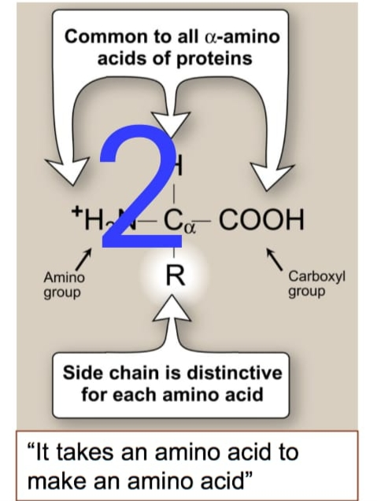
Question number 1..
Answer.Defination ..
.This as in alternativ pathway to glycolysis and TCA cycle for the oxidation of glucose . HMA shunt is more anabolic in nature and all reaction occurs in cytosol.

Other name ..
*. Phosphogluconate pathways.
* Pentos cycle
* Hexose Monophosphate pathway at shunt
* Werburg, Dickens , Lipman pathway.
Horecker,s pathway..
. Horecker pathway a secondary pathway for the oxidation of d glucose ( not occuring in skeletal muscle ) generating reducing power ( NADPH) is the cytoplasm and synthases Pentoses and a few other sugers..
Irreversible phase of HMP pathway..
.Divided into two phase oxidative and non oxidative.
* Oxidative phase.
Step 1.
* Glucose 6- phasohaote is oxidative by Glucose 6+ phosphate dehydrogenase ( G6PD) to formed 6- phosphogluconolactone.
NADP+ act as co enzymes is specific for this reaction.
.one molecule of NADPH is formed in this reaction and this is a rate limiting step.
* This reaction is irreversible.
*********""*********""""""""******"""""**************""""""""
"THE END"

