FINAL TERM
ADNAN BASHIR ID # 16010
SOCIALOGY ZAFAR ul Haq

What is child labor?
“Child labor” is generally speaking, struggle for children that difficulties them or deeds them in some technique (physically, mentally, morally or by obstructive entree to education).
It is the reason of POVERTY
Types of Poverty
- Absolute Poverty
- Relative Poverty
Absolute Poverty:
It mentions to the state of severe deprivation of basic social desires
It mentions to the measure of poverty, keeping in view the per capital intake of calories and lowest level of feeding.
Per capital income: National income/ Population
Relative Poverty:
In Relative Poverty the economic environments of different districts or countries is matched.
It is clear contextually as Economic difference in location or society in which people live.
The capital earnings and the national earnings are the two indicators of relative poverty
Peshawar:
As many as 1.5 million children are currently involved in child Labour in Khyber-Pakhtunkhwa, an Islamabad-based child honesties organization has said on the eve of the world day in contradiction of child Labour. “Of the whole number, 60,000children are below the age of 10 years.
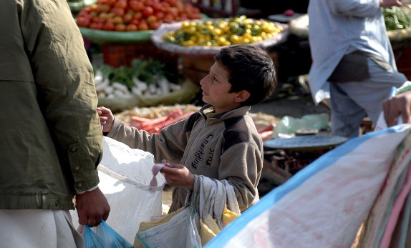
CAUSES
- The poverty is the top single cause overdue child labour. Pakistan has a per-capita income of almost $1900. A middle class person in Pakistan earns nearby $6 a day on normal. The average Pakistani has to food nine or ten people with their daily earnings. There is also a high inflation rate.
- Poverty stages look to require that children work in order to allow families to spread their target take‐home pay.
- The highest causes of child labour in the fishing area on the Baluchistan bank were the low quality of education, want of job scenes, and lack of movement in the region.
ISSUE
All over the world, children are being broken through child labour. This emotionally and physically dangerous work affects with schooling and long-term development the worst forms contain slavery, trafficking, sexual corruption and hazardous work that placed children at risk of death, injury or disease.
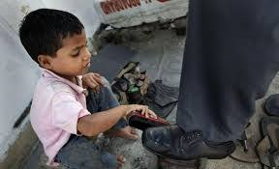
Impacts
Child labour includes working children under a certain minimum age. This repetition is going on since long and is one of the nastiest forms of child use. Child labour not only causes harm to a child's physical and emotional health but also removes him of his basic right to education, growth and liberty.
