Final-Term Assignment (Summer-2020) (BS-MLT)

Course Title: Biotechnology Instructor: Mr. Fazli Zahir Mian
S;Name JAMAL KHAN ID 13363

Q1: Write short notes on the following.
PCR Technical Workflow

DNA Extraction

Sampling PCR Data Analysis

RNA Extraction DNase Treatment Reverse Transcription

Gene Probe
Genetic Probes is a fragment of DNA or RNA of variable length (usually 100-1000 bases long) which is radioactively labeled used in DNA or RNA samples to detect the presence of nucleotide sequences (the DNA target) that are complementary to the sequence in the probe.

Genomic Library
A genomic library is a collection of bacteria which have been genetically engineered to hold the entire DNA of an organism.A genomic library is a collection of genes or DNA sequences created using molecular cloning.These libraries are constructed using clones of bacteria or yeast that contain vectors into which fragments of partially digested DNA have been inserted.
Killed And Attenuated Vaccine
Killed Vaccine
When it is unsafe to use live microorganisms to prepare vaccines, they are killed or inactivated.
These are preparations of the normal (wild type) infectious, pathogenic microorganisms that have been nonpathogenic, usually by treatment with using heat so that they cannot replicate at all.
Attenuated Vaccine
Attenuation (bacterial or viral represents the process of eliminatio or greatly reducing the virulence of a pathogen.
Q2: What is restriction endonuclease? Write in detail the practical uses of restriction endonucleases.
Restriction Endonuclease;
Restriction endonucleases (also called as molecular scissors) are a class of nuclease enzymes which cut the DNA strand at precise locations.
They are specific endonuclease enzymes in the cells which first recognize the specific sequence (called restriction sites) within the DNA strand and cleave the phospho-diester backbone of the DNA at specific sites.
Restriction enzymes are now an inevitable tool for the manipulation of DNA in various recombination studies both in vitro and in vivo.
Uses Of Restriction Endonucleases.
The main applications/uses of restriction enzymes are:

Construction of Restriction Maps
Restriction map: a diagram or map of DNA molecule of an organism that shows specific sites of cleavage (restriction sites).
Construction of restriction maps was one of the first described uses of restriction enzymes.
Restriction maps are used to identify the fragments of DNA which contain specific genes.
Restriction maps are also design and engineer cloning vectors and plasmids.
Construction of DNA Fingerprints
DNA fingerprinting is a forensic technique used to identify individuals based on the variations in their DNA sequences.
Many methods are now available for DNA fingerprinting and the most accurate one is DNA sequencing based methods.
Restriction Enzymes also can be used to construct DNA fingerprints.
The principle of DNA fingerprinting is that the different strains or species of DNA sample will have slightly different restriction maps.
This difference in the restriction maps is because of their difference in the DNA sequences.
Recombinant DNA Technology (rDNA Technology)
The first recombinant DNA was produced by Stanley N. Cohen and Herbert Boyer in 1973. in their experiment, they combined two plasmids; pSC-101 and pSC-102 and the newly created recombined DNA were incorporated into E. co/i.
The pSC-101 contains the gene for tetracycline resistance.
The pSC-102 contains the gene for kanamycin resistance.
The transformed bacteria after recombination show resistance to both these antibiotics. Many diverse techniques are now available in recombinant DNA technology.

Q3: Discuss in detail different types of DNA Sequencing methods.
Sanger Sequencing
Researchers choose Sanger sequencing when performing low-throughput, targeted, or short-read sequencing. Due to its sensitivity and relative simplicity in terms of both workflow and technique, Sanger sequencing remains the gold standard in sequencing technology today and is used in a variety of applications from targeted seqencing to confirming variants identified using orthogonal methods.
Sanger sequencing utilizes a chain-termination method to provide the identity and order of nucleotide bases in a given strand of DNA. This method makes use of chemical analogues of the four nucleotide bases. These analogues, called ddNTPs, are missing the hydroxyl group that is required for extension of the polynucleotide chains that form the DNA molecule. By mixing radiolabeled ddNTPs with template DNA, strands of each possible length are produced when the ddNTPs get randomly incorporated, terminating the chain.
By the mid-1990s, researchers were performing Sanger sequencing using capillary electrophoresis. With this technology, the labeled DNA fragments are separated by size in long, thin, acrylic-fiber capillaries filled with a gel matrix. A sample containing the labeled fragments is injected electrokinetically into the capillary, and an electric field is applied to draw the fragments upward. As they pass a detection laser inside the instrument, the labels are detected, and the sequence is determined
Next-Generation Sequencing (NGS)
While a number of improvements have been made to Sanger sequencing over the years, new high-throughput techniques have also arisen, termed next-generation sequencing (NGS) technologies. NGS is conducted in a massively parallel fashio
The spectrum of analysis of NGS can extend from a small number of genes to an entire genome, depending on the goal. Whole-genome sequencing (WGS) and whole-exome sequencing (WES) provide the sequence of DNA bases across the genome and exome, respectively. Whole-transcriptome sequencing provides sequence information about coding and multiple noncoding forms of RNA to assess variations and gene expression levels across the entire transcriptome. Targeted sequencing covers a relatively small set of genes or targeted regions of interest. The fast turnaround time, low cost, low sample input requirement, and relative ease of interpretation make targeted sequencing particularly well suited for both translational and clinical research applications. Sanger sequencing is often used to confirm variants identified by NGS.

Q4: Suppose if you are working in a forensic lab and there is a case of parental matching, how will you isolate DNA from baby and parents?
Basic Steps For DNA Extraction
- Breaking the cells open, commonly referred to as cell disruption or cell lysis, to expose the DNA within. This is commonly achieved by grinding, sonicating or treating the sample with lysis buffer .
- Removing membrane lipids by adding a detergent.

- Removing proteins by adding a protease (optional but almost always done).
- Precipitating the DNA with an alcohol — usually ice-cold ethanol or isopropanol. Since DNA is insoluble in these alcohols, it will aggregate together, giving a pellet upon centrifugation. This step also removes alcohol-soluble salt.

Q5: Explain the Restriction modification System (RM-System) with diagram.
Restriction Modification System
Phage (or viruses) invade all types of cells. Bacteria are one favorite target. Defense mechanisms have been developed by bacteria to defend themselves from these invasions. The system they possess for this defense is the restriction-modificiation system. This system is composed of a restriction endonuclease enzyme and a methylase
enzyme and each bacterial species and strain has their own combination of restriction and methylating enzymes.
Restriction enzyme - an enzyme that cuts DNA at internal phosphodiester bonds; different types exist and the most useful ones for molecular biology (Type II) are those which cleave at a specific DNA sequence
Methylase - an enzyme that adds a methyl group to a molecule; in restriction-modification systems of bacteria a methyl group is added to DNA at a specific site to protect the site from restriction endonuclease cleavage
(RM-System) diagram.
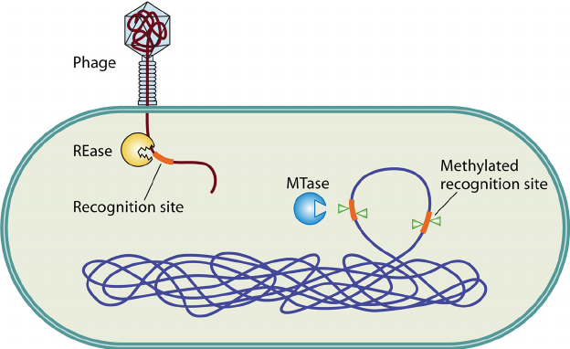

____________________________________________________________________________
Good luck.

