IQRA NATIONAL UNIVERSITY
NAME : Hidayatullah khan
ID: 14311
DEP: BS(SE)
SUBJECT: Object Oriented Software Engineering
SEMESTER: 5TH

Question #1:
An ATM machine can be used for Money Withdrawal and getting Mini Account statement. Make a State Machine Diagram for these two cases?

ANSWER:
- (Case A) cash withdrawal:

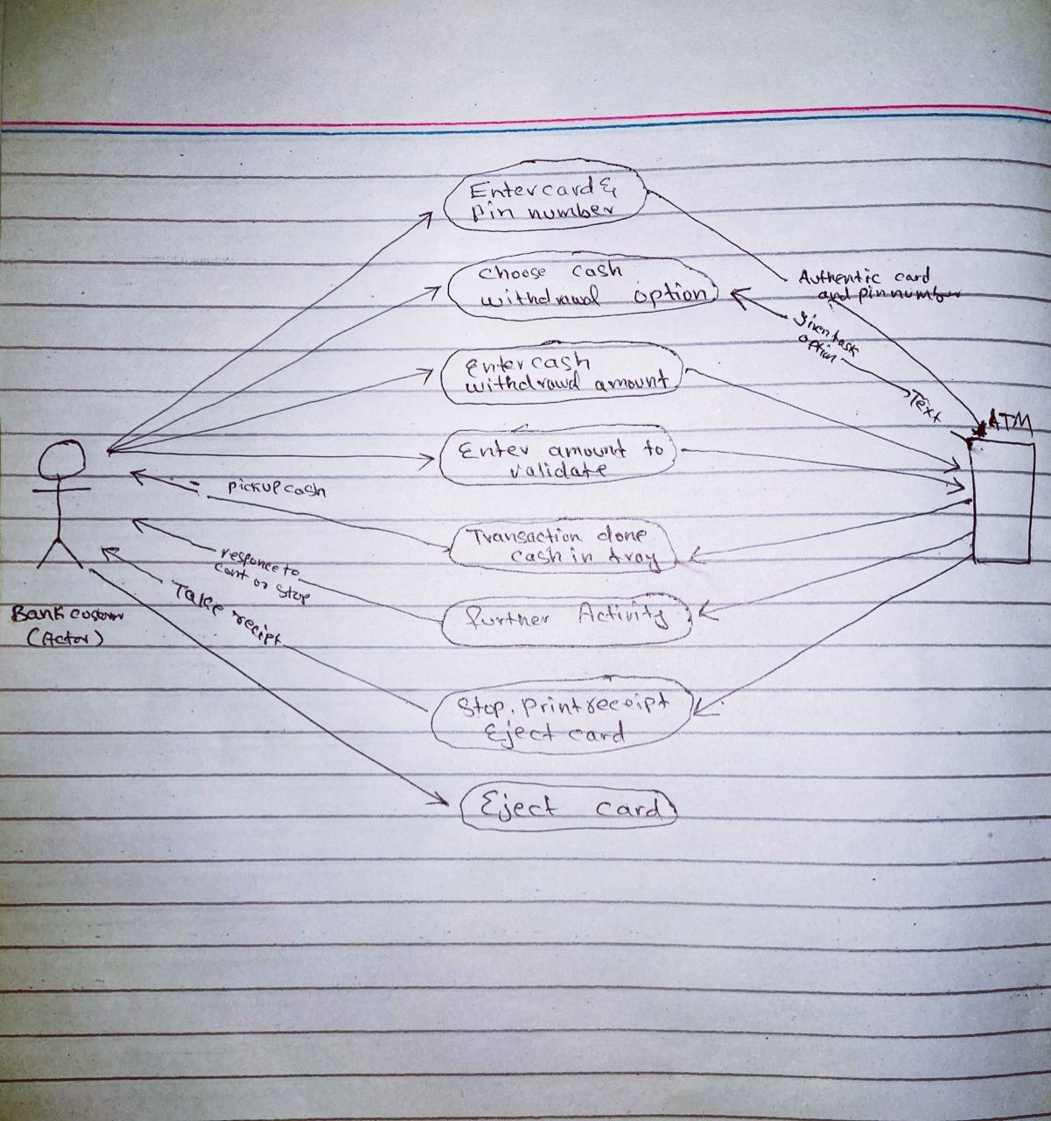

- (Case B) Getting mini Account statement.

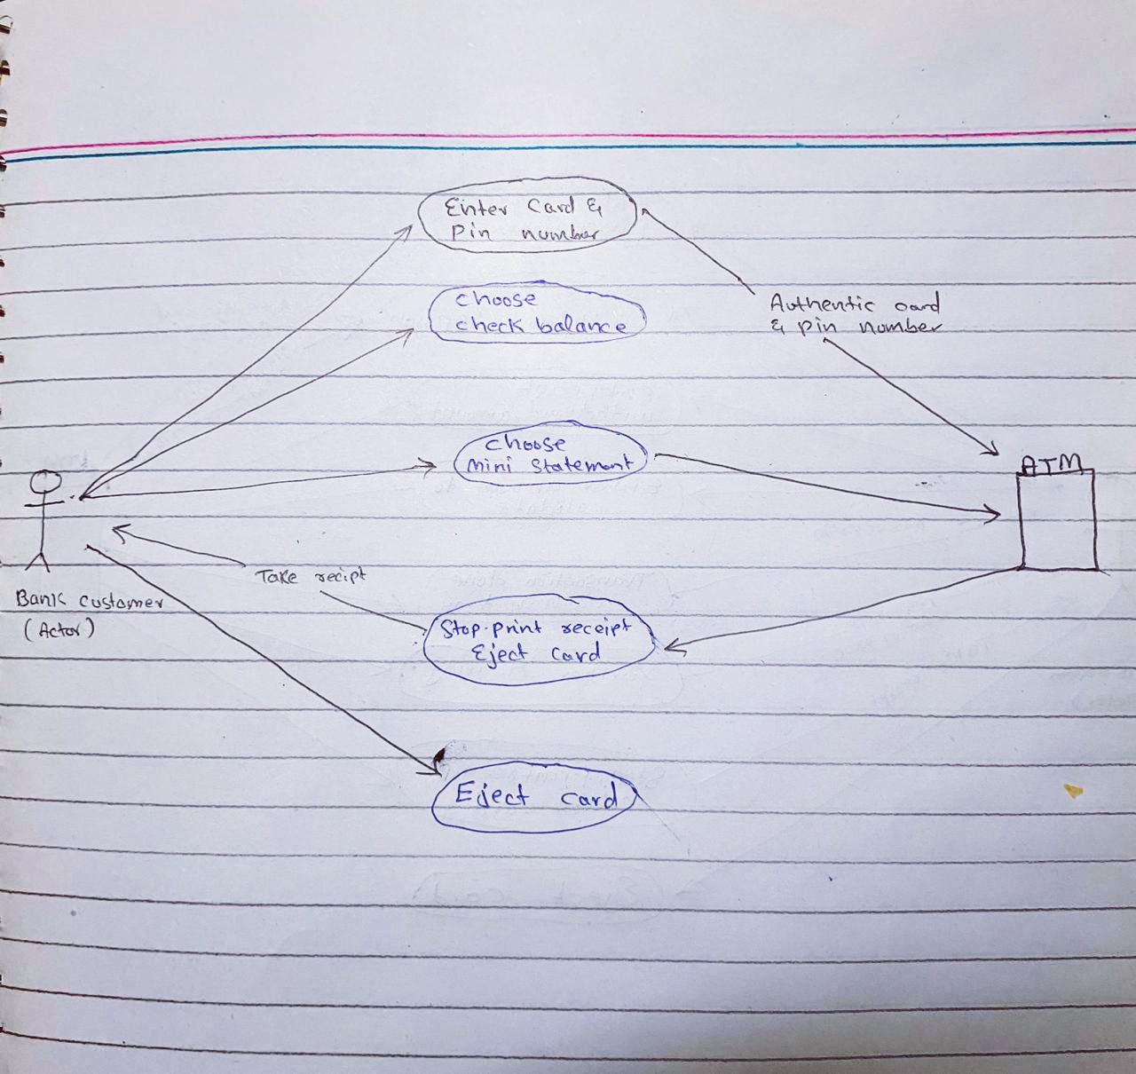

Question #2:
You have to make a personalized software for a consultancy firm. Some components of the software are those for which you already have code. Some parts of the software are such that you can find ready-to-be-used code from internet. If you want to embed both types of code into your product, and complete the software by coding the remaining part, what can you expect during this whole process? Will it be easy or hard? What problems you might face and how will you overcome those problems?

ANSWER:
Embed codes in software for consultancy firm:
Now a days complete coding is difficult for us to write. Most of codes (ready to be used) are available on internet which help us saves our time. Main thing in software is logic or idea. Compiler will point out Syntax error due to which downloaded code can be easily implement in our project. There is also a chance of logical error which are difficult to remove. If logical error occurred our software will not work.
If we embed code from internet we must know about the inputs in code we will assign those inputs which we created in our code and similarly the output of downloaded code will be assign to our output variables or resource.
Problems in Downloaded code:
- Syntax error can easily be detect by compiler.
- logical error difficult to find compiler unable to find and removed by human thinking.
- find input variables or way of giving input to code.
- find output variables or way of receiving.

Question #3:
- What is the difference between a Task and a Work Product? Explain in your own words and give an example of each?
ANSWER:
Work product:
- Work Product is management term used to describe different parts of the same project.
- A work product includes the beginning stages of a project, proposals, agendas, reports, analysis and information on the project.
- A work product may begin as an analysis made during the development of a project, creating a type of proposal for the project that a company cannot deliver until the project has received approval.
- A work product is a “concrete result of a planned project-related activity such as analysis or project management. Work products include items delivered to the customer and items used purely internally within a project.”
- Types of information available in a work product might include prototypes, presentations, recorded discussions, diagrams and status reports.
Examples of Work Products for the TicketDistributor Project:

Work Product | Type
Operation Manual | Deliverable
Specification | Deliverable
Status Report | Internal work product
Test Manual | Internal work product

Task:
- A task is a simple thing that you can do in one session. A task might be labeling your products or making a single item.
- Task is some duty which is assing to a spefic person for specific time.In task you will not get any clue.you will have to solve your problems by yourself.
Examples of Tasks for the TicketDistributor Project:
- Develop "Out of Change"
test case for TicketDistributor
- Review "Access Online
Help" use case for usability

Question no 3:
- You are working on coding of a software in which a lot of calculations are involved. The calculations are quite easy to be done, but you do expect some inconsistency in the calculations because of some inner problem with the software. Would you rather go for Fault Avoidance technique or Fault Detection technique in the Testing Phase? Explain your Answer.

ANSWER:
In testing phase we perform different types of testing. We check small error and fix these errors. It does not matter how many calculations occur but we must verify the error and remove any in consistency exist. Clients believe on software quality assurance which means that client received error free software.

Inconsistency will be check in functional testing.
- In unit testing if any error occur we will remove in this phase.
- If any error occur in integration test we will check all the connections of unit testing. Which unit is providing false information to next unit?
- System testing may also occur in consistency if any input read by hardware i.e barcode etc are incorrect will also result in inconsistency. So we must provide accurate hardware.
- After all of that error fixing we will check the Acceptance testing. Is our software in consistent or not. If result driven correctly we will implement otherwise the testing will be revised.

Question no 3:
- There are different types of testing. State which techniques are performed by the developer and which of them are performed by the client.

Answer:
Types of Software Testing:
Software testing is generally classified into two main broad categories:
- functional testing
- non-functional testing.
Functional Testing:
The functional testing part of a testing methodology is typically broken down into four components - unit testing, integration testing, system testing and acceptance testing
- Unit Testing:
is a type of testing that is performed by software developers. Unit testing follows white box testing approach where a developer will test units of source code like statements, branches, functions, methods, interface.
- Integration Testing:
Integration testing is one of the most common and important types of software testing. Once the individual units or components are tested by developers as working then testing team will run tests that will test the connectivity among these units/component or multiple units/components.
- System Testing:
The system testing part of a testing methodology involves testing the entire system for errors and bugs. This test is carried out by interfacing the hardware and software components of the entire system (that have been previously unit tested and integration tested), and then testing it as a whole.
- Acceptance Testing:
Acceptance testing is a formal type of software testing that is performed by end user when the features have been delivered by developers.
Non functional testing:
- Usability Testing:
The usability testing part of a testing methodology looks at the end-user usability aspect of the software. The ease with which a user can access the product forms the main testing point.
- Compatibility testing:
Compatibility tests check that the product works as expected across all the different hardware/software combinations and that all functionality is consistently supported.
- performance testing:
performance testing is measuring how a system behaves under an increasing load.
- Security testing:
Security testing tests the software for confidentiality, integrity, authentication, availability, and non-repudiation.

