Name: Ahmad Ali
ID NO: 13473
Degree: BS (SE)
Subject: Data Mining
Lecturer: Mr.Zain shaukat

Q1. Implement a code of Genetic Algorithm in any language and show the output.
Answer
// C++ program to create target string, starting from
// random string using Genetic Algorithm

#include <bits/stdc++.h>
using namespace std;

// Number of individuals in each generation
#define POPULATION_SIZE 100

// Valid Genes
const string GENES = "abcdefghijklmnopqrstuvwxyzABCDEFGHIJKLMNOP"\
"QRSTUVWXYZ 1234567890, .-;:_!\"#%&/()=?@${[]}";

// Target string to be generated
const string TARGET = "I love GeeksforGeeks";

// Function to generate random numbers in given range
int random_num(int start, int end)
{
int range = (end-start)+1;
int random_int = start+(rand()%range);
return random_int;
}

// Create random genes for mutation
char mutated_genes()
{
int len = GENES.size();
int r = random_num(0, len-1);
return GENES[r];
}

// create chromosome or string of genes
string create_gnome()
{
int len = TARGET.size();
string gnome = "";
for(int i = 0;i<len;i++)
gnome += mutated_genes();
return gnome;
}

// Class representing individual in population
class Individual
{
public:
string chromosome;
int fitness;
Individual(string chromosome);
Individual mate(Individual parent2);
int cal_fitness();
};

Individual::Individual(string chromosome)
{
this->chromosome = chromosome;
fitness = cal_fitness();
};

// Perform mating and produce new offspring
Individual Individual::mate(Individual par2)
{
// chromosome for offspring
string child_chromosome = "";

int len = chromosome.size();
for(int i = 0;i<len;i++)
{
// random probability
float p = random_num(0, 100)/100;

// if prob is less than 0.45, insert gene
// from parent 1
if(p < 0.45)
child_chromosome += chromosome[i];

// if prob is between 0.45 and 0.90, insert
// gene from parent 2
else if(p < 0.90)
child_chromosome += par2.chromosome[i];

// otherwise insert random gene(mutate),
// for maintaining diversity
else
child_chromosome += mutated_genes();
}

// create new Individual(offspring) using
// generated chromosome for offspring
return Individual(child_chromosome);
};

// Calculate fittness score, it is the number of
// characters in string which differ from target
// string.
int Individual::cal_fitness()
{
int len = TARGET.size();
int fitness = 0;
for(int i = 0;i<len;i++)
{
if(chromosome[i] != TARGET[i])
fitness++;
}
return fitness;
};

// Overloading < operator
bool operator<(const Individual &ind1, const Individual &ind2)
{
return ind1.fitness < ind2.fitness;
}

// Driver code
int main()
{
srand((unsigned)(time(0)));

// current generation
int generation = 0;

vector<Individual> population;
bool found = false;

// create initial population
for(int i = 0;i<POPULATION_SIZE;i++)
{
string gnome = create_gnome();
population.push_back(Individual(gnome));
}

while(! found)
{
// sort the population in increasing order of fitness score
sort(population.begin(), population.end());

// if the individual having lowest fitness score ie.
// 0 then we know that we have reached to the target
// and break the loop
if(population[0].fitness <= 0)
{
found = true;
break;
}

// Otherwise generate new offsprings for new generation
vector<Individual> new_generation;

// Perform Elitism, that mean 10% of fittest population
// goes to the next generation
int s = (10*POPULATION_SIZE)/100;
for(int i = 0;i<s;i++)
new_generation.push_back(population[i]);

// From 50% of fittest population, Individuals
// will mate to produce offspring
s = (90*POPULATION_SIZE)/100;
for(int i = 0;i<s;i++)
{
int len = population.size();
int r = random_num(0, 50);
Individual parent1 = population[r];
r = random_num(0, 50);
Individual parent2 = population[r];
Individual offspring = parent1.mate(parent2);
new_generation.push_back(offspring);
}
population = new_generation;
cout<< "Generation: " << generation << "\t";
cout<< "String: "<< population[0].chromosome <<"\t";
cout<< "Fitness: "<< population[0].fitness << "\n";

generation++;
}
cout<< "Generation: " << generation << "\t";
cout<< "String: "<< population[0].chromosome <<"\t";
cout<< "Fitness: "<< population[0].fitness << "\n";
OUTPUT
Generation: 1 String: tO{"-?=jH[k8=B4]Oe@} Fitness: 18
Generation: 2 String: tO{"-?=jH[k8=B4]Oe@} Fitness: 18
Generation: 3 String: .#lRWf9k_Ifslw #O$k_ Fitness: 17
Generation: 4 String: .-1Rq?9mHqk3Wo]3rek_ Fitness: 16
Generation: 5 String: .-1Rq?9mHqk3Wo]3rek_ Fitness: 16
Generation: 6 String: A#ldW) #lIkslw cVek) Fitness: 14
Generation: 7 String: A#ldW) #lIkslw cVek) Fitness: 14
Generation: 8 String: (, o x _x%Rs=, 6Peek3 Fitness: 13
.
.
.
Generation: 29 String: I lope Geeks#o, Geeks Fitness: 3
Generation: 30 String: I loMe GeeksfoBGeeks Fitness: 2
Generation: 31 String: I love Geeksfo0Geeks Fitness: 1
Generation: 32 String: I love Geeksfo0Geeks Fitness: 1
Generation: 33 String: I love Geeksfo0Geeks Fitness: 1
Generation: 34 String: I love GeeksforGeeks Fitness: 0

Q2. Implement a code of Fuzzy logic in any language and show the output.
Ans No 2:
To implement a fuzzy system in C, the following types of data must be accommodated:
- System inputs.
- Input membership functions.
- Antecedent values.
- Rules.
- Rule-output strengths.
- Output membership functions.
- System outputs.
Listing One includes the C-code definition of these data structures:
/*CODE is about General-purpose fuzzy inference engine supporting any number of system
inputs and outputs, membership functions, and rules. Membership functions can
be any shape defineable by 2 points and 2 slopes--trapezoids, triangles,
rectanlges, etc. Rules can have any number of antecedents and outputs, and can
vary from rule to rule. "Min" method is used to compute rule strength, "Max"
for applying rule strengths, "Center-of-Gravity" for defuzzification. This
implementation of Inverted Pendulum control problem has: System Inputs, 2
(pendulum angle and velocity); System Outputs, 1 (force supplied to base of
pendulum); Membership Functions, 7 per system input/output; Rules, 15 (each
with 2 antecedents & 1 output). If more precision is required, integers can
be changed to real numbers.*/

#include <stdio.h>
#define MAXNAME 10 /* max number of characters in names */
#define UPPER_LIMIT 255 /* max number assigned as degree of membership */

/* io_type structure builds a list of system inputs and a list of system
outputs. After initialization, these lists are fixed, except for value field
which is updated on every inference pass. */
struct io_type{
char name[MAXNAME]; /* name of system input/output */
int value; /* value of system input/output */
struct mf_type /* list of membership functions for */
*membership_functions; /* this system input/output */
struct io_type *next; /* pointer to next input/output */
};
/* Membership functions are associated with each system input and output. */
struct mf_type{
char name[MAXNAME]; /* name of membership function (fuzzy set) */
int value; /* degree of membership or output strength */
int point1; /* leftmost x-axis point of mem. function */
int point2; /* rightmost x-axis point of mem. function */
int slope1; /* slope of left side of membership function */
int slope2; /* slope of right side of membership function */
struct mf_type *next; /* pointer to next membership function */
};
/* Each rule has an if side and a then side. Elements making up if side are
pointers to antecedent values inside mf_type structure. Elements making up then
side of rule are pointers to output strength values, also inside mf_type
structure. Each rule structure contains a pointer to next rule in rule base. */
struct rule_element_type{
int *value; /* pointer to antecedent/output strength value */
struct rule_element_type *next; /* next antecedent/output element in rule */
};
struct rule_type{
struct rule_element_type *if_side; /* list of antecedents in rule */
struct rule_element_type *then_side; /* list of outputs in rule */
struct rule_type *next; /* next rule in rule base */
};
struct rule_type *Rule_Base; /* list of all rules in rule base */

Listing Two:
main()
{
initialize_system();
while(1){
get_system_inputs();
fuzzification();
rule_evaluation();
defuzzification();
put_system_outputs();
}
}

Listing Three:
/* Fuzzification--Degree of membership value is calculated for each membership
function of each system input. Values correspond to antecedents in rules. */
fuzzification()
{
struct io_type *si; /* system input pointer */
struct mf_type *mf; /* membership function pointer */
for(si=System_Inputs; si != NULL; si=si->next)
for(mf=si->membership_functions; mf != NULL; mf=mf->next)
compute_degree_of_membership(mf,si->value);
}
/* Rule Evaluation--Each rule consists of a list of pointers to antecedents
(if side), list of pointers to outputs (then side), and pointer to next rule
in rule base. When a rule is evaluated, its antecedents are ANDed together,
using a minimum function, to form strength of rule. Then strength is applied
to each of listed rule outputs. If an output has already been assigned a rule
strength, during current inference pass, a maximum function is used to
determine which strength should apply. */
rule_evaluation()
{
struct rule_type *rule;
struct rule_element_type *ip; /* pointer of antecedents (if-parts) */
struct rule_element_type *tp; /* pointer to consequences (then-parts) */
int strength; /* strength of rule currently being evaluated */
for(rule=Rule_Base; rule != NULL; rule=rule->next){
strength = UPPER_LIMIT; /* max rule strength allowed */
/* process if-side of rule to determine strength */
for(ip=rule->if_side; ip != NULL; ip=ip->next)
strength = min(strength,*(ip->value));
/* process then-side of rule to apply strength */
for(tp=rule->then_side; tp != NULL; tp=tp->next)
*(tp->value) = max(strength,*(tp->value));
}
}
/* Defuzzification */
defuzzification()
{
struct io_type *so; /* system output pointer */
struct mf_type *mf; /* output membership function pointer */
int sum_of_products; /* sum of products of area & centroid */
int sum_of_areas; /* sum of shortend trapezoid area */
int area;
int centroid;
/* compute a defuzzified value for each system output */
for(so=System_Outputs; so != NULL; so=so->next){
sum_of_products = 0;
sum_of_areas = 0;
for(mf=so->membership_functions; mf != NULL; mf=mf->next){
area = compute_area_of_trapezoid(mf);
centroid = mf->point1 + (mf->point2 - mf->point1)/2;
sum_of_products += area * centroid;
sum_of_areas += area;
}
so->value = sum_of_products/sum_of_areas; /* weighted average */
}}
Q3. Solve this using KNN.
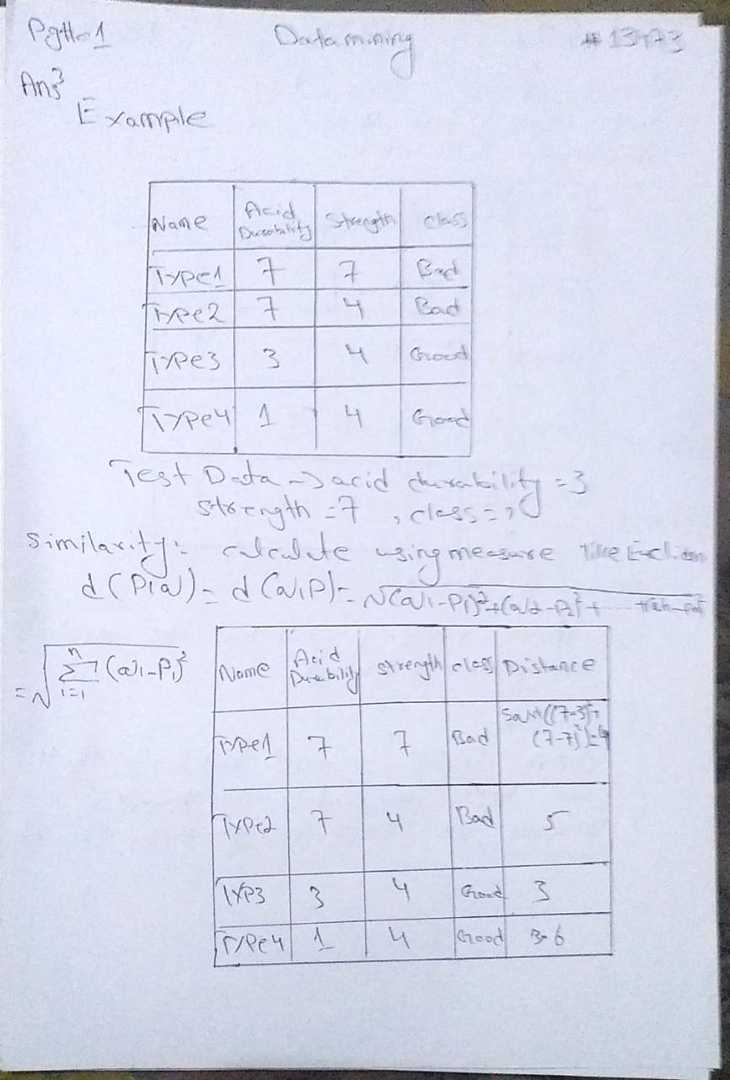
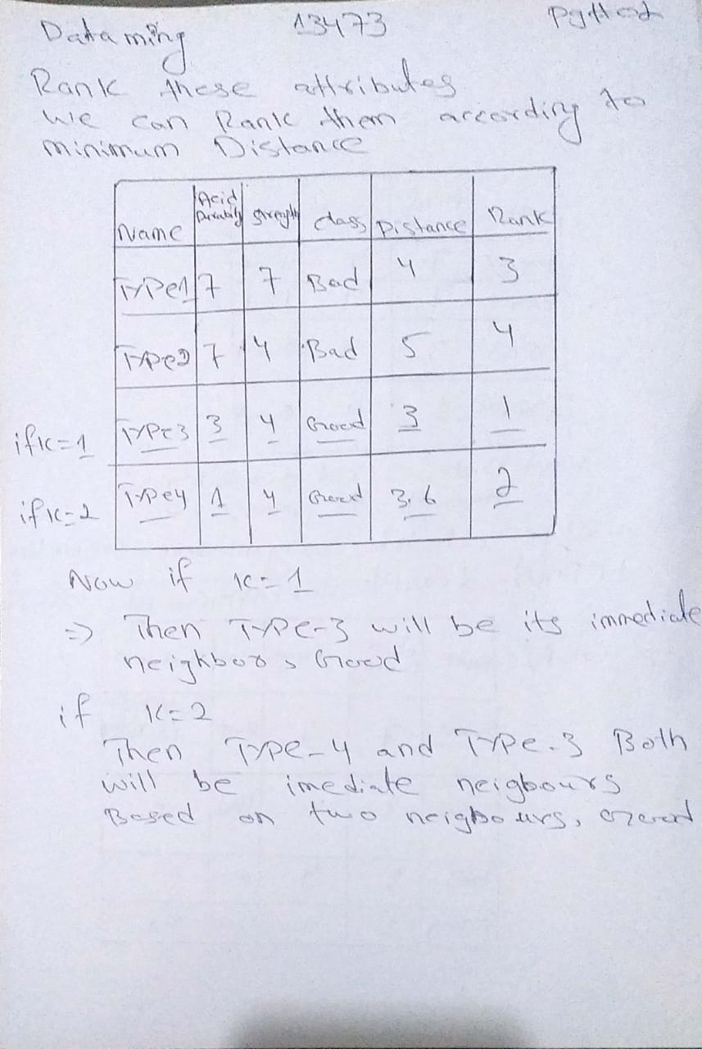
Q4. Give solved example of hierarchical Clustering.
Objective : For the one dimensional data set {7,10,20,28,35}, perform hierarchical clustering and plot the dendogram to visualize it.
Solution: First, let’s visualize the data.
Observing the plot above, we can intuitively conclude that:
- The first two points (7 and 10) are close to each other and should be in the same cluster
- Also, the last two points (28 and 35) are close to each other and should be in the same cluster
- Cluster of the center point (20) is not easy to conclude
Let’s solve the problem by hand using both the types of agglomerative hierarchical clustering :
- Single Linkage : In single link hierarchical clustering, we merge in each step the two clusters, whose two closest members have the smallest distance.
Using single linkage two clusters are formed :
Cluster 1 : (7,10)
Cluster 2 : (20,28,35)
- Complete Linkage : In complete link hierarchical clustering, we merge in the members of the clusters in each step, which provide the smallest maximum pairwise distance.
Using complete linkage two clusters are formed :
Cluster 1 : (7,10,20)
Cluster 2 : (28,35)
Conclusion : Hierarchical clustering is mostly used when the application requires a hierarchy, e.g creation of a taxonomy. However, they are expensive in terms of their computational and storage requirements

