**Final Term Assignment**

**Spring Semester, Date: 25/June/2020**

**Course Title: INTRODUCTION TO ICT**

**Dr Atif Ishtiaq**

**Total Marks: 50 ID#16975**

**Note: Attempt all Questions. Time Allowed: 06 hours**

**Q1) What are the relation between hardware and software. And types of software with Logical system architecture. (10marks)**

**Computer hardware;** includes the physical parts of a **computer**, such as the case, central processing unit (CPU), monitor, mouse, keyboard, **computer** data storage, graphics card, sound card, speakers and motherboard. By contrast, software is the set of instructions that can be stored and run by **hardware**.

**Computer software;** Software is a program that enables a **computer** to perform a specific task, as opposed to the physical components of the system (hardware). ... **Computer software** has to be "loaded" into the **computer's** storage (such as a hard drive, memory, or RAM).

**Difference between Hardware and Software:**

| **HARDWARE** | **SOFTWARE** |
| --- | --- |
| Hardware is a physical parts computer that causes processing of data. | Software is a set of instruction that tells a computer exactly what to do. |
| It is manufactured. | It is developed and engineered. |
| Hardware cannot perform any task without software. | Software cannot be executed without hardware. |
| As Hardware are physical electronic devices, we can see and touch hardware. | We can see and also use the software but can’t actually touch them. |
| It has four main categories: input device, output devices, storage, and internal components. | It is mainly divided into System software, Programming software and Application software. |
| Hardware is not affected by computer viruses. | Software is affected by computer viruses. |
| It cannot be transferred from one place to another electrically through network. | But, it can be transferred. |
| If hardware is damaged, it is replaced with new one. | If software is damaged, its backup copy can be reinstalled. |
| Ex: Keyboard, Mouse, Monitor, Printer, CPU, Hard disk, RAM, ROM etc. | Ex: MS Word, Excel, Power Point, Photoshop, MySQL etc. |

Logical System Architecture HARDWARE 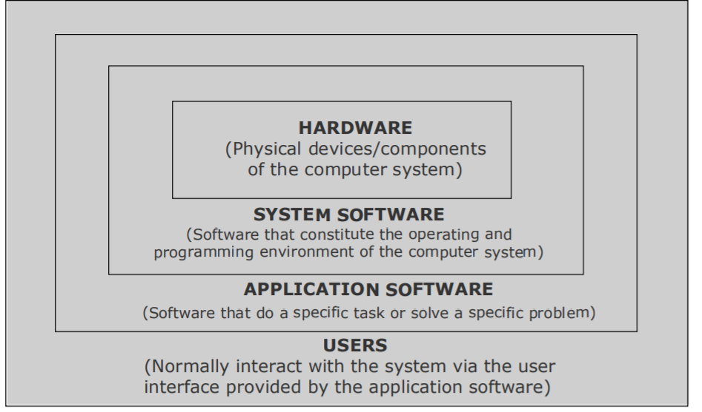(Physical devices/components of the computer system) SYSTEM SOFTWARE (Software that constitute the operating and programming environment of the computer system) APPLICATION SOFTWARE (Software that do a specific task or solve a specific problem) USERS (Normally interact with the system via the user interface provided by the application software) Relationship among hardware, system software, application software, and users of a computer system.

**Q 2) Write a note on Multimedia and its type with common media for storage access and transmission in details. (10 marks)**

Answer

Multimedia:

1. Media is something that can be for presentation of information.

2. Two basic ways to present some information are:

.Numidia Presentation: Single Medias used to present information.

. Multimedia Presentation: More than one, media is used to present information.

3. Multimedia presentation of any information greatly enhances comprehension capability of the user as it involves use of more of our senses.

**Types of media:**

**1. Common Media**

Common media for storage, access, and transmission of information are :

.text (alphanumeric characters)

.graphic (line drawings and images)

.animation (moving images)

.Audio (sound)

.video (videographer real _life events )

.Multimedia information technology refers use of more than one of these media for information presentation to users.

**2. Multimedia Computer system.**

.Multimedia computer system is a computer having capability to integrate two are more types of media (text, graphics, animation, audio, and video)

. in general size for multimedia information is much larger than plain text information **.**

.Multimedia computer systems require :

1. Faster CPU

2. Lager storage devices (for storing large data files)

3. Larger main memory (for large data size)

4. Good graphics terminals

5. I/0devices to play any multimedia

**3. Text Media**

Alphanumeric characters are used to present information in text form. Computers are widely used for text processing § Keyboards, OCRs, computer screens, and printers are some commonly used hardware devices for processing text media § Text editing, text searching, hypertext, and text importing/exporting are some highly desirable features of a multimedia computer system for better presentation and use of text information**.**

**4. Graphics Media.**

Computer graphics deals with generation, representation, manipulation, and display of pictures (line drawings and images) with a computer § Locating devices (such as a mouse, a joystick, or a stylus), digitizers, scanners, digital cameras, computer screens with graphics display capability, laser printers, and plotters are some common hardware devices for processing graphics media § Some desirable features of a multimedia computer system are painting or drawing software, screen capture software, clip art, graphics importing, and software support for high resolution

**5. Animation Media.**

Computer animation deals with generation, sequencing, and display (at a specified rate) of a set of images (called frames) to create an effect of visual change or motion, similar to a movie film (video) § Animation is commonly used in those instances where videography is not possible or animation can better illustrate the concept than video § Animation deals with displaying a sequence of images at a reasonable speed to create an impression of movement. For a jerk-free full motion animation, 25 to 30 frames per second is required

**6. Audio Media .**

Computer audio deals with synthesizing, recording, and playback of audio or sound with a computer § Sound board, microphone, speaker, MIDI devices, sound synthesizer, sound editor and audio mixer are some commonly used hardware devices for processing audio media § Some desirable features of a multimedia computer system are audio clips, audio file importing, software support for high quality sound, recording and playback capabilities, text-to-speech conversion software, speech-to-text conversion software, and voice recognition software

**7. Video Media**

Computer video deals with recording and display of a sequence of images at a reasonable speed to create an impression of movement. Each individual image of such a sequence is called a frame § Video camera, video monitor, video board, and video editor are some of the commonly used hardware devices for processing video media § some desirable features of a multimedia computer system with video facility are video clips and recording and playback capabilities

**Q3) Write a note on each of the following in details. (20 marks)**

**(a)  Modulation Techniques. (b) Multiplexing**

**(c) Switching Techniques. (d) Optical Fiber Communication System**

**Answer:**

1. **Modulation Techniques:** In [electronics](https://en.wikipedia.org/wiki/Electronics) and [telecommunications](https://en.wikipedia.org/wiki/Telecommunication), **modulation** is the process of varying one or more properties of a periodic [waveform](https://en.wikipedia.org/wiki/Waveform), called the [*carrier signal*](https://en.wikipedia.org/wiki/Carrier_signal), with a modulating signal that typically contains information to be transmitted. Most radio systems in the 20th century used [frequency modulation](https://en.wikipedia.org/wiki/Frequency_modulation) (FM) or [amplitude modulation](https://en.wikipedia.org/wiki/Amplitude_modulation) (AM) for [radio broadcast](https://en.wikipedia.org/wiki/Radio_broadcast).

**The most common digital modulation techniques are:**

* Phase-shift keying (PSK) ...
* Frequency-shift keying (FSK) ...
* Amplitude-shift keying (ASK)
* On-off keying (OOK), the most common ASK form. ...
* Quadrature amplitude **modulation** (QAM), a combination of PSK and ASK. ...
* Continuous phase **modulation** (CPM) methods.

**b)Multiplexing:** In [telecommunications](https://en.wikipedia.org/wiki/Telecommunications) and [computer networks](https://en.wikipedia.org/wiki/Computer_networks), **multiplexing** (sometimes contracted to **muxing**) is a method by which multiple analog or digital signals are combined into one signal over a [shared medium](https://en.wikipedia.org/wiki/Shared_medium). The aim is to share a scarce resource. For example, in telecommunications, several [telephone calls](https://en.wikipedia.org/wiki/Telephone_call) may be carried using one wire. Multiplexing originated in [telegraphy](https://en.wikipedia.org/wiki/Multiplexing#Telegraphy) in the 1870s, and is now widely applied in communications. In [telephony](https://en.wikipedia.org/wiki/Multiplexing#Telephony), [George Owen Squire](https://en.wikipedia.org/wiki/George_Owen_Squier) is credited with the development of telephone carrier multiplexing in 1910.

The multiplexed signal is transmitted over a communication channel such as a cable. The multiplexing divides the capacity of the communication channel into several logical channels, one for each message signal or data stream to be transferred. A reverse process, known as DE multiplexing, extracts the original channels on the receiver end.

A device that performs the multiplexing is called a [multiplexer](https://en.wikipedia.org/wiki/Multiplexer) (MUX), and a device that performs the reverse process is called a [DE multiplexer](https://en.wikipedia.org/wiki/Demultiplexer) (DEMUX or DMX).

[Inverse multiplexing](https://en.wikipedia.org/wiki/Inverse_multiplexing) (IMUX) has the opposite aim as multiplexing, namely to break one data stream into several streams, transfer them simultaneously over several communication channels, and recreate the original data stream.

**c) Switching Techniques:** In large networks, there can be multiple paths from sender to receiver. The switching technique will decide the best route for data transmission.

Switching technique is used to connect the systems for making one-to-one communication.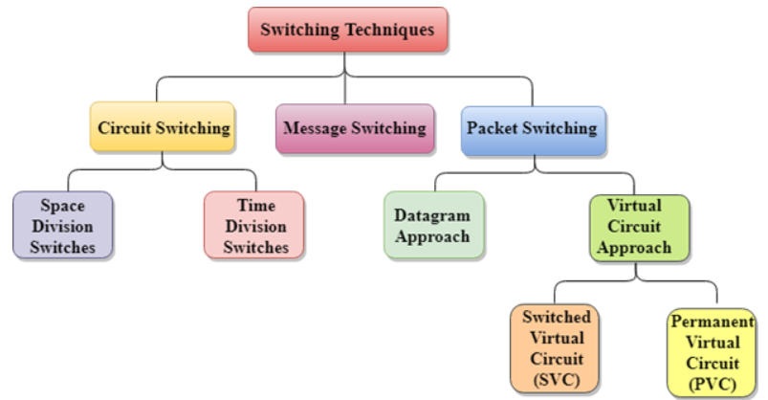

**d) Fiber-Optics Communication system: Optical** fiber is used by many telecommunications companies to transmit telephone signals, Internet communication, and cable television signals. Fiber optics communication system is a method of transmitting information from one place to another by sending pulses of [infrared](https://en.wikipedia.org/wiki/Infrared) light through an [optical fiber](https://en.wikipedia.org/wiki/Optical_fiber). The light forms an [electromagnetic](https://en.wikipedia.org/wiki/Electromagnetic_radiation) [carrier wave](https://en.wikipedia.org/wiki/Carrier_wave) that is [modulated](https://en.wikipedia.org/wiki/Modulation) to carry information. Fiber is [preferred over electrical cabling](https://en.wikipedia.org/wiki/Fiber-optic_communication#Comparison_with_electrical_transmission) when high [bandwidth](https://en.wikipedia.org/wiki/Bandwidth_(computing)), long distance, or immunity to [electromagnetic interference](https://en.wikipedia.org/wiki/Electromagnetic_interference) is required. This type of communication can transmit voice, video, and telemetry through local area networks, computer networks, or across long distances

**.**

**Q 4) what is OSI reference model explain each layer of OSI model in details. (10 marks)**

The open systems interconnection (OSI) model is a conceptual model by the international organization for standardization which enables diverse communication system to communicate using standard protocols .In plain English, the OSI provides a standard for different computer systems to be able to communicate with each other.

The OSI model can be as a universal language for computer networking. It’s based on the concept of splitting up a communicate system into seven abstract layers, each one stacked upon the last.

#### 

## The seven layers of the OSI model?

The seven abstraction layers of the OSI model can be defined as follows,

#### 7. The Application Layer

This is the only layer that directly interacts with data from the user. Software applications like web browsers and email clients rely on the application layer to initiate communications. But it should be made clear that client software applications are not part of the application layer; rather the application layer is responsible for the protocols and data manipulation that the software relies on to present meaningful data to the user. Application layer protocols include [HTTP](https://www.cloudflare.com/learning/ddos/glossary/hypertext-transfer-protocol-http/) as well as SMTP (Simple Mail Transfer Protocol is one of the protocols that enables email communications).

#### 6. The Presentation Layer

This layer is primarily responsible for preparing data so that it can be used by the application layer; in other words, layer 6 makes the data presentable for applications to consume. The presentation layer is responsible for translation, [encryption](https://www.cloudflare.com/learning/ssl/what-is-encryption/), and compression of data.

Two communicating devices communicating may be using different encoding methods, so layer 6 is responsible for translating incoming data into a syntax that the application layer of the receiving device can understand.

If the devices are communicating over an encrypted connection, layer 6 is responsible for adding the encryption on the sender’s end as well as decoding the encryption on the receiver's end so that it can present the application layer with unencrypted, readable data.

Finally the presentation layer is also responsible for compressing data it receives from the application layer before delivering it to layer 5. This helps improve the speed and efficiency of communication by minimizing the amount of data that will be transferred.

#### 5. The Session Layer

This is the layer responsible for opening and closing communication between the two devices. The time between when the communication is opened and closed is known as the session. The session layer ensures that the session stays open long enough to transfer all the data being exchanged, and then promptly closes the session in order to avoid wasting resources.

The session layer also synchronizes data transfer with checkpoints. For example, if a 100 megabyte file is being transferred, the session layer could set a checkpoint every 5 megabytes. In the case of a disconnect or a crash after 52 megabytes have been transferred, the session could be resumed from the last checkpoint, meaning only 50 more megabytes of data need to be transferred. Without the checkpoints, the entire transfer would have to begin again from scratch.

#### 4. The Transport Layer

Layer 4 is responsible for end-to-end communication between the two devices. This includes taking data from the session layer and breaking it up into chunks called segments before sending it to layer 3. The transport layer on the receiving device is responsible for reassembling the segments into data the session layer can consume.

The transport layer is also responsible for flow control and error control. Flow control determines an optimal speed of transmission to ensure that a sender with a fast connection doesn’t overwhelm a receiver with a slow connection. The transport layer performs error control on the receiving end by ensuring that the data received is complete, and requesting a retransmission if it isn’t.

#### 3. The Network Layer

The network layer is responsible for facilitating data transfer between two different networks. If the two devices communicating are on the same network, then the network layer is unnecessary. The network layer breaks up segments from the transport layer into smaller units, called packets, on the sender’s device, and reassembling these packets on the receiving device. The network layer also finds the best physical path for the data to reach its destination; this is known as routing.

#### 2. The Data Link Layer

The data link layer is very similar to the network layer, except the data link layer facilitates data transfer between two devices on the SAME network. The data link layer takes packets from the network layer and breaks them into smaller pieces called frames. Like the network layer, the data link layer is also responsible for flow control and error control in intra-network communication (The transport layer only does flow control and error control for inter-network communications).

#### 1. The Physical Layer

This layer includes the physical equipment involved in the data transfer, such as the cables and switches. This is also the layer where the data gets converted into a bit stream, which is a string of 1s and 0s. The physical layer of both devices must also agree on a signal convention so that the 1s can be distinguished from the 0s on both devices