Subject: Anatomy II Total Marks 50
Final Term Assignment. Semester: DPT 2nd.

Q:1 Enumerate muscles in the posterior compartment of the lower leg with clinical significances also write action and innervation of each posterior compartment muscle.

Q:2 Explain the following
- Foot drop
- Deep venous thrombosis

Q:3 Explain blood supply of thigh and gluteal region with the help of diagram.

Q 4: Describe anatomical course, motor and sensory function of Sciatic Nerve

Q 5: Enumerate Muscles of the medial compartment of thigh, what is tarsal tunnel syndrome?

Name:Atif Amjad
ID No:15992
Semester:2nd ‘A’(DPT)
Paper:Anatomy
(ANSWERS)
QUESTION NO 2:
Foot drop:
Foot Drop is a clinical sign indicating paralysis of the muscles in the anterior compartment of the leg. It is most commonly seen when the common fibular nerve is damaged.
- In the foot drop, the muscles in the anterior compartment are paralyzed.
The unopposed pull of the plantar flexor produces.
Permanent plantar flexion.
- This can interfere with walking-as the affected limb can drag along the ground.
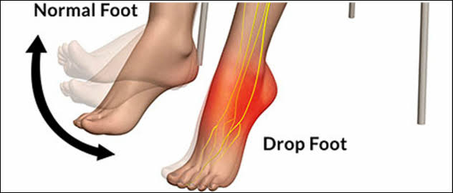
- Diagram:

B. Deep venous thrombosis:
Deep venous thrombosis(DVT) is the formation of the blood clot within the deep veins of the lower limbs, causing blockage of the vessel. Locally, this causes pain, swelling and tenderness of the affected limb.
The complication of a DVT is pulmonary embolism. The
thrombus become dislodged, and travel into pulmonary
circulation. Pulmonary occlusion prevents blood from returning to the
heart, resulting in mechanical shock.
• Patients that are considered having a high risk of developing a DVT
They undergo prophylactic treatment to prevent the disease known as thrombosis.
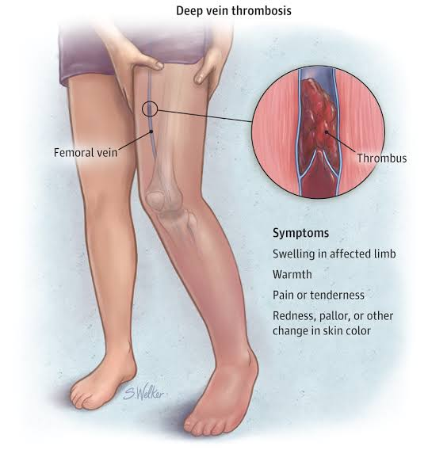
Diagram:

QUESTION NO 1:
Posterior compartment of the lower leg with clinical significance also write their actions and innervations of each:
- Muscles in the posterior compartment of lower leg:
The posterior compartment of leg contains seven muscles,
These muscles are organized into two layers – superficial and deep.
• The two layers are separated by a band of fascia.
• The posterior leg is the largest of the three compartments.
Collectively, the muscles in this area plantarflex and invert the foot.
• They are innervated by tibial nerve, a branch of the
sciatic nerve.
- Superficial muscles:

The superficial muscles from the characteristics ‘call' shape of posterior leg.
They are inserted into calcaneus of the foot, via the calcaneal tendon.
The calcaneal reflex tests spinal roots S1-S2.
• To minimize friction during movement, there are two bursae associated with the calcaneal tendon:
• Subcutaneous calcaneal bursa – lies between the skin and the calcaneal tendon.
- Deep bursa of the calcaneal tendon—lies between the tendon and the calcaneus.
Gastrocnemius:
The gastrocnemius is the most superficial of all the muscles in the
posterior leg. It has two heads – medial and lateral, which converge
to form a single muscle belly.
• Actions: It plantarflexes at the ankle joint, and because it crosses the
knee, it is a flexor there.
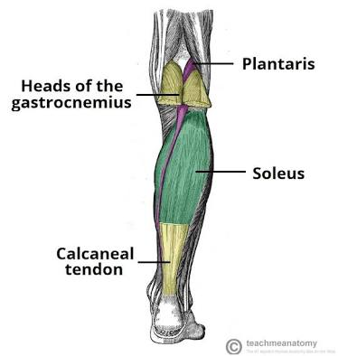
• Innervation: Tibial nerve.
Plantaris:
The plantaris is a small muscle with a long tendon, which can be
mistaken for a nerve as it descends down the leg. It is absent in 10%
of people.
• Actions: It plantarflexes at the ankle joint, and because it crosses the
knee, it is a flexor there. It is not a vital muscle for these movements.
• Innervation: Tibial nerve.
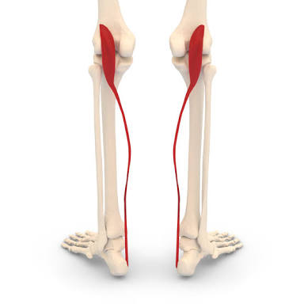

Soleus:
It is located deep to the gastrocnemius. It is large and flat,
named soleus due to resemblance of a sole – a flat fish.
• Actions: Plantarflexes the foot at the ankle joint.
• Innervation: Tibial Nerve.

Deep muscles:
There are four muscles in the deep compartment of the posterior leg.
One muscle, the popliteus, acts on knee joint. The remaining
three muscles (tibialis posterior, flexor hallucis longus and flexor
digitorum longus) act on the ankle and foot.
Popliteus:
• The popliteus is located superiorly in the leg. It lies behind the knee
joint, forming the base of the popliteal fossa.
• Actions: Laterally rotates the femur on the tibia – ‘unlocking’ the
knee joint so that flexion can occur.
• Innervation: Tibial nerve.
Diagram:
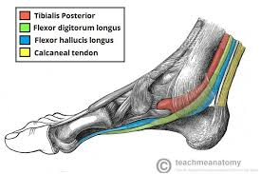
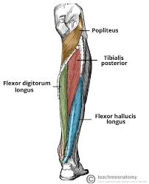

QUESTION NO 3:
Blood supply of thigh and gluteal region:
Femoral artery:
The main artery of the lower limb is the femoral artery. It is a continuation of the
external iliac artery (terminal branch of the abdominal aorta). The external iliac becomes
the femoral artery when it crosses under the inguinal ligament and enters the femoral
triangle.
• In the femoral triangle, the profunda femoris artery arises from the posterolateral
aspect of the femoral artery. It travels posteriorly and distally, giving off three main
branches:
• Perforating branches – Consists of three or four arteries that perforate the adductor
magnus, contributing to the supply of the muscles in the medial and posterior thigh.
• Lateral femoral circumflex artery – Wraps round the anterior, lateral side of the femur,
supplying some of the muscles on the lateral aspect of the thigh.
• Medial femoral circumflex artery – Wraps round the posterior side of the femur,
supplying its neck and head. In a fracture of the femoral neck this artery can easily be
damaged, and avascular necrosis of the femur head can occur.
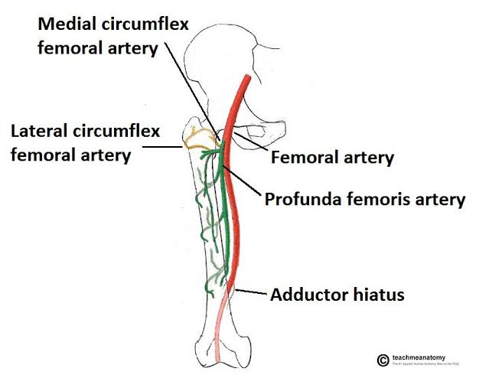

After exiting the femoral triangle, the femoral artery continues down
the anterior surface of the thigh, via a tunnel known as the adductor
canal. During its descent the artery supplies the anterior thigh
muscles.
• The adductor canal ends at an opening in the adductor magnus,
called the adductor hiatus. The femoral artery moves through this
opening, and enters the posterior compartment of the thigh, proximal
to the knee. The femoral artery is now known as the popliteal artery.

Other Arteries of the Thigh:
• In addition to the femoral artery, there are other vessels supplying the lower
limb.
• The obturator artery arises from the internal iliac artery in the pelvic region. It
descends via the obturator canal to enter the medial thigh, bifurcating into two
branches:
• Anterior branch – This supplies the pectineus, obturator externus, adductor
muscles and gracilis.
• Posterior branch – This supplies some of the deep gluteal muscles.
• The gluteal region is largely supplied by the superior and inferior gluteal arteries.
These arteries also arise from the internal iliac artery, entering the gluteal region
via the greater sciatic foramen.
• The superior gluteal artery leaves the foramen above the piriformis muscle, the
inferior below the muscle. In addition to the gluteal muscles, the inferior gluteal
artery also contributes towards the vasculature of the posterior thigh.
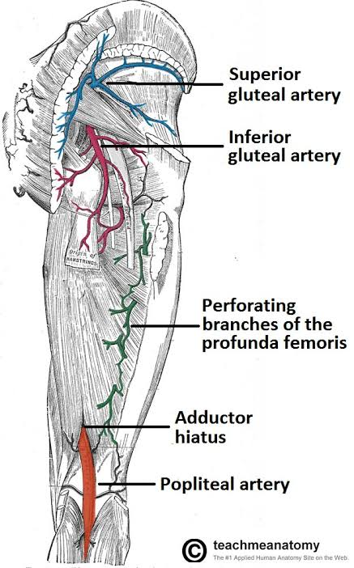
The Foot and Leg:
• The main venous structure of the foot is the dorsal venous arch,
which mostly drains into the superficial veins. Some veins from the
arch penetrate deep into the leg, forming the anterior tibial vein.
• On the plantar aspect of the foot, medial and lateral plantar veins
arise. These veins combine to form the posterior
tibial and fibular veins. The posterior tibial vein accompanies the
posterior tibial artery, entering the leg posteriorly to the medial
malleolus.
• On the posterior surface of the knee, the anterior tibial, posterior
tibial and fibular veins unite to form the popliteal vein. The popliteal
vein enters the thigh via the adductor canal
The Thigh:
• Once the popliteal vein has entered the thigh, it is known as
the femoral vein. It is situated anteriorly, accompanying the femoral
artery.
• The deep vein of the thigh (profunda femoris vein) is the other main
venous structure in the thigh. Via perforating veins, it drains blood
from the thigh muscles. It then empties into the distal section of the
femoral vein.
• The femoral vein leaves the thigh by running underneath the inguinal
ligament, at which point it is known as the external iliac vein.
The Gluteal region:
• The gluteal region is drained by inferior and superior gluteal veins.
These empty into the internal iliac vein.
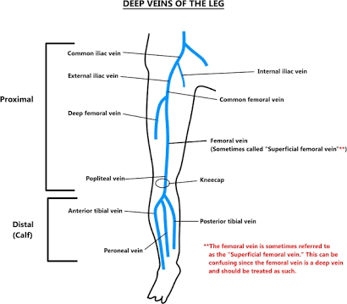
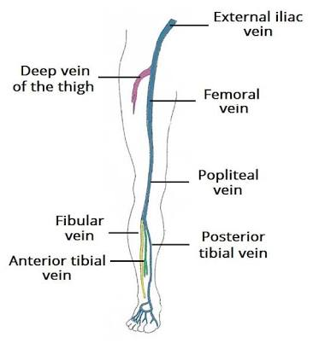

QUESTION NO 4:
Anatomical course, motro and sensory functions of sciatic nerve:
Sciatic nerve
The sciatic nerve is a major nerve of the lower limb. It is a thick flat band,
approximately 2cm wide – the largest nerve in the body.
Nerve root: L3-S4.
Motor functions:
• Innervates the muscles of the posterior thigh (biceps femoris, semimembranosus
and semitendinosus) and the hamstring portion of the adductor magnus (remaining
portion of which is supplied by the obturator nerve).
Sensory functions: No direct sensory functions in thigh region .( Indirectly
innervates (via its terminal branches) the skin of the lateral leg, heel, and
both the dorsal and plantar surfaces of the foot)
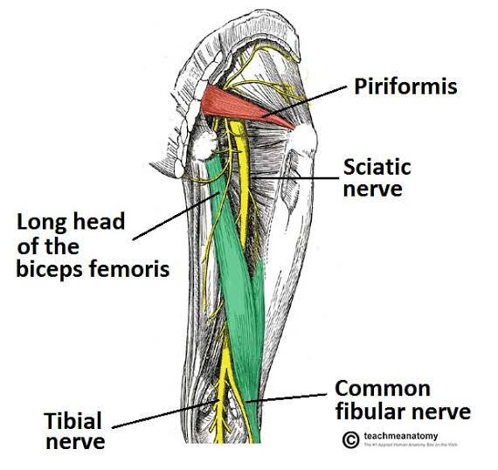
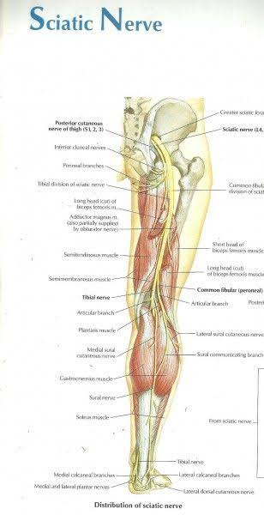
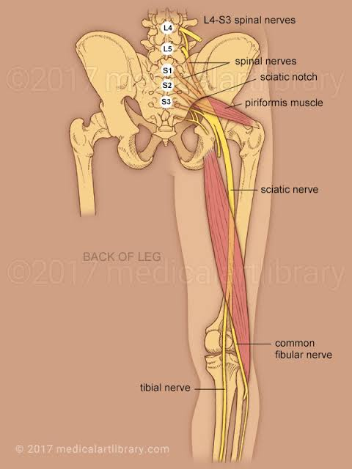
Motor functions:
• The sciatic nerve also indirectly innervates several other muscles, via
its two terminal branches:
• Tibial nerve – the muscles of the posterior leg (calf muscles), and some of the intrinsic muscles of the foot.• Common fibular nerve – the muscles of the anterior leg, lateral leg, and the remaining intrinsic foot muscles.
Common fibular nerve – the muscles of the anterior leg, lateral leg,
and the remaining intrinsic foot muscles.

Clinical Relevance: Intramuscular Injections:
• The anatomical course of the sciatic nerve must be considered when
administering intramuscular injections into the gluteal region. The
region can be divided into quadrants using 2 lines, marked by bony
landmarks:
• One line descends vertically from the highest point on the iliac crest.
• The other horizontal line passes through the vertical line half way
between the highest point on the iliac crest and ischial tuberosity.
• The sciatic nerve passes through the lower medial quadrant. To avoid
damaging the sciatic nerve therefore, intramuscular injections are
given only in the upper lateral quadrant of the gluteal region.
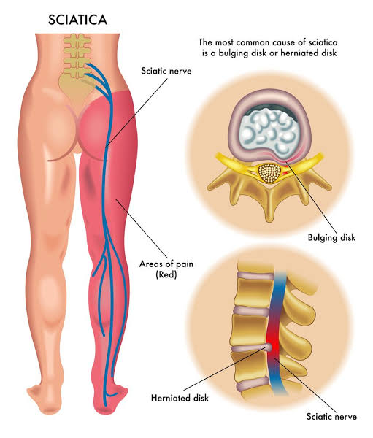
Sleeping Foot:
• The sciatic nerve is uncovered on the back of thigh in the angle
between the lower border of gluteus maximus and long head of
biceps femoris. The temporary compression of the sciatic nerve
against femur at the lower border of gluteus maximus causes
paresthesia in the lower limb. It’s named “sleeping foot, example,
when a man sits on the hard edge of the seat for a long time”.• The sciatic nerve is uncovered on the back of thigh in the angle
between the lower border of gluteus maximus and long head of
biceps femoris. The temporary compression of the sciatic nerve
against femur at the lower border of gluteus maximus causes
paresthesia in the lower limb. It’s named “sleeping foot, example,
when a man sits on the hard edge of the seat for a long time”.
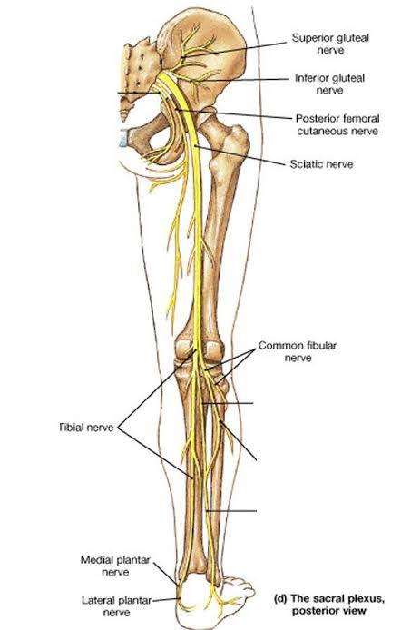
QUESTION NO 5:
Muscles of the medial compartment of thigh and tursal tunnel syndrome:

- The muscles in the medial compartment of the thigh are collectively as known as the hip adductors. There are five muscles in this group:
- 1.Gracilis.
- Obturator externus.
- Adductor brevis.
- Adductor longus.
- Adductor magnus.

All the medial thigh muscles are innervated by the obturator nerve,
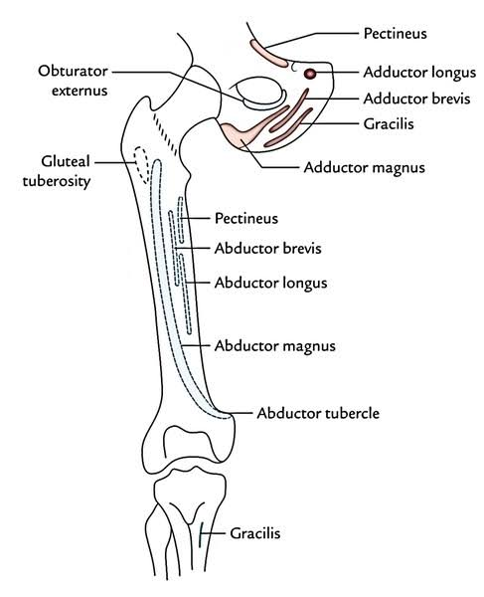
which arises from the lumbar plexus. Arterial supply is via the obturatoartery.
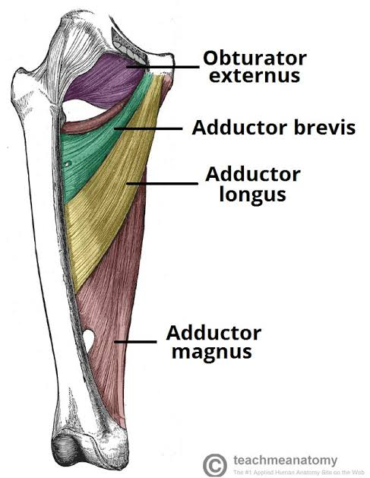

Gracilis:
• The gracilis is the most superficial and medial of the muscles in this
compartment. It crosses at both the hip and knee joints. It is
sometimes transplanted into the hand or forearm to replace a
damaged muscle.
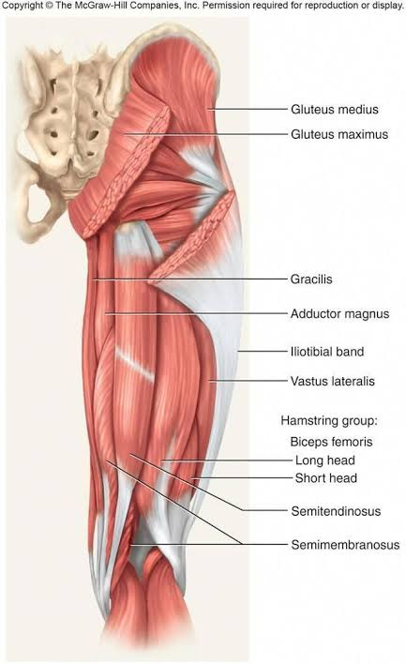

Clinical Relevance: Injury to the Adductor Muscles:
• Strain of the adductor muscles is the underlying cause of what is
colloquially known as a ‘groin strain‘. The proximal part of the muscle
is most commonly affected, tearing near their bony attachments in
the pelvis.
• Groin injuries usually occur in sports that require explosive
movements or extreme stretching. Treatment of any muscle strain
should utilise the RICE protocol – rest, ice, compression and
elevation.
Clinical Relevance: Tarsal Tunnel Syndrome:
• This is a condition where the tibial nerve is compressed within the tarsal
tunnel (posterior to the medial malleolus). There are varying causes, of
which the main three are:
• Osteoarthritis
• Rheumatoid arthritis
• Post-trauma ankle deformities
• Patients complain of paraesthesia in the ankle and sole of the foot, which
can radiate up the leg slightly. It is aggravated by activity and relieved by
rest.
• Tarsal tunnel symptoms can be treated conservatively by anti-inflammatory
drugs and changes in footwear.
• If these interventions are not successful, the flexor retinaculum can be cut
surgically, which releases the pressure.
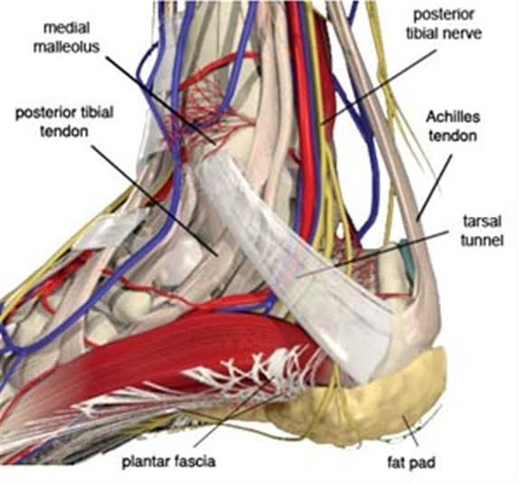

THANKS

