IQRA NATIONAL UNIVERSITY
DEPARTMENT OF ALLIED HEALTH SCIENCES

Max Marks: 50 Time: 6 hours

Name: ………………………………………………………………………………………………………………………………….
Note:

Name: Arbaz khan
Id:16033
Department:DPT 2nd
Section:A
Subject: anatomy viva

Question no 1
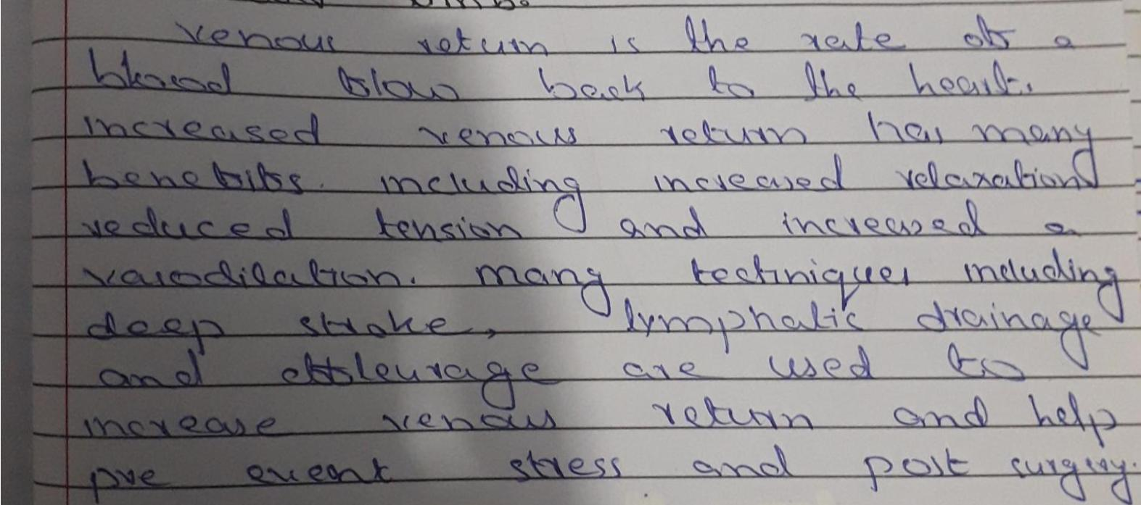
pg:2
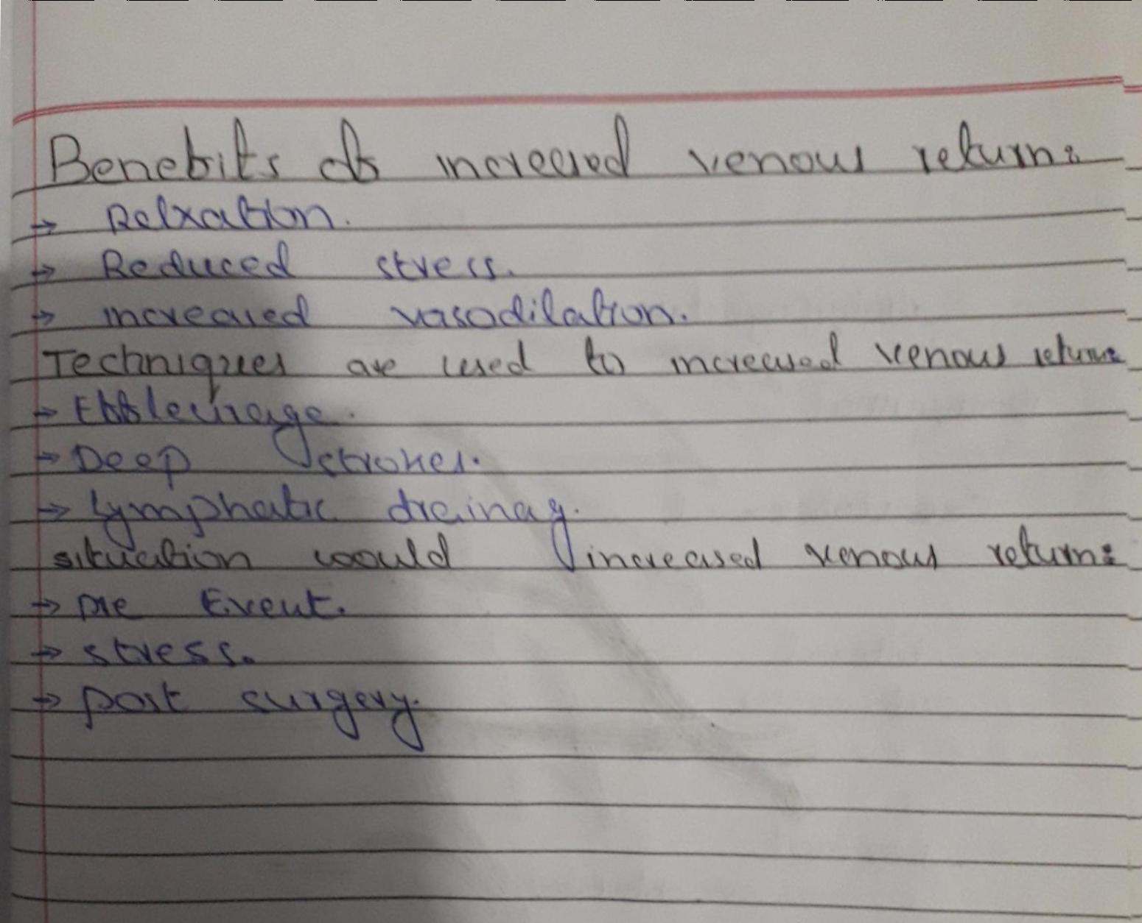
Question no 2
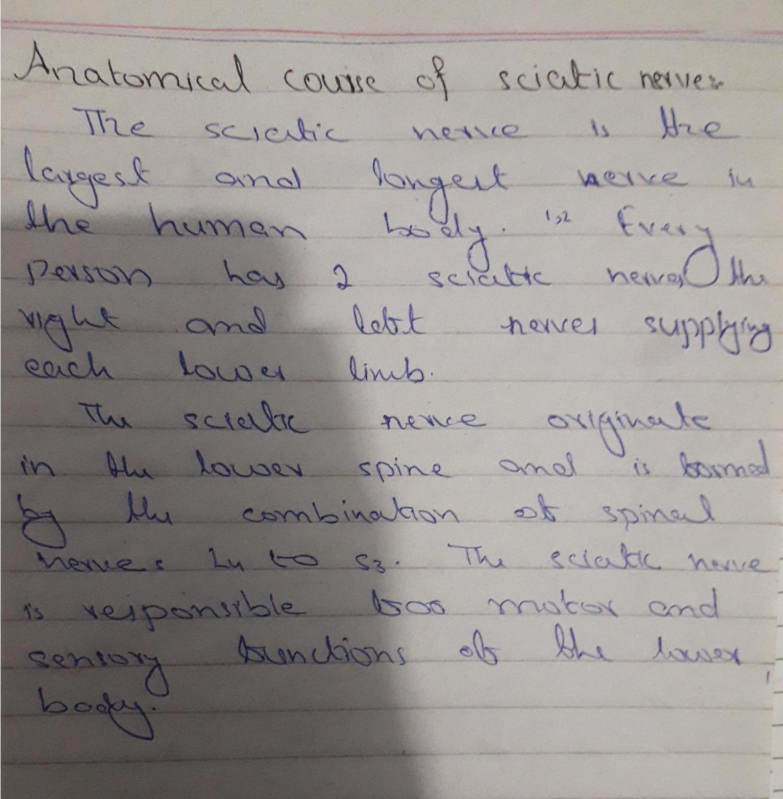
pg:2
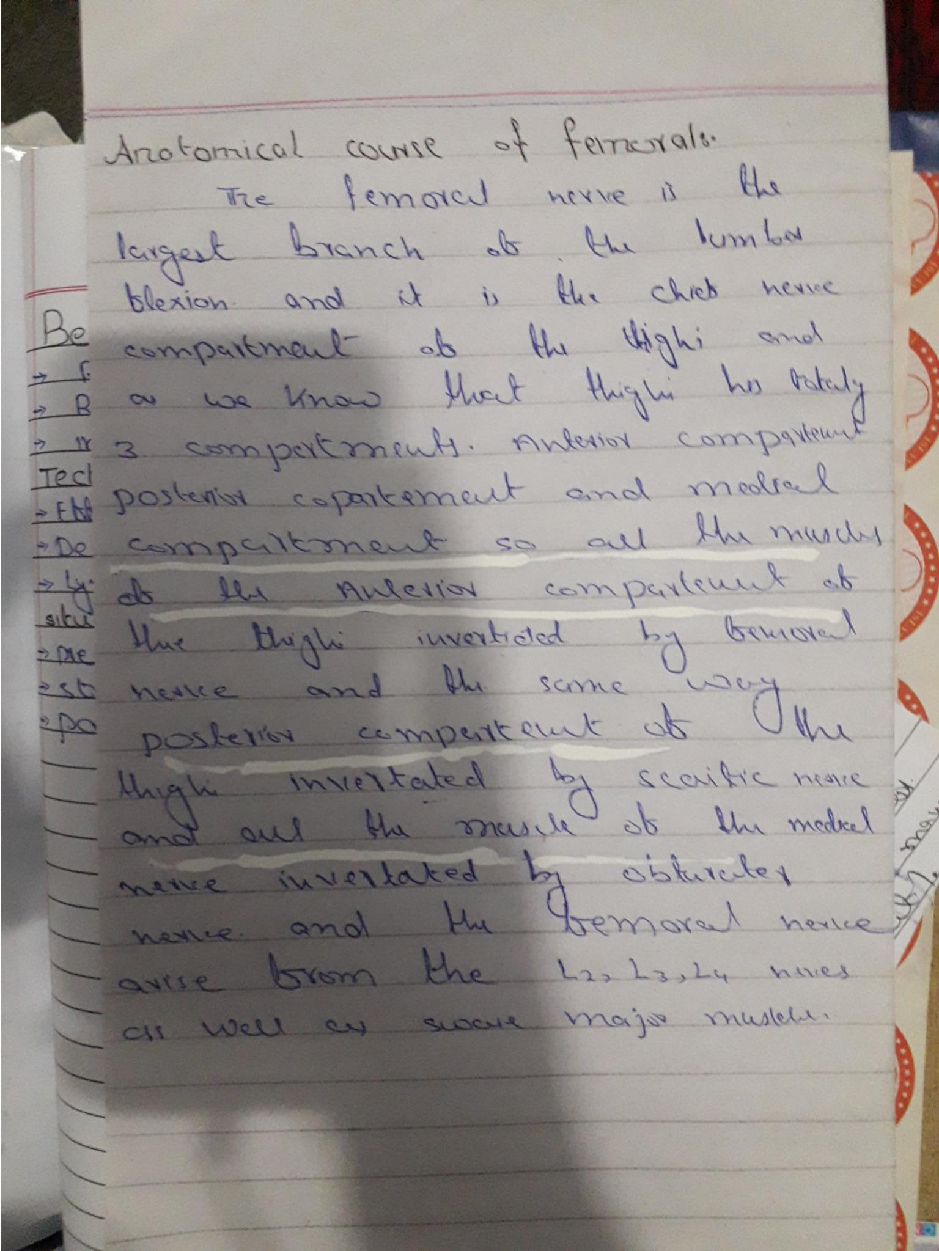
Sciatic nerve
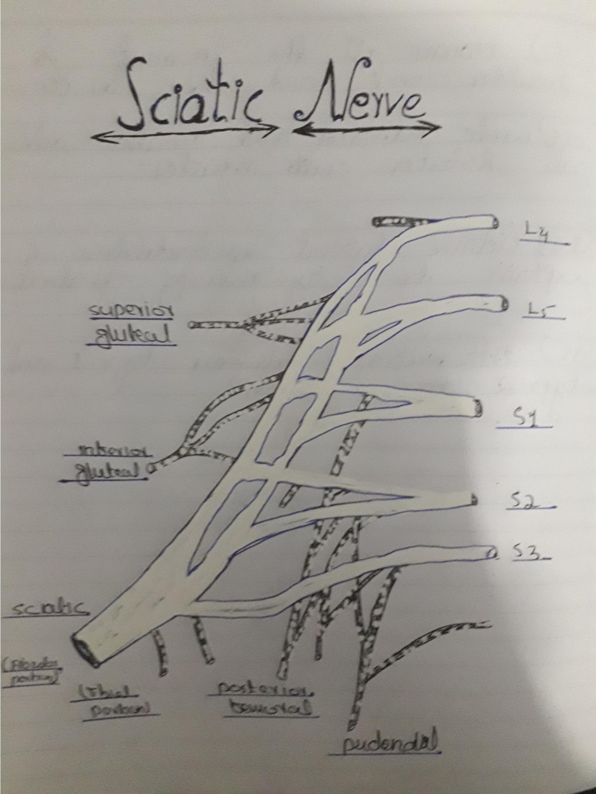
femoral Nerve
