PAGE 1
Paper : Clinical Medicine
Name : adil khan
I’d : 16876
Semester 4th : radiology
SECTION-A
Q1:
ANS : C
Q2:
ANS : d
Q3:
Ans: d
Q4:
Ans: a
Q5:
Ans: b
Q6:
PAGE 2
Ans: d
Q7:
Ans: a
Q8:
Ans: b
Q9:
Ans: b
Q10:
Ans: c
SECTION-B
Q1:
Ans: Eisenmenger Syndrome :
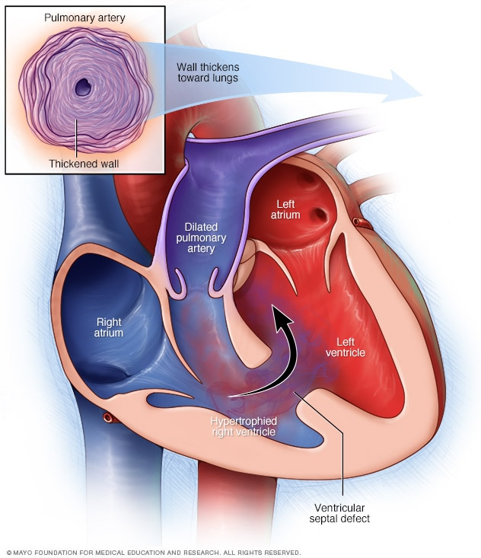
it occurs as the result of a heart defect in which there is a defect or hole (shunt) between two chambers in your heart. With this defect, blood moves from the left side of the heart to the corresponding right chamber. The previous left-to-right shunt is converted into a right-to-left shunt secondary to elevated pulmonary artery pressures and associated pulmonary vascular disease.when the pressure in the pulmonary arteries becomes so high that it causes oxygen-poor blue blood to flow from the right to left ventricle and then to the body, causing cyanosis.

PAGE 3
Q2:
Ans : Among nonselective COX inhibitors, intravenous indomethacin was the first drug used for PDA treatment, presenting a closure rate of about 70–85% without any other short-term benefits . Since indomethacin has been used as a prophylaxis in PDA management, it has been shown to reduce the incidence of intraventricular hemorrhage grade and severe pulmonary hemorrhage by 35%, symptomatic PDA development, and necessity of surgical ligation, without effects on mortality or long-term neurodevelopmental outcome
, has pointed out also a protective effect of prophylactic indomethacin on development of BDP and death, instead of delayed PDA treatment in extremely premature neonates.
The nephrotoxic effect of NSAIDs is related to prostaglandin important role during kidney and cardiovascular system adaptation afterSAIDs renal damage, urinary revealed a useful and noninvasive biomarker of nephrotoxicity, becoming significantly decreased in the urine of preterm infants after treatment for PDA closure, both with indomethacin and with ibuprofen,
NSAIDs inhibit the production of prostaglandins by decreasing the activity of cyclooxygenase. The result is a functional closure of the patent ductus arteriosus PDA in 80% of patients.
Q3:
Ans: When plaque (fatty deposits) clogs your arteries, that's called atherosclerosis. These deposits are made up of cholesterol, fatty substances, cellular waste products, calcium and fibrin (a clotting material in the blood). As plaque builds up, the wall of the blood vessel thickens.
Atherosclerosis is a disease in which the inside of an artery narrows due to the buildup of plaque. Initially, there are generally no symptoms. When severe, it can result in coronary artery disease, stroke, peripheral artery ... The buildup of an atheromatous plaque is a slow process, developed over a period of several .
Symptoms: Atheroma

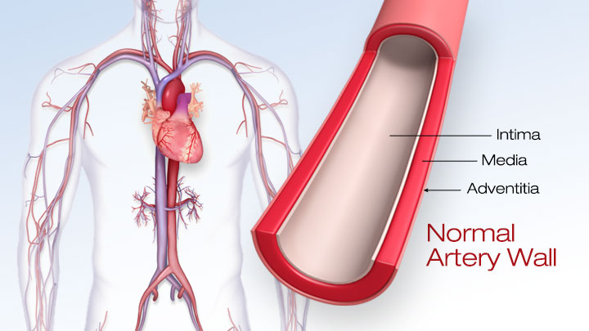
PAGE 4

Q4:
Ans: A myocardial infarction MI, also known as a heart attack, occurs when blood flow decreases or stops to a part of the heart, causing damage to the heart muscle. The most common symptom is chest pain or discomfort which may travel into the shoulder, arm, back, neck or jaw. Often it occurs in the center or left side of the chest and lasts for more than a few minutes. The discomfort may occasionally feel like heartburn. Other symptoms may include shortness of breath, nausea, feeling faint, a cold sweat or feeling tired. About 30% of people have atypical symptoms. Women more often present without chest pain and instead have neck pain,
A myocardial infarction MI, also known as a heart attack, occurs when blood flow decreases or ... An acute myocardial infarction, according to current consensus, is defined by elevated cardiac biomarkers with a rising or falling ... A more explicit classification system, based on international consensus in 2012, also exists.

THE END

