NAME= RABIA AHMED ZAI
DEPARTMENT= DPT 4th semester
SUBJECT= PHYSIOLOGY
SUBMITTED TO= SIR Ahmed hayat
ID= 15310

Q#1
ANS:
“WORK"
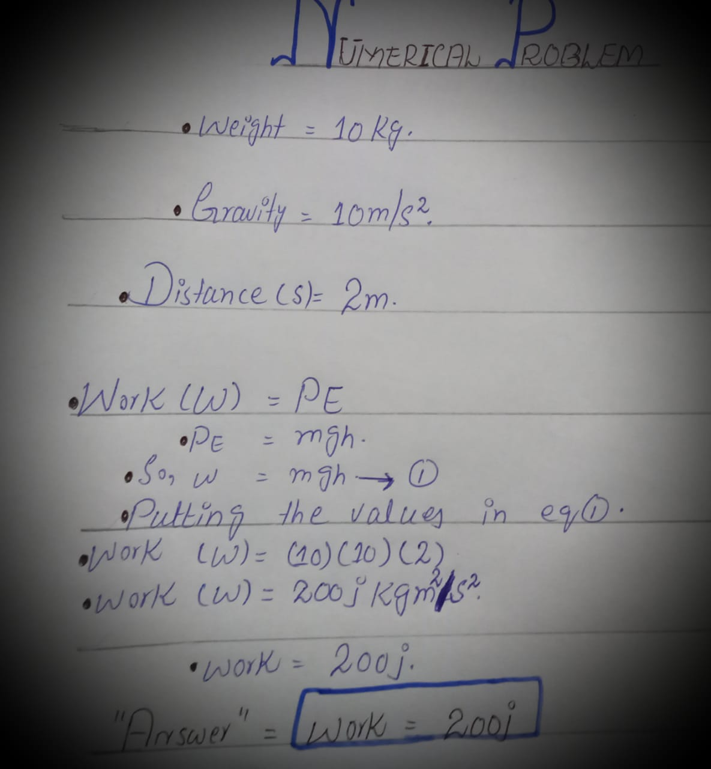
It is an activity involving mental or physical effort done in order to achieve a purpose or result.

Q#2

ANS:
“TRAINING"
_It is the act of teaching a person aor animal a specific skill or type of behaviour.
“Principles of training"
There are four basic principle of training:
- Over load= = it is a basic sports fitness training concept. Simply it increase the intensity, duration, type or time of workout progressively in order to see the changes. And these changes help in the improvements of endurance, strength, or muscle size.
- Specificity =It simply means that if a fitness objective is to increase flexibility, then flexibility training are very important.
- Progression = In this training their is a perfect level of overload that should be taken, as well as an perfect time frame for this overload to occour.
- Reversibility =It means that when there is any changes that occour as a result of training will be reversed when we stop training.

Q#3
ANS:
“LOAD":
Load can be defined as volume× intensity.
“PRELOAD":
- Also known as the left ventricular end _diastolic pressure.
- It is an amount of sarcomere stretch exprienced by cardiac muscle cell, called cardio-myosites at the end of the ventricular filling during duastole.
- It is the initial stretching of the cardiac muscles cells prior to contraction.
- It is related to ventricular filling.
- This period is affected by venous blood pressure and the rate of venous return.
- Preload is increased due to last filling time.
- It increase end diastolic volume , increase the stroke volume.
- Decrease thyroid hormones.
- Decrease calcium ions.
- High or low potasium ions.
- High or low sodium ions.
- Low the body temperature.
- Abnormal the PH balance.

“AFTERLOAD"
- It is also known as the systemic vascular resistance, is the amount of resistance the heart must over come to open the aortic valve and push the blood volume out into the systemic circulation.
- It is the force or load against which the heart has to contract to eject the blood.
- Afterload is represented by the knot at the end of the balloon. To get the air out, the ballon must work against that knot.
- It increase vascular resistance, it is increased due to increase in vascular resistance.
- Increase end systolic volume.
- It is raised due to increase in end systolic volume and decrease in stroke volume.
- It is decreased due to decreases in vascular resistance.
- It is lower down due to decreases in end systolic volume and increases in stroke volume.

Q#4
ANS:
“STROKE VOLUME"
It is the volume of blood pumped out of the left ventricle of the heart during each systolic cardiac contraction.
Typical value = 70ml
Normal range = 50-100ml

“FACTORS INCREASING STROKE VOLUME"
There are the following factors which increases the stroke volume :
- Contractility
- Preload
- Total peripheral resistance
- Autonomic inervation
- Blood volume

“CONTRACTILITY":
It is the ability or quality of shrinking or contracting. It is actually the power of muscle fibres of shortening into a more compact form. According to the starling’s law, the heart will eject a greater stroke volume at greater filling pressure. For any filling pressure the stroke volume will increase if the contractility of the heart is increases.
CONTRACTILITY IS DIRECTLY PROPORTIONAL TO STROKE VOLUME.
“PRELOAD"
It is the filling pressure of the heart at the end of the diastole.
PRELOAD IS DIRECTLY PROPORTIONAL TO STROKE VOLUME.
Increase preload increases stroke volume. Decrease preload decreases stroke volume.
By changing the force of contraction of the cardiac muscle.
“TOTAL PERIPHERAL RESISTANCE"
Total peripheral resistance is the resistance of the artries to blood flow. As the artries contract the resistance increases and as they dialate the resistance decreases.
TOTAL PERIPHERAL RESISTANCE (after load) IS DIRECTLY PROPORTIONAL TO STROKE VOLUME.
Total peripheral resistance increases with vasoconstriction increasing arterial blood pressure making it harder for the heart to expel blood into the artriesthus reducing the stroke volume.

“AUTONOMIC INERVATION"
Autonomic out flow from the medulla is divided into sympathetic and parasympathetic branches. Sympathetic nerves inervate the myo- cardium. So, when there is increase in sympathetic activity then the increase also accour in myo- cardial contractility and therefore increase occour in stroke volume.
“BLOOD VOLUME"
It is the volume of blood in the circulatory system of any individual . Increase in right ventricular stroke volume increases the pulmonary venous blood flow to the left ventricle there by increasing left ventricular preload and stroke volume. An increase in stroke volume than increases cardiac output and arterial blood pressure.

“Diagramatical form"
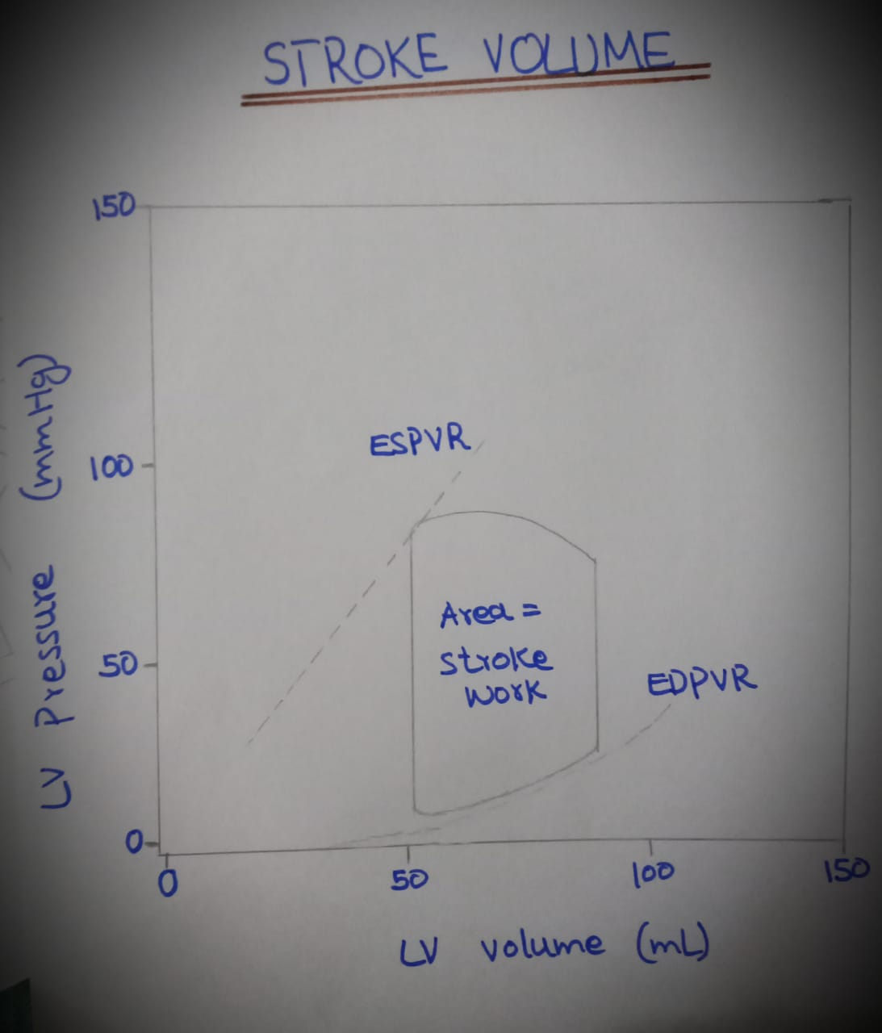

Q#5
ANS:
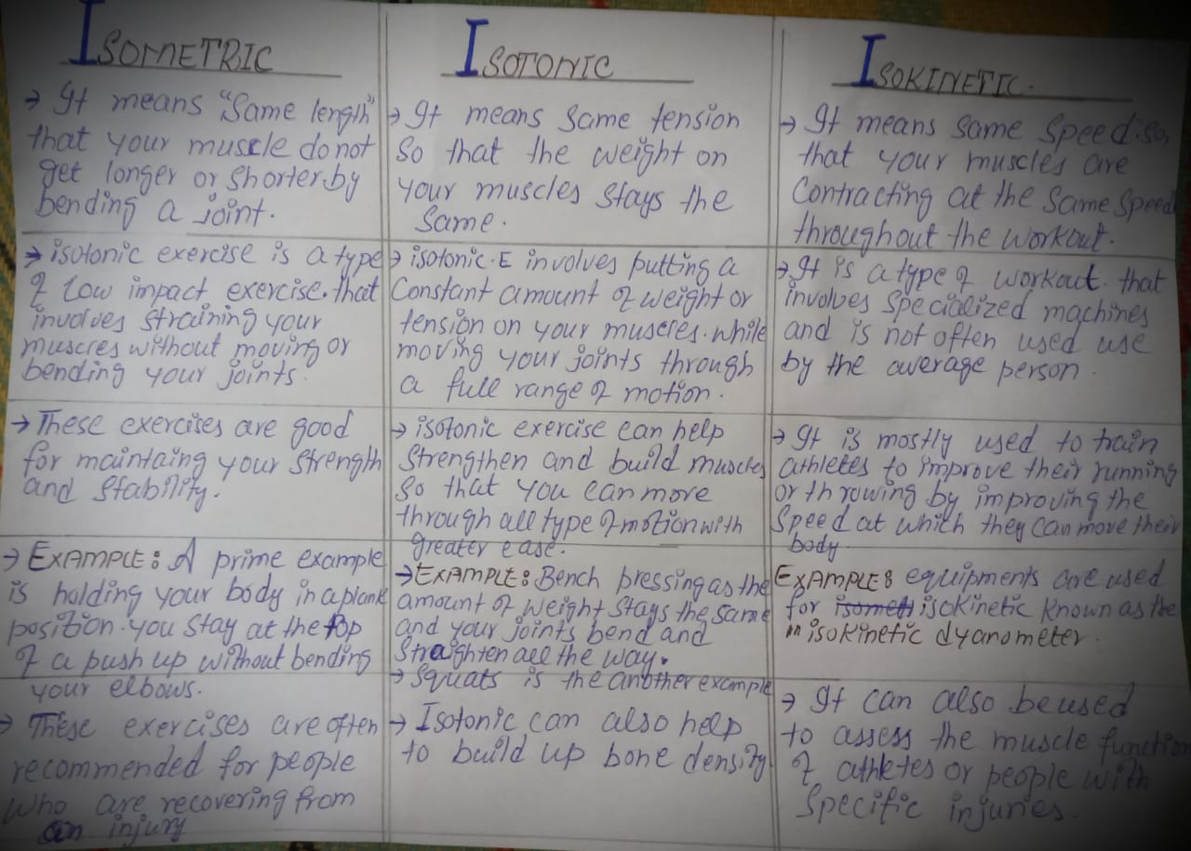

“Diagram"
