IQRA NATIONAL UNIVERSITY
DEPARTMENT OF ALLIED HEALTH SCIENCES
Final-Term Examination (spring -20) (BS. Radiology)
Course Title: Therapeutic Radiology Instructor: Atoofah Azmat
Id 13847
Name Iqra Safdar
Question Answer:
Q1. Write a note on brachytherapy?
Ans. Brachytherapy:
Brachytherapy is a type of internal radiotherapy. A small radioactive material called a source is put into your body, inside or close to the cancer. Or into the area where the cancer used to be before having surgery.
There are different types of radioactive sources (also called implants) such as seeds, wires or discs. They deliver radiotherapy to the area, destroying the cancer cells. Healthy tissue near to the cancer gets a lot less radiation.
Your doctor works out how much radiation you need. This affects how long the radioactive source stays inside you for. This can be anything from several minutes to a few days, or can stay in place permanently. If the source stays inside you permanently, it stops giving off radiation after a few weeks or months.
Types of brachytherapy
The way you have brachytherapy varies depending on the type of cancer you have. But there are 2 main types:
- High dose rate (HDR) brachytherapy
- Low dose rate (LDR) brachytherapy
Brachytherapy treats cancers throughout the body, including the:
- prostate
- cervix
- head and neck -
- breast
- gallbladder
- uterus
- vagina
- lung
- skin
- eye
- rectum
preparation for the procedure:
Your doctor will tell you how to prepare for treatment. These preparations may include:
- Bowel preparation
- Pre-treatment ultrasound, MRI or CT scan
- Blood tests
- Electrocardiogram EKG
- Chest X-rays
Your doctor may also use a computer to plan the treatment before the actual procedure.
Before you begin brachytherapy, you may meet with a doctor who specializes in treating cancer with radiation (radiation oncologist). You may also undergo scans to help your doctor determine your treatment plan.
Procedures such as X-rays, computerized tomography (CT) or magnetic resonance imaging (MRI) may be performed before brachytherapy.

Procedure:
Permanent brachytherapy:
Permanent brachytherapy inserts needles pre-filled with radioactive seeds into the tumor. The doctor will remove the needle and leave the seeds behind. Seeds may also be implanted using a device that inserts them individually at regular intervals. The procedure may use medical imaging to help position the seeds. The doctor may do more imaging tests later to verify seed placement.
Temporary brachytherapy:
Temporary brachytherapy places a delivery device, such as a catheter, needle, or applicator into the tumor. Medical imaging helps position the radiation sources. The doctor may insert the delivery device into a body cavity such as the vagina or uterus (intracavity). Or, the doctor may insert an applicator (needle or catheter) into body tissues (interstitial).
High dose-rate (HDR) treatments deliver radiation over 10 to 20 minutes per session. Low dose-rate (LDR) treatments deliver radiation over 20 to 50 hours. Pulsed dose-rate (PDR) treatments deliver radiation in periodic pulses.
HDR treatment is usually an outpatient procedure. However, some patients are admitted to the hospital for one to two days to have several HDR treatments using the same applicator. HDR treatment delivers a specified dose of radiation to the tumor in a short burst using a remote after loading machine. The machine stores a powerful source of radioactive isotopes (Iridium-192) and protects personnel from unnecessary radiation exposure. The HDR treatment lasts about 10 to 20 minutes. The entire procedure (including placement of the delivery device) may take up to several hours. This may be repeated a couple times in a day before the delivery device is removed. Patients may receive up to 10 separate HDR treatments over one or more weeks.
LDR treatment delivers radiation at a continuous rate over one to two days. It requires an overnight stay at the hospital. This allows the delivery device to remain in place throughout the treatment period. PDR treatment delivers radiation similarly using periodic pulses (usually one per hour). The doctor may insert the material through the delivery device by hand and remove it later once treatment is complete.
Or, the patient may be moved to a shielded room for HDR treatment using a remote after loading unit. The unit inserts the material into the delivery device within the tumor. It automatically removes the material when someone enters the room and when the treatment is complete.
Once treatment is complete, the doctor removes the delivery device from the patient.

Q2. What do you know about leaner accelerator. How the machine work?
Ans . leaner Accelerator:
A medical linear accelerator (LINAC) customizes high energy x-rays or electrons to conform to a tumor's shape and destroy cancer cells while sparing surrounding normal tissue. It features several built-in safety measures to ensure that it will deliver the dose as prescribed and is routinely checked by a medical physicist to ensure it is working properly.
If you're scheduled for radiation therapy using a LINAC, your radiation oncologist will collaborate with a radiation dosimetrist and a medical physicist to develop a treatment plan for you. They will double-check this plan before treatment begins and implement quality assurance procedures to ensure that each treatment is delivered in the exact same manner

Types of Cancer Treated with a Linear Accelerator
Radiation therapy using a LINAC can treat a broad range of cancers.
- These include
- brain and
- spine tumor
- cancers of the head and neck
- Lung cancer
- Breast cancer
- esophagus stomach, rectum, uterus, prostate cancer
- Bladder, liver, and bones cancer.
External beam radiation may be the only treatment you need, or it may be combined with other treatments such as chemotherapy or cancer surgery.
Equipment used for :
A medical linear accelerator (LINAC) is the device most commonly used for external beam radiation treatments for patients with cancer. It delivers high-energy x-rays or electrons to the region of the patient's tumor. These treatments can be designed in such a way that they destroy the cancer cells while sparing the surrounding normal tissue. The LINAC is used to treat all body sites, using conventional techniques, Intensity-Modulated Radiation Therapy (IMRT), Volumetric Modulated Arc Therapy (VMAT), Image Guided Radiation Therapy (IGRT), Stereotactic Radiosurgery (SRS) and Stereotactic Body Radio Therapy (SBRT).

How machine or equipment work:
The linear accelerator uses microwave technology (similar to that used for radar) to accelerate electrons in a part of the accelerator called the "wave guide," then allows these electrons to collide with a heavy metal target to produce high-energy x-rays. These high energy x-rays are shaped as they exit the machine to confirm the shape of the patient's tumor and the customized beam is directed to the patient's tumor. The beam is usually shaped by a multileaf collimator that is incorporated into the head of the machine. The patient lies on a moveable treatment couch and lasers are used to make sure the patient is in the proper position. The treatment couch can move in many directions including up, down, right, left, in and out. The beam comes out of a part of the accelerator called a gantry, which can be rotated around the patient. Radiation can be delivered to the tumor from many angles by rotating the gantry and moving the patient couch.
Q3. Explain how volumetric modulated arc therapy work for cancer body ?
Ans. VOLUMETRIC MODULATED ARC THERAPY (VMAT):
VMAT is a form of IMRT where the dose of radiation is applied to the tumor by continuous 360º rotation of the treatment unit
The dose distribution is precise with the shaping and adaptation of the dose to the form of the tumor. Sessions may include one or more arcs for treatment and stop and start at some particular angles.
This form of treatment requires the accelerators to meet very specific and demanding technical specifications such as high dose rates (dose delivery rate), strict control of the accelerator rotation speed and movement of the leafs, etc.
In the treatment, a linear accelerator should be used. In practice, this technique allows applying the treatment much more rapidly than other techniques with one full rotation. Treatment with a single arc of 360º can be performed in less than 2 minutes.
VMAT has an advantage in patient treatment, compared with conventional static field intensity modulated radiotherapy (IMRT), of reduced radiation delivery times. Comparisons between VMAT and conventional IMRT for their sparing of healthy tissues and Organs at Risk (OAR) depends upon the cancer type. In the treatment of nasopharyngeal, oropharyngeal and hypopharyngeal carcinomas VMAT provides equivalent or better OAR protection. In the treatment of prostate cancer the OAR protection result is mixed with some studies favoring VMAT, others favoring IMR
Automated planning
Automated treatment planning has become an integrated part of radiotherapy treatment planning. There are in general two approaches of automated planning.
1) Knowledge based planning where the treatment planning system has a library of high quality plans, from which it can predict the target and OAR DVH.
2) The other approach is commonly called protocol based planning, where the treatment planning system tried to mimic an experienced treatment planner and through an iterative process evaluates the plan quality from on the basis of the protocol.

Particle therapy
In particle therapy (proton therapy being one example), energetic ionizing particles (protons or carbon ions) are directed at the target tumor. The dose increases while the particle penetrates the tissue, up to a maximum the Bragg peak that occurs near the end of the particle's range, and it then drops to almost zero. The advantage of this energy deposition profile is that less energy is deposited into the healthy tissue surrounding the target tissue.

Auger therapy
Auger therapy (AT) makes use of a very high dose of ionizing radiation in situ that provides molecular modifications at an atomic scale.
AT differs from conventional radiation therapy in several aspects; it neither relies upon radioactive nuclei to cause cellular radiation damage at a cellular dimension, nor engages multiple external pencil-beams from different directions to zero-in to deliver a dose to the targeted area with reduced dose outside the targeted tissue/organ locations
Instead, the in situ delivery of a very high dose at the molecular level using AT aims for in situ molecular modifications involving molecular breakages and molecular re-arrangements such as a change of stacking structures as well as cellular metabolic functions related to the said molecule structures.
Q4. Write the interaction of matter photoelectric effect and Compton effect?
Ans . Photoelectric effect:
In the photoelectric (photon-electron) interaction, as shown above, a photon transfers all its energy to an electron located in one of the atomic shells. The electron is ejected from the atom by this energy and begins to pass through the surrounding matter. The electron rapidly loses its energy and moves only a relatively short distance from its original location. The photon's energy is, therefore, deposited in the matter close to the site of the photoelectric interaction. The energy transfer is a two-step process. The photoelectric interaction in which the photon transfers its energy to the electron is the first step. The depositing of the energy in the surrounding matter by the electron is the second step.
Photoelectric interactions usually occur with electrons that are firmly bound to the atom, that is, those with a relatively high binding energy. Photoelectric interactions are most probable when the electron binding energy is only slightly less than the energy of the photon. If the binding energy is more than the energy of the photon, a photoelectric interaction cannot occur. This interaction is possible only when the photon has sufficient energy to overcome the binding energy and remove the electron from the atom.
The photon's energy is divided into two parts by the interaction. A portion of the energy is used to overcome the electron's binding energy and to remove it from the atom. The remaining energy is transferred to the electron as kinetic energy and is deposited near the interaction site. Since the interaction creates a vacancy in one of the electron shells, typically the K or L, an electron moves down to fill in. The drop in energy of the filling electron often produces a characteristic x-ray photon. The energy of the characteristic radiation depends on the binding energy of the electrons involved. Characteristic radiation initiated by an incoming photon is referred to as fluorescent radiation. Fluorescence, in general, is a process in which some of the energy of a photon is used to create a second photon of less energy. This process sometimes converts x-rays into light photons. Whether the fluorescent radiation is in the form of light or x-rays depends on the binding energy levels in the absorbing material.
Compton effect :
A Compton interaction is one in which only a portion of the energy is absorbed and a photon is produced with reduced energy. This photon leaves the site of the interaction in a direction different from that of the original photon, as shown in the previous figure. Because of the change in photon direction, this type of interaction is classified as a scattering process. In effect, a portion of the incident radiation "bounces off' or is scattered by the material. This is significant in some situations because the material within the primary x-ray beam becomes a secondary radiation source. The most significant object producing scattered radiation in an x-ray procedure is the patient's body. The portion of the patient's body that is within the primary x-ray beam becomes the actual source of scattered radiation. This has two undesirable consequences. The scattered radiation that continues in the forward. Direction and reaches the image receptor decreases the quality (contrast) of the image; the radiation that is scattered from the patient is the predominant source of radiation exposure to the personnel conducting the examination.
Q5. What are the side effects of therapeutic radiology on the human body?
Ans. Side effects from radiation are usually limited to the area of the patient's body that is under treatment. Side effects are dose- dependent; for example higher doses of head and neck radiation can be associated with cardiovascular complications, thyroid dysfunction, and pituitary axis dysfunction. Modern radiation therapy aims to reduce side effects to a minimum and to help the patient understand and deal with side effects that are unavoidable.
The main side effects reported are fatigue and skin irritation, like a mild to moderate sun burn. The fatigue often sets in during the middle of a course of treatment and can last for weeks after treatment ends. The irritated skin will heal, but may not be as elastic as it was before.

Acute side effects
Nausea and vomiting
This is not a general side effect of radiation therapy, and mechanistically is associated only with treatment of the stomach or abdomen (which commonly react a few hours after treatment)
Damage to the epithelial surfaces
Epithelial surfaces may sustain damage from radiation therapy. Depending on the area being treated, this may include the skin, oral mucosa, pharyngeal, bowel mucosa and ureters . The rates of onset of damage and recovery from it depend upon the turnover rate of epithelial cells. Typically the skin starts to become pink and sore several weeks into treatment.
Mouth, throat and stomach sore If the head and neck area is treated, temporary soreness and ulceration commonly occur in the mouth and throat. If severe, this can affect swallowing, and the patient may need painkillers and nutritional support/food supplements. The esophagus can also become sore if it is treated directly, or if, as commonly occurs
- Intestinal discomfort
- Swelling
- Infertility
The gonads (ovaries and testicles) are very sensitive to radiation. They may be unable to produce gametes following direct exposure to most normal treatment doses of radiation. Treatment planning for all body sites is designed to minimize, if not completely exclude dose to the gonads if they are not the primary area of treatment.

Late side effects
Late side effects occur months to years after treatment and are generally limited to the area that has been treated. They are often due to damage of blood vessels and connective tissue cells. Many late effects are reduced by fractionating treatment into smaller parts.

Fibrosis
Tissues which have been irradiated tend to become less elastic over time due to a diffuse scarring process.
Epilation
Epilation (hair loss) may occur on any hair bearing skin with doses above 1 Gy. It only occurs within the radiation field/s. Hair loss may be permanent with a single dose of 10 Gy, but if the dose is fractionated permanent hair loss may not occur until dose exceeds 45 Gy.
Dryness
The salivary glands and tear glands have a radiation tolerance of about 30 Gy in 2 Gy fractions, a dose which is exceeded by most radical head and neck cancer treatments. Dry mouth (xerostomia) and dry eyes (xerophthalmia) can become irritating long-term problems and severely reduce the patient's quality of life. Similarly, sweat glands in treated skin (such as the armpit) tend to stop working, and the naturally moist vaginal mucosa is often dry following pelvic irradiation.
Lymphedema
Lymphedema, a condition of localized fluid retention and tissue swelling, can result from damage to the lymphatic system sustained during radiation therapy. It is the most commonly reported complication in breast radiation therapy patients who receive adjuvant axillary radiotherapy following surgery to clear the axillary lymph nodes .
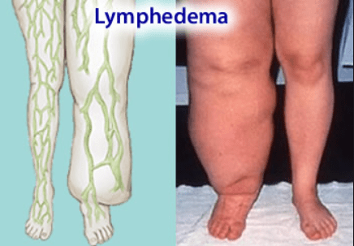
Cancer
Radiation is a potential cause of cancer, and secondary malignancies are seen in some patients. Cancer survivors are already more likely than the general population to develop malignancies due to a number of factors including lifestyle choices, genetics, and previous radiation treatment. It is difficult to directly quantify the rates of these secondary cancers from any single cause. Studies have found radiation therapy as the cause of secondary malignancies for only a small minority of patients. New techniques such as proton beam therapy and carbon ion radiotherapy which aim to reduce dose to healthy tissues will lower these risks. It starts to occur 4 - 6 years following treatment, although some haematological malignancies may develop within 3 years. In the vast majority of cases, this risk is greatly outweighed by the reduction
in risk conferred by treating the primary cancer even in pediatric malignancies which carry a higher burden of secondary malignancies 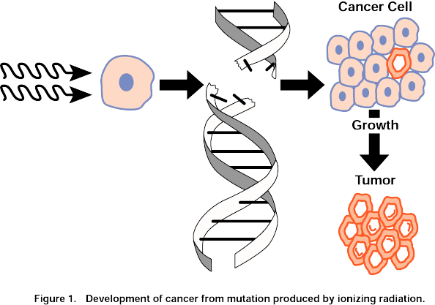

Cardiovascular disease

Radiation can increase the risk of heart disease and death as observed in previous breast cancer RT regimens Therapeutic radiation increases the risk of a subsequent cardiovascular event (i.e., heart attack or stroke) Cardiovascular late side effects have been termed radiation-induced heart disease (RIHD) and radiation-induced vascular disease (RIVD). Symptoms are dose dependent and include cardiomyopathy, myocardial fibrosis, valveular heart disease, coronary artery disease, heart arrhythmia and peripheral artery disease. Radiation-induced fibrosis, vascular cell damage and oxidative stress can lead to these and other late side effect symptoms. Most radiation-induced cardiovascular diseases occur 10 or more years post treatment, making causality determinations more difficulte side effects by 1.5 to 4 times a person's normal rate, aggravating factors included. The increase is dose dependent, related to the RT's dose strength, volume and location.

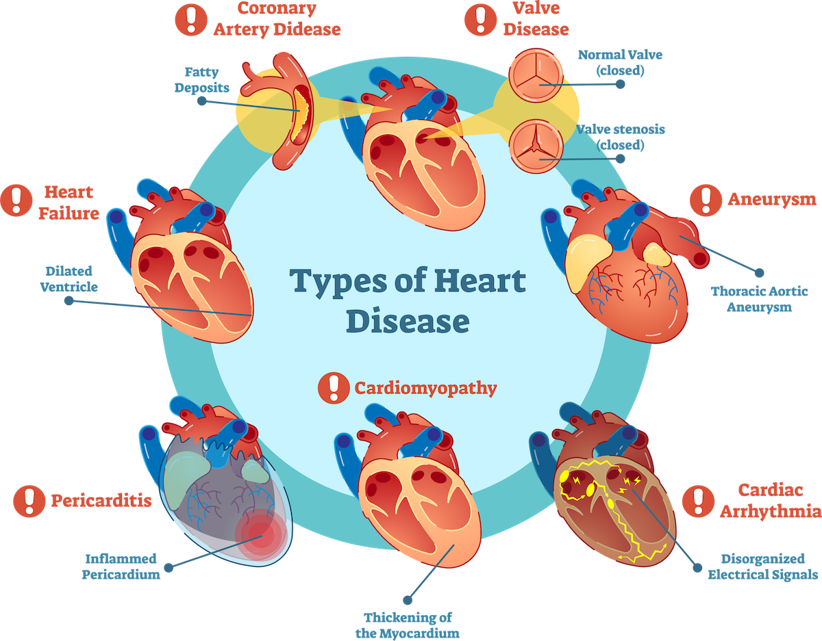

Cumulative
Cumulative effects from this process should not be confused with long-term effects—when short-term effects have disappeared and long-term effects are subclinical, are irradiation can still be problematic. These doses are calculated by the radiation oncologist and many factors are taken into account before the subsequent radiation takes place.

Effects on reproduction
During the first two weeks after fertilization radiation therapy is lethal but not taratogenic. High doses of radiation during pregnancy induce anomalies, impaired growth and intellectual disability and there may be an increased risk of childhood leukemia and other tumors in the offspring.
In males previously having undergone radiotherapy, there appears to be no increase in genetic defects or congenital malformations in their children conceived after therapy. However, the use of assisted reproductive technologies and micromanipulation techniques might increase this risk.

Effects on pituitary system:
Hypopituiterism commonly develops after radiation therapy for sellar and paracellular neoplasm, extracellular brain tumors, head and neck tumors, and following whole body irradiation for systemic malignancies. Radiation-induced hypopituitarism mainly affects growth hormone and gonadal hormones. In contrast, adrenocorticotrophic hormone (ACTH) and thyroid stimulating hormone (TSH) deficiencies are the least common among people with radiation-induced hypopituitarism. Changes in prolactin-secretion is usually mild, and vasopressin deficiency appears to be very rare as a consequence of radiation
