M Mubeen Alam
6906 – BS SE
admin
10/4/2020

Iqra National University Peshawar Pakistan
Department of Computer Science
Summer Semester (Lab Paper), Final Term Exam, September 2020

Paper : | Programming Fundamentals (Lab) | Date and Starting Time: | 01/October /2020, 09:00 am
Program: | BS (CS & SE) | Uploading Date and End Time: | 04/October/2020, 12:00 pm
Teacher Name: | Dr. Fazal-e-Malik | Marks | 100

Note: Attempt all Questions.
Q. 1 | Read A, B and C representing the three sides of a triangle. Write a program to find out its area the formula is given below:  $$Area=\sqrt{S(S-A)(S-B)(S-C)}$$  Where S= $\frac{A+B+C}{2}$  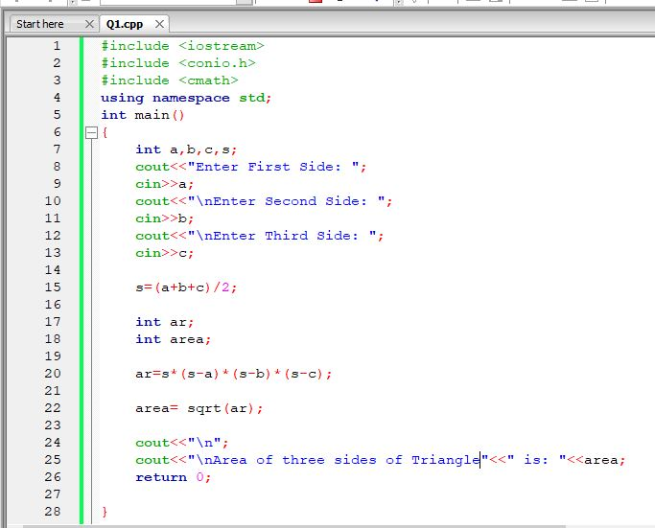
 | 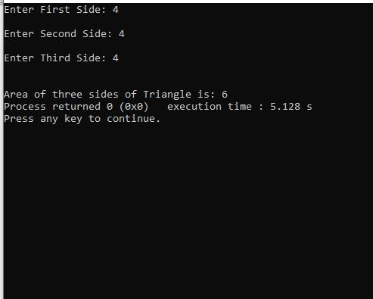
Q. 2 | Write a C++ program to get marks obtained by a student in percentage P and then find the division according to the below rules:  - If Percentage P is above or equal to 60 then display…………..1st Division.  - If Percentage P is between 50 & 59 then display…………………2nd Division.  - If Percentage P is between 40 & 49 then display….……………3rd Division.  - If Percentage P is less than 40 then display………………………Fail.  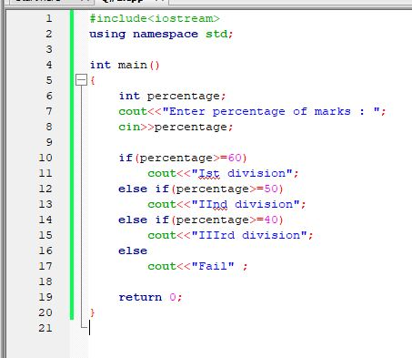  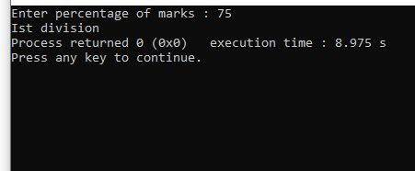
Q. 3 | Write a C++ program to convert 5 feet to the equivalent number of (a) Inches (b) Yards. Where 1foot =12 Inches and 1 yard=3 feet)  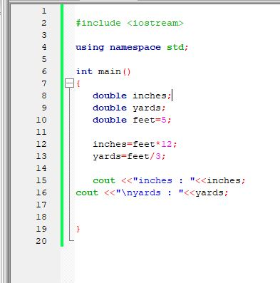  OUTPUT:  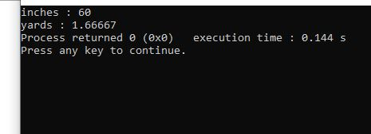
Q.4 | Write a C++ program to find the sum of the following series:  2+4+6+8+10  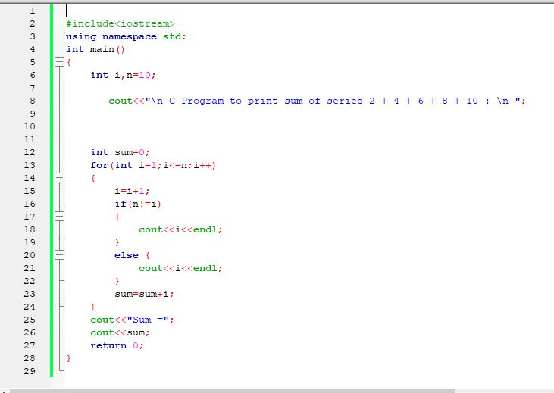  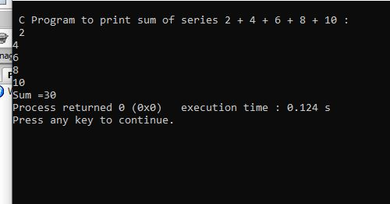
Q.5 | Write a C++ program to input Hours Worked and Hour Rate of an Employee. Calculate and display the Gross-Pay, Tax and Net-Pay; where  Gross-Pay=Hour-Worked*Hour-Rate  Tax=10% of Gross-Pay  Net-Pay=Gross-Pay - Tax  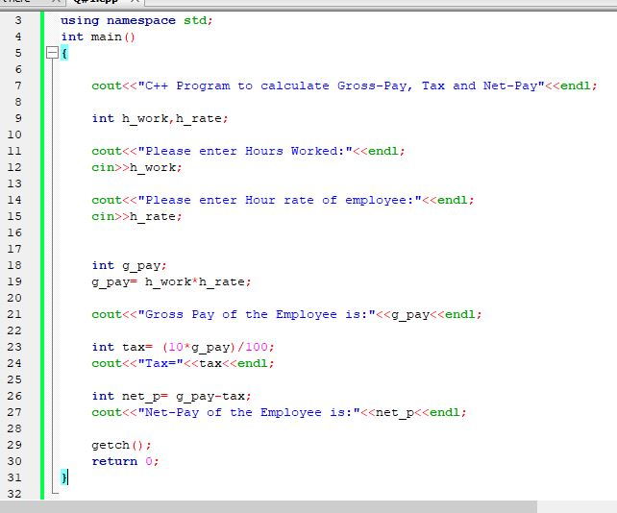  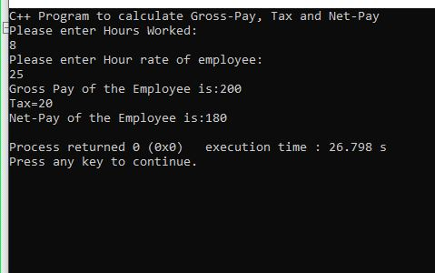
************************

Note:
- I have already uploaded a 20 Marks assignment. If a student does not upload then he/she will get Zero marks out of 20
- Write the answers in MS Word or hand written in scanned PDF Form in one documents and do not send in Zip Form
- Please write your Name and ID on top of your answer Paper otherwise you will get zero marks.

