Mid Term Assignment (2020)
Course Title: Basic Physiology (DT– 2nd) Instructor: Dr. Irfan Ali Khan

Multiple Choice Questions Time: 48 hours
Class Code. __________________________ Name/Class Rollno: MUHAMMAD KAMRAN KHAN__15725___________________
Note:
- Attempt all questions from this section. Select the best answer from given choices.
- Use Blue / Black Ink only. Do not use red color.
- Tick or encircle only one option in each given question.
It’s an open book Conceptual Assignment paper. Time to Use your brain now.

- A short Gap in the myelin sheath around a nerve fiber is called
- Dendrite
- Axon terminal
- Node of Ranvier
- None of these
- The maximum amount of carbon dioxide in the human body is transported as:_______________
- Bicarbonate
- Carbide
- Amylase
- None of the above
- The lungs are protected by___________
- Ribcage
- Sternum
- Backbone
- All of the above
- The three different cells found in the stomach
a) Chief cells, renal cells, nephron
b) Renal cells, mucous cells, hepatic cells
c) Nephrons, hepatic cells, parietal cells
d) Chief cells, parietal cells, mucous cells
- For action potential to occur,
- The stimulus should reach or exceed threshold
- Na+ influx must exceed K+ efflux
- Both A & B
- None of these
- During rising phase of action potential,
- Voltage gated Na+ channels open
- Voltage gated K+ channels open
- Voltage gated Na+ channels close
- Voltage gated K+ channel close

Stay home, stay Safe

- The movement of an esophagus to help the food down the GI tract __________
a) Mastication
b) Emulsification
c) Peristalses
d) Ejection
- Simple diffusion is ________.
- Movement of molecules against the conc. gradient
- Movement of molecules down the conc. gradient
- Both A & B
- None of these
- 97% of Oxygen is carried in blood from lungs is __________________
- Bound to Sulphate ion
- Bound to Hemoglobin
- Dissolved in plasma
- All of these
- Intrinsic factor secreted in stomach helps in
- Absorption of vitamin D
- Absorption of vitamin K
- Absorption of vitamin B12
- Removal of vitamin B12

Midterm Assignment(2020)
Course Title: Basic Physiology (DT- 2nd) Instructor: Dr. Irfan Ali Khan

Time: 72 Hours Section 2

Name: ……………………..…………………… Class/Roll.no …………………………………….
Note:
- Attempt all questions from this section.
- Use only Blue / Black Ink other than diagrams
- Answer Briefly and to the point, avoid un-necessary details

- Draw and Label the Action Potential in a large myelinated nerve fiber. Which ion channels are involved in its different stages?
Key points:
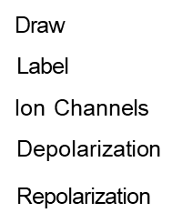

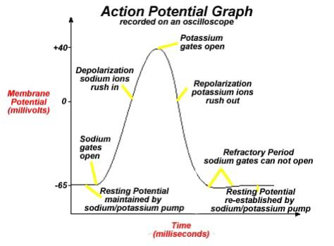

ANSWER NO 1:-
According to the graph
- Resting potential maintained by sodium/potassium pump
- Sodium gates open
- Depolarization sodium ions rush in
- Repolarization potassium ions rush out
- Resting potential re-established by sodium /potassium pump

- What is the role of oxygen, carbon dioxide and hydrogen ions in control of respiration? Marks 10

ANSWER NO 2:-
ROLE OF OXYGEN:-
Oxygen also control the rate of decreases from 60 mm of Hg at will stimulate respiratory center and increases role of respiration.

ROLE OF CO2 AND HYDROGEN AND R
- Carbon dioxide play major role in control of respiration as compared to oxygen because :-
- Co2 is metabolic waste product
- CO2 is toxic
- Most be eliminated from body because it crosses blood brain bareier

ii) Increase Co2 will cause increase in hydrogen ions due to which PH of blood decreases and become more acidic it will activate respiratory center dye which the rate and depth of pulmonary ventilation increases.
iii) Similarly on the other hand decreases co2 level causes decrease in hydrogen ion due which PH will be increases and respiratory rate will be decreased.
Carbon dioxide oxygen and hydrogen ions play important role in regulation of respiration.
CHEMORECEPTOR:-
These are sencory receptor that detect CO2 O2 and H level in blood
LOCATION OF CHEMEORECEPTOR:-
- Respiratory Center (Medulla Oblangata)
- Aorta (Arch of aorta)
- Carotid arteries
ROLE OF CHEMORECEPTOR:-
When blood carbon dioxide level increases it will detected by chemoreceptor in Aorta and carotid arteries .these detection will send impulses to respiratory center (medulla oblangata) through vagus nerve.
Stimulation of respiratory center increases the rate and depth of respiration to eliminate excess carbon dioxide from body.

