Iqra National University
Final Term Paper (Online)
Subject Name: Applied Physics
Class: BS SE-1, CS-1
Instructor: M Khalid Hamid
ID# 16975

Note: Attempt all questions in your own handwriting and then send it only through university portal.
Q1: A slit of width α is illuminated by white light.
- For what value of α will the first minimum for red light of wavelength λ = 650 nm appear at θ = 15°?
ANSWER: 2.5 µm
Therefore, the value of a the first minimum for red light of λ = 650 nm be at θ = 15° would be 2.5 µm.

- What is the wavelength λ’ of the light whose first side diffraction maximum is at 15°, thus coinciding with the first minimum for the red light?
ANSWER: From the above observation we conclude that, the wavelength λ' of the light whose first side diffraction maximum is at 15° would be 430 nm. Light of this wavelength is violet.
Q2:
- What is the difference between reflection and refraction?

ANSWER: Difference Between Reflection and Refraction,
The phenomenon of a light beam rebounding after hitting a surface is called reflection. To put it simply, the mirror images are what are called reflection generally. The light beam that hits the surface is called incident ray. The light beam that leaves the surface is called the reflected ray.
There’s another phenomenon called refraction. Here, the light changes direction, or ‘bends’ as it passes through the boundary between these two media. The images that are witnessed through the glass/see-through objects are a result of refraction.
The angle of incidence and angle of reflection are the same in the case of reflection. For example, when a ray of light strikes a horizontal surface at a 45 degree angle (angle of incidence), it always rebounds at the same 45 degree angle (angle of reflection). These angles are the same even when multiple rays hit the surface and bounce back. For example, a flat mirror produces an image that is upright, and of the same size as the object that is being reflects. The length between the image and object from the mirror also remains the same. This type of reflection is called specular reflection. While most of the objects reflect light in all directions in a microscopic level, the irregularities on the object’s surface will determine the specific rate of reflection. When the light passes through a rough surface, the reflection also happens in different directions. This is called diffuse reflection.

- Explain the difference among angle of incident, angle of reflection and angle of refraction with the help of formulae and a single diagram?
ANSWER: The relationship between the angle of incidence and angle of refraction is explained by Snell's law, which states that ratio of the sine of the angle of refraction and the sine of the angle of incidence is always constant and equivalent to the ratio of phase velocities of the two mediums it is passing through.

What is the relationship between angle of incidence and angle of refraction:
When light passes from one medium to another with different densities, its path gets deviated. This phenomenon is called the refraction of light. Like a reflection, there are similar components in refraction too. They are:
- Incident ray
- Refracted ray
- Normal
- Point of incidence
The angle formed at the point of incidence between the incident ray and the normal is called the angle of incidence. And the angle formed between the refracted ray and the normal is called the angle of refraction.
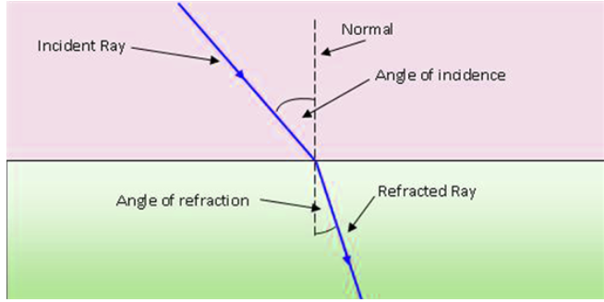

Q3: The long solenoid S shown (in cross section) in the following diagram has 220 turns/cm and carries a current i = 1.5 A; its diameter D is 3.2 cm. At its center we place a 130-turn closely packed coil C of diameter d = 2.1 cm. The current in the solenoid is reduced to zero at a steady rate in 25 ms. What is the magnitude of the emf that is induced in coil C while the current in the solenoid is changing?
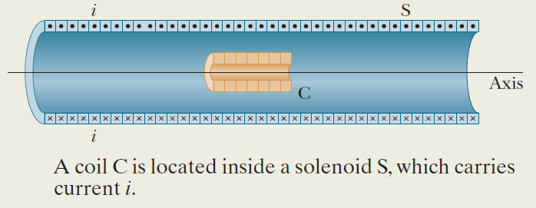

ANSWER:The long solenoid S shown (in cross section) in the figure has 220 turns/cm and carries a current 𝑖 = 1.5 A; its diameter 𝐷 is 3.2 cm. At its center we place a 130-turn closely packed coil C of diameter 𝑑 = 2.1 cm. The current in the solenoid is reduced to zero at a steady rate in 25 ms. What is the magnitude of the emf that is induced in coil C while the current in the solenoid is changing? The initial flux through solenoid C is Φ𝐵𝑖 = 𝐵𝐴C = 𝜇0𝑖𝑛S𝐴C = 𝜋𝜇0𝑖𝑛S𝑟𝐶 2.
Now we can write 𝑑Φ𝐵 𝑑𝑡 = ∆Φ𝐵 ∆𝑡 = Φ𝐵𝑓 − Φ𝐵𝑖 ∆𝑡 = 0 − 𝜋𝜇0𝑖𝑛S𝑟𝐶 2 ∆𝑡 = − 𝜋𝜇0𝑖𝑛S𝑟𝐶 2 ∆ . Substituting gives 𝑑Φ𝐵 𝑑𝑡 = − 𝜋 4𝜋 × 10−7 T ∙ m A 1.5 A 25 ms × 22000 turn m 0.0105 m 2 = −5.76 × 10−4 V.
The magnitude of the induced emf is then ℰ = 𝑁 𝑑Φ𝐵 𝑑𝑡 = 130 5.76 × 10−4 V = 75 mV.
Φ𝐵 = 𝐵𝐴 = 𝜋𝐵𝑟 2 . 𝑑Φ𝐵 𝑑𝑡 = 2𝜋𝐵𝑟 𝑑𝑟 𝑑𝑡 = 2𝜋 0.800 T 0.120 m −0.750 m s = −0.452 Wb s . ℰ = − 𝑑Φ𝐵 𝑑𝑡 = 0.452 V.

Q4:
- How to calculate the magnetic force on current carrying wire?
ANSWER: Magnetic Force:
The force is perpendicular to both the velocity v of the charge q and the magnetic field B. 2. The magnitude of the force is F = qvB sinθ where θ is the angle < 180 degrees between the velocity and the magnetic field.
Calculate the force on the wire shown in Figure 1, given B = 1.50 T, l = 5.00 cm, and I = 20.0 A.
Strategy
The force can be found with the given information by using F=IlBsinθF=IlBsin⁡θ and noting that the angle θ between I and B is 90º, so that sin θ = 1.
Solution
Entering the given values into F = IlB sin θ yields
F = IlB sin θ = (20.0 A)(0.0500 m)(1.50 T)(1).
The units for tesla are 1 T=NA⋅m1 T=NA⋅m; thus,
F = 1.50 N.
Discussion
This large magnetic field creates a significant force on a small length of wire.
Magnetic force on current-carrying conductors is used to convert electric energy to work. (Motors are a prime example—they employ loops of wire and are considered in the next section.) Magnetohydrodynamics (MHD) is the technical name given to a clever application where magnetic force pumps fluids without moving mechanical parts.
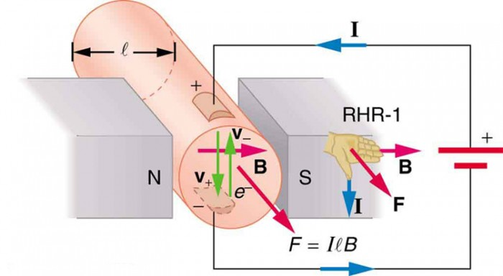
- A straight, horizontal length of copper wire has a current i = 28 A through it. What are the magnitude and direction of the minimum magnetic field B needed to suspend the wire, that is, balance the gravitational force on it? The linear density (mass per unit length) of the wire is 46.6 g/m.
ANSWER:
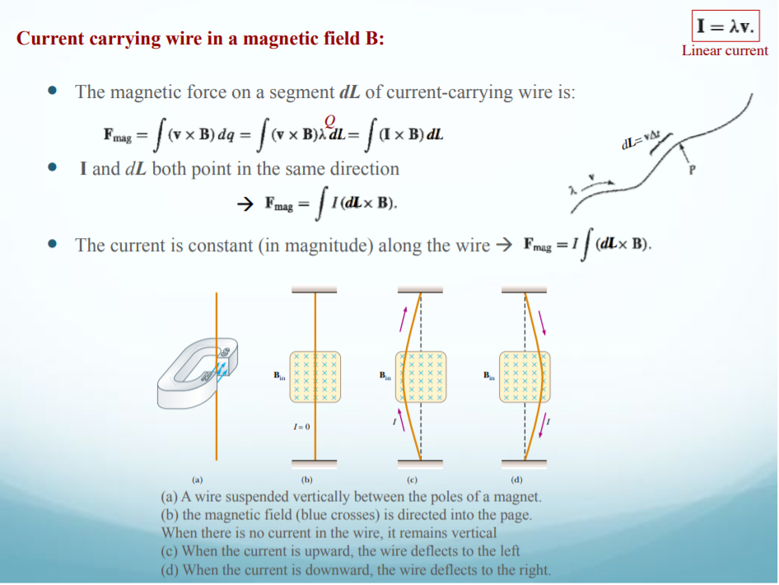
Q5:
- What is the difference between Resistance and Resistivity?
Difference Between Resistance and Resistivity:
Differentiating Property | Resistance | Resistivity
1 | Definition | Resistance is the physical property of a substance because of which it opposes the flow of current i.e. electrons. | Resistivity is the physical property of a particular substance which is having particular dimensions.
2 | Proportionality | Resistance is directly proportional to the length and temperature while it is inversely proportional to the cross-sectional area of the material. | Resistivity is only proportional to the nature and temperature of the particular material.
3 | Symbol | R | ρ
4 | Formula | R = V/I or,  R = ρ(L/A)  V = Voltage, I = Current, ρ = Resistivity | ρ = (R×A)/L  R = Resistance, L= Length, A = Cross-sectional area
5 | SI Units | The SI unit of resistance is Ohms | The SI unit of resistivity is Ohms-meter.
6 | Applications | The property of resistance is used in several places like heaters, fuses, sensors, etc. | Electrical resistivity measurement is used as a quality control test for calcareous soil.

- A rectangular block of iron has dimensions 1.2 cm x 1.2 cm x 15 cm. A potential difference is to be applied to the block between parallel sides and in such a way that those sides are equipotential surfaces as shown in the following diagram. What is the resistance of the block if the two parallel sides are 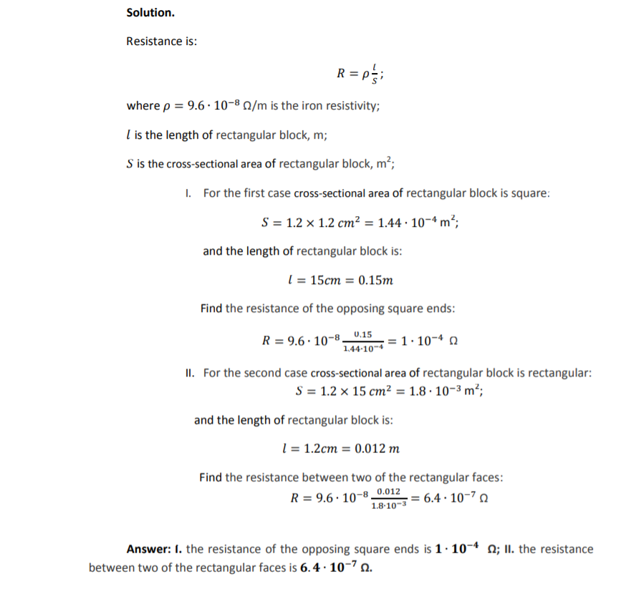

- the square ends (with dimensions 1.2 cm x 1.2 cm)
- two rectangular sides (with dimensions 1.2 cm x 15 cm)?

