Course Title: Histology ll Instructor: Ms. Salma Ishaq
Max Marks: 50
NOTE:
Final term
Name: HILAL AHMAD ID: 14573

Each question carries 10 marks.
Q1: Distinguish the fibrous capsule and articular disc?
Answer:

Fibrous capsule
- It is a thin inelastic fibrous connective tissue envelope that attaches to the margins of the articularsurfaces.
- It is attached superiorly to whole circumference of mandibular fossa inferiorly to neck of mandible
- It stablizesthe joint.
- It acts to resist any medial , lateral or inferior forces that tend to dislocate the articularsurfaces.
- The capsular ligament is well innervated and provide proprioceptive feedback regarding position and movement of the joint.
- The capsule is lined by synovium and joint cavity is filled with synovial fluid.
- The synovial membrane consists of macrophage type A cells and fibroblast like type B cells , like any other joint.
- Synovial fluid is a filtrate of plasma with added mucins and proteins.
- Main constituent is hyaluronic acid.
- It lubricates the joint and decreses friction during joint compression and motion.
- Joint lubrication occurs in two ways:
- Weeping lubrication
- Boundary lubrication

- WEEPING LUBRICATION :
- it occurs as fluid is forced laterally during compression and expressed through the unloaded fibrocartilage.
- As the adjacent areas become loaded , weeping lubrication aids in reducing friction.

- BOUNDARY LUBRICATION :
- It is a function of water that is physically bound to the cartiliginious surface by a glycoprotein.

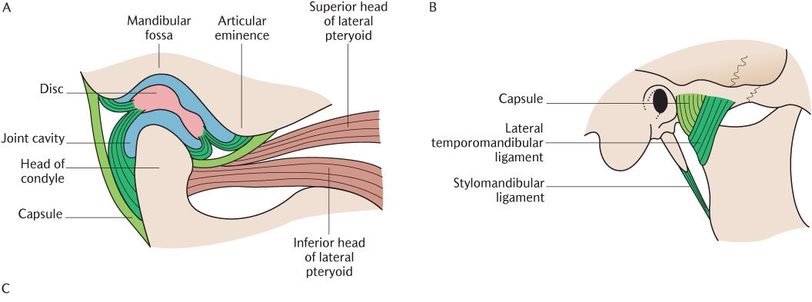

Articular disc:
- The articular disk is a thin, oval plate, placed between the condyle of the mandible and the mandibular fossa.
- Made up of dense collagen,cartilage-like proteoglycans , elastic fibers.
- Arrangement of collagen fibers, at centre, perpendicular to transverse axis periphery, interlaced and many fibers orient parallel to mediolateral aspect of disc.
- Cartilage – like proteoglycans contribute to compressive stiffness of the articular cartilage.
- Disc is attached by ligaments to medial and lateral poles of the condyle.these ligaments permits rotational movement of the disc on the condyle during mouth opening and closing.
- Disc is thinnest at the centre and thickens to form anterior and posterior band ,this arrangement stablizes condyle in the glenoid fossa. In between the anterior and posterior band is the intermediate zone which is the thinnest.
- In the normal joint the articulating surface is located on intermediate zone of the disc.
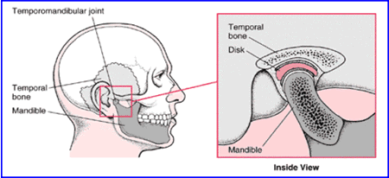

Function of articular disc
- Stabilize the tmj
- Make articular surface
- Reduce wear of TMJ
- Lubrication

Q2: Write a short note on the clinical consideration of salivary glands.
Answer:

Clinical consideration of salivary gland:
- Careful examination of a patient’s medical history and profile can lend clues to dysfunction of the salivary glands because they are often associated with other systemic disorders such as hormonal imbalances, diabetes mellitus, arteriosclerosis, and neurological disorders

For example:
Xerostomia (dry mouth), Sialorrhea (increase salivary flow,both could result from dysfunction of the madullary salivary center, autonomic innervations to the glands, damage to the gland itself, or imbalances in fluid and electrolyte

Clinical consideration:
Radiation caries:
- Radiation caries is a rampant form of dental decay that may occur in individuals who receive a course of radiotherapy that include exposure of salivary glands.

Etiology:
- Carious lesions are produced due to the exposure of salivary glands and reduced flow of saliva, decreased pH, decreased buffering capacity, and increased viscosity.

Signs:
- Superficial lesions (abnormal change in structure) attack the buccal, occlusal, incisal, and lingual surfaces.
- It includes cementum and dentin in cervical lesions.
- Lesions progress around the teeth circumferentially and resulting in loss of the crown

- Sjogren’s syndrome:
- It consists of keratoconjunctivitis (inflammation of cornea and conjunctiva), xerostomia (dry mouth), and rheumatoid arthritis (inflammation of joint). The cause of the disease can be genetic, autoimmunological, etc.

- Xerostomia :
- It is defined as a subjective complaint of dry mouth that may result from a decrease in the production of saliva. It is not a disease but a symptom caused by many factors.

Other consideration
- Viral inflammation of the gland causes it to swell, resulting pain on movement of the jaw.
- Abscesses or cysts of the gland may result in pressure to the facial nerve.
- Stones or calculi in the duct can block it, causing painful swelling of the gland.
- Aplasia, Atresia, stafnnes cyst, Fordyce's granules, local/systemic disease, endocrine, autoimmune, infectious etc

- PAROTID GLAND
- Because of fibrous fascia is covering the parotid, its inflammatory swelling is tense and hard.
- Parotid duct is slightly larger along their course than at their caruncle.
- This permits storage of secretions so that a ready flow may be available on stimulation without waiting for secretary process.
- This relatively static reservoir may form obstructions and are a ready nidus for bacterial activity.
- The close association of the facial nerve with the gland is very important consideration, during surgical procedures.

- SUBMANDIBULAR GLAND
- The entire submandibular gland and duct system lies in a dependent position, which predisposes it to retrograde invasion by oral flora.
- Similar to the parotid duct, the Wharton's duct is also wider before reaching the papilla. This can lead to sangulation of saliva and organic matter.
- The sharp bends of Wharton's duct at the posterior border of the myohyoid muscle allows stasis of the saliva favoring the formation of salivary stones.

- SUBLINGUAL GAND
- The sublingual gland and the minor salivary glands have short ducts, where the chances of stasis are less.
- Thus obstructive lesions do not occur in the glands.
- Since minor salivary glands are placed superficially, the traumatic lesions such as mucoceles commonly effect these glands.

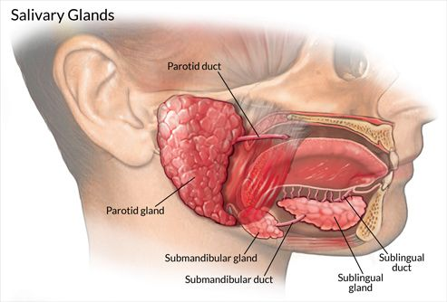
Q3: Describe the factors that play a role in shading?
Answer

Factors that play a role in shadding:
- Odontoclasts
- Pressure

- Odontoclasts:
- Odontoclasts are resorbing cells derived from monocytes & migrate from blood vessels to resorption site, wthere they form multinucleated odontoclast with a clear attachment zone & ruffled border.
- Giant multinuclear cells with 4-20 nuclei
- Resorption occurs at ruffled border which greatly increses surface area of odontoclast in contact with bone.
- Distribution of odontoclast during tooth resorption found on surface of roots in relation to advancing permanent tooth.
- Single rooted tooth shed before root resorption is completed.
- Odontoclasts are not found in pulp chamber of these teeth.
- In molars, roots are completely resorbed & crown is partially resorbed.
- Odontoblasts layer is replaced by odontoclasts.
- Sometimes all dentine is removed & vascular tissue is seen beneath translucent cap of enamel.
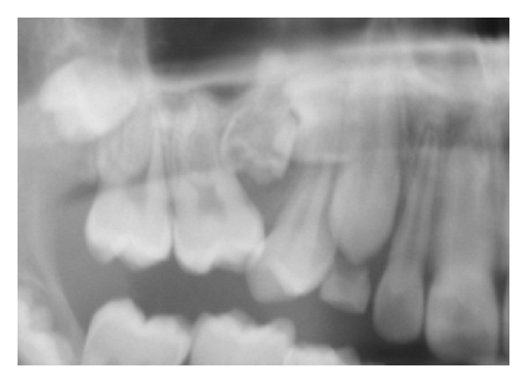

- Pressure:
- The pressure exerted by the erupting permanent teeth seem to play an important role in resorption of deciduous teeth.
- The local pressure is responsible for initiation of resorption.
- In addition to this local pressure, heavy masticatory and muscular forces play a role in resorption.

Mechanism of resorption and shedding

- Pressure from the erupting successional tooth and appearance of odontoclasts at the site of pressure.
- Membrane of ruffled borders act as proton pump -- adding hydrogen ions to extracellular region --- acidification --- mineral dissolution.
- Increased forces of mastication with increase in jaw size leading to trauma to PDL --- degeneration of PDL.
- Resorb bone for the eruption pathway.
- Dental follicle is interposed between the alveolar bone and tooth, it is an ideal location to regulate the cellular events of eruption and receive signals from the tooth.
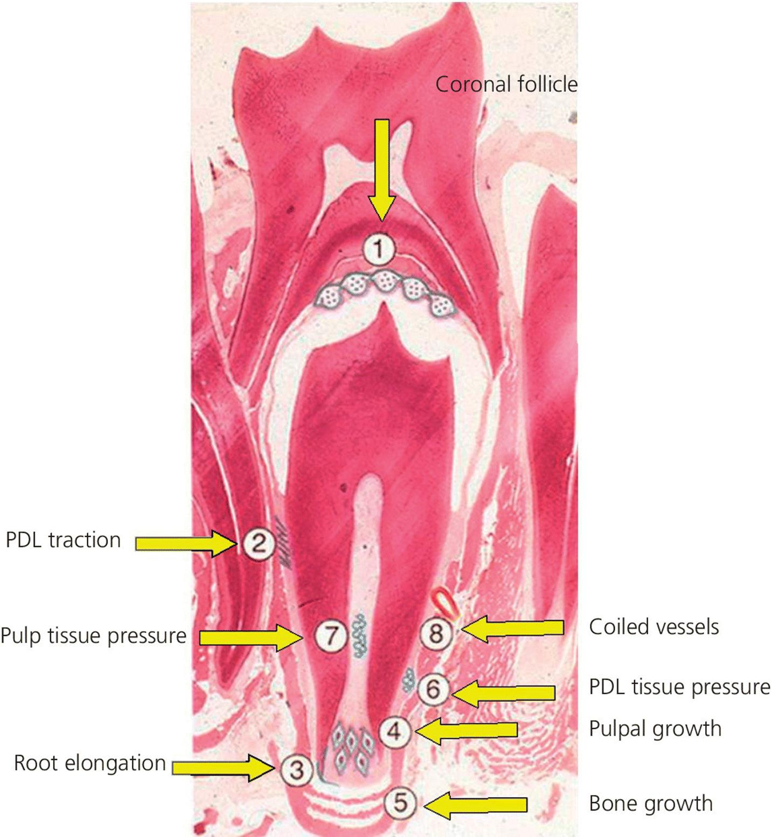

Q4: Explain the classification of tooth movement?
Answer:

Physiology of tooth movement
- The term physiological tooth movement primarily refers to the slight tipping of the tooth in its socket and secondarily to the chapnges in tooth osition that occur during and after tooth eruption

Classification of tooth movement:

- Physiologic tooth movement
- Eruption
- Drifting

- Pathologic tooth movement
- Periodontal pathology
- Oral pathologies

- Orthodontic tooth movement
- Tooth movement under external clinical forces

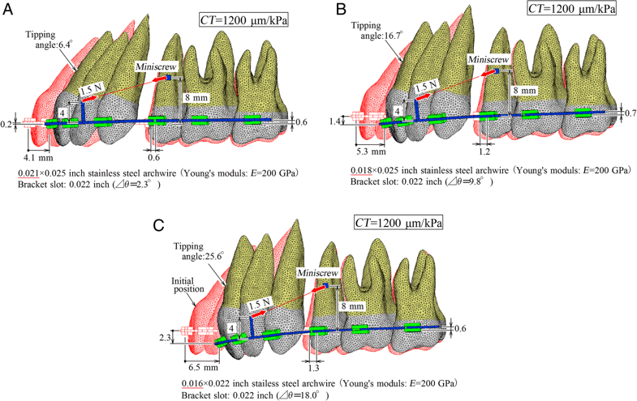

- Physiologic tooth movement
- Naturing cccuring tooth movements that take place during and after tooth eruption

This include:
- Tooth eruption
- Migration or drift of teeth
- Changes in tooth position during mastication.
- Orthodontic tooth movement
- It is a pathological process from which the tissue recovers.

Histology if tooth movement:
- Orthodontic movement bring about areas of pressure and tension around the tooth.
- The histologic changes seen during tooth movement vary according to the amount and duration of force applied.
- Force + pressure = movement

Changes on tension side:
- PDL stretched
- Distance between alveolar process and tooth is widened
- Increased vascularity
- Mobilization of fibroblasts and osteoclasts.
- Osteoid is laid down by osteoblast in PDL immediately adjacent to lamina dura.
- Lightly calcified bone mature to form woven bone

On the tension side
- Over stretched PDL
- Tearing of blood vessels and ischaemia
- Extreme forces applied net Increase in osteoclastic activity and tooth loosened in socket.
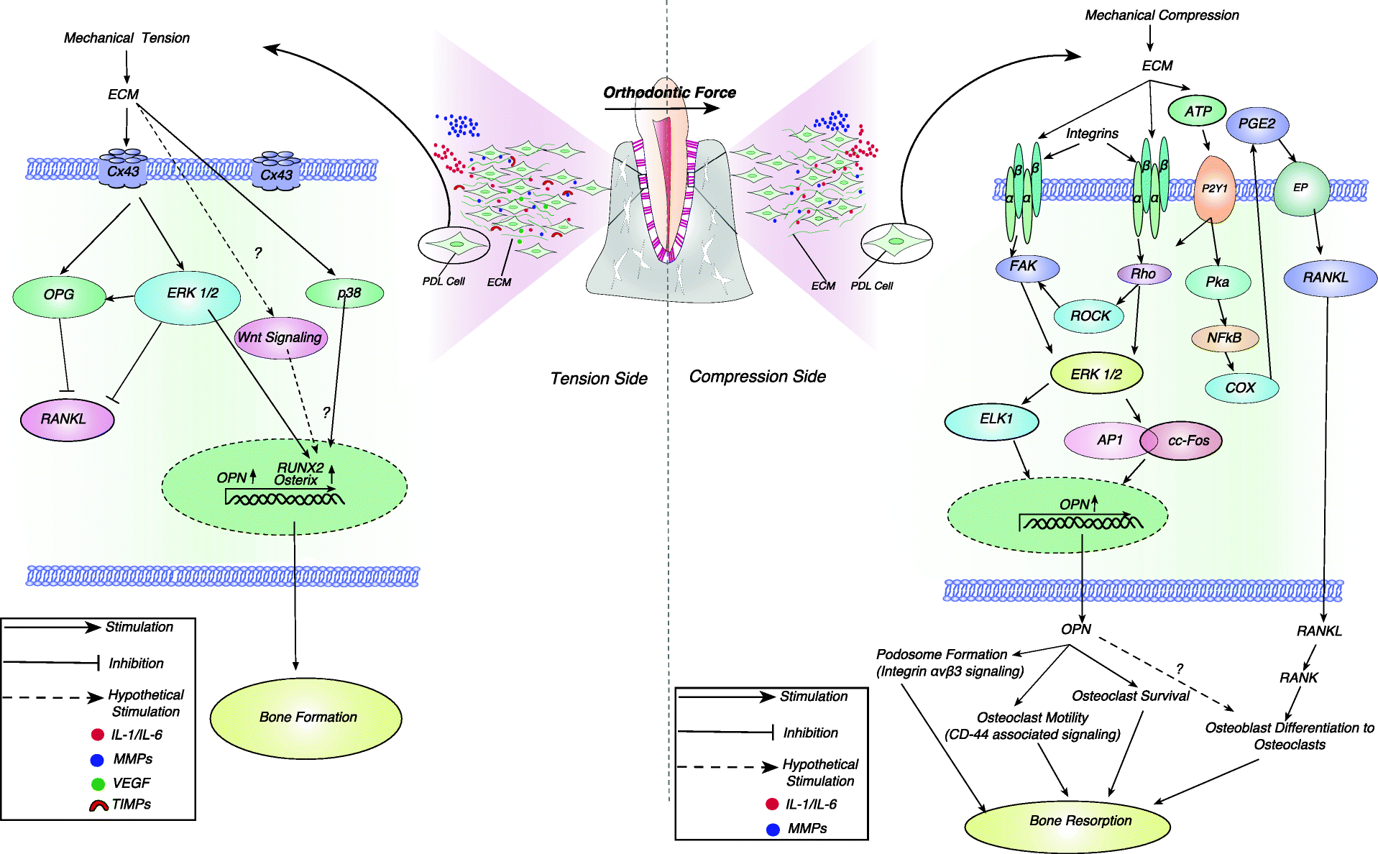
Phases of tooth movement
Burstone categorize the stage as
- Initial phase
- Lag phase
- Post lag phase

Q5: Enlist the function and component of TMJ.
Answer:

Function of the TMJ:
- The temporomandibular joints allow the movement of the lower jaw against the upper jaw, so you can speak and eat.
- The temporomandibular joint is a complex joint system. It has a combination of 2 basic movements. These movements are termed rotation (the initial movement of the jaw when you open your mouth) and translation (gliding motion of the jaw as it is opened widely).
- The rotation occurs in the lower part of the joint and the translation occurs in the upper part of the joint.
- The right and left temporomandibular joints always work together.

Jaw Movement
The movements of the mandible include
Open and close: the opening and closing of the mouth is a combination of rotational and translational movements.
Forward and backward: no rotation occurs. The forward and backward movements of the lower jaw occur in the upper part of the joint.
Side to side: it is also known as grinding movement. Simply, one condyle moves anteriorly while the other rotates around its vertical axis.

Component of TMJ:
The temporomandibular joint (TMJ) consists of:
1. ligaments
2. fibrous capsule
3. Articular disc
4. Lateral ligament
5. Sphenomandibular ligament
6. Stlomandibular ligament

- Fibrous capsule
- Above to the interior edge of the preglenoid plane
- Posteriorly to the squamo tympanic fissure, between these to edges of the articular fossa.
- Below to the periphery of the neck of mandible

- Articular diac
- Fibro cartilaginous disc didviding joint cavity upper and lower compoenent
- Shape ovel
- Its make articular surface

- lateral ligament of jaw
- Attached above the articular bubercle on the root of zygomatic process of temporal bone
- Extend down word and up word angle of 45degree to horizontal attached to lateral surface.
- Function: Prevent posterior displacement of the resting condyle

- Sphenomandibular ligament
- It is an accessory ligament which lies on a deep plane away from the fibrous capsule.
- It is attached auperiorly to the spine of sphenoid and inferiorly to the lingual of the mandibular foramen.
- The fiber are directed downward and outward.

- Synovial fluid
- Synovial fluid serves 2 purposes
- Medium for providing metabolic requirement to the non vascular articular surface of the joint.
- Lubrication between articular surface during fiction.
- The two mechanisms by which synovial fluid lubricates are:
- Boundary lubrication
- Weeping lubrication

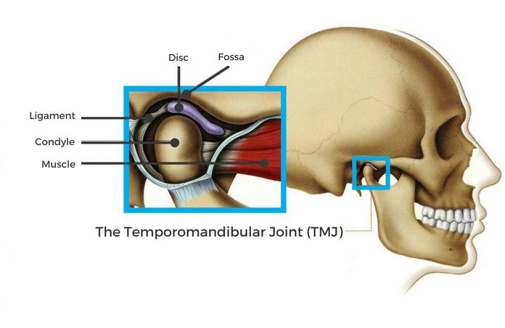

_______________________________________________________________________________
Thank you

