MID TERM ASSIGNMENT
DEPARMENT OF SOFTWARE ENGINEERING

NAME: JIBRAN KHAN
ID NO: 16107
SEMESTER: 2nd
COURSE TITLE : PROGRAMMING
COURSE INSTRUCTOR: SIR AYUB

Question.No.01:
Answer:

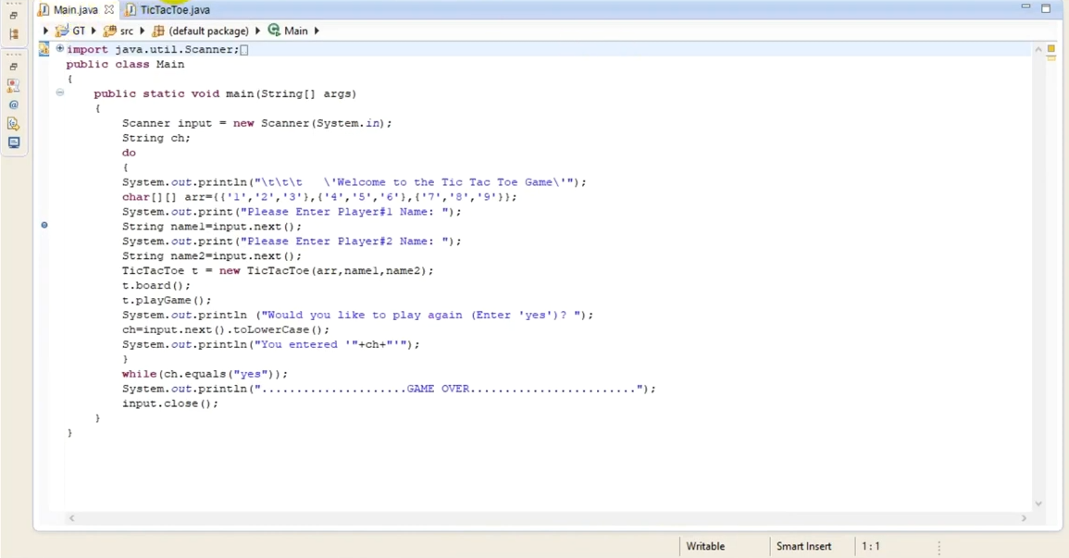

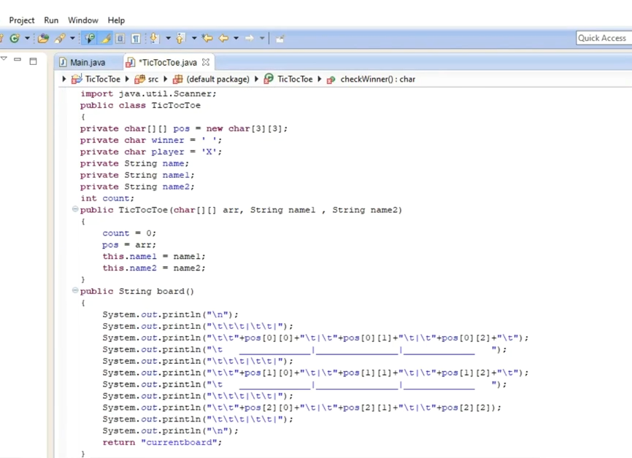

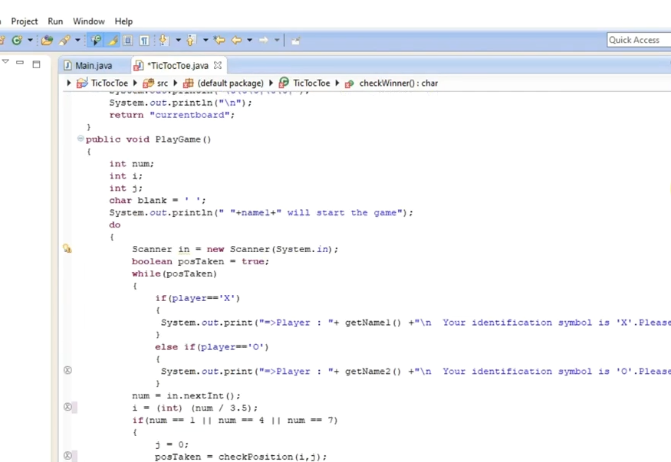
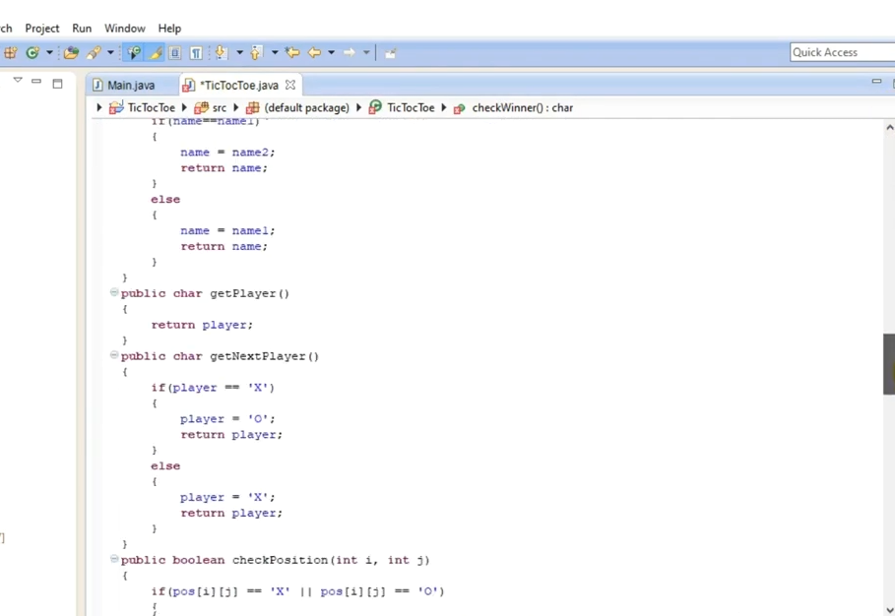

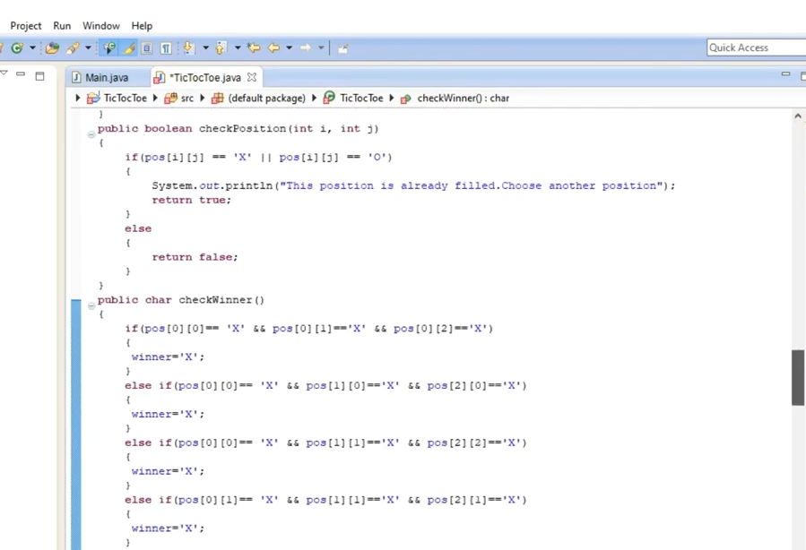
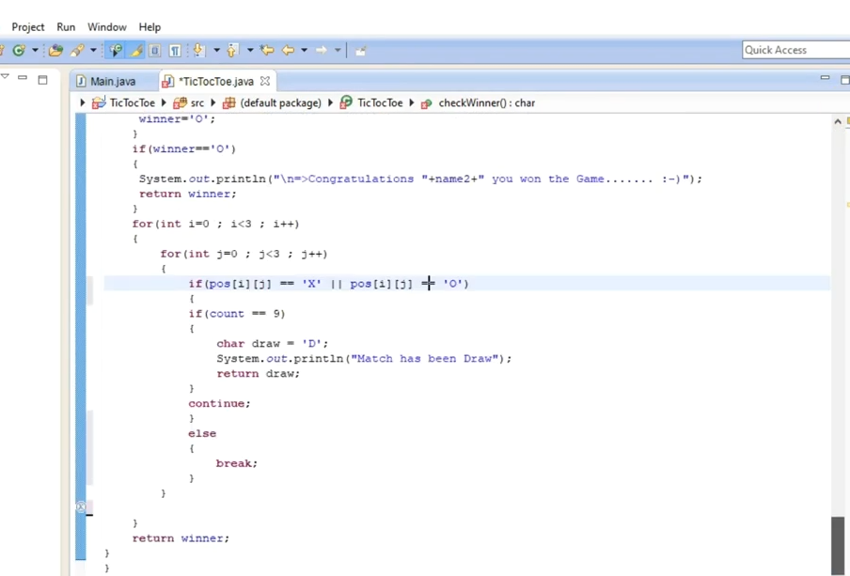
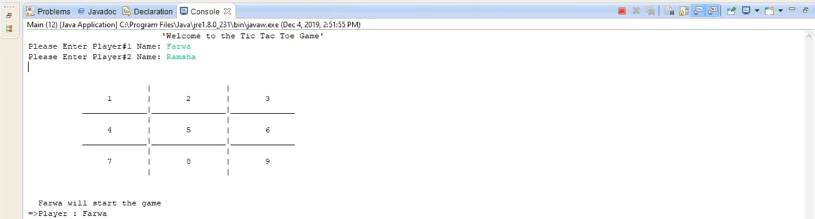

Explanation:
At first, we have to created the two classes - one is main class and the other is Tic Toc Toe class. In main class, we want to the user to enter the name. The Tic Toc Toe game contain some characters so that’s why we are writing the numbers from one to nine. Now we just move towards Tic Toc Toe class, so here we will create a “Two Dimensional Array” and we put the name “position” and add some more variables like string name, string name 1, string name 2 etc. The name 1 and name 2 will contain the player names. The variable will hold either an “X” or an “0” representing which players turn it is at any given point of time. In this Program we used all these methods - Board, play Game, getName1, getName2, get Next Player Name, check Position, check Winner for Tic Toc Toe game. The Board Method display us the board for Tic Toc Toe. The “play Game” is basically just start the game. The “set Name” is being setting the name for player 1 and player 2. The “get Name 1” just return us the player 1 name and as well as the “get Name 2” will just return us the player 2 name. Now the other method “get Next Player Name” will just tell us about who is the next player. The “check Position” will basically check that whether if we choose the position 3 to put up for a circle, so this method would tell us that this position is vacant or not. Hence, the “check Winner” method will check that all the patterns that cross and circles are making gap for make that specific pattern for winning or not and hence any other pattern that is use to win the game. It will just check that and tell us that specific pattern has been achieve and this is the winner. So we will declare the winner. At the last we will click on the console option just for running our program. The output will asking for the players name and hence the Tic Toc Toe game will being started.
THE END

