Name: M Fahad Kamal

ID:13068

Assignment:

Computer Application

1.Insert a Multilevel List:
  - One
  - Two
  - Three
  - Four
  - Five
2.Insert a Heading and Draw an outside border around that heading:
CORONA VIRUS
3.Insert a heading , apply a heading style from home ribbon and customize that heading style. Insert a screen shot of customizing heading style.

Global Communication
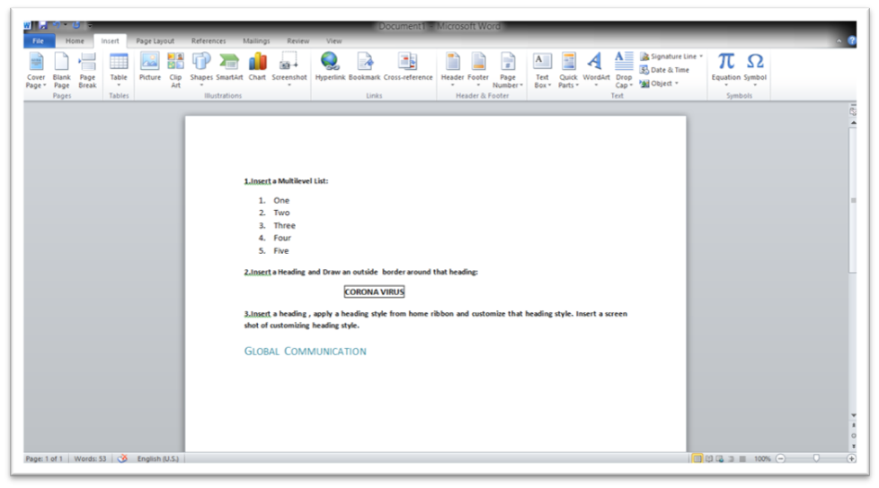
- Insert a hyperlink in the same document.
Word-Eexercise.docx

5.Insert a table of 3 columns ( heading are Roll Number, Name, Address) and 20 rows. Set table property to repeat header rows.

Roll Number | Name | Address
1
2
3
4
5
6
7
8
9
10
11
12
13
14
15
16
17
18
19
20

6.Use header and footer of your choice in your exercise file.
7.Draw the following hierarchy chart using shapes in Insert Ribbon

HRM Director
Operations Director
MarketingDirector
Finance
Director

Personnal Manager
Production Team Leaders
Finance Supervisors
MarketingManagers

Production Team Members Supervisors
Accounts Assistants
Sales Teams

8. Insert a bookmark (insert a random paragraph and use bookmark)

On the Insert tab, the galleries include items that are designed to coordinate with the overall look of your document. You can use these galleries to insert tables, headers, footers, lists, cover pages, and other document building blocks. When you create pictures, charts, or diagrams, they also coordinate with your current document look.
You can easily change the formatting of selected text in the document text by choosing a look for the selected text from the Quick Styles gallery on the Home tab. You can also format text directly by using the other controls on the Home tab. Most controls offer a choice of using the look from the current theme or using a format that you specify directly.
To change the overall look of your document, choose new Theme elements on the Page Layout tab. To change the looks available in the Quick (Bookmark)Style gallery, use the Change Current Quick Style Set command. Both the Themes gallery and the Quick Styles gallery provide reset commands so that you can always restore the look of your document to the original contained in your current template.
On the Insert tab, the galleries include items that are designed to coordinate with the overall look of your document. You can use these galleries to insert tables, headers, footers, lists, cover pages, and other document building blocks. When you create pictures, charts, or diagrams, they also coordinate with your current document look

9. Change the page color of your exercise and page border.
10.Use a watermark in your document.
11. Insert table of contents in your document

CONTENTS
1.Global Communication
2.Agenfa setting
3.Communication Strategies
4.Models

Table of Contents

C Language 1
Introduction 2
Statements 3

C++ 4
Introduction 5
Statements 6

