Mid Term Assignment (2020)
Course Title: Basic Physiology (DT– 2nd) Instructor: Dr. Irfan Ali Khan

Multiple Choice Questions Time: 48 hours
Class Code. ___ID 16592_______________________ Name/Class Rollno: ______Ikramullah jan______________________
Note:
- Attempt all questions from this section. Select the best answer from given choices.
- Use Blue / Black Ink only. Do not use red color.
- Tick or encircle only one option in each given question.
It’s an open book Conceptual Assignment paper. Time to Use your brain now.

- A short Gap in the myelin sheath around a nerve fiber is called
- Dendrite
- Axon terminal
- Node of Ranvier
- None of these
- The maximum amount of carbon dioxide in the human body is transported as:_______________
- Bicarbonate
- Carbide
- Amylase
- None of the above
- The lungs are protected by___________
- Ribcage
- Sternum
- Backbone
- All of the above
- The three different cells found in the stomach
a) Chief cells, renal cells, nephron
b) Renal cells, mucous cells, hepatic cells
c) Nephrons, hepatic cells, parietal cells
d) Chief cells, parietal cells, mucous cells
- For action potential to occur,
- The stimulus should reach or exceed threshold
- Na+ influx must exceed K+ efflux
- Both A & B
- None of these
- During rising phase of action potential,
- Voltage gated Na+ channels open
- Voltage gated K+ channels open
- Voltage gated Na+ channels close
- Voltage gated K+ channel close

Stay home, stay Safe

- The movement of an esophagus to help the food down the GI tract __________
a) Mastication
b) Emulsification
c) Peristalses
d) Ejection
- Simple diffusion is ________.
- Movement of molecules against the conc. gradient
- Movement of molecules down the conc. gradient
- Both A & B
- None of these
- 97% of Oxygen is carried in blood from lungs is __________________
- Bound to Sulphate ion
- Bound to Hemoglobin
- Dissolved in plasma
- All of these
- Intrinsic factor secreted in stomach helps in
- Absorption of vitamin D
- Absorption of vitamin K
- Absorption of vitamin B12
- Removal of vitamin B12

Midterm Assignment(2020)
Course Title: Basic Physiology (DT- 2nd) Instructor: Dr. Irfan Ali Khan

Time: 72 Hours Section 2

Name: ……………………..…………………… Class/Roll.no …………………………………….
Note:
- Attempt all questions from this section.
- Use only Blue / Black Ink other than diagrams
- Answer Briefly and to the point, avoid un-necessary details

- Draw and Label the Action Potential in a large myelinated nerve fiber. Which ion channels are involved in its different stages?
Key points:
1:rest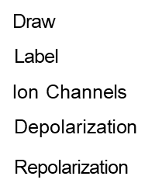
3:depolarization
4:repolarization
5:potential
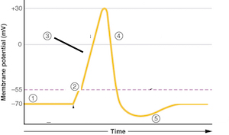

- What is the role of oxygen, carbon dioxide and hydrogen ions in control of respiration? Marks 10

ANSWER: Role of oxygen,carbondioxide and hydrogen ions
In control of respiration.
Carbondioxide,oxygen and hydrogen ions play very
Important role in respiration of human body.The
Chemicals (carbondioxide,hydrogen ions and oxygen)
Levels are the most iportant factors that regulate
Respiration.During respiration oxygen goes inside
The body while carbondioxide outside the body.
The inhalation of air called Inspiration ,and The
Exhalation of air called Expiration.

