NAME AFTAB SHEHZAD
ID 16138
SECTION A
SEMESTER 2ND
PAPER (ENGINEERING MECHANICS) Civil engineering department

Q.1
ANS
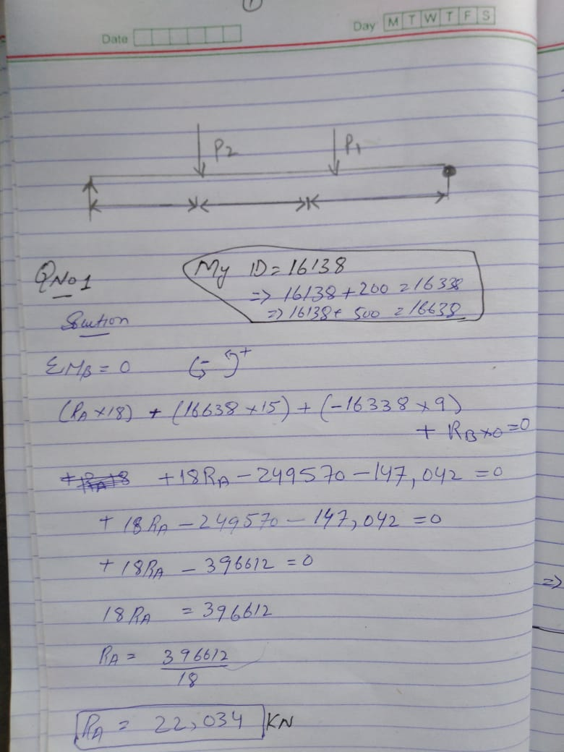
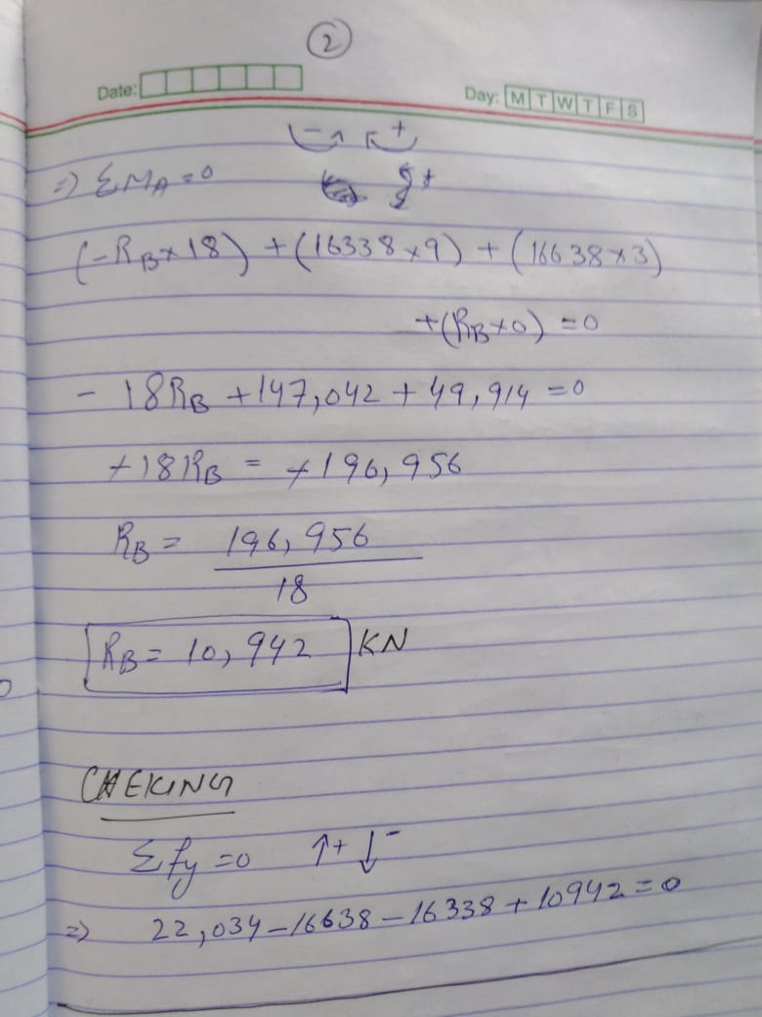

Q.2
ANS
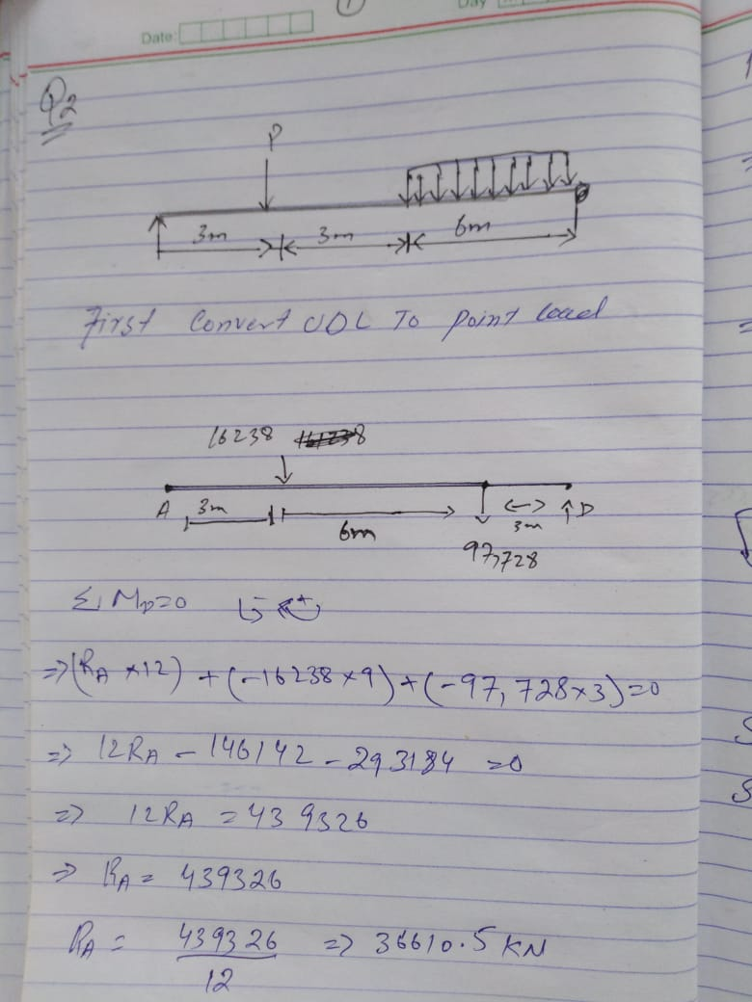
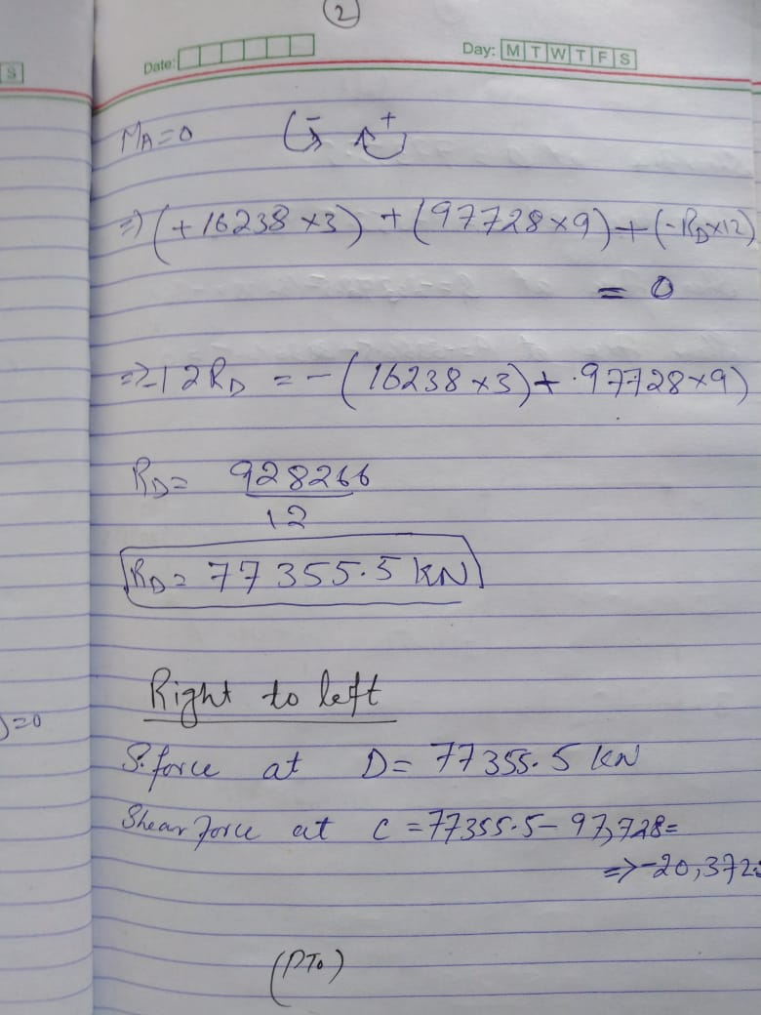
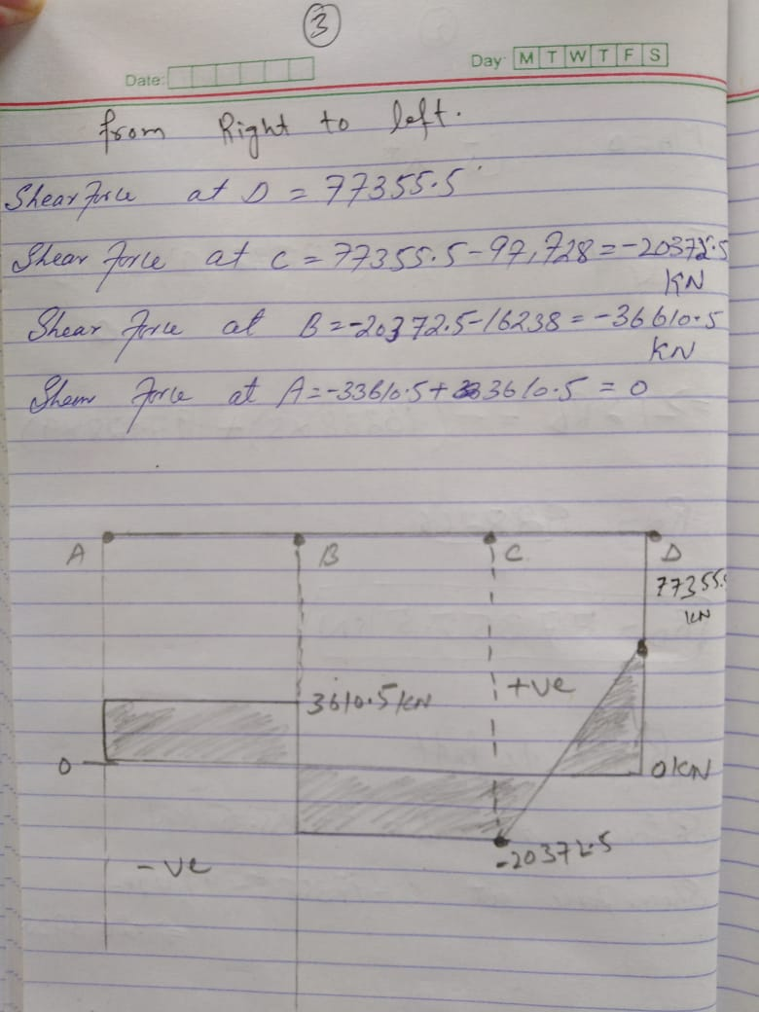

Q.3
Ans
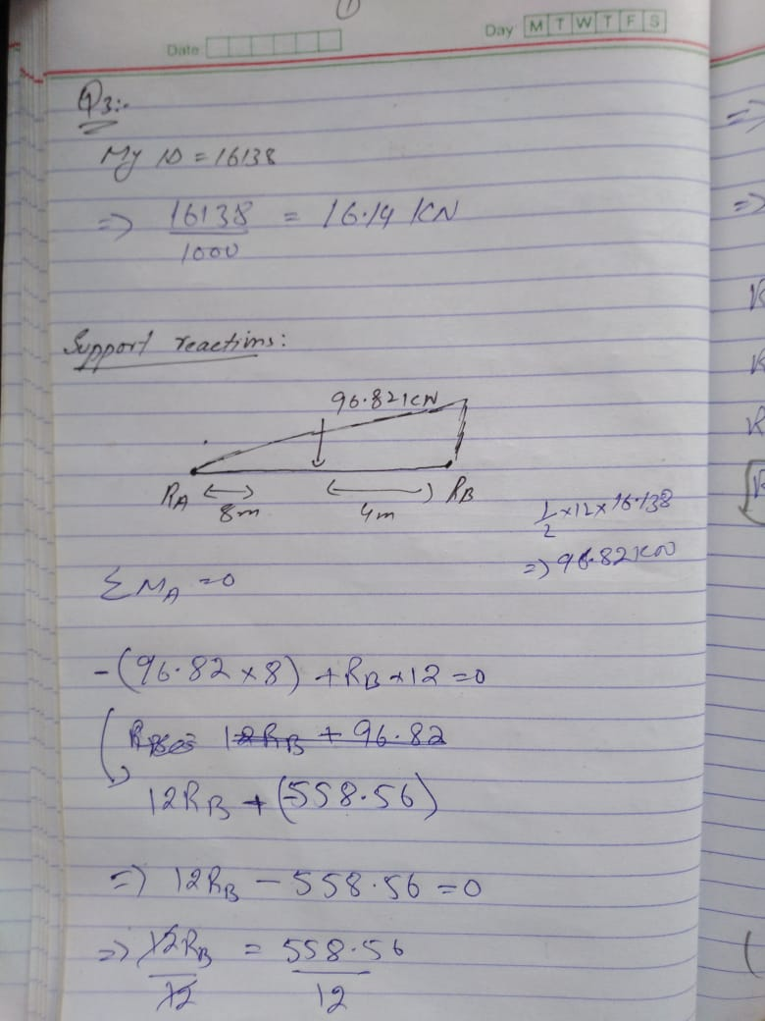
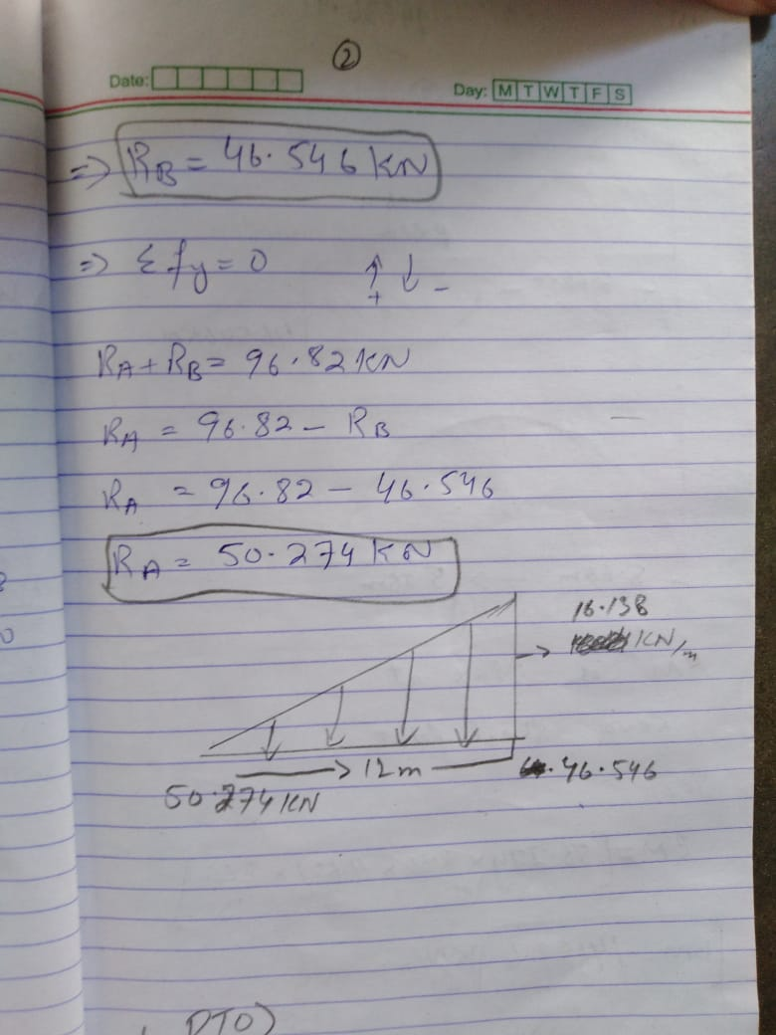
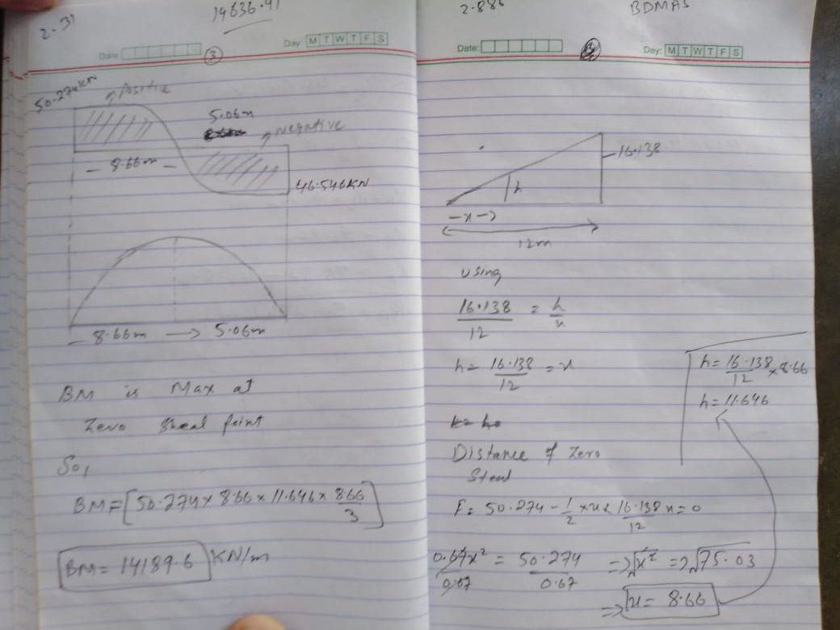
Q.4
ANS
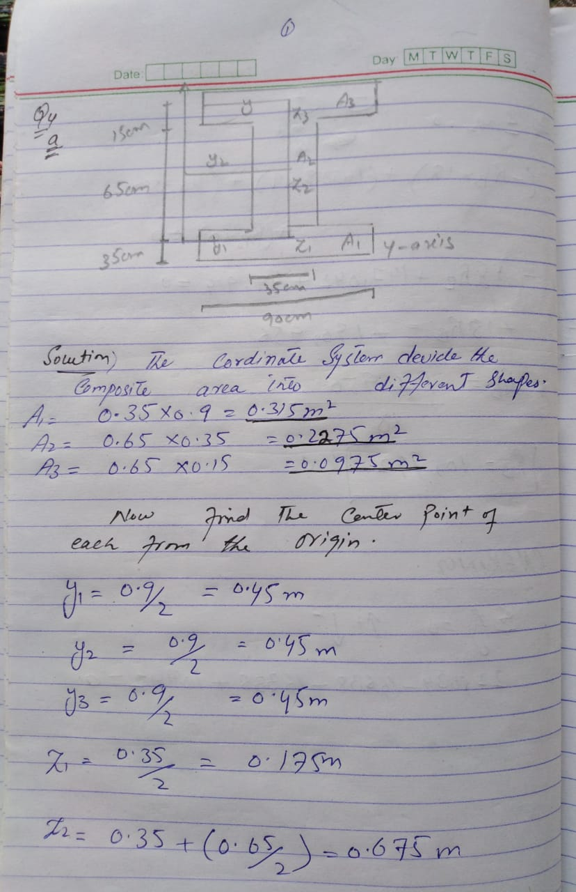
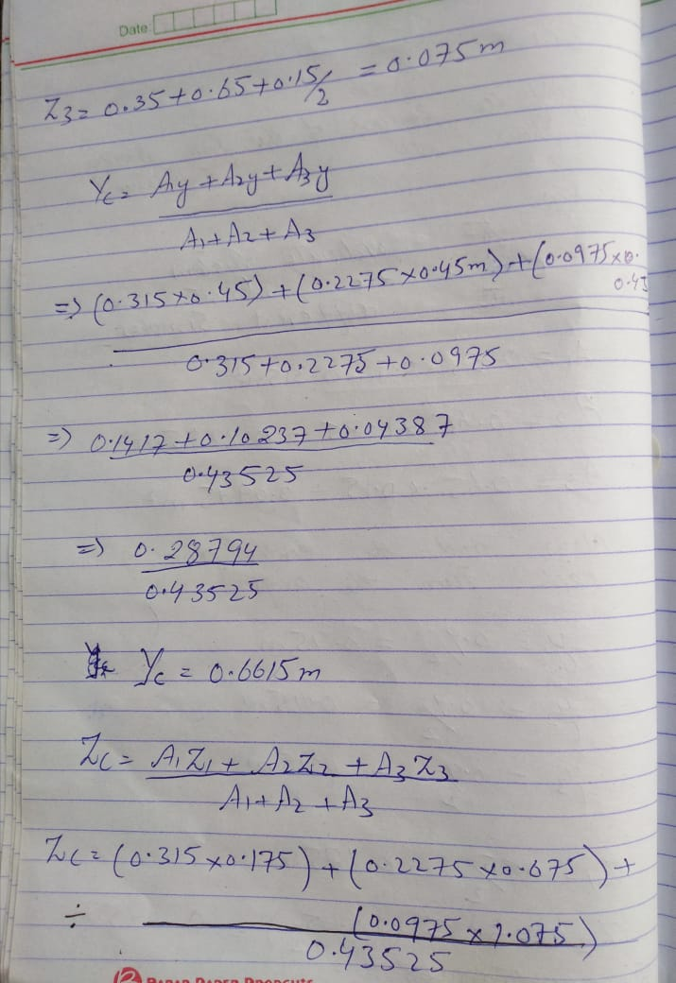
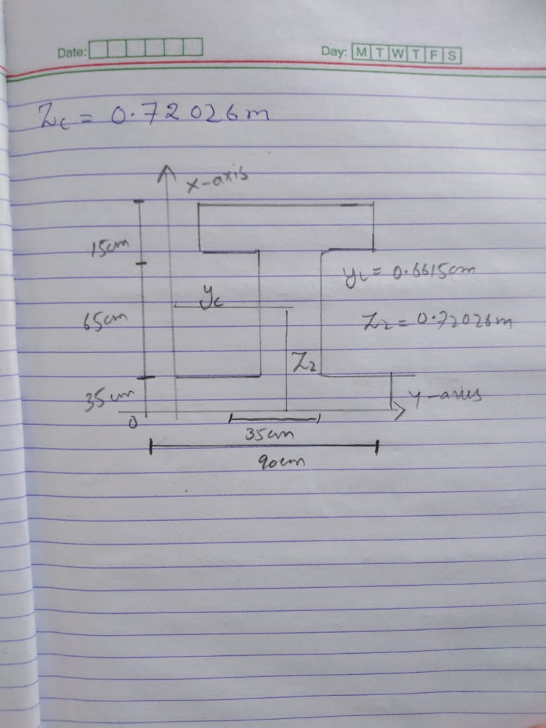
B
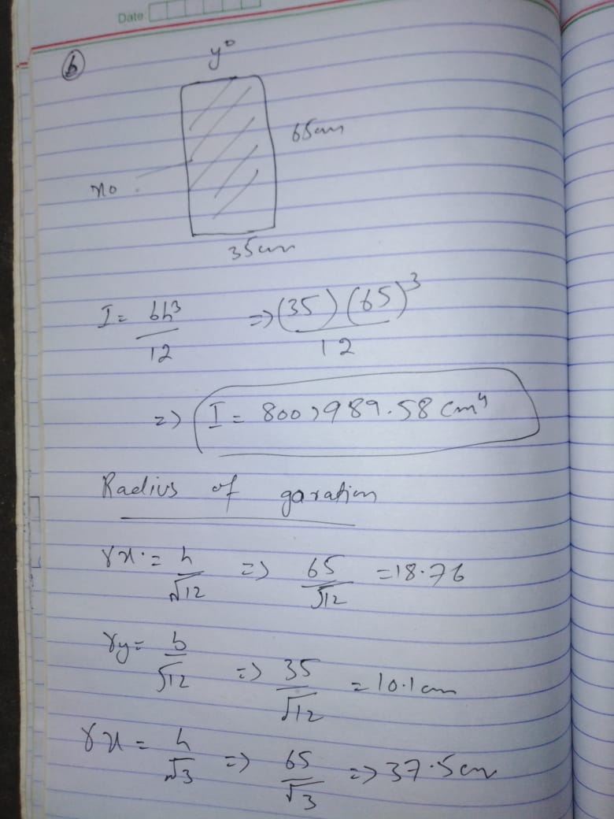
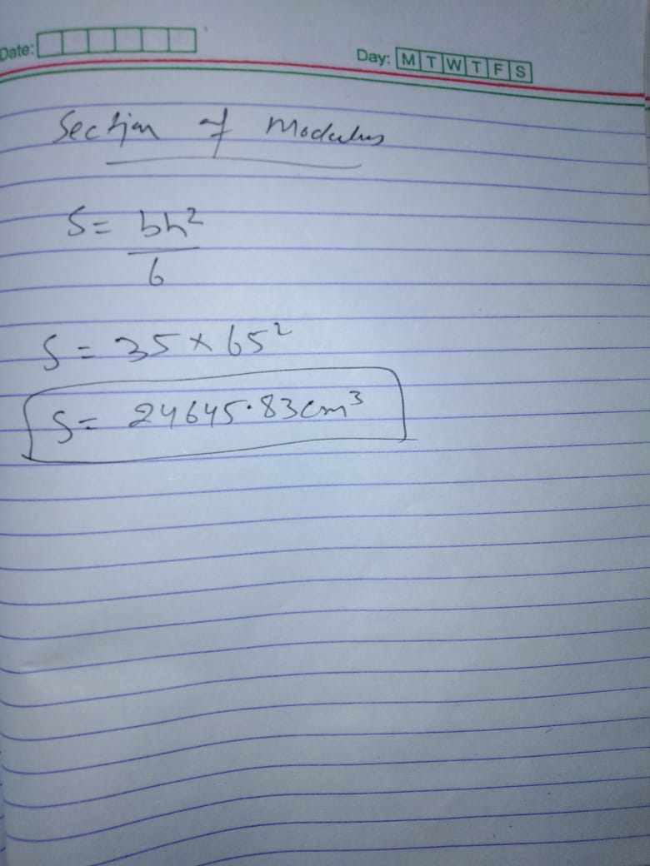
Q.5
ANS
Work:
work is defined as a force causing the movement—or displacement—of an object. In the case of a constant force, work is the scalar product of the force acting on an object and the displacement caused by that force. Though both force and displacement are vector quantities, work has no direction due to the nature of a scalar product (or dot product) in vector mathematics.
Explanation of Work
work is the product of force and displacement. A force is said to do positive work if (when applied) the force has a component in the direction of the displacement of the point of application. A force does negative work if the force has a component opposite to the direction of the displacement at the point of application of the force.Work transfers energy from one place to another, or one form to another.
Work W done by a constant force of magnitude F on a point that moves a displacement s in a straight line in the direction of the force is the product
W=Fs.
If the force is being exerted at an angle θ to the displacement, the work done is
W = fd cos θ.
Work transfers energy from one object to another. We've already talked about moving objects. Work is closely related to energy.
Unit of Work
If a force of 5 newtons is applied to an object and it moves 2 meters, the work will be 10 newton-meter. Newton meter in termed and Joules and it is the unit of Work.
Example of work
There are several good examples of work that can be observed in everyday life, Pushing a car horizontally from rest; shooting a bullet (the powder does the work); walking up stairs; sawing a log.
Energy:
Energy is the ability to perform work. Energy can neither be created nor destroyed. It can only be transformed from one kind to another. The unit of Energy is same as of Work i.e. Joules. Energy is found in many things and thus there are different types of energy.All forms of energy are either kinetic or potential. The energy in motion is known as Kinetic Energy whereas Potential Energy is the energy stored in an object and is measured by the amount of work done.Some other types of energy are, Chemical energy, Electric energy, Magnetic energy etc.
Unit of energy
The SI unit of energy is joules (J), which is named in honour of James Prescott Joule.
Example of energy
They include watching television, washing clothes, heating and lighting the home, taking a shower, working from home on your laptop or computer, running appliances and cooking.
Formula for energy
formula E= 1/2 mv^2.
Power:
Power is a physical concept that has several different meanings, depending on the context and the information that is available. We can define power is the rate of doing work. It is the amount of energy consumed per unit time.
Formula of power
As discussed power is the rate of doing work. Therefore it can be calculated by dividing work done by time. The formula for power is given below.
P=Wt
Where, P = Power, W = Work done, T = Time taken.
Unit of Power
As powers don’t have any direction, it is a scalar quantity. The SI unit of power is Joules per Second (J/s), which is termed as Watt. Watt can be defined as the power taken to do one joule of work in one second.
Example of power
An example of power is the strength needed to run five miles. A car engine is an example of a machine that is given a power rating.

