Physiology paper
Name warda
Id 16101
DPT section B
2nd semester
Submitted to mam kausar

Question 1
Answer:
Pituatry gland:
- The pituatry gland is small pea size gland.
- This gland is attached to the part of the brain the hypothalamus. Which controls its activitie.
- The pituitary gland is also called master gland of the body because it controls the activity of most other hormone secreating gland.

Hormones secreted by pituitary gland :
Anterior pituitary gland:

1 ) Growth hormone:
- It is also called somatotrpin.
- It regulates growth, Metabolism and body composition.

Abnormalities og growth hormones:
- When less amount of growth hormones are secreated than normal during childhood than dwarfism occurs.
- When large amount of growth hormones are produced than Gigantism occurs.
- Acromegaly a condition in which a person cannot grow taller but the bones become thicker And the soft tissues continues to grow.
Prolactin :
- It stimulates milk production.
Abnormalities:
Hyperprolacitnemia;
- Excess production of prolactin in non pregnant woman can result in irregular or absent period, lack of ovulation and sometimes head ache and visual symptoms.

Adrenocorticotropin hormone :
- Acts on adrenal gland and secrets adrinocortical hormone , mainly cortisol.

Abnormalities:
- Too much cortisol over a prolonged period of time can lead to a condition called cushning’s syndrome.
- Less production of cortisol results in adrenal insufficiency.

Thyroid stimulating hormone:
- It acts on thyroid gland and secrets thyroxin (T4) and Triiodothyronine (T3) which stimulates the metabolism of almost every tissue in the body.
Abnormalities:
- Goiter is formed due to underproduction of thyroid hormone.
Lutenizing hormone and follicles stimulating hormone:
- These are also called gonadotrophins because they act on ovaries or testes to stimulate sex hormone production and maturity of egg and sperm.
Abnormalities:
- Deficiency of LH cause sexual dysfunction and infertility .
Posterior pituatry gland:
Oxytocin:
- It stimulates uterine contraction during labour and milk secretion during breast feeding.
Abnormalities
- Low level of Oxytocin can lead to autism autistic spectrum disorder.

Antidiuretic hormone (ADH)
- It is also called vassopressin , which controls water balance and blood pressure.

Abnormalities:
- Very high level of ADH can cause fluid imbalance which lead to cerebral edema.
- Diabetes inspidus is caused by lack of ADH.

Question 2
Answer:
Erythrocyte:
- A red blood cell,which (in human ) is a biconcave disc without nucleus.

- Itt contain hemoglobin, and helps in transport of oxygen and carbondioxide to and from the tissues.

Erythropoiesis:
- It is process by which red blood cells are produced .
- The whole process last about 7 days .
- This process is stimulated by the decrease O2 in circulation which is detected by kidney,and then secrets a hormone erythropoitin.
Erythrocytosis:
- Increase in red blood cells mass than normal is called erythrocytosis .
- polyChythemia are sometimes called erythrocytosis but these two terms are not synonymous because polychythemia is ,any increase in Red blood cells.

Erythropenia:
- Decrease or Deficiency of erythrocytes is called erythropenia.
- It is also associated with anemia.
- Pathological : primary erythropenia caused by bone marrow dosorder.
- Secondary erythropenia is caused by kidney disorder.
Question 3
Answer
Platelets:
- It is also known as thrombocytes.
- Platelets are tiny blood cells that help your body to form clots to stop bleeding .
- Lifespan 10 days.
Clotting :
- Clotting is also known as coagulation, is the process by which blood changes from the liquid to gel, forming a blood clot .

Initiation of mechanism:
- Instantly after an injury to the blood vessels which has damaged the endothelium lining vessel.
- Clotting mechanism stops bleeding from damaged vessels and maintain hemostasis.
Clotting mechanism:
Clotting mechanism involves following steps;

Adhesion:
- Injury to the blood vessel.
- Endothelium lining damaged
- Blood comes into space under endothelium .
- Underlying collagen exposed to circulating platelets.
- Platelets binds with surface receptors of collagen and adhere tightly. This all process is called adhesion.

Activation :
- Platelets change shape.
- Turn on receptors and secrets chemical messengersto activate and invite additional platelets.
- Activated platelets adhere tightly at injury sites.
Aggregation:
- Platelets connect to each other through receptor bridges
- Platelets plug formed at the injury site unless the interruption is physically too large.

Fibrin deposition:
- Formation of platelet plug will ensure primary hemostasis .
- Now fibrin deposition start and thus started Secondary hemostasis.
- Thus fibrin clot formed.
- Now clot retraction and platelet inhibition.

Question 4
Answer
ABO blood system:
- It is the classification of human blood based on the inherited properties of red blood cells as determined by the absence or presence of the antigen A and B, which are carried on the surface of red cells.
- Discovered by:
- In 1900, karl Landsteiner, at the University of Vienna , discovered the ABO blood group system.
Blood types:
1 ) A group
2 ) B group
3 ) AB group
5 ) O group

Role of blood group in blood transfusion:
- The accurate grouping of blood is very important when it comes to having a blood transfusion . If blood is given to a patient that has a blood type that is incompatible with the blood type of the blood that the patient receive , it can cause clumping in the patient blood which can be fatal.
- The patient body can start producing antibodies that attack the antigens on the blood cells in the blood that was given to the patient causing reaction and rejection.
- Example;
- A patient having blood group A has Anti B antibodies in their blood plasma . If this patient recive blood group B than anti B antibodies in the plasma of the patient will cause the blood group B red cells to clump which is life threatening.

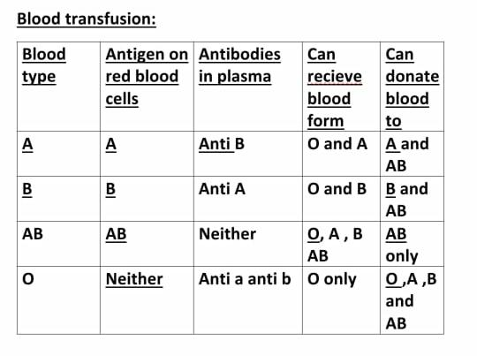
O blood group is universal donor
Ab blood group is universal recipent.

Question: 5 (a)
Answer :
If a person fell from tree and become unconscious with bleeding from head ;
- Keep the person still ,until medical health arrives,keep the injured person lying down and quiet with the head and shoulder slightly elevated.
- Stop bleeding. Apply firm pressure to the wound with sterile gauze or a clean cloth.
- Watch for changes In breathing and alertness.

Question 5 (b)
Answer:
- First we Should avoid meeting with our friend and talk on the phone or do a video call with her.
- But if its very important to meet her than keep 6 feet of distance between you and your friend.
- Wear a cloth face covering or face mask .
- Use of gloves
- And use of hand sanitizer
- And donot shake hand.

