Final term paper
Subject: water demand supply and distribution

Course code: CE-562

Submitted to: Engr Nadeem Ullah

Submitted by: Muhammad Izhar Khan

ID:12838

Q1. Define desalination and briefly describe various desalination methods? Which
method is more effective, please elaborate briefly?

Answer1:
Desalination: is a technique where the excess salts are removed from sea water or brackish water converting it into safe potable or usable water or desalination is a water supply option that is used widely around the world and involves taking the salt out of water to make it drinkable

Distillation
Distillation is the process of separating the components or substances from a saline water by using selective boiling and condensation. Distillation may result in essentially complete separation (nearly pure components), or it may be a partial separation that increases the concentration of selected components in the saline water.

Electro dialysis
Electrodialysis (ed) is used to transport salt ions from one solution through ion-exchange membranes to another solution under the influence of an applied electric potential difference.
It draws metal ions to the positive plate on one side, and other ions (like salt) to the negative plate on the other side

Freezing method
It is based on the principle that Saline Water Sample water excludes salts when it
crystallizes to ice. It involves three steps: Ice formation, ice washing, and ice melting to obtain fresh water with subsequent removal of contaminants

Reverse osmosis
Reverse osmosis (RO) is a water purification process that uses a partially permeable membrane to remove ions, unwanted molecules and larger particles from drinking water. In reverse osmosis, an applied pressure is used to overcome osmotic pressure, a colligative property that is driven by chemical potential differences of the solvent, a thermodynamic parameter.

Reverse osmosis Membrane methods are the most effective and fouling can be mitigated. The most robust systems are Reverse Osmo

since they are the most used in the world

Q2. Briefly describe merits and demerits of 4 types of water distribution layouts?Which layout will you recommend for newly proposed township in hilly area?Support your answer with justification?
Answer:
There are four principal methods to design a distribution system:
- Dead end or tree system
- Gridiron system
- Circular or ring system
- Radial system

1. Dead-end or tree distribution system
Description
In the dead end system (also called tree system), one main pipeline runs through the centre of the populated area and sub-mains branch off from both sides. The sub-mains divide into several branch lines from which service connections are provided.
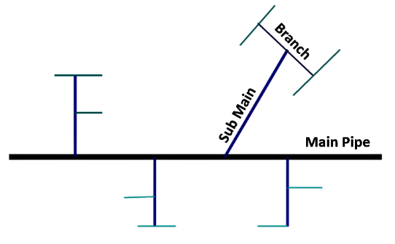
Advantages dead-end System:
- The design calculation is simple and easy.
- A smaller number of cut-off valves are required and the operation and maintenance cost is low.
- Pipe laying is simple
Disadvantages dead-end system:
- The system is less successful in maintaining satisfactory pressure in remote areas and is therefore not favoured in modern waterworks practice
- One main pipeline provides the entire city, which is quite risky
- The head loss is relatively high, requiring larger pipe diameter, and/or larger capacities for pumping units. Dead ends at line terminals might affect the quality of water by allowing sedimentation and encouraging bacterial growth due to stagnation. Water hammer could also cause burst of lines. A large number of scour valves are required at the dead ends, which need to be opened periodically for the removal of stale water and sediment
- The discharge available for fire fighting in the streets is limited due to high head loss in areas with weak pressure

2. Gridiron distribution system
Description:
In this system the main supply line runs through the centre of the area and sub mains branch off in perpendicular directions. The branch lines interconnect the sub-mains. This system is ideal for cities laid out on a rectangular plan resembling a gridiron. The distinguishing feature of this system is that all of the pipes are interconnected and there are no dead ends. Water can reach a given point of withdrawal from several directions, which permits more flexible operation, particularly when repairs are required.
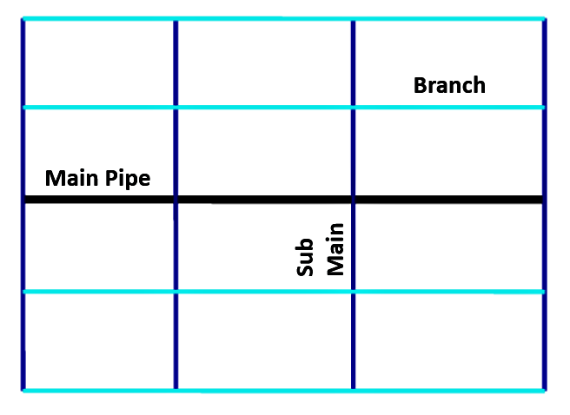
Advantages of the Gridiron distribution system:
- The free circulation of water, without any stagnation or sediment deposit, minimises the chances of pollution due to stagnation.
- Because of the interconnections water is available at every point with minimum loss of head.
- Enough water is available at street fire hydrants, as the hydrant draws water from the various branch lines.
- During repairs, only a small area of distribution is affected.
Disadvantages of the Gridiron distribution system:
- A large number of cut-off valves are required.
- The system requires longer pipe lengths with larger diameters.
- The analysis of discharge, pressure and velocities in the pipes is difficult and cumbersome.
- The cost of pipe laying is higher.

3. Circular or ring distribution system
Description:
In a circular or ring system, the supply main forms a ring around the distribution area. The branches are connected cross-wise to the mains and also to each other. This system is most reliable for a town with well-planned streets and roads. The advantages and disadvantages of this system are the same as those of the gridiron system. However, in case of fire, a larger quantity of water is available, and the length of the distribution main is much higher.
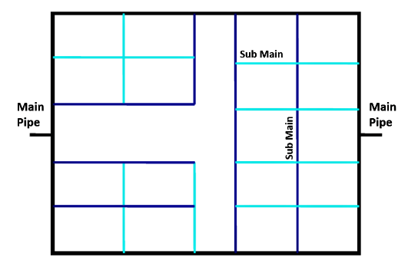

4. Radial distribution system
Description:
In this system, the whole area is divided into a number of distribution districts. Each district has a centrally located distribution reservoir (elevated) from where distribution pipes run radially towards the periphery of the distribution district. This system provides swift service, without much loss of head. The design calculations are much simpler.
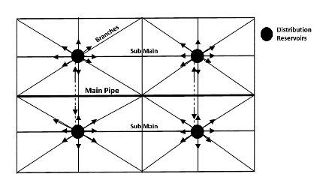

Recommended layout for distribution of water in hilly area:

Radial distribution system
Water distribution systems in hilly areas are always divided into several zones due to the undulating terrain. so area is divided into different zones. The water is pumped into the distribution reservoir kept in the middle of each zone and the supply pipes are laid radially ending towards the periphery.

Q3. What are different types of reservoirs used in water supply systems? Briefly describe its importance and how its storage capacity be calculated?

Answer:

Types of Distribution Reservoirs:
According to the situation with respect to ground, the distribution reservoirs are classified in the following three types:
1. Surface Reservoirs:
Surface reservoirs are circular or rectangular in shape. These reservoirs are constructed at ground level or below ground level and hence these are also called ground reservoirs or non-elevated reservoirs. The treated water stored in these reservoirs is pumped to elevated reservoirs from which it is supplied to the consumers.
However, if surface reservoirs are located at high points in the distribution system then water may be supplied to the consumers directly from these reservoirs by gravity, as far as possible surface reservoirs should be located at high points in the distribution system.
It is usual practice to construct a surface reservoir in two compartments, so that one can be used while the other is being cleaned or repaired. The two compartments are connected with each other by control valves. Overflow pipes are provided at full supply level so as to maintain a constant level of water in the reservoir.
Ventilators are provided in the roof slab so as to affect free circulation of air over the water surface in the reservoir. Although treated water is stored in the reservoir, yet some sludge may be present in the stored water which will be deposited in the reservoir. The deposited sludge can be removed by occasional cleaning through the washout pipes provided at the bottom of the reservoir. The outlet pipes are placed at a slightly higher level, say at least 10 cm, than that of the washout pipes.

2. Elevated Reservoirs:
Elevated reservoirs are constructed at an elevation from ground level. These reservoirs are also known as overhead tanks. These reservoirs may be rectangular, circular or elliptical in shape. However, with the advancement in structural analysis it is possible to construct the elevated reservoirs in any shape to suit the architectural requirements.
An R.C.C. tank known as Intz tank is very commonly adopted these days.
Water is pumped to elevated reservoirs from surface reservoirs and then supplied to the consumers.

The various accessories provided for elevated reservoirs are as indicated below:
(i) Inlet pipe for the entry of water.
(ii) Outlet pipe for the exit of water.
(iii) Overflow pipe for the exit of water above full supply level.
(iv) Ladders to reach the top of reservoir and then to the bottom of reservoir for inspection.
(v) Manholes in top cover or roof of reservoir for providing entry to the inside of reservoir for inspection.
(vi) Ventilators for free circulation of air.
(vii) Washout pipe (or drain pipe) for removing water after cleaning of reservoir.
(viii) Water level indicator for indicating from outside the depth of water in reservoir.
(ix) A lightning conductor for protection against lightning.

3. Standpipes:
A standpipe is a vertical cylindrical tank resting just above the ground. The diameter of standpipe varies from 10 to 15 m and its height varies from 15 to 30 m. Standpipes are made of steel or R.C.C. Steel standpipes are more common as it is very difficult to construct watertight R.C.C. standpipes under heads greater than 15 m. Alike elevated reservoirs, standpipes are also provided with inlet pipe, outlet pipe, overflow pipe, washout pipe and various other accessories for their efficient working, inspection and maintenance.
However, in the case of standpipe the outlet pipe is located in the tank with its entrance being kept above the bottom of the tank at an elevation such that the storage of water created in the tank above this elevation gives the necessary pressure for distribution of water. The volume of water stored in the tank above the entrance of the outlet pipe can only be used and hence it is the useful storage of standpipe.
On the other hand the lower portion of the storage lying below the entrance of the outlet pipe cannot be ordinarily used and it only serves as a support for the useful storage and hence it is termed as supporting storage. However, the supporting storage can also be effectively used by providing boosters or for fire protection with the help of fire engines. Further standpipes are usually located on a high ground so as to successfully utilize its entire storage.
Since large variations in pressure are undesirable in a distribution system, fluctuation of the water level in a standpipe is usually limited to 10 m or less. Generally standpipes of height more than 15 m are not economical since the lower portion of a standpipe serves only to support the upper useful portion.
The economic limit of height for standpipes is reached when the supporting structure for an elevated reservoir becomes less costly than the lower ineffective portion of the standpipe.

The following two methods are generally used for determining the capacity of a storage reservoir:

1. Analytical Method:
In this method an analysis of demand and inflow of water per month of the year is made.
The following data are required:
(i) Total inflow of the stream during each month of a critical low flow year (or dry year) at the reservoir site.
(ii) Total loss of water due to evaporation, percolation, etc., during each month of the year.
(iii) Total precipitation (if any) during each month of the year.
(iv) Total amount of water required to be released from the reservoir during each month of the year to satisfy the prior water right requirements of the residents on the downstream of the reservoir.
(v) Total demand of water during each month of the year.

2. Mass Curve Method:
The mass curve method is more commonly used for determining the capacity of a storage reservoir.
Mass Curve and Determination of Capacity of a Storage Reservoir Required For a Specified Yield or Demand Using Mass Curve:
Mass Curve of Inflow:
A mass curve of inflow (or mass curve) is a plot of accumulated flow in a stream against time. As indicated below a mass curve of inflow can be prepared from the flow hydrograph of a stream for a large number of consecutive previous years.
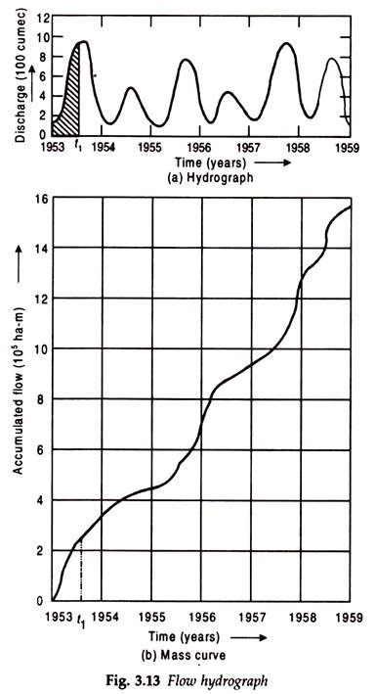
Figure 3.13 (a) shows a typical flow hydrograph of a stream for six consecutive years. The area under the hydrograph from the starting year (i.e., 1953) upto any time t₁ [shown by hatching in Fig. 3.13 (a)] represents the total quantity of water that has flown through the stream from 1953 upto t₁ time and hence it is equal to the ordinate of the mass curve at time t₁.
The ordinates of the mass curve corresponding to different times are thus determined and plotted at the respective times to obtain the mass curve as shown in Fig. 3.13 (b). A mass curve continuously rises as it shows accumulated flows.
The slope of the curve at any point indicates the rate of flow at that particular time. If there is no flow during certain period the curve will be horizontal during that period. If there is high rate of flow the curve rises steeply. Thus relatively dry periods are indicated as concave depressions on the mass curve.

Q4. Why pumps are used in water supply schemes and how to calculate pump curve
to meet water demand?

Basics on Water Pumping:
Pumping machinery is used for transfer of water from one place to another and pumping of water from water source. Pumping is required for
- Lifting water from the source (surface or ground) to purification works or the service reservoir.
- Transfer of water from source to distribution system.
- Pumping water from sump to elevated/ground surface tanks.
Pump house (civil works) is constructed for installation of pumping machinery.
Pump House is designed for life of at least 30 years, while pumping machinery is designed for at least 15 years life span.
Pumping Machinery consists of 3 major components:
- Pump for lifting of water: The function of pump is to transfer water to higher elevation or at higher pressure. Pumps are driven by electricity or diesel or even solar power. They are helpful in pumping water from the sources, that is from intake to the treatment plant and from treatment plant to the distribution system or service reservoir.
- Electric/diesel/solar powered motor: For pumping, 3 phase electric connection is required.
- Panel board: Panel board consists of circuit breaker or switch and fuse, starter level controls etc for transmission of electric supply.

For water supply system, three main types of pumps are used
- Centrifugal Pump.
- Turbine pump
- Submersible pump

What is a Pump Curve?
A pump performance curve is simply a graph or chart that represents the performance capabilities of a given water pump. A pump manufacturer conducts a variety of tests and the findings are then reflected on a graph, which we refer to as the pump curve. A pump curve will typically show not just the maximum capabilities of the pump, but just as important, many pump curves will give information helpful in determining the best efficiency point (BEP) for flow rates as well as reflecting the preferred operating range (POR) of the water pump. Once you know how to read a pump curve you will be able to determine what to expect from your water pump: how many feet is it capable of pumping, how many gallons per minute, and what will be the ideal operating performance for efficiency, as well as other important information.

The Most Common Information a Pump Curve Provides
- Total Dynamic Head
Total dynamic pump head, most commonly referred to as total head, concisely stated is the height that a water pump is capable of raising a liquid. It is the total vertical distance that the pump is capable of ‘pumping’. It answers the question, “How high can it pump?” The greater the pressure, the higher the head. The lower the pressure, the lower the head.
- Flow Rate
Flow rate, or rate of flow, is the total maximum amount of liquid flow that a pump can produce during a specified period of time. It is almost always measured per minute and most pump curves will show either gallons per minute (GPM) or liters per minute (LPM), or commonly both. Flow rate answers the question, “How many gallons can I expect?” The greater the pressure, the higher the flow rate. The lower the pressure, the lower the flow rate.
- NPSHr (Net Positive Suction Head Required)
Net positive suction head required is the minimum amount of pressure or force of energy that is required at the suction port (inlet) to overcome the losses from friction that are caused between the suction head/nozzle (inlet) and the eye of the impeller, without causing vaporization (cavitation) of the liquid being pumped.
- Best Efficiency Point
Every pump has a best efficiency point (BEP) and many pump curves will clearly show the BEP. BEP is the rate of flow and the total head at which a pump efficiency is at a maximum at a given motor speed and impeller diameter.
BEP is a combination of the head/flow rate as it corresponds to the highest efficiency. BEP directly corresponds to the input horsepower of the motor required to drive the pump and the horsepower created by the flow of water created by the pump.
- Preferred Operating Range (POR)
Referred to as the preferred operating range or preferred operating region. A pump will run best the closer it is to the BEP. For this reason, The Hydraulic Institute has determined that the preferred operation range as it pertains to water flow is between 70%-120%. Most manufactures will recommend a POR that is between 80% and 110% as operation in the POR has direct implications on the life of the pump as well as power consumption.
Pump manufactures give a variety of information on their pump curves. Some are more detailed than others. However, most manufacturers will offer more detailed specs, requirements, additional curves, etc. in their product manuals. But the most basic information that the average consumer needs typically boils down to 2 items: Total Pump Head & Gallons Per Minute

Reading a Pump Curve
Let’s look at an example situation to help you pick out the right pump for your application using just pump head and gallons per minute to help us come to a decision on the right pump.
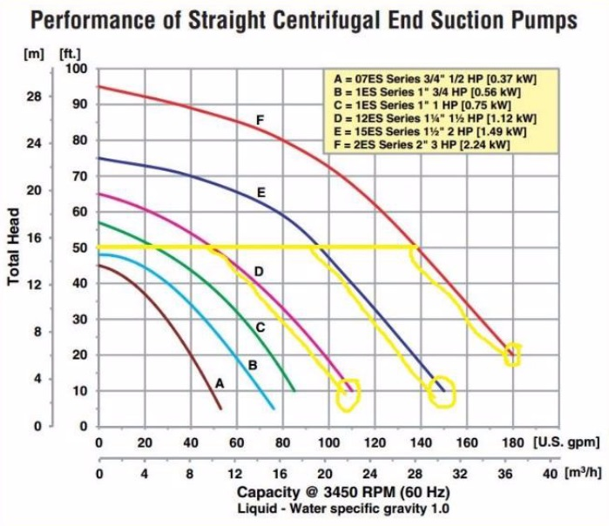
Situation #1: You are replacing an old pump that already has the pipes in place that are 2” going into the pump and 2” going out. The old pump is pumping water from a 5,000 gallon tank and pumping the water to a second tank that is 50 feet above the first tank. Your old pump was pumping approximately 100gpm (gallons per minute) and you would like to try to get a pump that will perhaps get you to 150gpm due to increased production demands.
So we can determine the following:
- You need a pump with a 2” inlet diameter and a 2” outlet diameter
- You have a minimum pump head of 50 feet
- You would like a pump that will give at least 150gpm

Looking at the pump curve below, which of the following 2” pumps will work for your application?

Step #1: Start with your required pump head (50 feet) on the left-hand side of the curve
- We can see that pumps A & B are below our required head, so we can rule them out.
- We now have 3 pumps on this curve that meet our total pump head requirement of 50ft.

Step #2: Determine which pump is capable of 125gpm or more
- From the left of the curve, starting at 50ft, draw an imaginary line to the right.
- Then follow each pump curve down towards the GPM.
- We can see that pump D will give us the 50 feet of head we require but will only give us 110gpm. It’s probably similar to the pump you are replacing.
- Pump E will meet our 50ft head requirement (it’s capable up to 75ft) and at 50ft head it will give us 145gpm. Pump F at 50ft of head will give us 180gpm.
Step #3: Decision Time!
You have 3 pumps to choose from that meet your requirements but you still have a few things to consider:
- Pump D:
  - Pro: similar to the pump you are replacing
  - Con: no real increase in performance in GPM (110gpm total)
  - Pro: guaranteed to be lower cost than pumps E & F

- Pump E:
  - Pro: increase of 45gpm compared to your old pump (145gpm total)
  - Pro: gets you close to your desire of 150gpm
  - Con: 5gpm lower than your 150gpm goal
  - Con: higher price than pump D

- Pump F:
  - Pro: increase of 80gpm compared to your old pump
  - Pro: 35gpm greater than pump E
  - Pro: gets beyond your desire of 150gpm (180gpm total)
  - Con: higher price than pumps D & E

