DPT IV name: Fatma nawab
Biochemistry id : 15151
Final term
Marks 50
Attempt the following questions each carries equal marks
- Write brief note on steroid hormone?
.Hormone
organic substance secreted by plants and animals that functions in the regulation of physiological activities and in maintaining homeostasis. Hormones carry out their functions by evoking responses from specific organs or tissues that are adapted to react to minute quantities of them.
. Steroid hormone
- Any of a group of hormones that belong to the class of chemical compounds known as steroids; they are secreted by three “steroid glands”—the adrenal cortex, testes, and ovaries—and during pregnancy by the placenta. All steroid hormones are derived from cholesterol.

- They are transported through the bloodstream to the cells of various target organs where they carry out the regulation of a wide range of physiological functions.

- These hormones often are classified according to the organs that synthesize them.
. Adrenal cortex:
- the adrenal steroids are so called because they are secreted by the adrenal cortex.

- and the sex hormones are those produced by the ovaries and testes.

- This distinction is not exclusive, however, because the adrenal cortex also secretes sex hormones,

- and the ovaries under abnormal conditions may produce adrenal steroids.

- The adrenal cortex produces the adrenocortical hormones, which consist of the glucocorticoids and the mineralocorticoids.
E.g:
Glucocorticoids, mineralocorticoids, testosterone, progesterone.
. glucocorticoids:
- Glucocorticoids such as cortisol control or influence many metabolic processes, including the formation of glucose from amino acids and fatty acids and the deposition of glycogen in the liver.

- Glucocorticoids also help to maintain normal blood pressure, and their anti-inflammatory and immunosuppressive actions have rendered them useful in treating rheumatoid arthritis and preventing the rejection of transplanted organs

. mineralocorticoids:
- Mineralocorticoids such as aldosterone help maintain the balance between water and salts in the body, predominantly exerting their effects within the kidney.

.testosterone:
- Testosterone is the primary male sex hormone and anabolic steroid. In male humans.

- testosterone plays a key role in the development of male reproductive tissues such as testes and prostate, as well as promoting secondary sexual characteristics such as increased muscle and bone mass, and the growth of body hair

.Progesterone :
- Progesterone is a female sex hormone. It’s produced mainly in the ovaries.

.Function of steroid hormone:
-Steroid hormones help control metabolism, inflammation, immune functions, salt and water balance, development of sexual characteristics, and the ability to - - withstand liness and injury.

- What is deamination and transanimation?
Ans : transanimation:
-the transfer of an amino [-HH2] group from an amino acid to ketoacid, with the formation of a new amino acid and a new keto acid.

- catalysed by a group of enzymes called transaminases( aminotransferases).

- pyriodoxalphosphate co-factor.

- liver, kidney heart, brain adequatw amount of these enzymes.

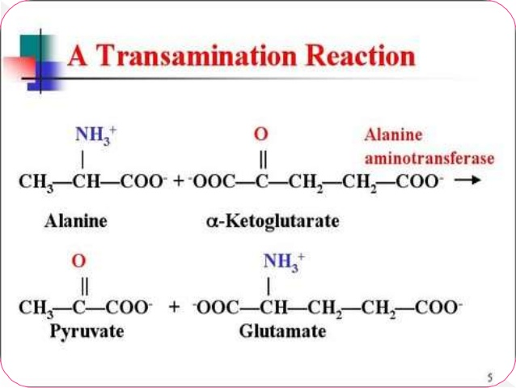

. Salient features of transaminati on:
- All transamination required PLP.

- no free NH3 liberated only transfer of amino group.

- Transamination is reversible.

- There are multiple transaminase enzymes which vary in subtrate specificity.

- Transamination is the important for redistribution of amino acid group and production of non-essentinal amino acid.

- It diverts excess amino acid towards the energy generation.

- Amino acid undergo transamination to finallyconcentrate nitrogen in glutamate.

-Gultamate undergoes oxidative deamination to liberate NH3 for urea synthesis.

- All amino acid except lysine threonine,prline& praticipate in transamination.

- It involves both anabolism and catabolism.

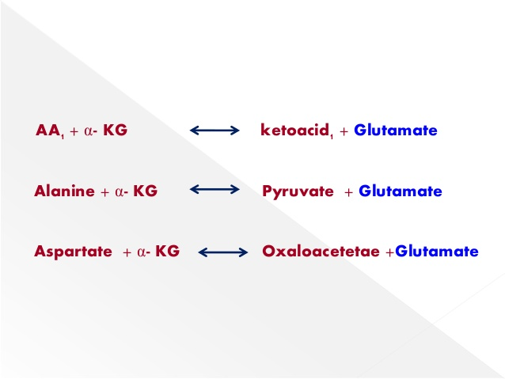
.mechanismof transamination:
Step 1:
- Transfer of amino acid group from AA the co-enzyme PLP to form pyridoxamine phosphate.
- Amino acid is converted to keto acid.
Step 2:
Amino group of pyridoxamine phosphate is them transferred to a keto acid to produced a new AA enzyme with PLP is regenerated.

. Deamination:
- the removal of amino group from the amino acids as NH3 is deamination.

- The deamination maybe oxidative or non oxidative.

- only liver mitochondria contain glutamate dehydrogenase which deaminates glutamate to α- ketoglurate and ammonia.

- It needs NAD+ as a co- enzyme.

- It is an allasteric enzyme.

- It is activated by ADP and inhibited by GTP.

.Oxidative deamination:
- oxidative deamination is the liberation of free aminoacid from the amino group of amino acid coupled with oxidation.
. Site:
- Mostly in liver and kidney.

- Oxidative deamination is to provide NH3 for urea synthesis and α-keto acids for a varity of reaction including energy generation.

. Role of glutamate dehydrogenase:
- Glutamate is a collection center for amino group.

- Glutamate rapidly undergos oxidative deamination

- Catalysed by GDH librate ammino.

- It can utilize either NAD+ or NADP

- This conversion occurs through the formation of an α- iminoglutrate.

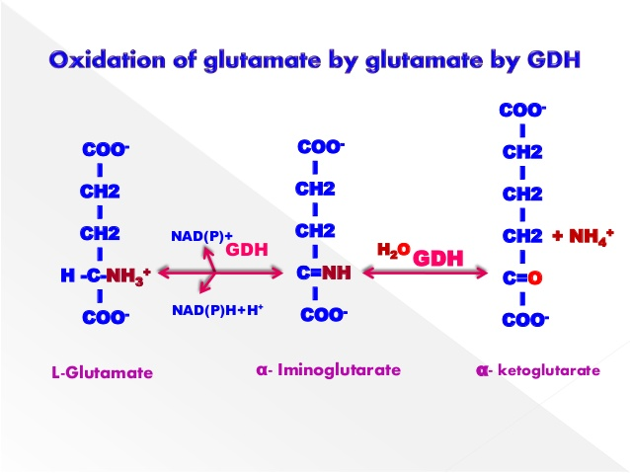

. Non- oxidative deamination:
- direct deamination, without oxidation

- Amino acid dehydratases

- Serine, threonine and homoserine are the hydrox amino acid

- They under go non-oxidative deamination catalyzed by PLP deprndent dehydratases.

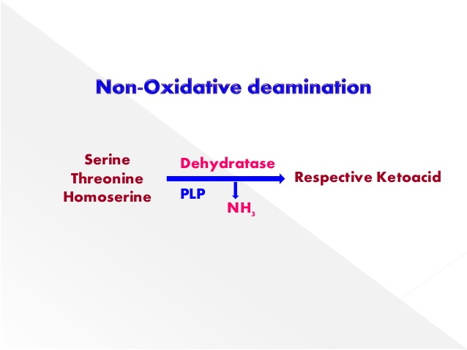

- Write down the metabolism of protein?

Ans : metabolism:
- metabolism is the sum total of all chemical reaction in the body
.Protein metabolism:

. Definition:

- Protein metabolism is the chemical cycle of breaking down protein (catabolism) and using the components to synthesizing (anabolism) new molecules to be used in the body. The process is also known as proteometabolism.

.Description
- Proteins, fats, and carbohydrates (called macronutrients) are part of a complex metabolic cycle that is essential to life.

During digestion food containing these nutrients is chemically broken down into its basic components and absorbed for use in the body

. Protein molecules are split into their basic building blocks, called amino acids, which are then chemically re-arranged to synthesize new proteins that the body needs.

Fats are broken down into fatty acids and cholesterol, and carbohydrates are split into simple sugars such as glucose and fructose, which provide most of the energy to drive chemical reactions in the body

. These smaller, simpler molecules are absorbed in the small intestine and enter the circulatory system.

They then pass through the liver where some of these "building block molecules" are synthesized into more complex compounds needed by the body.

- Catabolism, or the breakdown of nutrients obtained from food, releases energy that drives all metabolic activities in the body.

- For example, glucose is broken down to provide energy for cellular respiration that allows functions such as muscle movement. Proteins are broken into amino acids then re-synthesized into hormones and enzymes to regulate chemical reactions in the cell, and molecules used for tissue growth and repair. Carbohydrates and fats are the preferred sources of energy for cellular metabolism. When the supply of fats and carbohydrates is insufficient to meet the body' needs, proteins can be broken down to supply energy. This accounts for the loss of muscle seen in prolonged cases of starvation.

.A complex molecule:
Proteins are complex nitrogen-containing molecules formed by a combination of about 20 amino acids. These twenty amino acids can be connected in thousands of different combinations to form all the different proteins in the body. During protein formation (anabolism) the amino acids are connected in long chains called polypeptides that fold into three-dimensional shapes. The combinations of amino acids produce proteins with unique shapes that perform specific functions in the body such as catalyzing metabolic reactions, repairing tissue, or stimulating glands to produce other proteins.

.Digestion of protein in stomach:
The digestion of proteins begins in the stomach where the hormone pepsin is secreted by the stomach. Pepsin breaks the long polypeptide molecules into smaller peptides. The mechanical churning of the stomach assists digestion by mixing food with gastric (stomach) secretions.
.Digestion in the intestine:
Digestion of protein is completed in the small intestine by proteolytic enzymes present in pancreatic juice.

.Function:
Protein metabolism consists of a cycle of breaking down proteins, synthesizing new ones and removing nitrogenous waste products that result from these reactions. The amount of protein needed to balance this cycle changes throughout an individual' life. Growing children who are creating new muscle and bone, for example, have higher protein needs than adults.

.Protein absorption:
- It is an active process that needs energy.

- It occurs in small intestine.

- Absorption of amino acid is rapid in the duodenum andjejunum but slow in the ileum.

- Explain briefly translation of DNA in eukaryotes?

Ans . translation of DNA in eukaryotes:
Translation is basically a synonym process of protein synthesis.

• It is the process in which the protein is synthesized from the information contained in a molecule of messenger RNA (mRNA).

• It can defined as “ the process by which the sequence of nucleotides in a messenger RNA molecule directs the incorporation of amino acid into protein.

.TRANSLATIONAL MACHINERY:

The machinery required for translating the language of messenger RNAs into the language of proteins is composed of four primary components

• mRNAs : Messenger RNA (mRNA) provides an intermediate that carries the copy of a DNA sequence that represents protein

• tRNAs : tRNA acts as an adaptor between the codons and the amino acids they specify.

• Enzymes : Required for the attachment of amino acids to the correct tRNA molecule. i. Aminoacyl-tRNA Synthetase. ii. Peptidyl Transferase

. • Ribosome : It is the macromolecular complex that directs the synthesis of proteins.

Steps of translation:
- initation
- elongation
Termination.

. Initation:
The initiation of translation in eukaryotes is complex, involving at least 10 eukaryotic initiation factors (eIFs) & divided into 4 steps : a. Ribosomal dissociation. b. Formation of 43S preinitiation complex. c. Formation of 48S initiation complex. d. Formation of 80S initiation complex.

- Ribosomal Dissociation • The 80S ribosome dissociates to form 40S & 60S subunits

. - Two initiating factors namely elF-3 & elF-1A bind to the newly formed 40S subunit & thereby block its reassociation with 60S subunit.

- Formation Of 43S Preinitiation Complex

- A ternary complex containing met-tRNA′ & elF-2 bound to GTP attaches to 40S ribosomal subunit to form 43S preinitiation complex.

- The presence of elF-3 & elF-1A stabilizes this complex.

- Formation Of 48S Initiation Complex

- The binding of mRNA to 43S preinitiation complex results in the formation of 48S initiation complex through the intermediate 43S initiation complex

. - elF-4F complex is formed by the association of elF-4G, elF-4A with elF-4E.

- The elF-4F (referred to as cap binding protein) binds to the cap of mRNA.

- Then elF-4A & elF-4B bind to mRNA & reduce its complex structure.

- This mRNA is then transferred to 43S complex.

- For the appropriate association of 43S preinitiation complex with mRNA, energy has to be supplied by ATP.

- The ribosomal initiation complex scans the mRNA for the identification of appropriate initiation codon.

- 5'-AUG is the initiation codon.

- Formation Of 80S Initiation Complex

- 48S initiation complex binds to 60S ribosomal subunit to form 80S initiation complex.

- The binding involves the hydrolysis of GTP

- This step is facilitated by the involvement of elF-5.

- As the 80S complex is formed, the initiation factors bound to 48S initiation complex are released & recycled.
.

elongation :
- Ribosomes elongate the polypeptide chain by a sequential addition of amino acids

. - The amino acid sequence is determined by the order of the codons in the specific mRNA.

- Elongation, a cyclic process involving certain elongation factors (EFs)

. - Elongation may be divided into three steps. a. Binding of Aminoacyl t-RNA to A-site. b. Peptide bond formation.

Binding of Aminoacyl t-RNA to A- site

- The 80S initiation complex contains met tRNA′ in the P- site & A-site is free.

- Another Aminoacyl-tRNA is placed in the A-site.

- This requires proper codon recognition on the mRNA & involvement of elongation factor 1a (EF-1a) & supply of energy by GTP

. - The Aminoacyl-tRNA is placed in the A-site, EF-1a & GDP are recycled to bring another Aminoacyl-tRNA translation

- The ribosome moves to the next codon of the mRNA

. - This process called translocation, involves the movement of growing peptide chain from A-site to P-site

. - Translocation requires EF-2 & GTP. • GTP gets hydrolyzed and supplies energy to move mRNA

. - EF-2 & GTP complex recycles for translocation. • About six amino acids per second are incorporated during the course of elongation of translation in eukaryotes.

.TERMINATION:

- One of the stop or termination signals (UAA, UAG and UGA) terminates the growing polypeptide

. - When the ribosome encounters a stop codon, - there is no tRNA available to bind to the A site of the ribosome, - instead a release factor binds to it

. - In eukaryotes, a single release factor- eukaryotic release factor 1 (eRF1)-recognizes all three stop codons, and eRF3 stimulates the termination events.

- once the release factor binds, the ribosome unit falls apart, - releasing the large and small subunits, - the tRNA carrying the polypeptide is also released, freeing up the polypeptide product.

- Ribosome recycling occurs in eukaryotes.

- Write down clinical significance of cholesterol?
- Ans: . cholesterol:
Cholesterol is a waxy, fat-like substance that's found in all the cells in your body. Your body needs some cholesterol to make hormones, vitamin D, and substances that help you digest foods. Your body makes all the cholesterol it needs. Cholesterol is also found in foods from animal sources, such as egg yolks, meat, and cheese.

.causes high cholesterol
The most common cause of high cholesterol is an unhealthy lifestyle. This can include
- .Unhealthy eating habits

- such as eating lots of bad fats. One type, saturated fat, is found in some meats, dairy products, chocolate, baked goods, and deep-fried and processed foods. Another type, trans fat, is in some fried and processed foods. Eating these fats can raise your LDL (bad) cholesterol.

- .Lack of physical activity

- with lots of sitting and little exercise. This lowers your HDL (good) cholesterol.
- . smoking
- which lowers HDL cholesterol, especially in women. It also raises your LDL cholesterol.
Genetics may also cause people to have high cholesterol. For example, familial hypercholesterolemia (FH) is an inherited form of high cholesterol. Other medical conditions and certain medicines may also cause high cholesterol.
.Metaboilsm:
Cholesterol is recycled in the body. The liver excretes cholesterol into biliary fluids, which is then stored in the gallbladder, which then excretes it in a non-esterified form (via bile) into the digestive tract. Typically, about 50% of the excreted cholesterol is reabsorbed by the small intestine back into the bloodstream.
clinical significance of cholesterol:
Normal range 150-200 ml/dl hypercholesterolemia; diabetes meltitus nephrotic syndrome( is akideny disorder that causes your body to pass too much protein in your urine).
.Hypothyroidism:
Hypothyroidism (underactive thyroid) is a condition in which your thyroid gland doesn't produce enough of certain crucial hormones.
Hypothyroidism may not cause noticeable symptoms in the early stages. Over time, untreated hypothyroidism can cause a number of health problems, such as obesity, joint pain, infertility and heart disease

.Hyperlidaemia:
Hyperlipidemia means your blood has too many lipids (or fats), such as cholesterol and triglycerides. One type of hyperlipidemia , hypercholesterolemia, means there's too much LDL (bad) cholesterol in your blood. This condition increases fatty deposits in arteries and the risk of blockages
.Atherosclerosis:
Atherosclerosis refers to the buildup of fats, cholesterol and other substances in and on your artery walls (plaque), which can restrict blood flow. The plaque can burst, triggering a blood clot. Although atherosclerosis is often considered a heart problem, it can affect arteries anywhere in your body.

