FINAL TERM EXAM 2020

Name: Arwa Asim
Roll No.: 16248
Subject: Art History
Submitted to: Ma’am Faiza Hassan

- TRUE/FALSE:
- Architects invented pendentive and squinch in Etruscan period. (False)
- Senate was a governing and advisory assembly. (True)
- Islamic buildings were richly decorated with sculptures. (False)
- In gothic time period books were produced by secular sources. (True)
- Augustus Caesar was infamously murdered at senate. (False)
- Use of perspective in paintings introduced in gothic era. (True)
- Catacombs found under city of Rome as burial grounds. (True)
- Toga style of dress belongs to the medieval civilization. (False)
- Moses and Pieta was sculpted by Botticelli. (False)
- Necropolis well-known for the city of the dead. (True)

- QUESTIONS/ANSWERS:

- Who was Leonardo Da Vinci?
Leonardo Da Vinci, son of a local lawyer, was one of the great creative minds. He was born on April 15, 1452 in Anchiono, Tuscany (now Italy), close to the town of Vinci that provided the surname for him. He started learning sculpting and painting from Andrea Del Verrocchio in Florence and in 1478 became an independent master. In 1478, he became an independent master. He is considered as one of the greatest painters of all the time. His most famous work around the globe is the “Mona Lisa”.
We lost this master mind forever on 2nd May, 1519 (age 67)
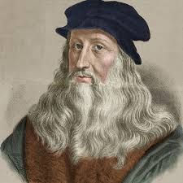

- What is the purpose of colosseum?
Colosseum means a large stadium, in Rome, whose construction was begun by Vespasian in 70AD.
IS:-
Colosseum is a huge building in round shape. It was build for the games, which included wrestling, fights with wild animals and naval battles.
The main purpose of colosseum is to provide platform for entertainment to the huge number of people at a time.
WAS:-
The Colosseum, also named the Flavian Amphitheater, is a large amphitheater in Rome. It was built during the reign of the Flavian emperors as a gift to the Roman people. Aside from the games, the Colosseum also hosted dramas and even public executions.
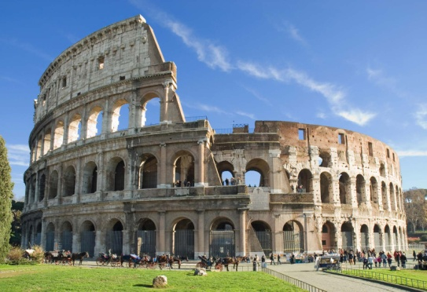

- What is meant by great schism?
Schism is a noun. It means division between parties caused by difference of opinion or belief.
The great schism marks a period of division in the Roman Catholic Church (1378-1417). It occurred due to a complex mix of religious disagreement. As a result, it split the main fraction of Christianity into two groups, Roman Catholic and Eastern Orthodox. Today, the Roman Catholicism is the largest Christian sect and eastern orthodoxy is the second largest Christian sect.
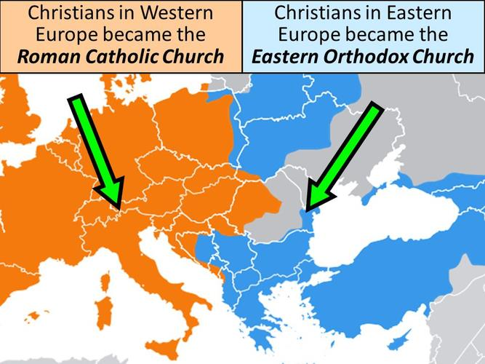

- Which painting art is famous in Mughal era?
The Emperor Shah Jahan standing on a globe, with a halo and European style putti, 1618-19 to 1629.
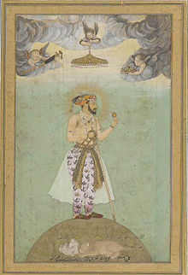
During the reign of Shah Jahan (1628–58), Mughal paintings continued to develop, but court paintings became more rigid and formal. The illustrations from the "Padshanama" (history of the King of the world), one of the finest Islamic documents from the Royal Collection, at Windsor, were painted during the reign of Shah Jahan, which was written in Persian on paper and was covered with gold. The "Padshahnama" has portraits of the courtiers and servants of the King painted with great detail.

- FILL IN THE BLANKS:
- In Byzantine era emperor banned the use of icons.
- Most popular events of horse race happened in Roman era.
- Protestant reformation arose against the teaching of Catholic Church.
- A predominant characteristic of Islamic art is nonrepresentational.
- Silk Road was intentionally used as trade routes.
- Sgraffito is decorating pottery techniques produced by applying layers of colors and then scratch it off.
- Leonardo Da Vinci and Michelangelo inspired the term Renaissance man.
- Patriarch is the highest church office in a major city.
- Painting and drawing merged in the illustration of Bibles produced by monks were called illuminated manuscripts.
- Etruscans were dark-skinned people who settle in parts of Europe

