Name Mohammad Zia ul Haq
Class: second semester
Program: B.tech ( civil)
ID: 16528
Q.1 (a) Suggest the type flooring for-Fabrication shop, Kitchen , platform, Vehicle Parking. Also explain the reasons for you selection.
1. Vehicle parking or garage:
The garage is usually the last room in your house to get a makeover. Still, having a nice garage can enhance the look of your home and add value.One of the first things people notice about a garage is the floor. With nice garage flooring, the space that’s usually best known for being grungy and grimy gets spruced up.If you’re interested in giving your garage floors a makeover, here are three types of garage flooring that you’ll want to consider.
1. Vinyl Flooring:
Vinyl flooring is becoming a popular trend in garages. They are made out of 100% virgin vinyl and come in a number of installation types and designs. Vinyl flooring is 100% waterproof, so washing your car in the garage on cold winter days is not an issue! It’s also resistant to strong chemicals, making them perfect for garages that see a lot of spills from road salts and oils. Just be mindful that your garage should be temperature controlled, or at least attached so it get’s some protection from the elements. Too extreme temperatures either way could damage your new vinyl flooring.
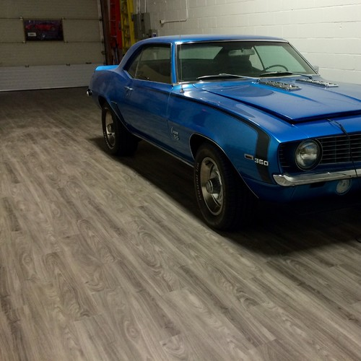

2. Epoxy Paint:
Epoxy paint is a popular option in garages that are used to store vehicles or engage in serious building projects. This paint is used to coat your floor and make it look nicer than a slab of concrete. It is resistant to stains from oil, sitting water, and strong chemicals. Concrete often has imperfections. Epoxy paint is able to hide those imperfections enhancing the look of your garage. It’s easy to clean, making it ideal for the garage that never seems to be free of dirt, water, and dust.
4. Kitchen:
Many people consider the kitchen to be the heart of the home. It’s not only where you’ll prepare meals, but also a popular space to gather and entertain, especially if you have a large island .In this high-traffic space, it’s important to choose a type that is both durable and easy to clean and maintain.You’ll likely see a number of spills on the surface, so choosing an option that’s waterproof is also critical. Additionally, surfaces that become slippery or slick when wet might not be the right fit, especially if you care for children or any one at risk of slipping and falling.
Generally, good choices in the kitchen are ceramic tiles, natural stone, linoleum, and wood that has been treated to be water resistant.
5. Fabrication shop:
Carpet: Commercial carpet is designed with a low profile and is comfortable underfoot. It is meant to withstand the heavier foot traffic in places of business. Choose from a broadloom or carpet tile in a huge array of colors, patterns, and thicknesses. We have options for every budget that can give your space a designer look. Carpet is one of the more economical options.
Q.1(b): Write the Fields Tests performed on bricks for its suitability.

FIELD TESTS ON BRICKS:
It is necessary to check the quality of brick before using it in any construction activities.There are some field tests that we can conduct in the field in order to check the quality of bricks. These tests are as follows.
- Water Absorption
- Visual inspection
- Efflorescence
- Dimension
- Hardness
- Soundness
- Structure

1. WATER ABSORPTION
5 bricks are taken and the bricks are weighed dry and the average dry weight of 5 bricks is calculated. Bricks are then immersed in water for a period of 24 hours. After 24 hours of immersion, bricks are weighed again and average of 5 bricks is calculated. The difference of the final average weight and initial average weight indicates the amount of water absorbed by the bricks. It should not in any case exceed 20percent of average weight of dry bricks.

2. VISUAL INSPECTION
In this test bricks are closely inspected for its shape. The bricks of good quality should be uniform in shape and should have truly rectangular shape with sharp edges.

3. EFFLORESCENCE
This test should be conducted in a well ventilated room. The brick is placed vertically in a dish 30 cm x 20 cm approximately in size with 2.5 cm immersed in distilled water. The whole water is allowed to be absorbed by the brick and evaporated through it. After the bricks appear dry, a similar quantity of wter is placed in the dish, and the water is allowed to evaporate as before. The brick is to be examined after the second evaporation and reported as follows:
- Nil: When there is no perceptible deposit of salt
- Slight: When not more than 10% of the area of brick is covered with salt
- Moderate: When there is heavy deposit covering 50% of the area of the brick but unaccompanied by powdering or flaking of the surface.
- Heavy: When there is heavy deposit covering more than 50% of the area of the brick accompanied by powdering or flaking of the surface.
- Serious: When there is heavy deposit of salts accompanied by powdering and/or flaking of the surface and this deposition tends to increase in the repeated wetting of the specimen.
Bricks for general construction should not have more than slight to moderate efflorescence.

4. DIMENSIONAL TOLERANCE
Twenty bricks are selected at random to check measurement of length, width and height. These dimensions are to be measured in one or two lots of ten each as shown in figure. Variation in dimensions are allowed only within narrow limits, ±3% for class one and ±8% for other classes.
5. HARDNESS:
In this test, a scratch is made on brick surface with the help of a finger nail. If no impression is left on the surface, brick is treated as to be sufficiently hard.

6. SOUNDNESS
Two bricks are taken, one in each hand, and they are struck with each other lightly. A brick of good quality should not break and a clear ringing sound should be produced.

7. STRUCTURE
A brick is broken and its structure is examined. It should be homogeneous, compact and free from any defects such as holes, lumps etc
Q.2 (a) which grade of concrete is generally applied in your home town? (Write the name of your home town as well) and what alternations do you suggest to improve its quality and durability?

Types of Concrete

Some common and main types of concrete are:
- Normal concrete
- High Strength Concrete
- High Performance Concrete
- Air Entrained Concrete
- Light Weight Concrete
- Self Compacting Concrete
- Short Concrete.
- Pervious Concrete.
- Roller Compacted concrete.
I belong to a village in charsadda, a district of kp province and most of villegers are using and applying concrete for construction of building etc.so hereby I am discussing the normal concrete in great details.
Normal concrete:
- The concrete in which common ingredients i.e. aggregate, water, cement are used is known as normal concrete. It is also called normal weight concrete or normal strength concrete.
- It has a setting time of 30 - 90 minutes depending upon moisture in atmosphere, fineness of cement etc.
- The development of the strength starts after 7 days the common strength values is 10 MPa (1450 psi) to 40 MPa (5800 psi). At about 28 days 75 - 80% of the total strength is attained.
- Almost at 90 days 95% of the strength is achieved.

Properties of Normal Concrete:
- Its slump varies from 1 - 4 inches.
- Density ranges from 140 pcf to 175 pcf.
- It is strong in compression and weak in tension.
- Air content 1 - 2 %.
- Normal concrete is not durable against severe conditions e.g. freezing and thawing.
Q.2 (b) Suggest the types of glass to be used for the following.
(1). laboratory apparatus:
Laboratory glassware refers to a variety of equipment used in scientific work, and traditionally made of glass. Glass can be blown, bent, cut, molded, and formed into many sizes and shapes, and is therefore common in chemistry, biology, and analytical laboratories. Many laboratories have training programs to demonstrate how glassware is used and to alert first–time users to the safety hazards involved with using glassware.
Laboratory glassware may be made from several types of glass, each with different capabilities and used for different purposes. Borosilicate glass is transparent and can withstand thermal stress. Quarts glass can be withstand very high temperatures and is transparent in certain parts of the electro spectrum. Darkened brown or amber (actinic) glass can block ultraviolet and infrared radiation. Heavy-wall glass can withstand pressurized applications. Fritted glass is finely porous glass through which gas or liquid may pass. Coated glassware is specially treated to reduce the occurrence of breakage or failure. Siliconized glassware is specially treated to prevent organic samples from sticking to the glass
(2). Sky Lights of roofs:
A homeowner who wants to install a skylight should consider the different types of skylight glass. There are several features to look for when choosing skylight glass. The most important feature is the quality of the glass. For instance, homeowners should research a skylight’s ability to endure harsh weather conditions such as hail, drenching rain and heavy snowfall. Also, skylight glass should be able to withstand the impact of small branches and perhaps even a ball thrown onto the roof of a home. Most homeowners want skylight glass with an attractive interior and exterior that complements the appearance of their residence. Take a look at a few varieties of skylight glass to find out about the qualities of each one.
Safety Laminated Glass:
The design of safety laminated glass involves two outer layers of glass with a sheet of plastic in-between them. This sheet of polyvinyl butyral, or PVB, ensures that the two sections of glass will remain together even if the skylight suffers damage. For instance, if a large tree branch fell on a skylight made with safety laminated glass, it would break into large pieces. The design of this type of glass would prevent the large pieces from breaking off and falling either onto the roof of the home or inside the home. Safety laminated glass allows plenty of sunlight into a room and gives an owner peace of mind about any breakage that may occur.
Tempered Glass:
Tempered glass is known for its high degree of hardness, according to the Department of Energy. But, the design of tempered glass differs from safety laminated glass. For instance, if a heavy branch or several weighty pieces of hail were to hit the skylight, the tempered glass would shatter. This could send small pieces of glass into the surrounding area. These tiny pieces may even end up inside the room below the skylight. To prevent this situation, a homeowner should opt for a skylight with an exterior of tempered glass and an interior of safety laminated glass.
Tinted Glass:
Tinted glass in a skylight can look attractive in a home, but can also greatly reduce the amount of sunlight that filters into a room. For most people, this defeats the purpose of having a skylight. Furthermore, tinted glass can reduce the amount of heat provided by a skylight. Many homeowners install a skylight to help lower their heating bills during the wintertime. Of course, there are different varieties of tinted glass. Some homeowners choose a skylight with lightly tinted glass that gives them the look they want while allowing plenty of sunlight to enter the room
3. Jewelry store:
Many types of glass can be used as an option for a storefront. Many of the common types of glass have features that make it a great choice for any type of business. The type of glass to use is based on what a business wants to display to passersby. If a business in considering updating their storefront with a new design, then review the types of glass selection that are available.
Clear Glass:
The use of clear glass is the most common option for the storefront of a business. Clear glass is used at most retail stores and small businesses, such as beauty salons. A clear glass storefront allows anyone to see what is inside the building or business. Seeing inside is important for a retail store because they are benefiting from displaying sale items and other types of promotions.
4. Making partition wall:
A partition wall is a usually thin wall that is used to separate or divide a room, primarily a pre-existing one. Partition walls are usually not load-bearing, and can be constructed out of many materials, including steel panels, bricks, cloth, plastic, plasterboard, wood, blocks of clay, terracotta, concrete, and glass.
Type1. Jewelry kiosk:
The first and popular types is jewelry kiosk. It can located in shopping center or store inside. We can see the kiosk basic material is MDF. It can match glass and stainless steel frame to display. Square and round is very common shape. Worker is inside. Client only can select the jewelry from outside
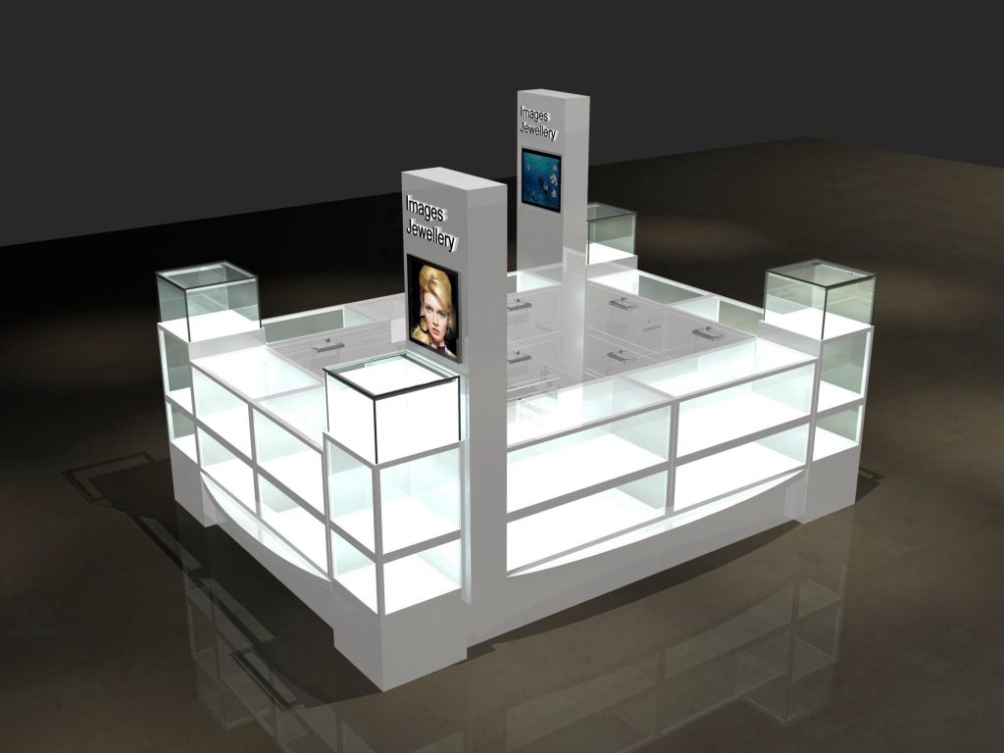
Type2. Cartier style stainless steel display showcase:
As we know Cartier is a very famous jewelry brand all around the world. This brand store inside display showcase is be made of stainless steel. Surface is electroplate finished. Match glass display and led light strip. It’s very luxury and high-end.
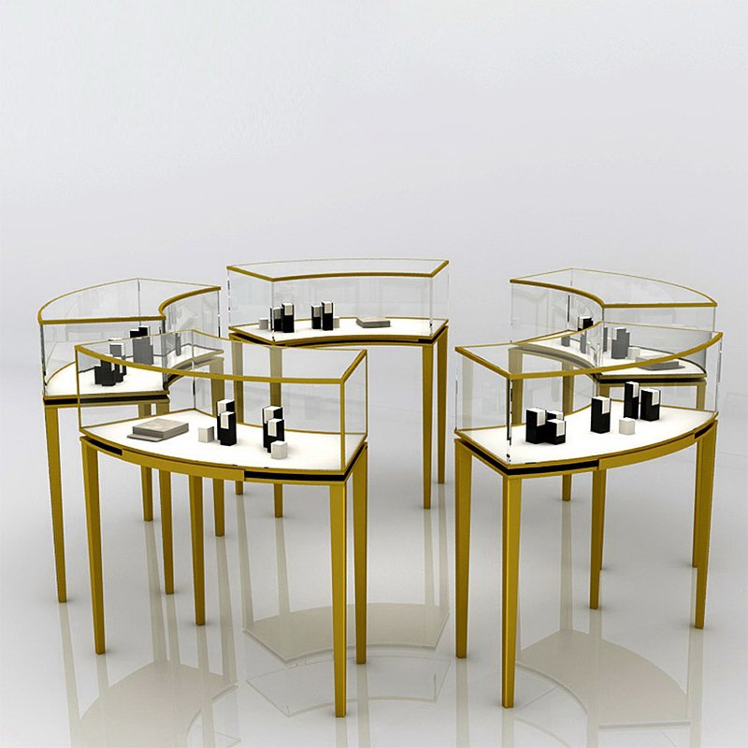
Q.3 Can varnishes be used in place of painting? Explain with suggestions.Also discuss the remedial measures you have to take if the paint starts peeling off, makes blisters, or makes wrinkles.(Explain)
Varnishes can assist the art work in several ways. They can be used to change the surface gloss, making the surface more matte or higher gloss, or to provide the various areas of a painting with a more unified finish. They can also be used to increase color saturation. Varnishes offer protection for the underlying surface and allow for ease of cleaning of the painting or object. They are also often used to consolidate art work, in a similar manner to a fixative for charcoal or pastel. Some varnishes offer additional protection in the form of Ultra Violet Light Stabilizers, which dissipate UV radiation before it can contact the artwork where damage may occur. These varnishes are especially useful for materials that are fugitive in nature, such as dyes, but will not render them completely lightfast. The thicker the film of varnish w/ UVLS, the greater the protection afforded.

