Iqra National University Peshawar
Online exam 2020
Paper no (1)
Paper (cross sectional anatomy)
I’d (14075)
Total question (5)
Total answer (5)
Sir Ihsan
DATE 13 APRIL2020

Q No 2 What do you know about circle of Willis?
ANS Circle of Willis. Schematic representation of the circle of Willis, arteries of the brain and brain stem. Blood flows up to the brain through the vertebral arteries and through the internal carotid arteries. ... Basilar artery labelled below canter.
Structure;
The circle of Willis is a part of the cerebral circulation and is composed of the following arteries:^{[2]}
- Anterior communicating artery
- Internal carotid artery
- Posterior cerebral artery
- Posterior communicating artery
- Anterior cerebral artery
The middle cerebral arteries, supplying the brain, are not considered part of the circle
Function;
The arrangement of the brain's arteries into the circle of Willis creates redundancy (analogous to engineered redundancy) for collateral circulation in the cerebral circulation. If one part of the circle becomes blocked or narrowed (stenosed) or one of the arteries supplying the circle is blocked or narrowed, blood flow from the other blood vessels can often preserve the cerebral perfusion well enough to avoid the symptoms of ischemia.
Q No 3 Write down the arteries of the neck?
ANS The carotid arteries are major blood vessels in the neck that supply blood to the brain, neck, and face. There are two carotid arteries, one on the right and one on the left. In the neck, each carotid artery branches into two divisions:
- The internal carotid artery supplies blood to the brain.
- The external carotid artery supplies blood to the face and neck.
Like all arteries, the carotid arteries are made of three layers of tissue:
- Intima, the smooth innermost layer
- Media, the muscular middle layer
Neck arteries are below
- Internal ceratoid artery
- External ceratoid artery
- Common ceratoid artery
- Subclavian artery
- Axillary artery
- Brachiocephalic trunk

Q No 1 Names the parts of the temporal and palatine bone appeared in the inferior view of cranium?
Ans The names of the both bones which are the appeared in the inferior of the cranium the Temporal bone appeared part in inferior view of the part are below;
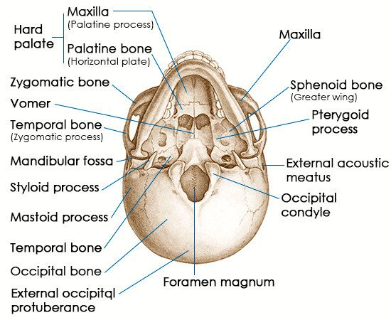
- Zygomatic process
- Mandibular fossa
- External acoustic meatus
- Mastoid process
- Styloid process
- Carotid canal
- Petrous temporal bone
- Jugular fossa
- Mostide foramen
The palatine bone appeared part in inferior view of the part below
- Pterygopalatine fossa
- Pterygoid fossa
- Horizontal plate
- Perpendicular plates
- Hard plate
- Pyramidal process
- Orbital process
- Sphenoid process
Q no 5 What is cross sectional anatomy? How are cross sectional images help full in diagnosing a patient?
ANS Cross-sections are two-dimensional, axial views of gross anatomical structures seen in transverse planes. They are obtained by taking imaginary slices perpendicular to the main axis of organs, vessels, nerves, bones, soft tissue, or even the entire human body.
Cross sectional imaging allows physicians to view the inside of your body to help them find any indications of a health condition. Some machines and methods can produce pictures of the activities and structures inside your body. Your doctor will decide which medical imaging tests they'll need to use based on the body part they're evaluating and your symptoms.
Q No 4 Name the structure appeared in the superior lobe of lung by viewing it medially?
ANS Names are the given below which are the appeared in the superior lobe of the lung medial,
- Apex
- Groove for subclavian artery
- Groove for left brachiocephalic vein
- Groove for 1st ribs
- Area for thymus and indicational fatty tissues
- Anterior boarder
- Left superior pulmonary veins
- Cardiac impression
- Oblique notch
- Lingula
- Area for notch trachea and oesophagus

