NAME: REHAN ULLAH
ID NO: 15929
DEGREE: RADIOLOGY SEC (B)
PAPER: BIOCHEMISTRY
SUBMITTED TO: MAM SANA KHAN

Q NO 1: WRITE DOWN THE POINTS OF CELL THEORY?
ANS: - POINTS OF CELL THEORY:-
The three points of cell theory are following
1. All living things are made up of one or more cells.
2 -Cells are the most basic units of structure and function in living things.
3 -All cells are created by pre- existing cells.

Q NO 2:-CLASSIFY MONOSACCHRIDES ON THE BASIS OF NUMBER OF C- ATOM ALONG WITH EXAMPLE.
ANS:- MONOSACCRIDES:-
Monosaccharide are the simplest carbohydrates in that they cannot be hydrolyzed to smaller carbohydrates. They are basic units of Carbohydrates. They are made up of only one carbohydrate moiety. The general chemical formula of an unmodified monosaccharide is (C•H₂O) _{n}, literally a “carbon hydrate”. This is termed as the empirical formula.
In this formula, the “n” varies from 3-6 and rarely seven. This implies that in nature no. of carbon atoms found in monosaccharide varies from minimum 3 to maximum 7.
The smallest monosaccharide (for which n = 3) are dihydroxyacetone and glyceraldehyde. However, not all carbohydrates conform to this precise stoichiometric definition (e.g., uronic acids, deoxy-sugars such as fucose), nor are all chemicals that do conform to this definition automatically classified as carbohydrates.

CLASSIFICATION OF MONOSACCRIDE ON THE BASIS OF NMBER OF C-ATOM:-
Monosaccharide with three carbon atoms are called trioses, those with four are called tetroses, five are called pentoses, and six are hexoses, and so on. These two systems of classification are often combined. For example, glucose is an aldohexose (a six-carbon aldehyde), ribose is an aldopentose (a five-carbon aldehyde), and fructose is a ketohexose (a six-carbon ketone). Various examples of other monosaccharide are given in the following table.
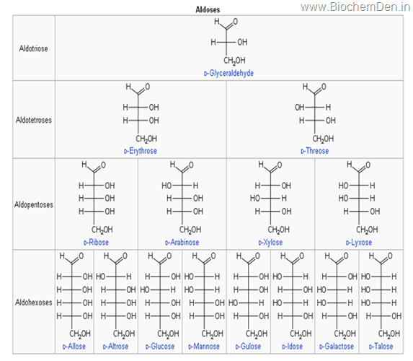

Trioses
A triose is a monosaccharide containing three carbon atoms. The general formula is C3H6O3. There are only two trioses, an aldotriose (glyceraldehyde) and a ketotriose (dihydroxyacetone). Trioses are important in respiration. Namely, lactic acid and pyruvic acid are derived from aldotriose and ketotriose, respectively.

Tetroses
A tetrose is a monosaccharide containing four carbon atoms. The general formula is C₄H₈O_{4.}
Exampled- Erythrose-4-P is an intermediate in hexose monophosphate shunt which is an alternative of glucose oxidation

Pentoses
A pentose is a monosaccharide containing five carbon atoms. The general formula is C₅H₁₀O_{5.}
Example of Pentoses are
- D- Ribose is a constituent of RNA and many co-enzymes e.g. FAD, NAD.
- D-2 deoxy is a constituent of DNA component of DNA.
- D-Lyxose is a constituent of lyxoflavin found in the human heart.
- D- arabinose is a constituent of plant cell wall
- Phosphate esters of D- Ribulose and D- xylose occurs as an intermediate in the HMP pathway
Hexoses
A Hexose is a monosaccharide containing six carbon atoms. The general formula is C₆H₁₂O₆

D- Glucose
It is the chief physiological sugar present in human blood. Its values are regulated between 70-110 mg/dl of blood by a pancreatic hormone Insulin and Glucagon. Increase in blood sugar levels leads to Diabetes. All tissues utilize glucose for energy. Brain and Erythrocytes depend exclusively on glucose. Its polymeric form glycogen is used as energy storage material in animals. Its polymeric form starch is used as energy storage material in plants.
D-Galactose
Seldom found free in nature occurs as a constituent of milk sugar lactose and in tissues as galactolipids and glycoproteins.
D-Mannose
It is used to stamp proteins by the process of glucosylation. It does not occur free in nature but is widely distributed in combination as the polysaccharide mannan
EXAMPLES:- It is also found as the constituent of glycoproteins
D- Fructose
It is a ketohexose and is commonly called the fruit sugar, as it occurs in fruit. It is a sweet sugar sweeter than glucose and sucrose. It is found in honey as laevulose. In the seminal fluid of man fructose is the chief source of energy for sperms.
Heptoses
A heptose is a monosaccharide containing seven carbon atoms. The general formula is C₇H₁₄O₇. Examples are Sedoheptulose It is a keto-heptulose found in plants of the sedum family. (Most of the aldoses end in “-oses” and ketoses end in “-uloses”
EXAMPLES: - erythrose and erythrulose).

QNO3:-BRIEFLY DISCUSS THE FUNCTION OF MACROMOLECULES FOUND IN CELL MEMBRANE?
ANS3:-FUNCTION OF MACROMOLECULES FOUND IN CELL MEMBRANE:-
- Carbohydrate (monosaccride):-
FUNCTION:-
- Energy storage
- Provide fuel, and build structure in body
- Main source of energy
- Structure of plant cell wall.

- LIPID:-
FUNCTION:-
- Insulator and stores fat and energy

- protein:-
FUNCTION:-
- Provide structural support, transport, enzymes, movement, and defence.

- Nucleic acid:-
FUNCTION:-
- Stores and transfer information.

QNO4:-DISCUSS AMINO ACIDS ON THE BASIS OF REQUIREMENT IN PROTEIN SYNTHESIS.
ANS 4:-AMINO ACID:-
During the 1950s and 1960s it became apparent that DNA is essential in the synthesis of proteins. Proteins are used as structural materials in the cells and function as enzymes. In addition, many specialized proteins function in cellular activities. For example, in bacteria, flagella and pili are composed of protein.
The genetic code. The key element of a protein molecule is how the amino acids are linked. The sequences of amino acids, determined by genetic codes in DNA, distinguish one protein from another. The genetic code consists of the sequence of nitrogenous bases in the DNA. How the nitrogenous base code is translated to an amino acid sequence in a protein is the basis for protein synthesis.

In order for protein synthesis to occur, several essential materials must be present. One is a supply of the 20 amino acids which make up most proteins. Another essential element is a series of enzymes that will function in the process. DNA and another form of nucleic acid called ribonucleic acid (RNA) are also essential. RNA carries instructions from the nuclear DNA into the cytoplasm, where protein is synthesized. RNA is similar to DNA, with three exceptions. First, the carbohydrate in RNA is ribose rather than deoxyribose. Second, RNA nucleotides contain the pyrimidine uracil rather than thymine. And third, RNA is usually single-stranded.

Types of RNA. In the synthesis of protein, three types of RNA are required. The first is called ribosomal RNA (rRNA) and is used to manufacture ribosomes. Ribosomes are ultramicroscopic particles of rRNA and protein where amino acids are linked to one another during the synthesis of proteins. Ribosomes may exist along the membranes of the endoplasmic reticulum in eukaryotic cells or free in the cytoplasm of prokaryotic cells.
A second important type of RNA is transfer RNA (tRNA), which is used to carry amino acids to the ribosomes for protein synthesis. Molecules of tRNA exist free in the cytoplasm of cells. When protein synthesis is taking place, enzymes link tRNA to amino acids in a highly specific manner.
The third form of RNA is messenger RNA (mRNA), which receives the genetic code from DNA and carries it into the cytoplasm where protein synthesis takes place. In this way, a genetic code in the DNA can be used to synthesize a protein at a distant location at the ribosome. The synthesis of mRNA, tRNA, and rRNA is accomplished by an enzyme called RNA polymerase.
Transcription. Transcription is one of the first processes in the overall process of protein synthesis. In transcription, a strand of mRNA is synthesized using the genetic code of DNA. RNA polymerase binds to an area of a DNA molecule in the double helix (the other strand remains unused). The enzyme moves along the DNA strand and selects complementary bases from available nucleotides and positions them in an mRNA molecule according to the principle of complementary base pairing. The chain of mRNA lengthens until a stop code is received.

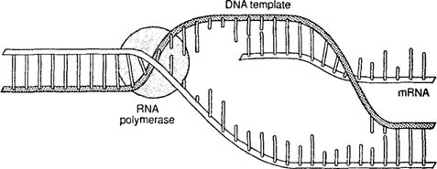
The synthesis of mRNA using a strand of DNA as a template.
The nucleotides of the DNA strands are read in groups of three. Each triplet is called a codon. Thus, a codon may be CGA, or TTA, or GCT, or any other combination of the four bases, depending on their sequence in the DNA strand. The mRNA molecule consists of a series of codons received from the genetic message in the DNA.
Once the stop codon has been reached, the mRNA molecule leaves the DNA molecule, and the DNA molecule rewinds to form a double helix. Meanwhile, the mRNA molecule proceeds thorough the cellular cytoplasm toward the ribosomes.
Translation. Translation is the process in which the genetic code will be “translated” to an amino acid sequence in a protein. The process begins with the arrival of the mRNA molecule at the ribosomes. While mRNA was being synthesized, tRNA molecules were uniting with their specific amino acids according to the activity of specific enzymes. The tRNA molecules then began transporting their amino acids to the ribosomes to meet the mRNA molecule.

After it arrives at the ribosomes, the mRNA molecule exposes its bases in sets of three, the codons. Each codon has a complementary codon called an anticodon on a tRNA molecule. When the codon of the mRNA molecule complements the anticodon on a tRNA molecule, the latter places the particular amino acid in that position. Then the next codon of the mRNA is exposed, and the complementary anticodon of a tRNA molecule matches with it. The amino acid carried by the second tRNA molecule is thus positioned next to the first amino acid, and the two are linked. At this point, the tRNA molecules release their amino acids and return to the cytoplasm to link up with new molecules of amino acid.

The ribosome then moves farther down the mRNA molecule and exposes another codon which attracts another tRNA molecule with its anticodon. Another amino acid is brought into position. In this way, amino acids continue to be added to the growing chain until the ribosome has moved down to the end of the mRNA molecule. The sequence of codons on the mRNA molecule thus determines the sequence of amino acids in the protein being constructed.

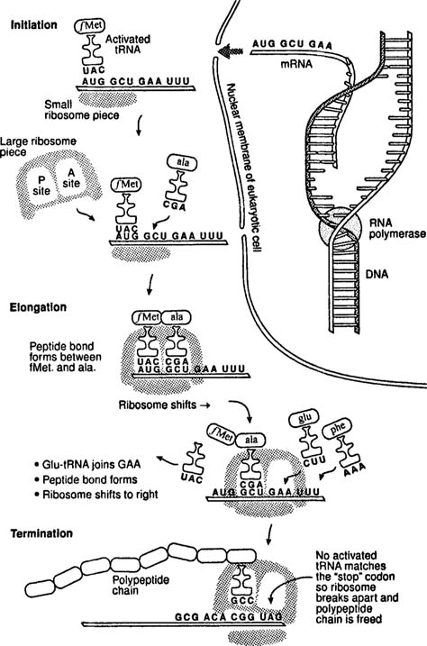
Steps in the synthesis of protein beginning with the genetic code in DNA and ending with the finished polypeptide chain.
Once the protein has been completely synthesized, it is removed from the ribosome for further processing. For example, the protein may be stored in the Golgi body of a eukaryotic cell before release, or a bacterium may release it as a toxin. The mRNA molecule is broken up and the nucleotides are returned to the nucleus. The tRNA molecules return to the cytoplasm to unite with fresh molecules of amino acids, and the ribosome awaits the arrival of a new mRNA molecule.

QNO 5:-EXPLAIN DIGESTION AND ABSORPTION OF CARBOHYDRATE.
ANS 5:-DIGESTION AND ABSORPTION OF CARBOHYDRATES:-
- The digestion of carbohydrates begins in the mouth. The salivary enzyme amylase begins the breakdown of food starches into maltose, a disaccharide.
- As the food travels through the esophagus to the stomach, no significant digestion or carbohydrates take place the esophagus produces no digestive enzyme but does produces mucous for lubrication.
- The acidic environment in the stomach stop the action of the amylase enzyme.
- The next step of the carbohydrates digestion take place in the duodenum. The food from the stomach enters the duodenum and mixes with the digestive secretion from the pancreas, liver, and gallbladder.
- Pancreatic juice also contain amylase, which continuous the breakdown of starch and glycogen into maltose, a disaccride.
- The disaccrides are broken down into manosaccrides by enzymes called maltose, sucrose and laxtoses which are present in the small intestinal wall.
- Maltose breaks down maltose into glucose. Other disaccrides, such as sucrose and lactose are broken down by sucrose and lactase, respectively.
- Sucrose breaks down sucrose into glucose and fructose, and lactase breaks down lactose into glucose and galactose.
- The monnosaccrides that produced are absorbed and then can used in metabolic pathways to produce energy the monnosaccrides are transported into the bloodstream to be transported to the different cells in the body.

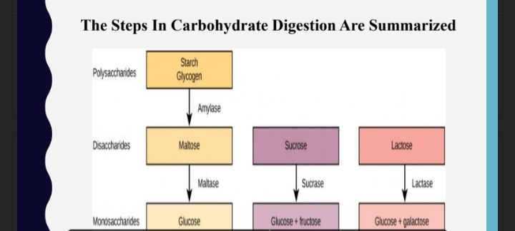

THE END

THANK YOU MAM

