Iqra National University
Department of CIVIL ENGINEERING

Assignment
Geotechnical & Foundation Engineering (Lab)
Name: Umar Farooq Afridi
ID: 7800
Section: A
Program: Civil Engineering
Semester: 6th
Instructor: Engr. Muneeb Khan

Question: 01

What is the difference between Standard Proctor Test and Standard Penetration Test?

Standard Proctor Test:

Standard Proctor Test is basically a Compaction test of soil that is carried out using Proctor’s test to understand compaction characteristics of different soils with change in moisture content.

Compaction is the process of densification of soil by reducing air voids. Compaction of soil is the optimal moisture content at which a given soil type becomes most dense and achieve its maximum dry density by removal of air voids.
- The degree of compaction of a given soil is measured in terms of its dry density. The dry density is maximum at the optimum water content.
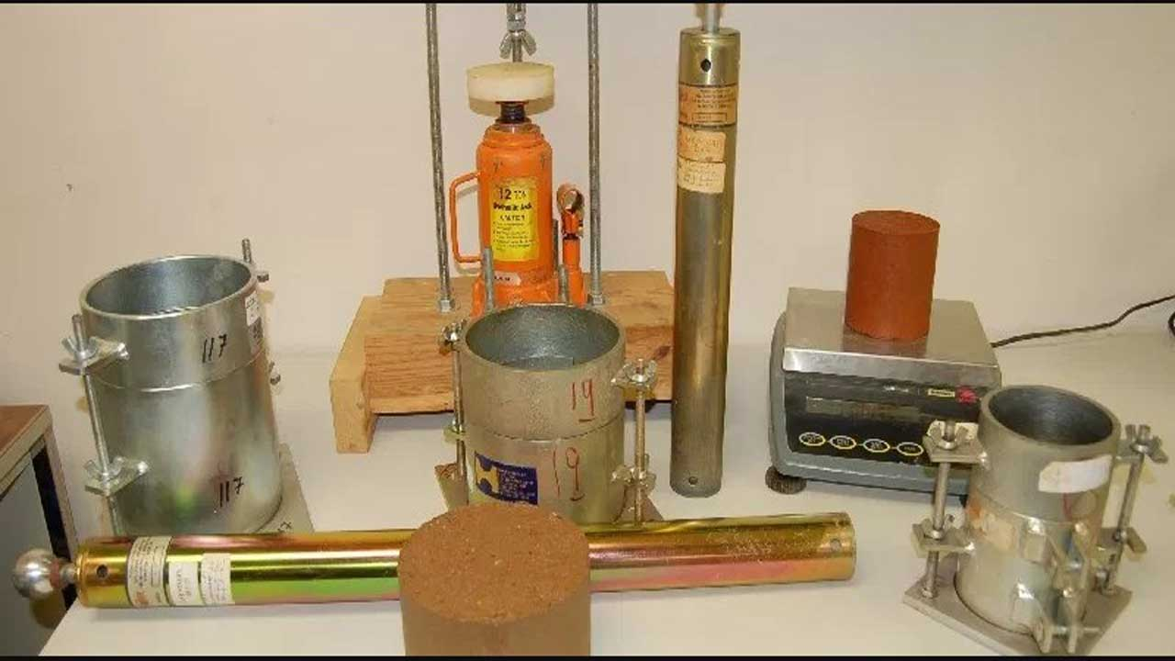

Apparatus of Standard Proctor Test

Standard Penetration Test (SPT):
- The standard penetration test is an in-situ test that comes under the category of penetrometer tests.
- The test is extremely useful for determining the relative density and the angle of shear resistance of cohesion-less soils. It can also be used to determine the unconfined compressive strength of cohesive soils
- The standard penetration tests are carried out in borehole. The test will measure the resistance of the soil strata to the penetration undergone.
- A penetration empirical correlation is derived between the soil properties and the penetration resistance.

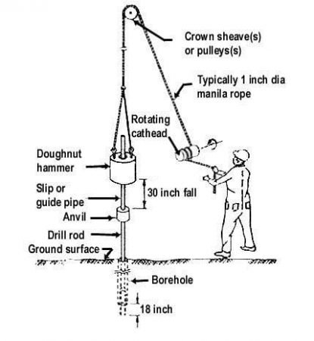

Sample of SPT picture with tools name mentioned

Question: 02

What is the Classification of Soil based on Free Swell Index?

On the basis of Swell Index, Soil are classified as,

Free Swell Index | Degree of Expensiveness | Liquid Limit | Plastic Limit | Shrinkage Limit | Degree of Severity
<20 | Low | 0.50 | 0-35% | <17% | Non-Crirical
20-35 | Moderate | 40-60% | 25-50% | 8-18% | Marginal
35-50 | High | 50-75% | 35-65% | 6-12% | Critical
>50 | Very High | >60% | >45% | <10% | Severe

Question: 03

Why is Permeability Test of Soil important?

Importance of Soil Permeability Test:

Soil permeability test is a laboratory experiment conducted to determine the permeability of soil

Following Applications illustrates the importance of soil Permeability,
- Permeability influences the rate of settlement of a saturated soil under load.
- The design of earth dams is very much based upon the permeability of the soils used.
- The stability of slopes and retaining structures can be greatly affected by the permeability of the soils involved
- Filters made of soils are designed based upon their permeability

