**Submitted By: Farjad Maqbool   MBA-3.5   
Student ID# 15506           3rd Semester  
Submitted To: Ms. Wajiha Amin Statistical Inference   
Date: 23/06/2020 Final Term Solved Paper**

**Part B**

**Answer No: 01**

**n= 500**

**x= 125**

**an approximate 75% Confidence interval for p is**

^p= x/n

^p = 125/500

**= 0.25**

**So**

^q = 1-^p

1. 0.25 = 0.75

The degree of C.I 75%

**So**

**1-α = 70%**

**α =1-0.75 = 0.25**

/2= 0.25/2=0.125

From the table value

**Z 0.125 = 1.150**

**Substituting the values in the formula we get**

^p ± z /2 √^p ^q/n

0.25 ± 1.150√0.25x0.75/500

(**0.2281,0.2719) Ans.**

**B:**

Z score is a conversion of raw data to a standard score, when the conversion is based on the population mean and population standard deviation.

T score is a conversion of raw data to the standard score when the conversion is based on the sample mean and sample standard deviation.

Standard deviation is statistics that measure the dispersion of dataset relative to it is mean and its calculated as the square root of variance.it is calculated as the square root of variance by determining the variation between each data point relative to the mean.

Mean is a mathematical average of the set of two or more number, the mean for the given number can be computed in more than one way.

In finance standard deviation is used for calculation of an annual rate of return, whereas mean is calculated for the use of calculating the average with the help of historical data.

Standard deviation used to measure the volatility of a stock, higher the standard deviation higher the volatility of a stock. Blue chip stock has low standard deviation so that have low volatility.

**B:**

1. 28.869
2. 0.686
3. 1.036
4. 0.0375

**Answer No: 02**

**A:**

**Solution:-**

n=90

x-= 5

σ = 1.2

Find 90% C.I

**α =1-0.90= 0.10**

/2= 0.10/2=0.05

From table value

Z 0.05 = 1.645

**Substitute the value in the formula we get**

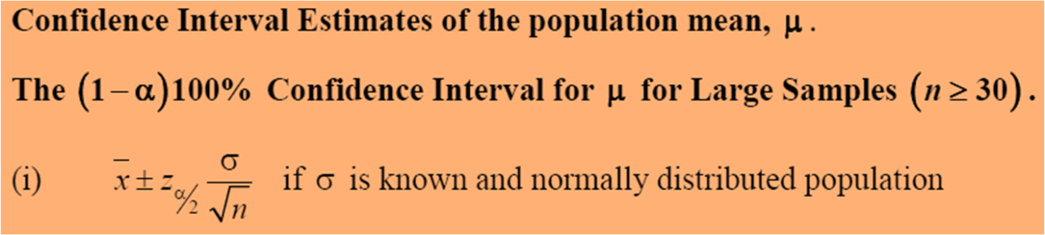

5 ± 1.645x 1.2**/**√90

5 ± 0.2081

(**4.7919, 5.2081) Ans.**

**(Part-B)**

**Solution:-**

**σ = 8cm**

**E = ± 1.5**

**C.I=99%**

**n= ?**

**1-α =0.99**

**α =1-0.99 = 0.01**

/2= 0.01/2=0.005

From table value

Z 0.005 = 2.58

n = (Z/2)2 σ2

E2

n = (2.58)2 x (8)2

(1.5)2  
**n= 189.34 Ans**

Hence, 189.34 or 189 trees should be sampled with 99% C.I

**Answer No.3 (Part-A)**

**Solution:-**

**Sample Size = 21**

**Standard Deviation = 1.3**

**Find 90% C.I**

**1-α =0.90**

**α =1-0.90= 0.10**

/2= 0.10/2=0.05

1-/2=1-0.05=0.95

Now

X2 /2 at df = 21-1=20

In the table value = 31.41

X2 1-/2at df = 21-1=20

In the table value = 10.85

Putting in formula



20 (1.3)2 ≤  σ2 ≤ 20.(1.3)2

31.41 10.85

1.076 ≤ σ2 ≤ 3.115 Ans.

**Answer No.3 (Part-B)**

Chi square

**C.I 95% , df = 18**

**1-α =0.95**

**α =1-0.95= 0.05**

/2= 0.05/2=0.025

1-/2=1-0.025=0.975

Tabulated value of X2 /2 with df = 18 is (31.53)

And tabulated value of

X2 1-/2 with df = 18 is (8.23)

T-Value

**C.I 50% , df = 22**

**1-α = 50%**

**α =1-0.50 = 0.5**

/2= 0.5/2 =0.25

so

t 0.25 (22) = 0.6858

Z-Value

**C.I 70%**

**1-α = 0.70**

**α =1-0.70 = 0.30**

/2= 0.30/2 =0.15

So,

Z 0.15 = 1.036

Z-value

When z= -1.78

P (Z≤ -1.78) = 0.5 –p(-1.78≤ Z≤0)

= 0.5 - 0.462

= 0.0375 Ans.

**Answer No: 04**

**A:**

I learned about the Statistical inference that Statistics is a branch of Mathematics that deals with the Collection, Analysis, Interpretation, and the presentation of the numerical data. In other words, it is defined as the collection of quantitative data. The main purpose of Statistics is to make an accurate conclusion using a limited sample about a greater population.

**Types of Statistics**

Descriptive Statistics

Inferential Statistics

In Statistics, descriptive statistics describe the data, whereas inferential statistics help you make predictions from the data.

**Definition**

Statistical inference is the process of analyzing the result and making conclusions from data subject to random variation. It is also called inferential statistics. Hypothesis testing and confidence intervals are the applications of the statistical inference.

**Types of Statistical Inference**

There are different types of statistical inferences that are extensively used for making conclusions. They are:

Sample hypothesis testing

Confidence Interval

Pearson Correlation

Bi-variate regression

Multi-variate regression

Chi-square statistics and contingency table

T-test.

**B:**

**Solution:-**

Sample size n= 10 so df=n-1 = 10-1= 9

Sample mean X bar = 317.2

Sample standard deviation (s) = 15.7

Confidence interval. 99% so alpha ( ) = 1% =0.01 then

/2 = 0.01/2 = 0.005

Find 0.005 and df i.e 9 in the t table. Match it and you would get the value 3.250 .

Now put all the values in the formula

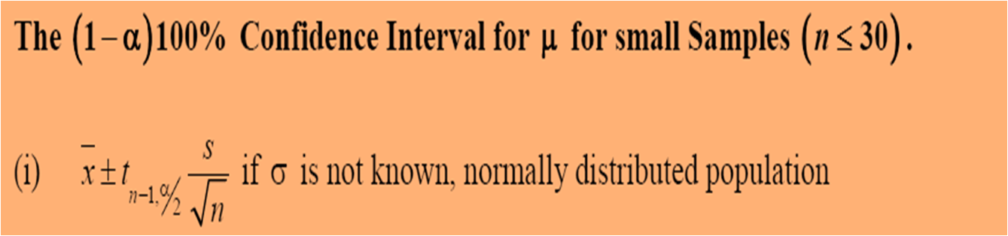

**μ=** 317.2 ± 3.250 . 15.7/√10

= 317.2 + 16.14 and 317.2- 16.14 so

=333.34 **(Upper interval) = 301 (**lower interval) Answer.

**Part A**

**Answer No : 01**

A

**Answer No : 02**

b. Interval estimate

**Answer No : 03**

B  
**Answer No: 04**

b. 2.58

**Answer No: 05**

B

**Answer No: 06**

a. Std. deviation is unknown

**Answer No: 07**

b. $15,966 and $ 15,034

**Answer No: 08**

C