Paper Communction Skills
Name, Asif Iqbal. ID, 16794.
Deportment, BS(MLT). Semester, 2nd.
Section, (B). Checked By, MS Samina Batool.
University Name, Iqra National University Peshawar.
Date.23/06/2020.

QUESTION.1: Conversion of Indirect into Direct Speech
- I wrote that I would visit him.
Ans:- I wrote,”I shall visit him.”
- He asked me if I had anything to say.
Ans:- He said to me, “Have you anything to say.”
- John said that he wanted to be a soldier.
Ans:- John said, “He wants to be a soldier.”
- An old mouse asked who would bell the cat
Ans:- An old mouse said, “Who will bell the cat.”.
- The stranger asked Alice where she lived.
Ans:- The stranger said to Alice, “Where did she live.”
- He said that the earth moves round the sun.
Ans:- He said, “The earth moves round the sun.”
- The king asked the philosopher whom he considered the happiest man living.
Ans:- The king said to the philosopher, “Whom you consider the happiest man living.”
- Abdul said that he had seen that picture.
Ans:- Abdul said, “I have seen this picture.”
- He asked his father when the next letter would come.
Ans:- He said to his father, “When the next letter will come.”
- He asked them whether they would listen to such a man.
Ans:- He said to them, “Will you listen to such a man.”
QUESTION.2: Write a letter to a bank manager asking him to stop payment of a cheque.

Sub: Letter For Stop Payment of Cheque to Bank
Dear Branch Manager,
On behalf of Iqra National University Peshawar, I am writing to request for stop payment of our cheque number 000-111-222; issued against our University Bank Account Number 123-456-789, Khyber Bank of Shangla. This cheque was issued to our vendor Zakir of shangla amounted 25000 and it was snatched on the road last evening from our employee. Meanwhile I am also reporting to police station for this incident. We will issue a new cheque after your response. I will be thankful for your cooperation.
Warm Regards,
Name, A b c
Contact no, 123456
Signaature, xyz
QUESTION.3:
- Write a memo to the Department Head regarding online classes.

To: Department Head.
From: Asif Iqbal.
Subject: Online Classes.
Date: 23/06/2020
Online education conflicts with our learn by doing culture: Our university has already demonstrated that students often experience our learn by doing culture outside the classroom.There’s no reason why our learn by doing experiential pedagogy could not be facilitated in an online environment, provided that the specific learning objectives can be achieved and measured. Interactive simulations, “Take it with you” projects and activities, and remote sensing application are just a few examples of how our learn by doing pedagogy could actually be strengthened, expanded, and reinforced in an online environment. .

- Write Adjective phrases equivalent to the following adjectives;
- Gray cloud.
Ans:- Black cat.
- French flag.
Ans:- Amiricon worl.
- A muddy path.
Ans:- A slippery skin.
- A hopeful soldier.
Ans:- A handful mind.
- A blank page.
Ans:- An empty jug.
QUESTION.4: Punctuate the following:
- the human mind is never stationary it advances or it retrogrades
Ans:- The human mind is never stationary! It advances or it retrogrades.
- england france and italy formed an alliance
Ans:- England France and Italy formed an alliance.
- exactly so , said Alice
Ans:- “Exactly so” said Alice,
- have you written your exercise
Ans:- Have you written your exercise.
- what a terrible fire it is
Ans:- What a terrible fire it is!
- mother in law
Ans:- mother-in-law.
- good hearted
Ans:- good-hearted.
- are you alright
Ans:- Are you alright?
- long live pakistan
Ans:- Long live Pakistan.
- he said, I shall go as soon as it is possible
Ans:- He said, “ I shall go as soon as it is possible”
QUESTION.5:
- Supply suitable Adverb Clauses.
    - Nobody likes him.
Ans:- Because he is rude.
    - He will succeed.
Ans:- Because he works hard.
    - He always does.
Ans:- What he lubes.
    - Will you wait.
Ans:- Till I return.
    - We Shall miss the train.
Ans:- Because we are to lazy.

- Pick out the Noun Phrases in the following examples.
      - He refuses to answer the question.
Ans:- He refuses.
      - Promise to come again.
Ans:- Promise to come.
      - I want to visit the museum.
Ans:- I want.
      - It grieved me to hear of your illness.
Ans:- It grieved me. Your illness.
      - Swimming across the river delights me.
Ans:- Swimming across the river.
_____________________________________________________________________________
Note:-
Assignment part-I ( I Attend Video and send to CR Bahar and Part-II is Below)

Name, Asif iqbal. ID, 16794.
Deportment, BS(MLT). Semester, 2nd,
Section, (B). Assignment, Communications Skills.
Topic, Picture Description. Checked By, MS Samina Batool.
University Name, Iqra National University Peshawar.
Date, 20/06/2020.
Picture Discription:
Picture Description Definition:-
A picture description is information about the picture paintings, working, and other art picture e.g Caricatures, is called picture description.

- Picture Description:
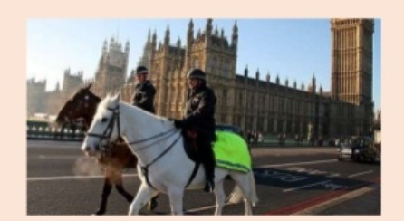
* In the picture I can see a beautiful and cape of the city of London.
* In the background I can see the houses of parliament and big Ben and there are also so me black taxis.
* there are some people walking down the road .
* I guess it is a touristic place, so they’re doing some sightseeing.
* In the foreground there are two police officers riding a horse.
* One of them is riding a lovely white horse and other is on a brown one.
* The one on the white looks older and shorter than that one on the brown horse.
* Both are wearing a uniform and helmets and they are also wearing coats since the weather is not so pleasant, even tough thy sky seems clear and bright.
* I would say that this is a busy area of London and these pfficers are just protecting the visitors’
Security, that’s why I would love to become a police officer.

- Picture Description:
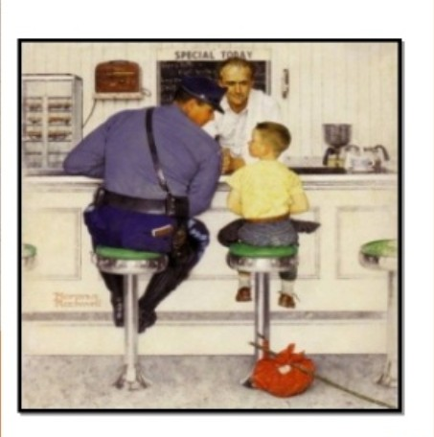

* First let’s describe the painting/the picture.
* As we can see the scene takes place in a cafe.
* It must be breakfast time / in the morning.
* There are three characters, a waiter who is standing from the other side of counter, A policeman and a boy who are in profile.
* the waiter is in the background and the other two characters are in the foreground.
* Both the waiter and the policeman look welcoming / friendly / kind / gentle / protective. They are smiling to the child.
* At the bottom of the painting our attention is drawn by a red bundle / hobo bag with a white spots
* The bag is on the floor. This red bag stands out against the rest of the painting.
* The boy is really young, he may be nine years old.
* He is wearing a yellow T-shirt and jeans. He has got short blond hair and a round fact.
* The boy’s bright yellow T-shirt is in contrast to the policeman’s dark blue uniform.

The E.N.D
Thank You!

