Hamza mustajab
Id 15045
Advanced Computer Networks
DR. NAEEM

Multimedia Networking
Outline
Multimedia networking applications
Streaming stored video
Voice-over-IP
Protocols for real-time conversational applications
Network support for multimedia

Multimedia: audio
Analog audio signal sampled at constant rate
• Telephone: 8,000 samples/sec
• CD music: 44,100 samples/sec
Each sample quantized, i.e., rounded
• e.g., 2^8=256 possible quantized values
• Each quantized value represented by bits
e.g., 8 bits for 256 values
Example: 8,000 samples/sec,
256 quantized values: 64,000 bps
Receiver converts bits back to
Analog signal:
• Some quality reduction
Example rates
CD: 1.411 Mbps
MP3: 96, 128, 160 kbps
Internet telephony: 5.3 kbps and up
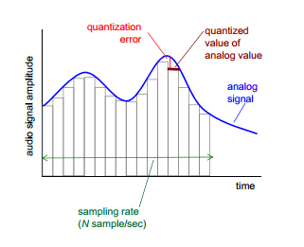
Multimedia: video
Video: sequence of images displayed at constant rate
• e.g., 24 images/sec
Digital image: array of pixels
• Each pixel represented by bits
Coding: use redundancy with in and between images to decrease # bits used to encode image
• Spatial (within image)
• Temporal (from one image to next)
CBR: (constant bit rate): video encoding rate fixed
VBR: (variable bit rate): video encoding rate changes as amount of spatial, temporal coding changes
Examples:
• MPEG 1 (CD-ROM) 1.5 Mbps
• MPEG2 (DVD) 3-6 Mbps
• MPEG4 (often used in Internet, < 1 Mbps)
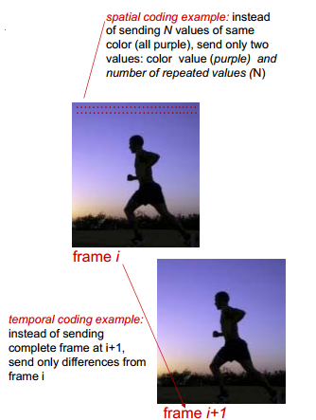

Multimedia networking: 3 application types
Streaming, stored audio, video
• Streaming: can begin play out before downloading entire file
• Stored (at server): can transmit faster than audio/video will be rendered (implies storing/buffering at client)
• e.g., YouTube, Netflix, Hulu
Conversational voice/video over IP
• Interactive nature of human-to-human conversation limits delay tolerance
• e.g., Skype streaming live audio, video
• e.g., live sporting event (futbol)

Streaming stored video:
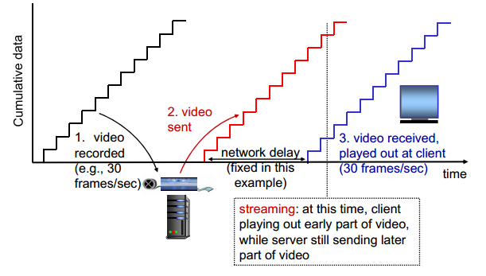

Streaming stored video: challenges
Continuous playout constraint: once client playout begins, playback must match original timing
•… but network delays are variable (jitter), so will need client-side buffer to match playout requirements
Other challenges:
•Client interactivity: pause, fast-forward, rewind, jump through video
•Video packets may be lost, retransmitted
Streaming stored video: revisited
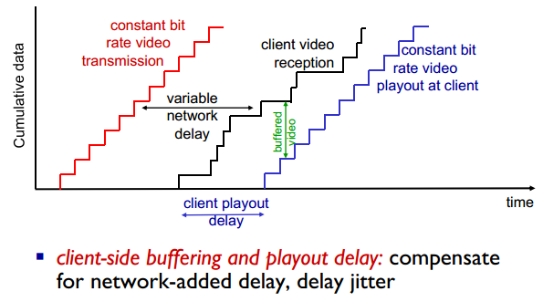

Client-side buffering, playout
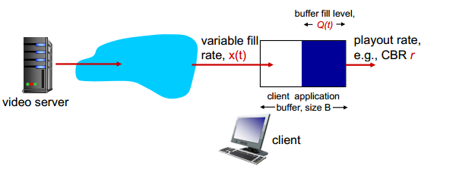

Client-side buffering, playout
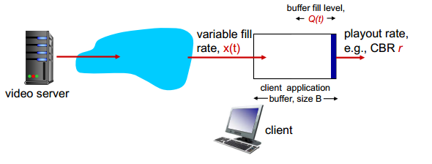
1. Initial fill of buffer until playout begins at tp
2. Playout begins at tp,
3. Buffer fill level varies over time as fill ratex (t) varies and playout rate r is constant

Client-side buffering, playout
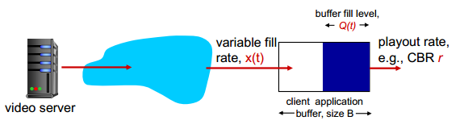

Playout buffering: average fill rate (x), playout rate (r):
x < r: buffer eventually empties (causing freezing of video
Playout until buffer again fills)
x > r: buffer will not empty, provided initial playout delay is large enough to absorb variability in x(t)
•Initial playout delay tradeoff: buffer starvation less likely with larger delay, but larger delay until user begins watching
Streaming multimedia: UDP
Server sends at rate appropriate for client
• Often: send rate = encoding rate = constant rate
• Transmission rate can be oblivious to congestion levels
Short playout delay (2-5 seconds) to remove network jitter
Error recovery: application-level, time permitting
RTP [RFC 2326]: multimedia payload types
UDP may notgo through firewalls

Streaming multimedia: HTTP
Multimedia file retrieved via HTTP GET
Send at maximum possible rate under TCP
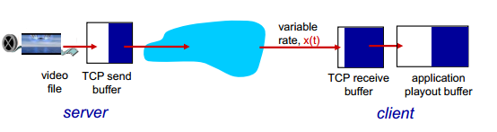

Fill rate fluctuates due to TCP congestion control, retransmissions (in-order delivery)
Larger playout delay: smooth TCP delivery rate
HTTP/TCP passes more easily through firewalls

Voice-over-IP (VoIP)
VoIP end-end-delay requirement: needed to maintain “conversational” aspect
• Higher delays noticeable, impair interactivity
• < 150 msec: good
• > 400 msec bad
•Includes application-level (packetization , playout), network delays
Session initialization: how does callee advertise IP address, port number, encoding algorithms?
Value-added services: call forwarding, screening, recording
Emergency services: 911

VoIP characteristics
Speaker’s audio: alternating talk spurts, silent periods.
• 64 kbps during talk spurt
• Pkts generated only during talk spurts
• 20 msec chunks at 8 Kbytes/sec: 160 bytes of data
Application-layer header added to each chunk
Chunk+header encapsulated into UDP or TCP segment
Application sends segment into socket every 20 msec during talkspurt

VoIP: packet loss, delay
Network loss: IP datagram lost due to network congestion (router buffer overflow)
Delay loss: IP datagram arrives too late for playout at receiver
• Delays: processing, queueing in network; end-system (sender, receiver) delays
• Typical maximum tolerable delay: 400 ms
Loss tolerance: depending on voice encoding, loss concealment, packet loss rates between 1% and
10% can be tolerated.

Delay jitter

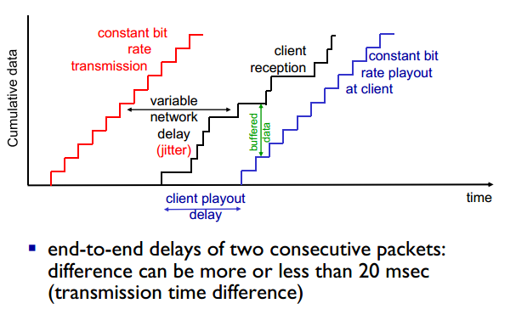

VoIP: fixed playout delay
Receiver attempts to playout each chunk exactly q msecs after chunk was generated.
• Chunk has time stamp t: play out chunk at t+q
• Chunk arrives after t+q: data arrives too late for playout: data “lost”
tradeoff in choosing q:
• Large q: less packet loss
• Small q:better interactive experience

VoIP: fixed playout delay
Sender generates packets every 20 msec during talk spurt.
first packet received at time r
First playout schedule: begins at p
Second playout schedule: begins at p’
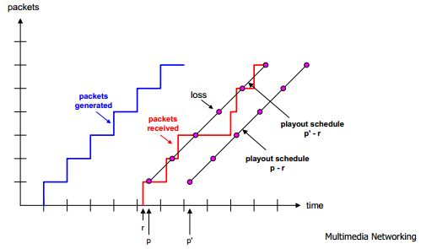

Adaptive playout delay (1)
Goal: low playout delay, low late loss rate
Approach: adaptive playout delay adjustment:
• Estimate network delay, adjust playout delay at beginning of each talk spurt
• Silent periods compressed and elongated
• Chunks still played out every 20 msec during talk spurt
Adaptively estimate packet delay: (EWMA -exponentially weighted moving average, recall TCP RTT estimate):
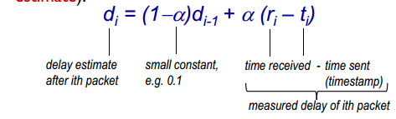
Adaptive playout delay (2)
Also useful to estimate average deviation of delay vi
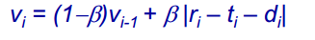

Estimates di ,vi calculated for every received packet, but used only at start of talk spurt
For first packet in talk spurt, playout time is:
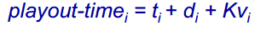
Remaining packets in talkspurt are played out periodically

Adaptive playout delay (3)
Q:How does receiver determine whether packet is first in a talkspurt?
if no loss, receiver looks at successive timestamps
• Difference of successive stamps > 20 msec -->talk spurt begins.
with loss possible, receiver must look at both time stamps and sequence numbers
• Difference of successive stamps > 20 msec andsequence numbers without gaps --> talk spurt begins

Real-Time Protocol (RTP)
RTP specifies packet structure for packets carrying audio, video data
RFC 3550
RTP packet provides
• Payload type identification
• Packet sequence numbering
• Time stamping
RTP runs in end systems
RTP packets encapsulated in UDP segments
Interoperability: if two VoIP applications run RTP, they may be able to work together
RTP runs on top of UDP
RTP libraries provide transport-layer interface that extends UDP:
• Port numbers, IP addresses
• Payload type identification
• Packet sequence numbering
• TIme-stamping
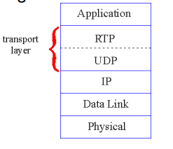

RTP example
Example: sending 64 kbps PCM-encoded voice over RTP
Application collects encoded data in chunks,
e.g., every 20 msec = 160 bytes in a chunk
Audio chunk + RTP header form RTP packet, which is encapsulated in UDP segment
RTP header indicates type of audio encoding in each packet
• sender can change encoding during conference
RTP header also contains sequence numbers, timestamps
RTP and QoS
RTP does not provide any mechanism to ensure timely data delivery or other QoS guarantees
RTP encapsulation only seen at end systems (not by intermediate routers)
• Routers provide best-effort service, making no special effort to ensure that RTP packets arrive at destination in timely matter
RTCP: multiple multicast senders

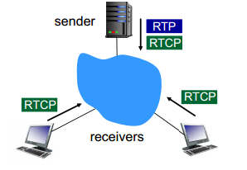
Each RTP session: typically a single multicast address; all RTP /RTCP packets belonging to session use multicast address
RTP, RTCP packets distinguished from each other via distinct port numbers
To limit traffic, each participant reduces RTCP traffic as number of conference participants increases

Network support for multimedia
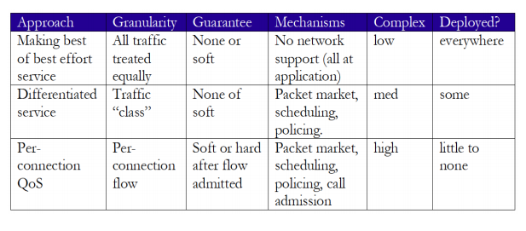
Dimensioning best effort networks
Approach: deploy enough link capacity so that congestion doesn’t occur, multimedia traffic flows without delay or loss
• Low complexity of network mechanisms (use current “best effort” network)
• High bandwidth costs
Challenges:
• Network dimensioning: how much bandwidth is “enough?”
• Estimating network traffic demand: needed to determine how much bandwidth is “enough” (for that much traffic)
Providing multiple classes of service
Thus far: making the best of best effort service
• one-size fits all service model
Alternative: multiple classes of service
• Partition traffic into classes
• Network treats different classes of traffic differently (analogy: VIP service versus regular service)
granularity: differential service among multiple classes, not among individual connections
History: ToS bits
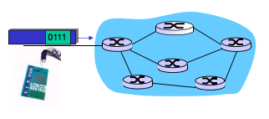
Multiple classes of service: scenario
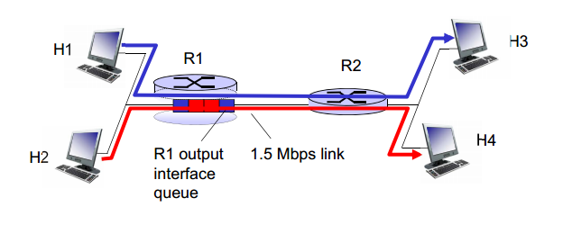

Scenario 1: mixed HTTP and VoIP
example: 1Mbps VoIP, HTTP share 1.5 Mbps link.
• HTTP bursts can congest router, cause audio loss
• want to give priority to audio over HTTP
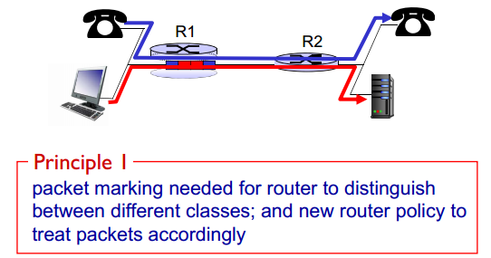

Principles for QOS guarantees (more)
What if applications misbehave (VoIP sends higher than declared rate)
• Policing: force source adherence to bandwidth allocations marking, policingat network edge
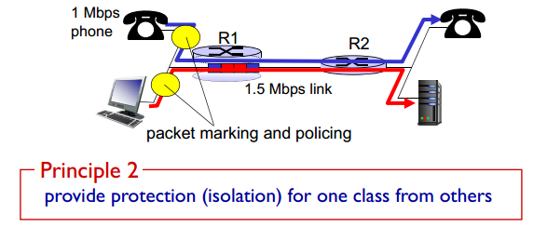

Principles for QOS guarantees (more)
Allocating fixed (non-sharable) bandwidth to flow: inefficient use of bandwidth if flows doesn’t use its
allocation
