Name: Muhammad akram.
Id : 16392.
Dep : SE.
Section: (B).
Esghiment: management.
Teacher : mam mehvish

Q1) How can you prepare yourself to become an effective manager in an increasingly uncertain and global business environment?
Answer: The world as it is today is much different than it was when our parents’ parents were in managerial positions. In fact, the way companies market products has changed more in the past five years than in the previous one-hundred combined! With such rapid, dramatic change in the business place, it is abundantly clear that managers must take necessary steps to be an effective manager in this current global business environment. Managers

can adapt to changes by boundary-spanning roles, interorganizational partnerships, and mergers or joint ventures. According to the online text book for Activated Logic, “Understanding the marketing environment in which your organization competes and also understanding how the micro & macro-economic forces impact your organization is very important, as these factors present both opportunities and threats.” As upcoming managers prepare themselves to be effective in the increasingly uncertain global business environment, it is evident that knowledge of the following is important: competitors, customers and other elements of the environment. One key component, not to be over looked, is the concept of team work (i.e. joint ventures, partnerships and mergers). it is richly clear that manager should take necessary steps to be an effective manager in this current global business environment. Manager can adapt to changes by boundary spanning role,interorganizational partnership and merger or joint ventures. According to the online textbook for Activated logic.

Q2) Explain the difference between efficiency and effectiveness and their importance for organizational performance.

Answer: Efficiency
Efficiency signifies a peak level of performance that uses the least amount of inputs to achieve the highest amount of output. Efficiency requires reducing the number of unnecessary resources used to produce a given output including personal time and energy. It is a measurable concept that can be determined using the ratio of useful output to total input. It minimizes the output.waste of resources such as physical materials, energy, and time while accomplishing the desired

Importance
- Efficiency is the fundamental reduction in the amount of wasted resources that are used to produce a given number of goods or services (output).
- Economic efficiency results from the optimization of resource-use to best serve an economy.
- Market efficiency is the ability for prices to reflect all of the available information.
- Operational efficiency is a measure of how well firms convert operations into profits.

Effectiveness
Management effectiveness can be measured by results. Goals such as increasing market share, improving customer satisfaction ratings and achieving desired revenue levels come under the heading of management effectiveness. This is how you measure whether management decisions are actually improving your business performance. For every decision that strategic managers make, you need to set a date in the future when you will measure the effectiveness of those decisions. Better yet, tell your managers to bring you data to show the effectiveness of their decisions.

Importance
Effectiveness means producing desired results. In this way, so long as a business manager makes effective planning which brings the results in a way that is wanted, the business will remain in the money. Since it involves making right decisions at the right time, it is essential for a business manager to do so.
Efficiency and effectiveness are often considered synonyms, but they mean different things when applied to process management. Efficiency is doing things right,
while effectiveness is doing the right things. ... This includes management processes as well as lower-level work processes.

Q3) Draw organogram/organization chart of any organization and explain the role of First line manager, middle line manager, and Top level manager from this chart.
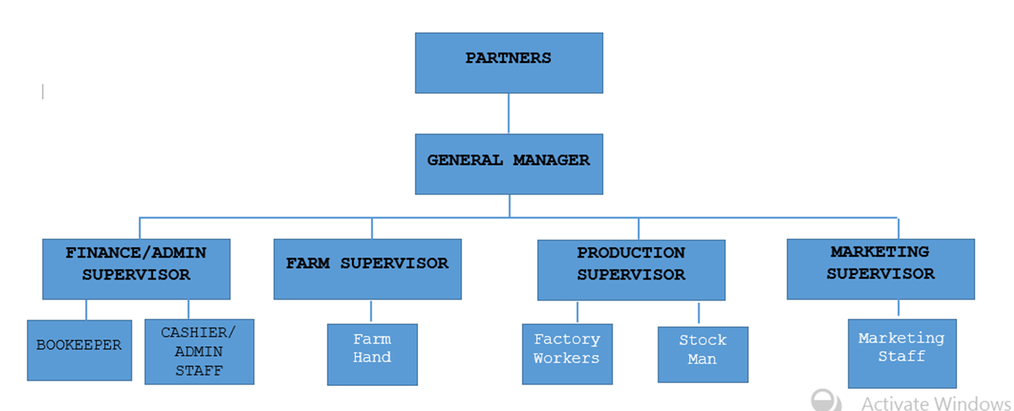
Answer:

First-line managers
First-line managers operate their departments. They assign tasks, manage work flow, monitor the quality of work, deal with employee problems, and keep the middle managers and executive managers informed of problems and successes at ground level in the company.
Examples of first line managers are the foreman or production supervisor in a manufacturing plant, the technical supervisor in a research department, and the clerical supervisor in a large office. First level managers are often called supervisors.

Middle Line Managers
Middle managers receive broad strategic plans from top managers and turn them into operational blueprints with specific objectives and programs for first-line managers. They also encourage, support, and foster talented employees within the organization.
Middle management is at the center of a hierarchical organization, subordinate to the senior management but above the lowest levels of operational staff. Middle managers are accountable to top management for their department's function. They provide guidance to lower-level managers and inspire them to perform better.

Top-level Managers
Top-level managers are responsible for controlling and overseeing the entire organization. ... These managers act at an intermediary between top-level management and low-level management. Low-level managers focus on controlling and directing. They serve as role models for the employees they supervise.

