IQRA NATIONAL UNIVERSITY
DEPARTMENT OF ALLIED HEALTH SCIENCES
Final-Term Examination
DPT 2nd Semester
Course Title: Human Physiology II Instructor: Dr Sara Naeem
Time: 6 Hours Max Marks:50

Q1. What would be the total lung capacity (TLC) if expiratory reserve volume ( ERV) is 1000 ml , (RV) residual volume is 1200 ml keeping the inspiratory capacity ( IC) as 3000 ml.
Given Data:
Expiratory reserve volume (ERV)= 1000 ml
Residual Volume (RV)=1200ml.
Respiratory Capacity (IC)=3000 ml
Required:
Total lung capacity (TLC)=?
Solution:
As, TLC= FRC + IC
SO, FRC = ERV + RV
= 1000 + 1200
= 2200
TLC = FRC + IC
TLC = 2200 + 3000
TLC = 5,200 ml.

Q2. What is pulmonary edema . Enlist the muscles of inspiration and muscles of expiration.
Pulmonary edema:
- Pulmonary edema is a condition in which the lung is filled with fluid.
- It is also known as lung congestion, lung water and pulmonary congestion,
- When pulmonary edema occurs, the body struggles to get enough oxygen and you start to have shortness of breath.
Congestive heart failure:
- The most common cause of pulmonary edema is congestive heart failure.
- Heart failure happens when the heart can no longer pump blood properly throughout the body.
- This creates a backup of pressure in the small vessels of the lungs, which causes the vessels to leak fluid.
Muscles of inspiration:
The diaphragm is the primary muscle involved in the breathing how ever several other muscles play a role in certain circumstances.
These muscles are referred to as accessory muscles of inhalation.
- External intercostal muscles:
- Muscles located between the ribs that help the thoracic cavity and pleural cavity expand during quiet and forced inspiration.
- Scalene muscles:
- Muscles in the neck that lifts the upper ribs ( and thoracic cavity around the ribs) to help breathing.
- They provide a mechanism for inspiration when the diaphragmis injured and cant contract.
- Sternocleidomastoid Muscles:
- Muscles that connects the sternum to the neck and allow for rotation and turning of head.
- They can lift the upper ribs like the scalene muscles can.
- Trapezius:
- Muscles in the shoulders that retract the scapula and expand the upper part of the thoracic cavity.
Muscles of Expiration:
While expiration is generally a passive process. It can also be active and forced process.
There are two group of muscles that are involved in forced exhalation:
1.Internal intercostal Muscles:
- Muscles of the ribcage that help lower the ribcage, which pushes down on the thoracic cavity, causing forced exhalation.
Note that these are not the same as external intercostal muscles involved in inspiration.
2.Abdominal recti:
- Main powerful effect.
3.Abdominal Muscles:
- Any number of muscles in the abdominal that exert pressure on the diaphragm from below to expand it.
- Which in turn contracts the thoracic cavity. Causing forced exhalation.

Q3. Compare the properties of different blood groups. Also mark universal donor and universal recipient.
Blood Types:
- A blood group is defined as the classification of blood based on the presence or absence of inherited antigenic substances on the surface of red blood cell (RBCs).
- A series of related blood group system, such as Rh or ABO system,
- The frequencies of ABO and Rh blood types vary from population to population.
- There are 4 main blood groups A, B, AB and O.
- Each group can be either RhD positive or RhD negative which mean in total there are 8 blood groups,
The ABO System:
There are 4 main blood groups defined by the ABO system:

Blood group  A | Has A antigens on the red blood cells with anti-B antibodies in the plasma.
Blood group  B | Has B antigen, with anti- A antibodies in the plasma
Blood group  O | Has no antigens, but both anti- A and anti- B antibodies in the plasma.
Blood group  AB | Has both A and B antigens, but no antibodies.

The Rh System:
- Red blood cells sometimes have another antigen, a protein known as the RhD antigen.
- If this is present, your blood group is RhD positive,
- If its absent, your blood group is RhD negative.
- This means you can be 1 of 8 blood groups:
- A RhD positive (A+)
- A RhD negative (A-)
- B RhD positive (B+)
- B RhD negative (B-)
- O RhD positive (O+)
- O RhD negative (O-)
- AB RhD positive (AB+)
- AB RhD negative (AB-)

Universal Donor:
- Blood group type O- is the variety of blood that has the lowest risk of causing serious reactions for most people who receive it.
- Because of this, its sometimes called the universal blood donor type.
Universal Recipient:
- AB+ is the universal recipient blood type.
- Patients with AB+ can receive blood from donors of any blood type if they require a transfusion.

Q4. Explain respiratory membrane . What are the factors that affect diffusion of gases across the membrane
Respiratory Membrane:
- The membrane separating air within the alveoli from the blood within pulmonary capillaries.
- It consists of the alveolar wall, the capillary wall, and their basement membranes.
- The respiratory membrane is very thin (less than 0.5mm).
Layers of Respiratory Membrane:
The respiratory membrane consists of four tissue layers:
- Alveolar wall (type 1 and type 11 alveolar cells and alveolar macrophages.
- Epithelial basement membrane- under the alveolar wall.
- Capillary basement membrane- fused to the epithelial basement membrane.
- Capillary Epithelium.
Factors that Affects the Rate of Gas Diffusion Through the Respiratory Membrane:
- Thickness of the membrane.
- Surface area of the membrane.
- Diffusion coefficient of the gas in substance of the membrane, and
- Partial pressure differences of the gas between the two sides of the membrane.
Diffusing capacity of the Respiratory Membrane:
Definition:
- Volume of gas that will diffuse through the membrane each minute for a partial pressure difference of 1 mm Hg.
- All the factors discussed earlier that affect diffusion through the respiratory membrane can effect this diffusing capacity.
Diffusing capacity for Oxygen
- 21ml/min/mm Hg.
- Oxygen pressure differences across the respiratory membrane during normal, quiet breathing is about 11 mmHg.
- Multiplication of the pressure by the diffusing capacity(11 multiply 21) gives a total of about 230 milli liters of oxygen.
Diffusing capacity for Carbon Dioxide:
- Carbon dioxide diffuses through the respiratory membrane so rapidly that the average Pco2 in the pulmonary blood is not far different from the Pco2 in the alveoli.
- The average difference is less than 1 mm Hg -and with the available techniques.
- The difference is too small to be measured.

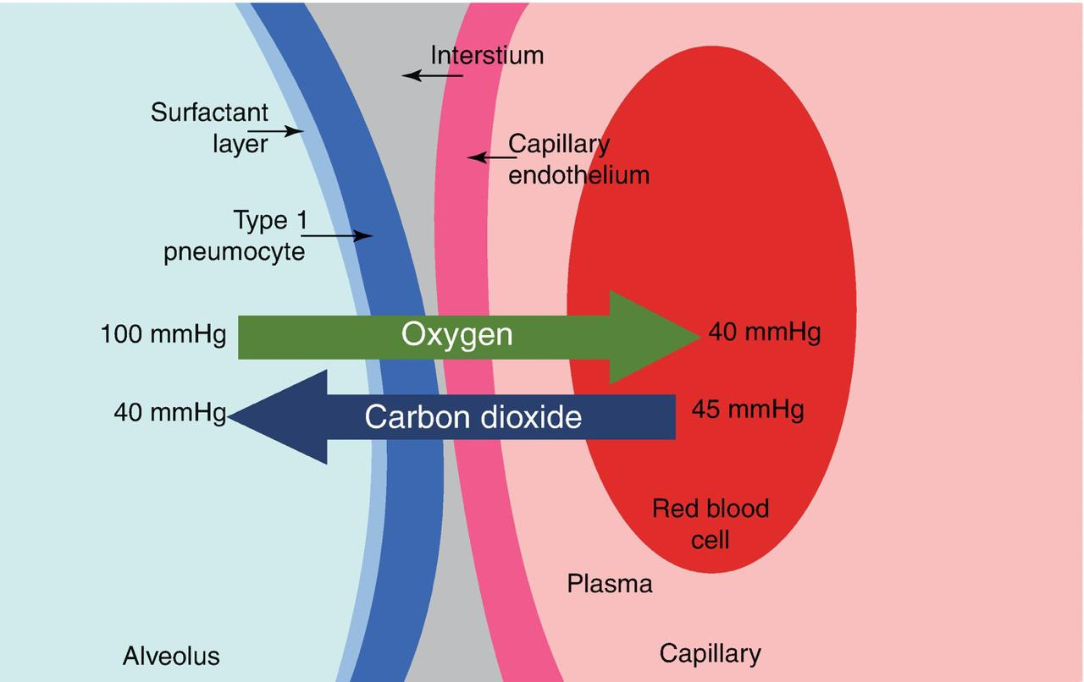

Q5. What is the difference between anatomical dead space and physiological dead space. What are the clinical manifestations of pulmonary effusion.

Anatomical Dead Space:

- Anatomical dead space is the total volume of the conducting airways from the nose or mouth down to the level of the terminal bronchioles.
- It is about 150 ml on the average in humans.
- The anatomical dead space fills with inspired air at the end of each inspiration.
- But this air is exhaled unchanged.
- Thus, assuming a normal tidal volume of 500 ml.
- About 30% of this air is “wasted” in the sense that it does not participate in gas exchange.

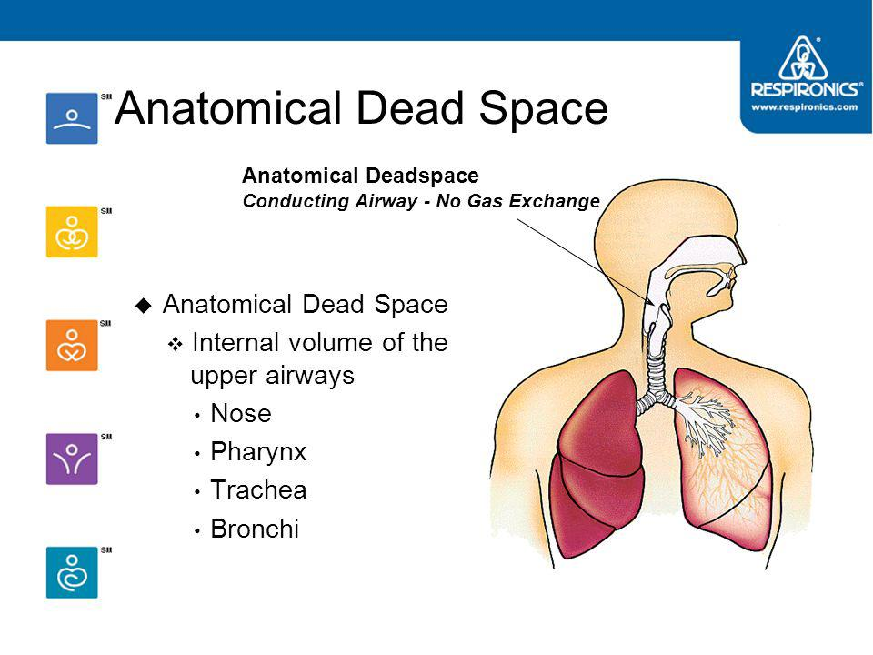
Physiological dead space:
- Physiological dead space includes all the non-respiratory parts of the bronchial tree include in anatomical dead space.
- Dead space is the volume of air that is inhaled that does not take part in either remains in the conducting airways.
- Physiological or total dead space is equal to anatomical plus alveolar dead space.
- The volume of the air in the respiratory zone that does not take part in gas exchange.
- The respiratory zone is comprised of respiratory bronchioles, alveolar duct, alveolar sac, and alveoli.

Symptoms of Pulmonary Effusion:
Some patients with pulmonary effusion have no symptoms, with the condition discovered on a chest x-ray that is performed for another reason.
The patient may have unrelated symptoms due to the disease or condition that has caused the effusion.
Symptoms of pulmonary effusion include:
- Chest pain.
- Dry, nonproductive cough.
- Dyspnea ( shortness of breath, or difficult, labored breathing)
- Orthopnea (the inability to breathe easily unless the person is sitting up straight or standing erect).
Causes of pulmonary effusion:
- Heart failure.
- Pulmonary embolism.
- Cirrhosis.
- Post open heart surgery.
- Certain medication, abdominal surgery and radiation therapy may also cause pleural effusion.
- Pleural effusion may occur with several types of cancer including lung cancer, breast cancer and lymphoma.
