Submitted by : sajjad Ahmad
ID# : 13638
Submitted to : DR Natasha kamran
Assignment : Maxillofacial surgery

BASIC HAND INSTRUMENTS:-
- Dental hand instruments are made of metal alloy or plastic resin.
- They are named according to their use or shape or named for the designer of the instrument.
- Hand instruments may be single- or double-ended.
- Advantages of double-ended: Two sizes of the same design in one instrument, two different working ends in one instrument, or two directions of use in one instrument (right/left).

PARTS OF HAND INSTRUMENTS:-
- There are three parts of a hand instrument:
1.Working end:- The design determines the function and may be a beveled cutting edge (chisel), a point(explorer), a nib (amalgam condenser), a blade (composite instrument) or beaks (pliers).
2.Shank:- Portion of the instrument that connects the handle and the working end. The shank may be straight or angled to provide better access to different areas of the mouth.
3.Handle or shaft:- Rounded or hexagonal in different diameters and materials for better fit and grip.

MOUTH MIRROR:-
- FUNCTION:
- To provide indirect vission.
- Use to retract lips and tounge.
- To view tissues of the oral cavity and reflect light for better visibility.
- FEATURES:
- Front surface mirrors reflect from the front surface or plane reflective surface. Magnifying and double-sided also available.
- CLINICAL APPLICATION:
- Also used to retract and protect tongue and cheek.
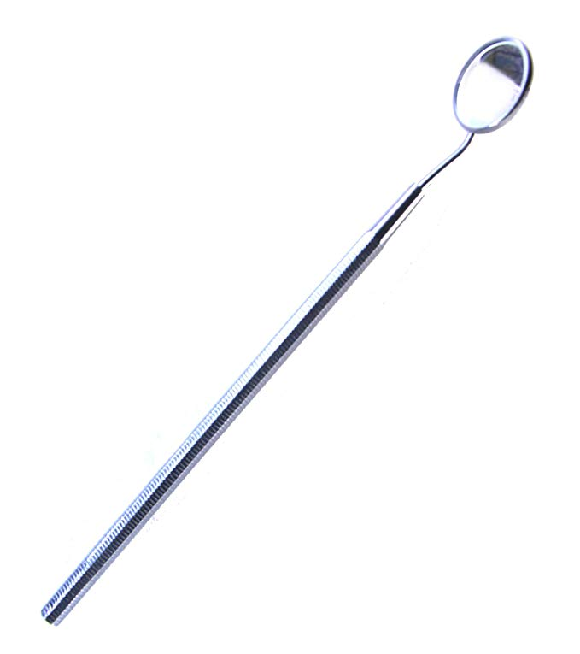

DENTAL EXPLORER:-
- FUNCTION:
- To examine tooth surfaces for caries, calculus, or defects using sense of touch (tactile).
- FEATURES:
- Thin, sharp working end comes in different designs. May be single- or double-ended (different design on each side)
CLINICAL APPLICATION:
1.To check fit of margins of restorations.
2. Evaluate root surfaces and furcation area in periodontal exam.
3. Remove excess material from restoration or preparation.
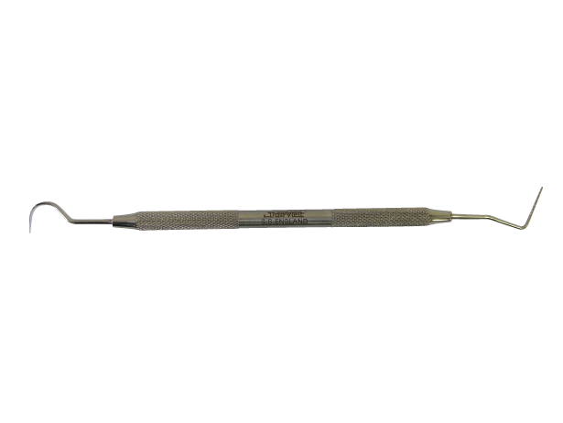

COTTON PLIERS:-
- FUNCTION:
- To place and remove small objects from the oral cavity (cotton pellets, root canal instruments, wedges)
- FEATURES:
- Serrated or nonserrated beaks, locking or nonlocking handles. Also known as college pliers or dressing pliers.
- CLINICAL APPLICATION:
- It is used to retrieve materials from drawers and containers to avoid cross-contamination.
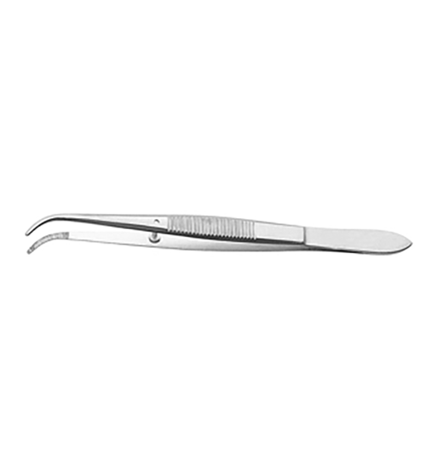

SCALPEL:-
- FUNCTION:
- To hold in place, cut tissues with blade, trim interproximal restoration.
- To cut soft tissue—a surgical knife.
- CLINICAL APPLICATION:
- For safety, blades are placed and removed from the metal handle with a hemostat or a specially designed scalpel blade remover.
- Used blades should be disposed of in a sharps container.
- CHARACTARISTICS:
- Blades are disposible after each use.
- Handle can be autoclaved or disposible.
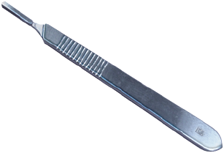
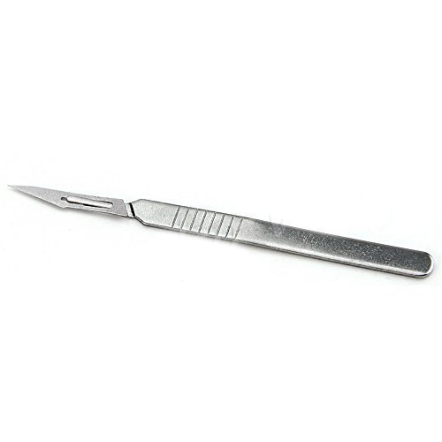
HEMOSTATS
- FUNCTION:
- To grasp tissue or bone fragment.
- To securely hold small items, clamp blood vessels, and remove small pieces of tooth or bone.
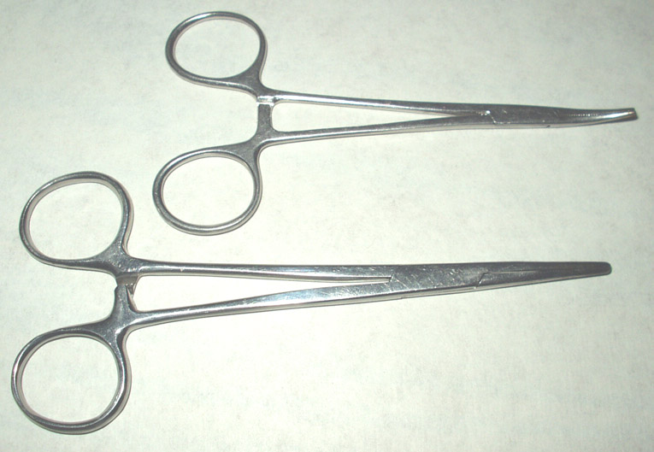

ORAL SURGERY INSTRUMENTS:-
DENTAL ELEVATOR:-
- Elevators (also known as luxators) are instruments used in dental extractions.
- They may be used;
1) To loosen teeth prior to forcep extraction,
2) To remove roots or impacted teeth when teeth are compromised and susceptible to fracture or when they are malpositioned and cannot be reached with forceps
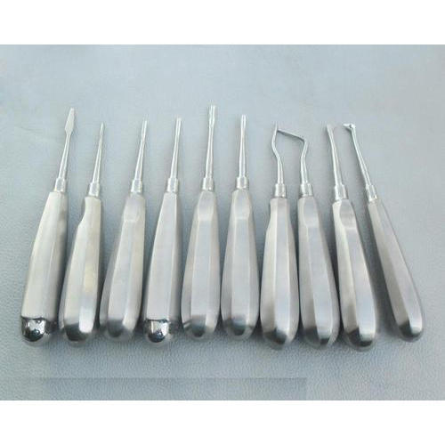
- STRAIGHT ELEVATOR:-

- FUNCTION:-

- To lossen tooth from periodontal ligaments before extraction.

- To separate and lift tooth from socket.

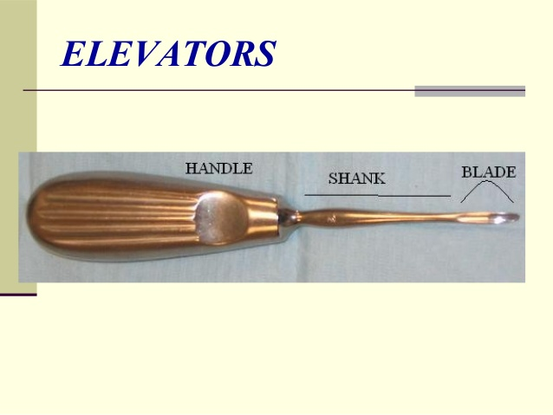

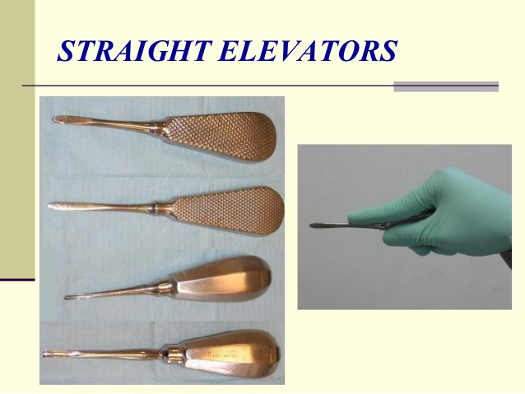

ROOT ELEVATORS:-
- FUNCTION:-
- To lossen root and separate and lift tooth from socket.
- To use on anterior teeth.

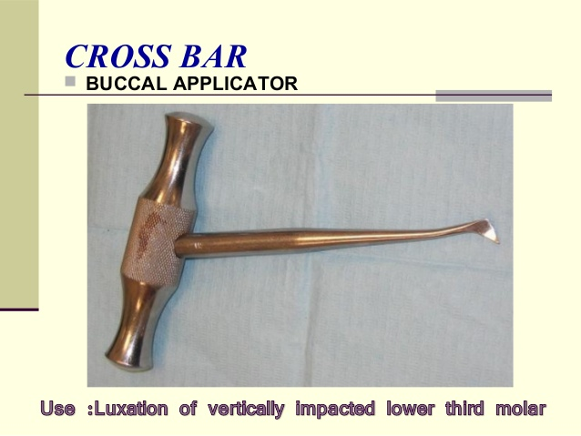
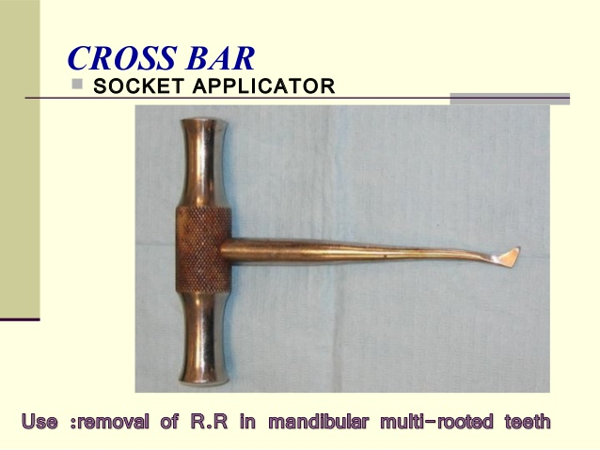

DENTAL FORCEPS:-
- Function:
- Removal of tooth from alveolar bone.
- Designed in various styles and configurations to adapt to variety of teeth for which they are used .
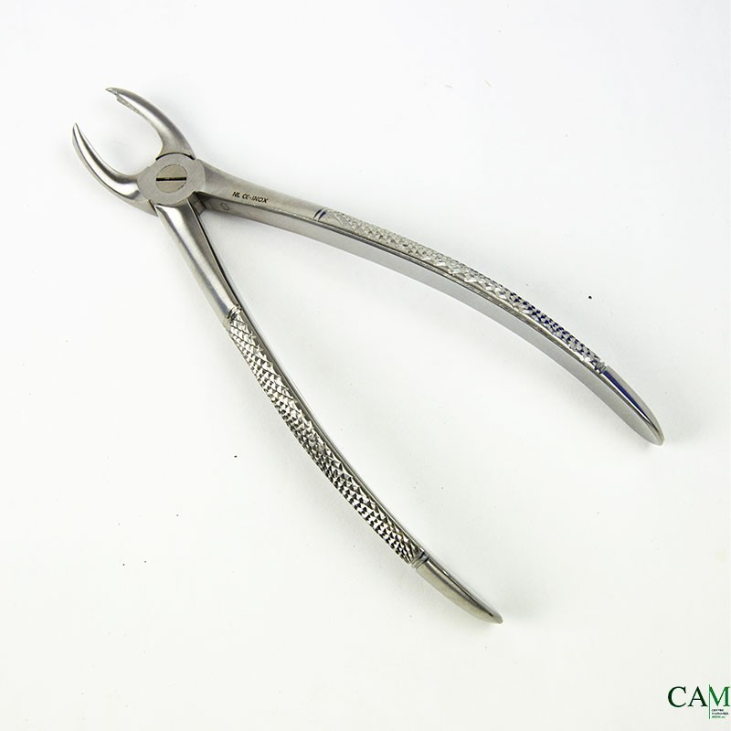

MANDIBULAR MOLAR FORCEP
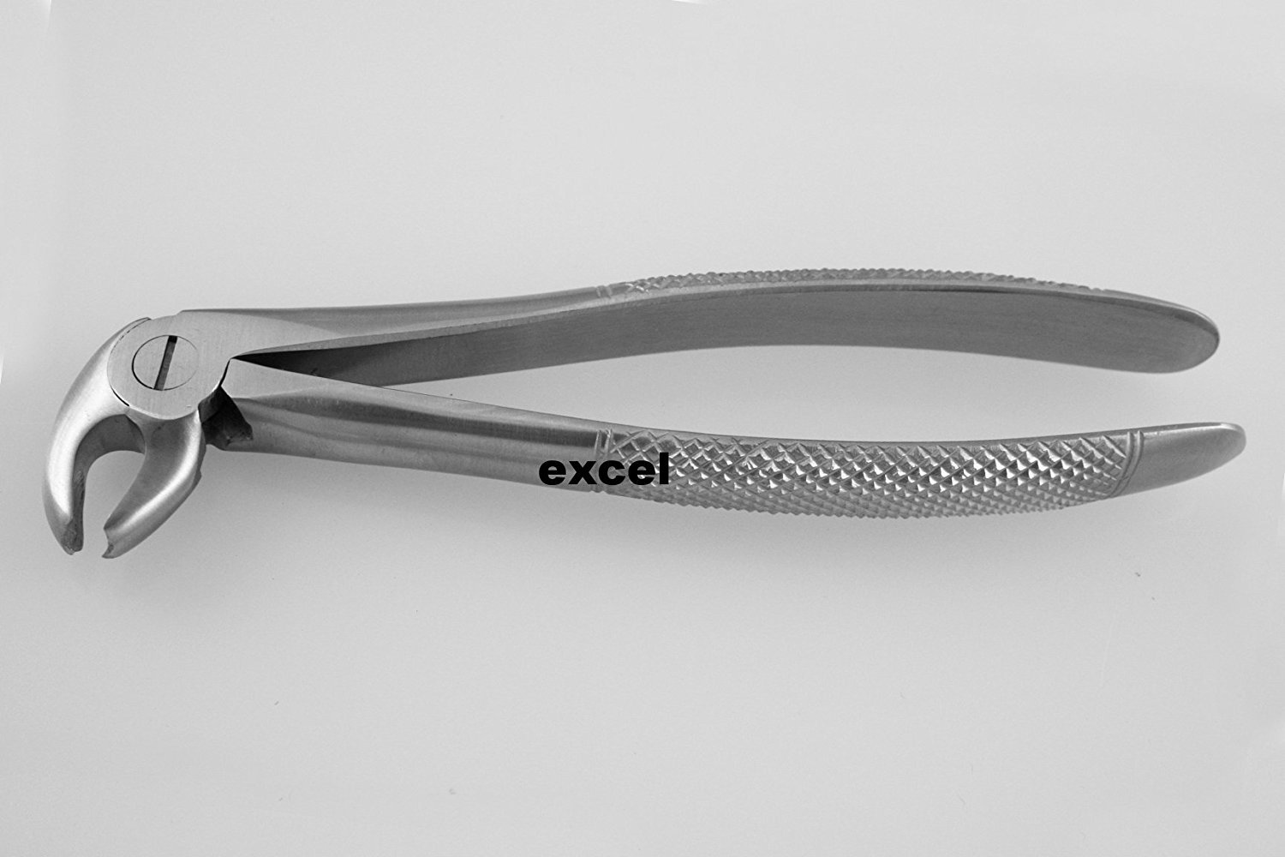
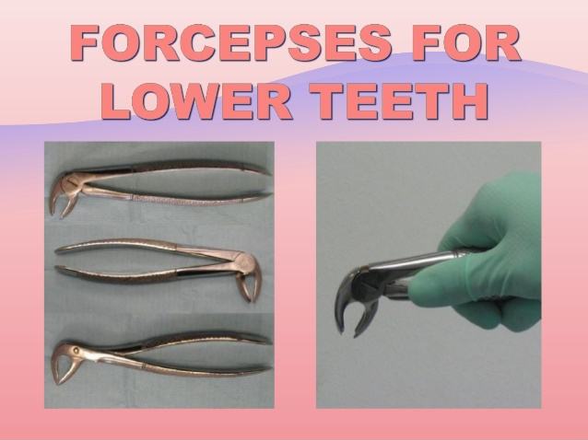

MAXILLARY MOLAR FORCEP:-
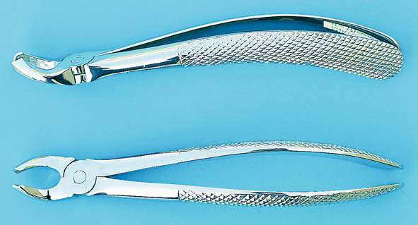
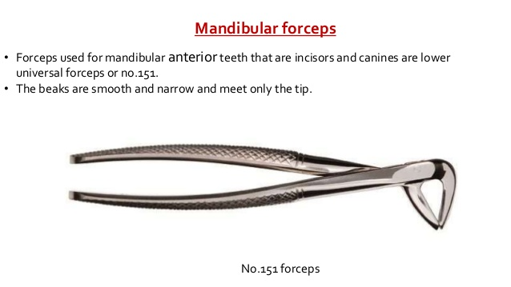

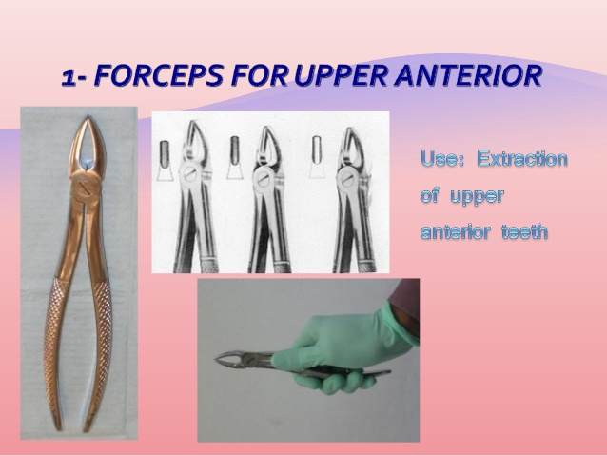
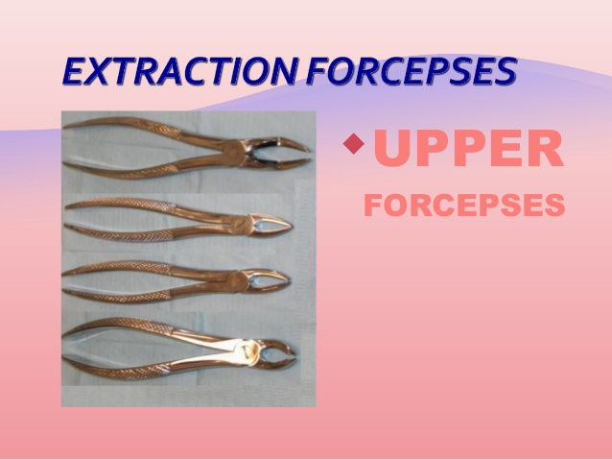
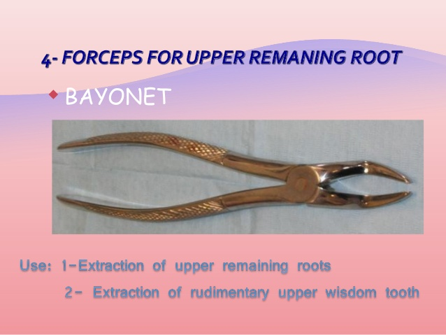

DECIDUOUS FORCEPS:-
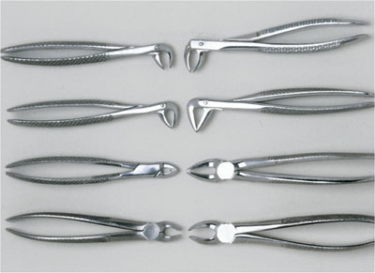

RONGEURS:-
- FUNCTION:-
To cut and contour bone, removes sharp edges of alveolar crest after extractions for better contour of alveolar ridge; removes exostoses.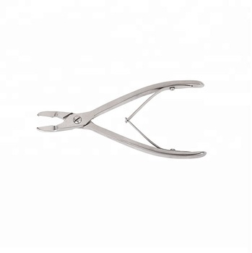
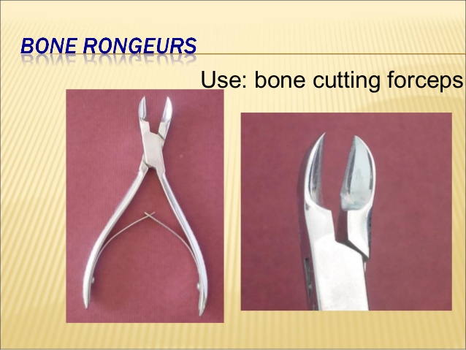

BONE FILE:-
- FUNCTION: To smooth bone for better contour of alveolar ridge, often following use of rongeurs.
- FEATURES: Straight or curved working ends Crosscut or straight cutting ridges Double ended.
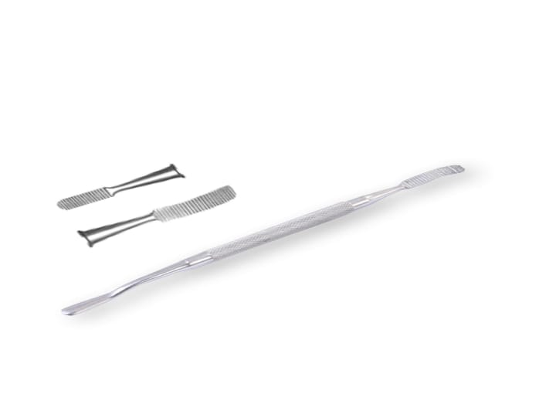

BONE CHISEL AND MALLET:-
- FUNCTION: To remove bone for better contour of alveolar ridge, remove exostoses i-e tori

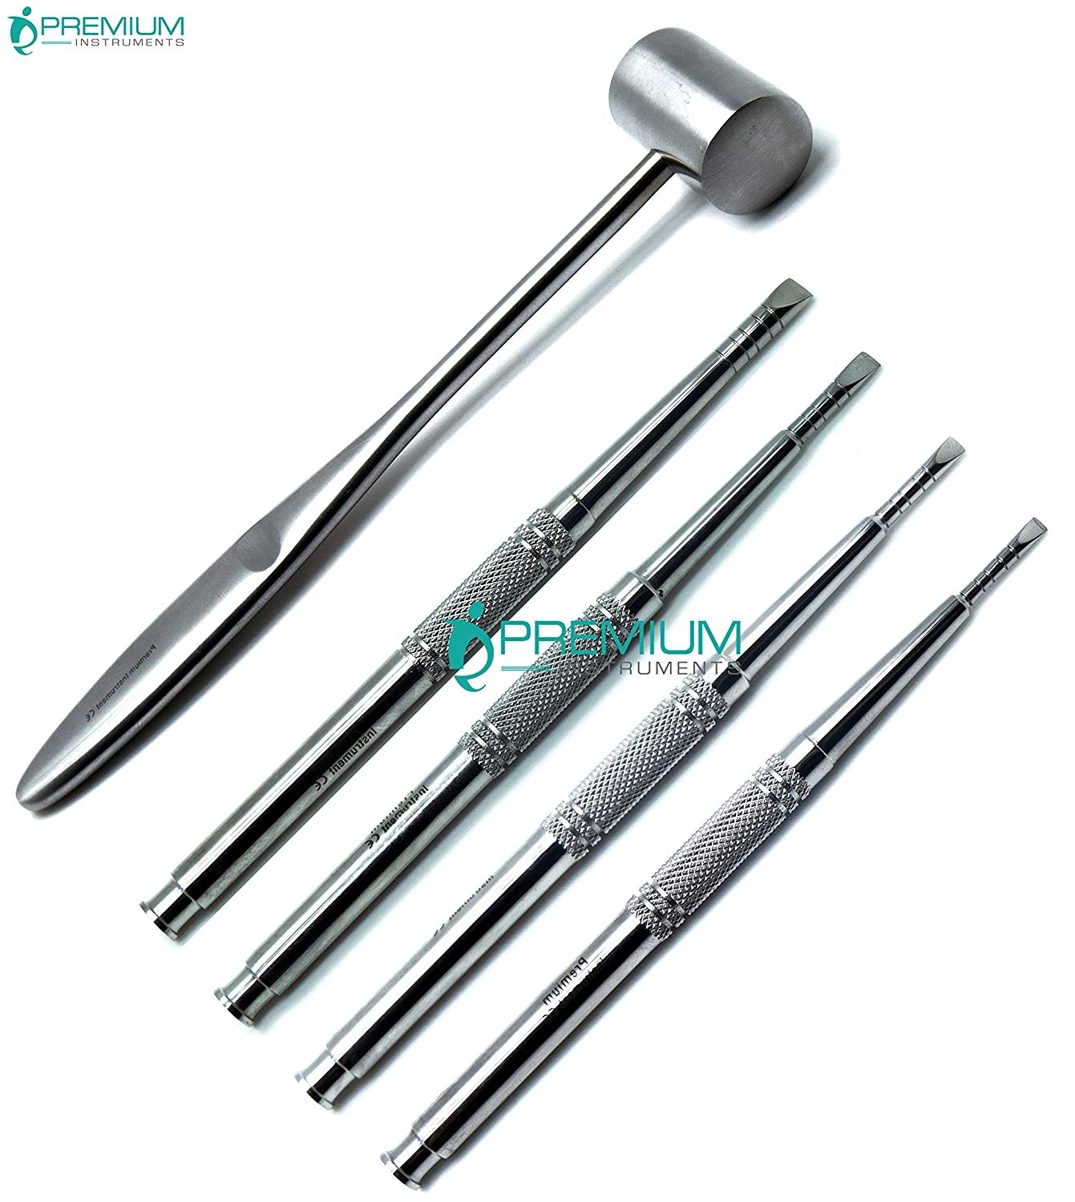

SALIVA EJECTOR TIP:-
- FUNCTION: To remove saliva and maintain dry field using low-volume evacuation.
- FEATURES: Disposable plastic, some designed with attached tongue deflector.
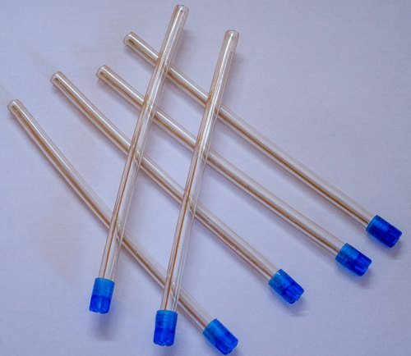

NEEDLE HOLDERS:-
- FUNCTION:
- To hold suture needle.
- FEATURES:
1) Similar to hemostat but with a concave area on inside of each beak to allow for curve of suture needle.
2) To avoid needle breakage, place the needle holder on the needle just beyond the suture attachment point and at right angles to the curve of the needle.
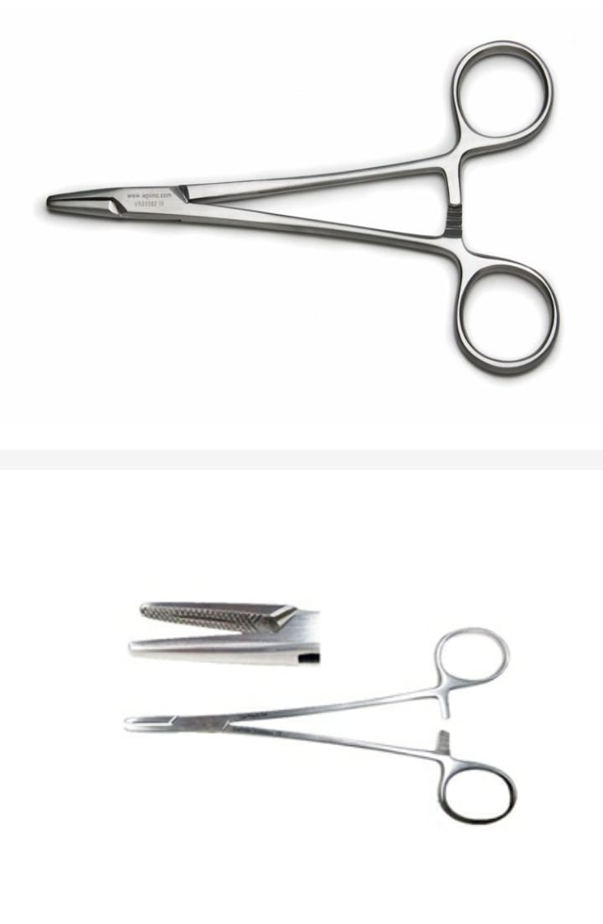
SUTURE:-
- FUNCTION: To close incision site “Stitches” hold tissues in place during healing
- FEATURES: Suture material attached to sterile stainless steel needle. Suture may be absorbable—plain or chromic gut, polyglycolic acid (PGA, Vicryl) or nonabsorbable—silk, polyester, nylon, polypropylene.
- CLINICAL APPLICATION: Non absorbable sutures usually removed at 7–10 days postsurgical visit. The suture is placed with needle holder or hemostat.
SUTURE WITH NEEDLE HOLDER:- 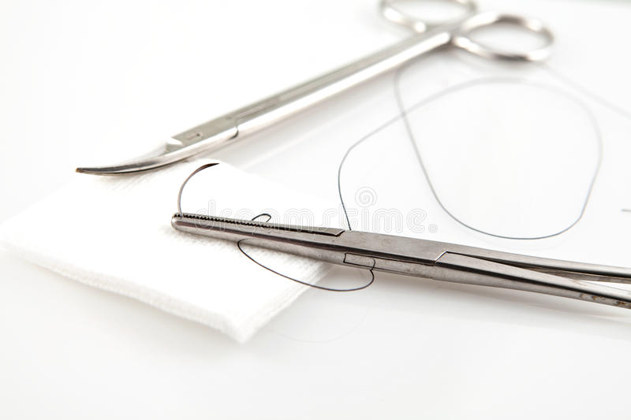
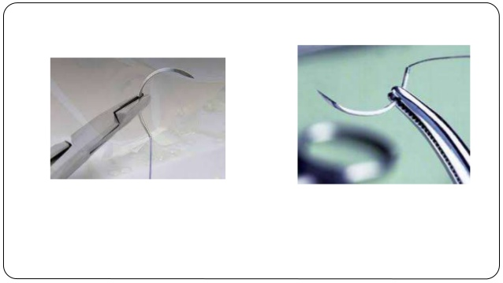

TISSUE SCISSORS:-
FUNCTION: To cut and remove excess or diseased soft tissue.
Also used to cut sutures after knots are tied during suture placement.

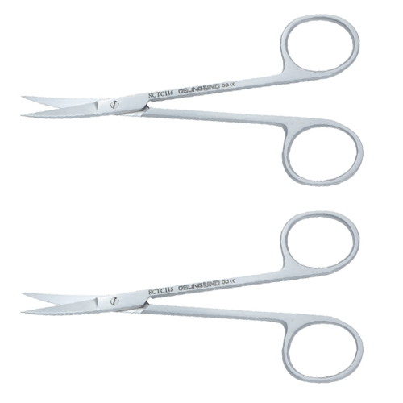

ANESTHETIC SYRINGE:-
- FUNCTION: To deliver local anesthesia to intraoral site.
- FEATURES: Aspirating and Non-aspirating.

SYRINGE:-
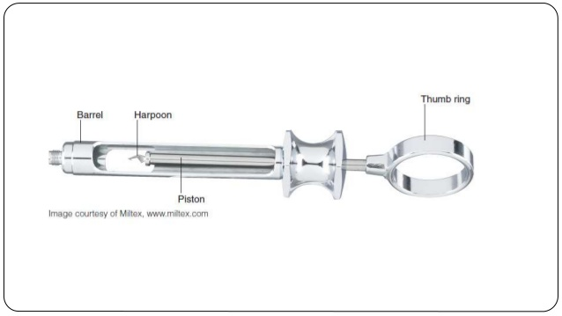

DISPOSABLE SYRINGE:-
