DENTAL TECHNOLOGY 3RD SEMESTER
PAPER : PHARMACOLOGY
Ma'am : NADRA
STUDENT NAME : SABILA
STUDENT ID : 15248

Question 1 : Define drug receptors, enumerate different receptor families and explain the receptor that shows its effect through second messenger system.
Ans. Drug receptors.
Receptor is a macromolecule in the membrane or inside the cell that specifically (chemically) bind a ligand (drug). The binding of a drug to receptor depends on types of chemical bounds that can be established between drug and receptor.
Major Receptor Families
These receptors may be divided into four families:
1) Ligand-gated ion channels,
2 )G proteins coupled receptors, 3)Enzyme linked receptors, 4) Intracellular receptors.
The type of receptor a ligand will interact with depends on the nature of the ligand. Hydrophillic ligands interact with receptors that are found on the cell surface (families 1, 2, and 3). In contrast, hydrophobic ligands can enter cells through the lipid bilayers of the cell membrane to interact with receptors found inside cells (family 4)
1. Ligand-gated ion channels
The first receptor family comprises ligand-gated ion channels that are responsible for regulation of the flow of ions across cell membranes
The activity of these channels is regulated by the binding of a ligand to the channel. Response to these receptors is very rapid, having durations of a few milliseconds. examples
1. Nicotinic receptor
Stimulation of the nicotinic receptor by acetylcholine results in sodium influx, generation of an action potential, and activation of contraction in skeletal muscle
2. Î³-aminobutyric acid (GABA) receptor
Stimulation of the GABA receptor by GABA, resulting in increased chloride influx and hyperpolarization of the respective cell.
2. G protein coupled receptors
These receptors are comprised of a single peptide tmembrane-spanning regions, and these receptors are linked to a G protein (Gs and others) having three subunits, an α subunit that binds guanosine triphosphate (GTP) and β, γ subunit.
Binding of the appropriate ligand to the extracellular region of the receptor activates the G protein so that GTP replaces guanosine diphosphate (GDP) on the α subunit. Dissociation of the G protein occurs, and both the α GTP subunit and the β, γ subunit subsequently interact with other cellular effectors, usually an enzyme or ion channel. These effectors then change the concentrations of second messengers that are responsible for further actions within the cell. Stimulation of these receptors results in responses that last several seconds to minutes.
Second messengers
1. A common pathway turned on by Gs, and other types of G proteins, is the activation of adenylyl cyclase by α GTP subunits.
2. G proteins also activate phospholipase C.
3. G proteins coupled receptors also activate guanylyl cyclase, which converts
(GTP) to cyclic guanosine monophosphate (cGMP),
4. a fourth second messenger that stimulates cGMP-dependent protein kinase.
3. Enzyme-linked receptors
Binding of a ligand to a activates or inhibits this cytosolic enzyme activity. Duration of responses to stimulation of these receptors is on the order of minutes to hours. The most common enzyme-linked receptors
(epidermal growth factor, platelet-derived growth factor, atrial natriuretic peptide, insulin, and others).
Intracellular receptors
This places constraints on the physical and chemical properties of the ligand in that it must have sufficient lipid solubility to be able to move across the target cell membrane.
These receptor ligands are lipid soluble, they are transported in the body attached to plasma proteins, such as albumin.
For example, steroid hormones exert their action on target cells via this receptor mechanism. Binding of the ligand with its receptor follows a general pattern in which the receptor becomes activated because of the dissociation of a small repressor peptide.

Question: 2 Define drug interactions, enumerate its various types, and explain pharmacokinetic drug interactions and its factors with examples.?
Ans. Definition
It is defined as “an alternation in the duration or magnitude of pharmacological effects of one drug produced by another drug, food, or any other substance”.
Types
1. (drug-drug interaction) interactions between drugs come to mind
2. (drug-food interactions) interactions may also exist between druges and foods
3. (drug-plant interactions) drugs and medicinal plants or herbs
4. (drug-disease interactions)
But there are essentially two types of drug interactions.
1. Pharmacokinetics DI
2. Pharmacodynamics DI
Drug-Drug interactions
Drug-drug interactions occur when a drug interacts, or interferes, with
another drug. This can alter the way one or both of the drugs act in the
body, or cause unexpected side effects.
▪ Codeine+ Paracetamol Addition ( increased analgesic effect)
▪Aspirin+ Warfarin Synergism (excessive bleeding)
▪ Clavulanic acid+ Amoxicillin Synergism (increased antibiotic effect)
Drug-Food interactions
A drug-food interaction happens when the food you eat affects the
ingredients in a medicine you are taking so the medicine cannot work the
way it should.
Benzodiazepines + grapefruit Inhabit enzymes involved in drug metabolism
TetracyclinDrug-Disease interactions
Drug- Disease interaction
Drug-condition interactions occur when a drug worsens or exacerbates an
existing medical condition
•Nasal decongestants+ Hypertension Increased blood pressure
• Calcium channel blocker + Heart failure Negative inotropic activity.
• Nicotine + high blood pressure increased heard rate
Mechanisms of drug interactions
Pharmacokinetics
Pharmacokinetics involve the effect of a drug on another drug kinetic that
includes absorption ,distribution , metabolism and excretion.
Pharmacokinetic interactions
1) Altered GIT absorption.
•Altered pH
•Altered bacterial flora
• formation of drug chelates or complexes
• drug induced mucosal damage
• altered GIT motility.
a) Altered pH
The non-ionized form of a drug is more lipid soluble and more readily
absorbed from GIT than the ionized form does.
Ex1., antiacids Decrease the tablet dissolution of Ketoconazole (acidic)
Ex2., H2 antagonists Therefore, these drugs must be separated by at least 2h in the time of administration of both
(B) Altered intestinal bacterial flora ;
EX., 40% or more of the administered digoxin dose is metabolised by the
intestinal flora.
Antibiotics kill a large number of the normal flora of the intestine Increase
digoxin conc. and increase its toxicity
c) Complexation or chelation;
EX1., Tetracycline interacts with iron preparations or Milk
(Ca2+)Unabsorpable complex
Ex2., Antacid (aluminum or magnesium) hydroxide Decrease absorption ofciprofloxacin by 85 % due to chelation

d) Drug-induced mucosal damage.
Antineoplastic agents e.g., cyclophosphamide, vincristine, Procarbazine Inhibit
absorption of several drugs eg., digoxin
e) Altered motility
Metoclopramide (antiemitic) Increase absorption of cyclosporine due to the
increase of stomach empting time Increase the toxicity of cyclosporine
f) Displaced protein binding (distribution)
It depends on the affinity of the drug to plasma protein. The most likely bound
drugs is capable to displace others. The free drug is increased by displacement
by another drug with higher affinity.
Phenytoin is a highly bound to plasma protein (90%), Tolbutamide (96%), and
warfarin (99%)
Drugs that displace these agents are Aspirin, Sulfonamides, phenylbutazone.
g) Altered metabolism
The effect of one drug on the metabolism of the other is well documented.
The liver is the major site of drug metabolism but other organs can also do
e.g., WBC,skin,lung, and GIT.
CYP450 family is the major metabolizing enzyme in phase I (oxidation
process). Therefore, the effect of drugs on the rate of metabolism
of others can involve the following examples.
Enzyme induction
A drug may induce the enzyme that is responsible for the metabolism of theophylline leading to decrease it's level reduces it's action.

_________________________________________________________
Question 3 Differentiate between general and local anesthesia, explain stages of anesthesia in detail?
Ans. Anesthesia
Anesthesia or anaesthesia (from Greek "without sensation") is a state of controlled, temporary loss of sensation or
awareness that is induced for medical purposes.
An anesthetic is a drug used to induce anesthesia or in other words, to result in a temporary loss
of sensation or awareness.
They may be divided into two broad classes:
1.General anesthetics, which result in a reversible loss of consciousness.
2.Local anesthetics, which cause a reversible loss of sensation for a limited region of the body without necessarily affecting consciousness.
1. General anesthesia
It is a state characterized by unconsciousness, analgesia, amnesia, skeletal muscle relaxation, and loss of reflexes.
STAGES OF ANESTHESIA
A. Stage 1: Analgesia
In stage 1, the patient has decreased awareness of pain,
sometimes with amnesia. Consciousness may be impaired but is
not lost
B. Stage 2: Disinhibition/ excitement
In stage 2, the patient appears to be delirious and excited.
Amnesia occurs, reflexes are enhanced, and respiration is
typically Irregular; retching and incontinence may occur.
C. Stage 3: Surgical Anesthesia
In stage 3, the patient is unconscious and has no pain
reflexes; respiration is very regular, and blood pressure is
maintained.
D. Stage 4: Medullary Depression
In stage 4, the patient develops severe respiratory and
cardiovascular depression that requires mechanical and
Local anesthesia
It is the condition that results when sensory transmission from a local area of the body to the CNS is blocked.
Classification of local anesthesia
1. According to clinical use
(a) Surface anesthesia : Cocaine lignocaine, tetracaine ,benzocaine, oxethazaine anesthesia
(I) short acting with low potency : procaine , chloroprocaine .
(ii) intermediate acting with intermediate potency : lignocaine, mepi vaxcaine , prilocaine , articaine.
(III) long acting with high potency : tetracaine , bupivacaine , dibucaine , rpopivacaine.
___________________________________________________________________
Question 4
Q.No:4 (a) What does heart failure means, explain the pathophysiology of heart failure .
Ans. (a) Heart failure means that the heart is unable to pump blood around the body properly. It usually occurs because the heart has become too weak or stiff. It's sometimes called congestive heart failure, although this name is not widely used nowadays.
Pathophysiology. In heart failure, the heart may not provide tissues with adequate blood for metabolic needs, and cardiac-related elevation of pulmonary or systemic venous pressures may result in organ congestion. This condition can result from abnormalities of systolic or diastolic function or, commonly, both.
(b)Classify the drugs used for the treatment of heart failure, explain along with mechanism.
Ans.(B) Treatment Of Heart Failure
Beta-blockers, ACE inhibitors, glycosides, and diuretics are the key medications used for managing congestive heart failure through regulating renal function and the sympathetic nervous system.
Angiotensin-Converting Enzyme (ACE) Inhibitors
Commonly prescribed include:
Captopril (Capoten)
Enalapril (Vasotec)
Fosinopril (Monopril)
Lisinopril (Prinivil, Zestril)
Perindopril (Aceon)
Quinapril (Accupril)
Ramipril (Altace)
Trandolapril (Mavik)
Beta Blockers (Also known as Beta-Adrenergic Blocking Agents)
Commonly prescribed include:
Bisoprolol (Zebeta)
Metoprolol succinate (Toprol XL)
Carvedilol (Coreg)
Carvedilol CR (Coreg CR)Toprol XL
Diuretics (Also known as water pills)
Commonly prescribed include:
Furosemide (Lasix)
Bumetanide (Bumex)
Torsemide (Demadex)
Chlorothiazide (Diuril)
Amiloride (Midamor Chlorthalidone (Hygroton)
Hydrochlorothiazide or HCTZ (Esidrix, Hydrodiuril)
Indapamide (Lozol)
Metolazone (Zaroxolyn)
Triamterene (Dyrenium)
Treatment Mechanism Of Heart Failure
Medical care for heart failure includes a number of non pharmacologic, pharmacologic, and invasive strategies to limit and reverse its manifestations. [3, 4, 105] ​ Depending on the severity of the illness, nonpharmacologic therapies include dietary sodium and fluid restriction; physical activity as appropriate; and attention to weight gain. Pharmacologic therapies include the use of diuretics, vasodilators, inotropic agents, anticoagulants, beta-blockers, and digoxin.
Question 5 (a) Differentiate between broad spectrum and narrow spectrum antibiotics, classify antibiotic drugs
Ans. A) Antibacterial agents
An antibacteraial is an agent that inhibits bacterial growth or kills bacteria
Spectrum of antibacterial activity
Gram positive “ cell wall composed of thick layer of peptidoglycan”
Gram negative “cell wall composed of thin layer of peptidoglycan”
Broad spectrum antibiotics “ effective against both gram +ve and gram –ve bacteria e.g. tetracycline
Narrow spectrum antibiotics “ effective against only specific type of bacteria such as
isoniazid bacillus bacteria tuberculosis, macrolides and penicillins G"
Bacteriocidal “ agents that kills/destroy bacteria
Bacteriostatic “that limit the growth and proliferation of bacteria.
(B)Explain briefly the mechanism of action of antiviral agents
Ans. Mechanism of Action of Antiviral Drugs
Recently, many antiviral drugs have been developed against viruses that are associated with high morbidity and mortality in humans. These viruses provide potential targets dur-ing the cycle of replication for action by antiviral drugs. The viral infection may be inhibited at the level of (i) attachment, (ii ) penetration and uncoating, (iii ) transcription of viral nucleic acid, (iv ) translation of viral mRNA, (v ) protein synthe-sis, (vi ) replication of viral DNA (vii ) nucleoside biosynthesis and nucleoside scavenging, and (viii ) assembly and release of viral progeny. Mechanisms of action of antiviral agents against the possible targets are summarized in Table
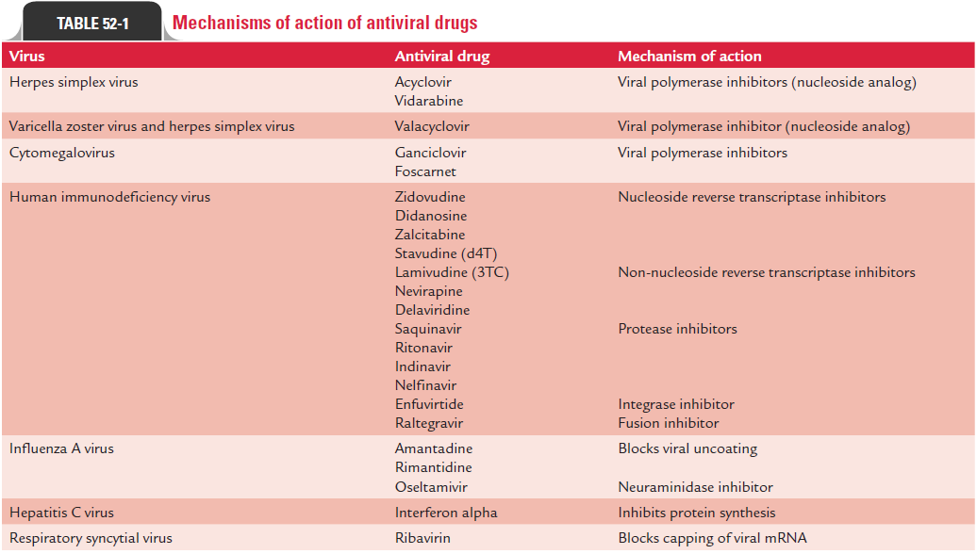

Thank you
___________________________________________________________________

