Department of Electrical Engineering
Assignment
Date: 23/06/2020

Course Details

Course Title: | Basic Mechanical Technology | Module: | 2nd
Instructor: | Engr. Sajid Nawaz | Total Marks: | 50

Student Details
Name: | Ihsan Ullah | Student ID: | 16717

Q 1 Define Strain and a cord has original length of 100 cm is pulled by a force. The change in length of the cord is 2 mm. Determine the strain?

Strain
Actually strain is a physical property, when material undergoes deformation within elastic limit, under
static loading, for e.g. in 1D strain, the factor ∆L/L is uniformly distributed along the length for each
smaller length.
Strain is defined as extension per unit length.
Strain = extension / original length
Where,
ε = strain,
lo
= the original length
e = extension = (l-lo), and
l = stretched length
Strain has no units because it is a ratio of lengths.
• We can use the above definitions of stress and strain for forces causing tension or compression.
• If we apply tensile force we have tensile stress and tensile strain
• If we apply compressive force we have compressive stress and compressive strain.
1. A cord has original length of 100 cm is pulled by a force. The change in length of the cord is 2 mm.
Determine the strain!
Known:
Original length (l0) = 100 cm = 1 m
The change in length (Δl) = 2 mm = 0.002 m
Wanted: The strain
Solution:
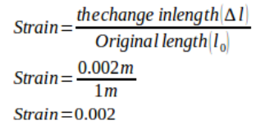

Q 2 Part A: If a tensile load of 5N is applied on a rectangular bar as shown in the figure. Where height of the bar is 8cm and breadth is 15cm. Calculate the tensile stress in the bar.
Solution:
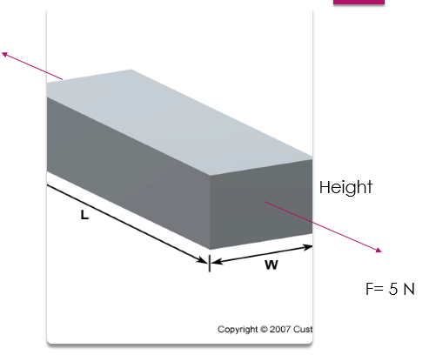
Given Data:
- Applied Load= F = 5N
- Rectangular Bar dimensions:
- Height= h= 8cm
- h= 8 x 10^-2 m
- Breadth= b= 15cm
- b=15 x 10^-2 m
Required Data:
Stress in the bar=?
Formula1:
α= F/A
- To find the stress first we will find the cross sectional area of the bar.
- Formula 2:
- A= b * h
- =(8 x 10^-2 m) x (15 x 10^-2 m)
- = 8 x 15 (10^-2) ^2 m^2
- = 120 x 10^-4 x m2

- Stress= σ = F/ A
- = 5N/ [120 x 10^-4 x m2 ]
- = (5 x 10^4) N/ 120 m2
- = 416 N/m2 Answer

Q 2 Part B: If a compressive load of 10N is applied on a rectangular bar as shown in the figure. Where height of the bar is 8cm, breadth is 15cm and length 30cm. Calculate the compressive stress in the bar.
Given data:
- Applied Load= F = 10N
- Rectangular Bar dimensions:
- Height= h= 8cm
- h= 8 x 10^-2 m
- Breadth= b= 15cm
- b=15 x 10^-2 m
- Length= L = 30cm
- L=30 x 10^-2 m
Required Data:
Stress in the bar= =?
Formula1:
- = F/A
- To find the stress first we will find the cross sectional area of the bar.
Formula 2:
A= L x b
- =(30 x 10^-2 m) x (15 x 10^-2 m)
- = 30 x 15 (10^-2) ^2 x m^2
- = 450 x 10^-4 m2
Stress= σ = F/ A
- = 10N
- [450 x 10^-4 xm^2 ]
- = (10 x 10^4) N
- 450 m2
= 222.22 N/m2 Answer

Q 3 Part A: Briefly explain principal of momentum and momentum of sea saw?
Principle of moment: The principle of moments states that when in equilibrium the total sum of the anti-clockwise moment is equal to the total sum of the clockwise moment.
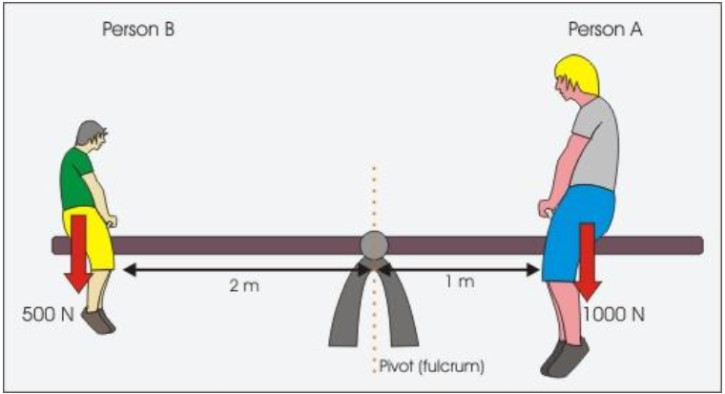
When a system is stable or balance it is said to be in equilibrium as all the forces acting on the system cancel each other out.

Moments Acting On a Seesaw:
Both people exert a downward force on the seesaw due to their weights.
Person A’s weight is trying to turn the seesaw anticlockwise whilst person B’s weight is trying to turn the seesaw clockwise.
Person A’s Moment = Force x perpendicular distance from fulcrum
1000 x 1 = 1000 Nm
Person B’s Moment = Force x perpendicular distance from fulcrum
500 x 2 = 1000 Nm
Persons A’s moment = Persons B’s Moment
Anticlockwise moment = Clockwise moment

Q 3 Part B: Differentiate between stable and unstable Equilibrium and give proper examples you will observe in daily life?
A state of balance between opposing forces or actions that is either static (as in a body acted on by forces whose resultant is zero) or dynamic (as in a reversible chemical reaction when the rates of reaction in both directions are equal).
Equilibrium is a state of a system which does not change.
For example, the equilibrium of a pencil standing on its tip is unstable; the equilibrium of a picture on the wall is (usually) stable.

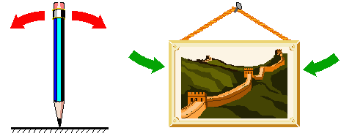

An equilibrium is considered stable (for simplicity we will consider asymptotic stability only) if the system always returns to it after small disturbances. If the system moves away from the equilibrium after small disturbances, then the equilibrium is unstable.
Q 4: Define stress and following terms
- Tensile stress
- Compressive stress
- Shear Stress

Stress: “The Stress is defined as the resistance force per unit cross sectional area of the body”.

Formula:
Stress = Resistance Force divided by Cross Sectional Area
σ= F / A

S.I Unit: Newton per meter square
N/mˆ2

- Tensile stress: If the force is going to pull the material, the stress is said to be tensile stress.

- Compressive stress: compressive stress develops when the material is being compressed by two opposing forces.

- Shear Stress: Shear stress is developed if the applied force is parallel to the resisting area.

